DAILY ONLINE ACTIVITIES SUMMARY
Date: | 30-06-20 |  |  |  |  | Name: | Raghavi H Gaonkar
Sem & Sec | VI Sem & B Sec |  |  |  |  | USN: | 4AL17CS071
Online Test Summary
Subject |  | Java & J2EE
Max. Marks |  | - |  | Score |  |  | -
Certification Course Summary
Course | -
Certificate Provider |  |  | - |  | Duration |  |  | -
Coding Challenges
Problem Statement:1 Java Program and 1 C Program
Status:Executed
Uploaded the report in Github |  |  |  |  | Yes
If yes Repository name |  |  |  |  | https://github.com/Raghavi26/dailystatus
Uploaded the report in slack |  |  |  |  | Yes

Online Test Details:

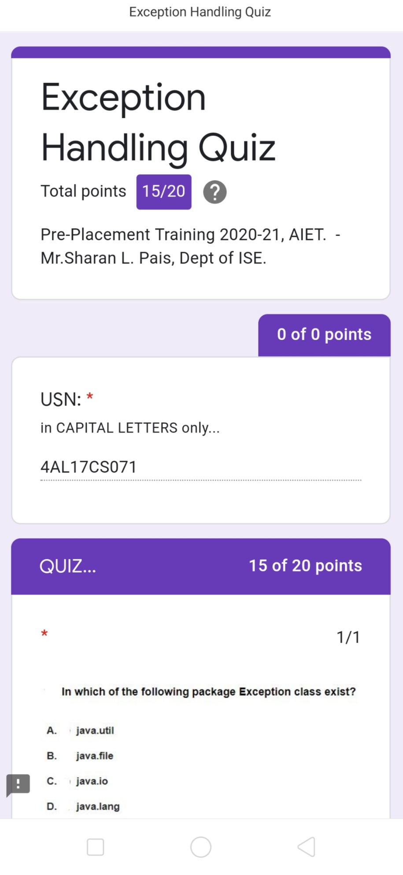

Coding Challenges Details:
Program 1:
This is output of java program to determine whether one string is a rotation of another.

Program 2:
This is output of C program to generate first n Ugly Numbers.

Refer Github Account For Detailed Information:
https://github.com/Raghavi26/dailystatus/tree/master/Online%20coding

