DAILY ONLINE ACTIVITIES SUMMARY
Date: | 19-06-20 |  |  |  |  | Name: | Raghavi H Gaonkar
Sem & Sec | VI Sem & B Sec |  |  |  |  | USN: | 4AL17CS071
Online Test Summary
Subject |  | Programming in C
Max. Marks |  |  |  | Score
Certification Course Summary
Course | Workshop on “Applications of Python Programming in DA & ML”
Certificate Provider |  |  | - |  | Duration |  |  | -
Coding Challenges
Problem Statement:1 Java and 2 C Program and 1 Python Program
Status:Executed
Uploaded the report in Github |  |  |  |  | Yes
If yes Repository name |  |  |  |  | https://github.com/Raghavi26/dailystatus
Uploaded the report in slack |  |  |  |  | Yes
Online Test Online:
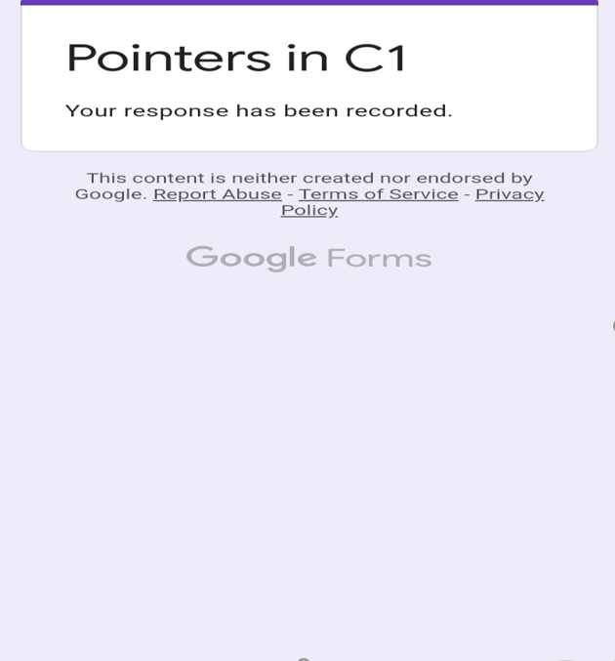

Workshop Details:

Coding Challenge Details:
Program1:
This is output of java program to create a doubly linked list of n nodes and display it in reverse order.

Program2:

Program3:

Program4:

Refer Github Account for Detailed Information:
https://github.com/Raghavi26/dailystatus/tree/master/Online%20coding

“Workshop on “Applications of Python Programming in DA and ML”
https://github.com/Raghavi26/Applications-0f-Python-Programming-in-DA-and-ML

