DAILY ONLINE ACTIVITIES SUMMARY
Date: | 1-7-20 |  |  |  |  | Name: | Raghavi H Gaonkar
Sem & Sec | VI Sem & B Sec |  |  |  |  | USN: | 4AL17CS071
Online Test Summary
Subject |  | -
Max. Marks |  | - |  | Score |  |  | -
Certification Course Summary
Course | -
Certificate Provider |  |  | - |  | Duration |  |  | -
Coding Challenges
Problem Statement:1 Java Program
Status:Executed
Uploaded the report in Github |  |  |  |  | Yes
If yes Repository name |  |  |  |  | https://github.com/Raghavi26/dailystatus
Uploaded the report in slack |  |  |  |  | Yes

Online Coding Contest:
Today I attended CODE-A-THON 2020.

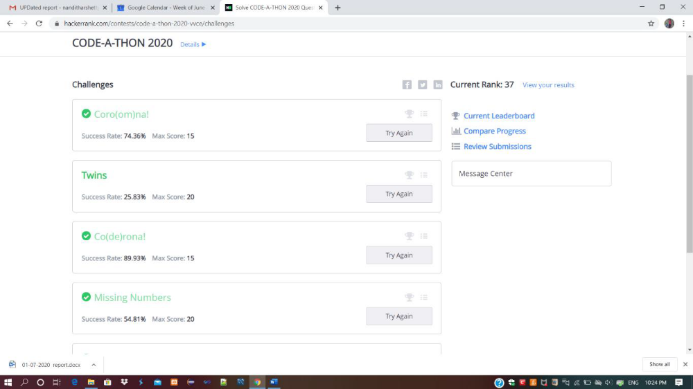

Coding Challenges Details:
Program 1:
This is output of java program to find given two trees are mirror or not.

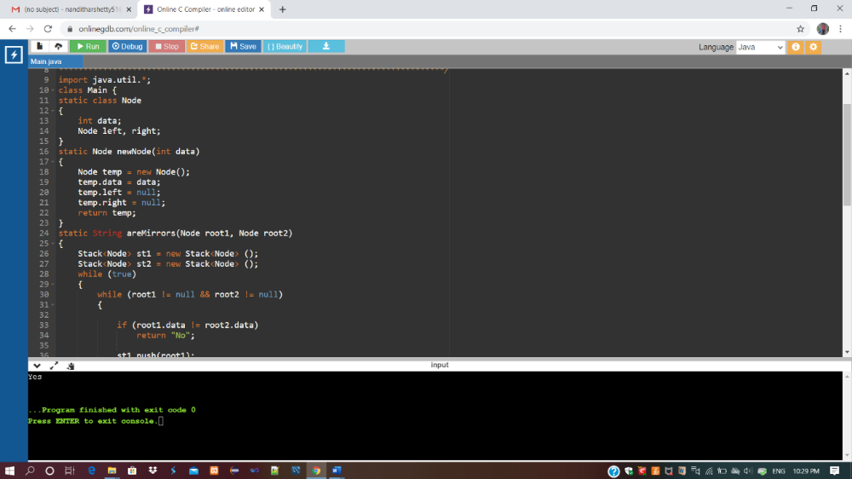

Refer Github Account For Detailed Information:
https://github.com/Raghavi26/dailystatus/tree/master/Online%20coding

https://github.com/Raghavi26/dailystatus/blob/master/Online%20coding/01-07-2020program1.docx

