DAILY ONLINE ACTIVITIES SUMMARY
Date: | 6-07-20 |  |  |  |  | Name: | Raghavi H Gaonkar
Sem & Sec | VI Sem & B Sec |  |  |  |  | USN: | 4AL17CS071
Online Test Summary
Subject |  | CNSC IA test
Max. Marks |  | - |  | Score |  |  | -
Certification Course Summary
Course | -
Certificate Provider |  |  | - |  | Duration |  |  | -
Coding Challenges
Problem Statement:1 C Program
Status:Executed
Uploaded the report in Github |  |  |  |  | Yes
If yes Repository name |  |  |  |  | https://github.com/Raghavi26/dailystatus
Uploaded the report in slack |  |  |  |  | Yes

Online Certification Course Details:
Today I completed 2 lessons:
• Blockchain Structure.
• Basic Operations in Blockchain.
And took quiz on these lessons.
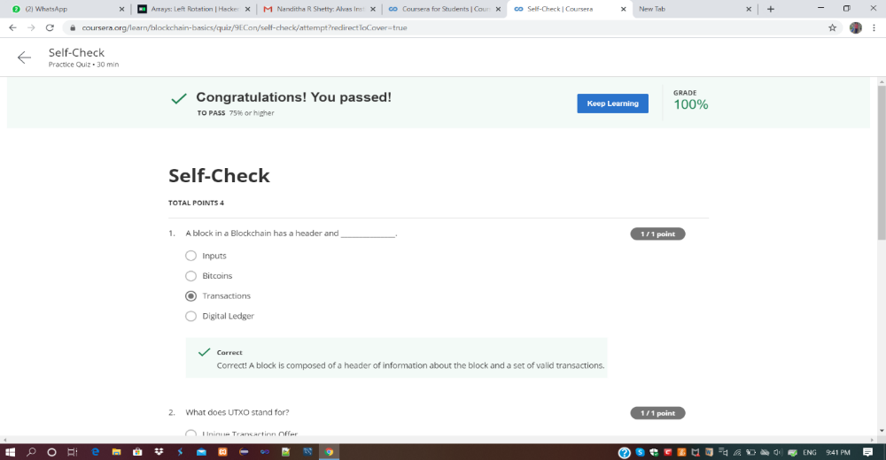

Coding Challenges Details:
Program 1:
This is output of C program to find sum of digits of 5 digit number.
Refer GitHub.
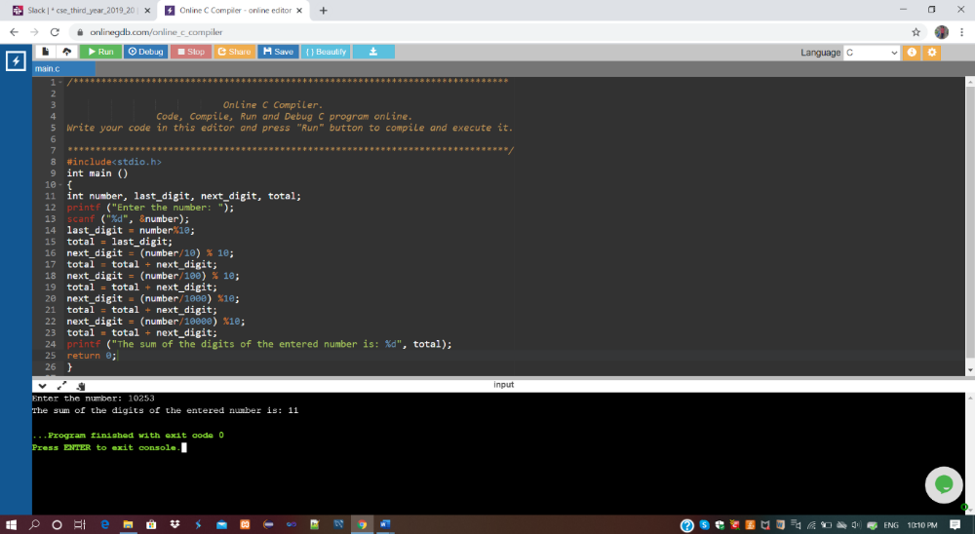

Refer Github Account for Detailed Information:
https://github.com/Raghavi26/dailystatus/blob/master/Online%20coding/6-07-2020program1.docx

