NAME : RAGHAVI.S

PROJECT NAME : MALICIOUS URL DETECTION USING MACHINE LEARNING IN PYTHON

IMPLEMENTATION:

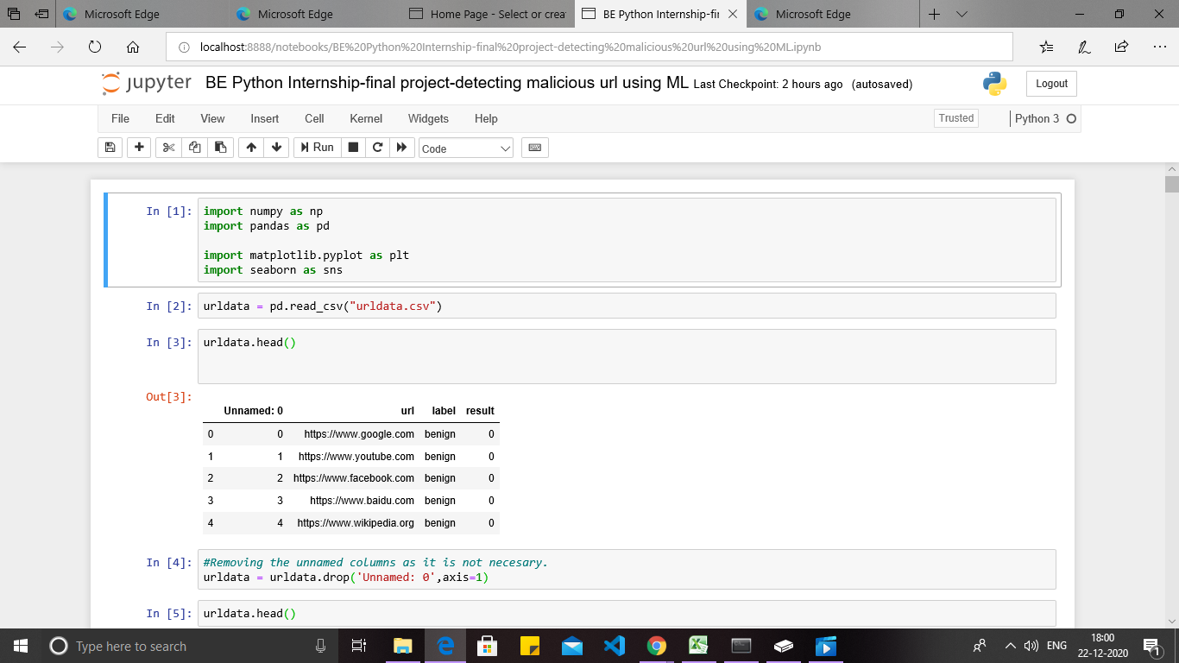

1)At first,I have imported required libraries

2)I have downloaded urldata.csv dataset and read the data.

3)I have displayed the first 5 rows using “head” command.

4)Removed unwanted column in dataset and checked for null values.

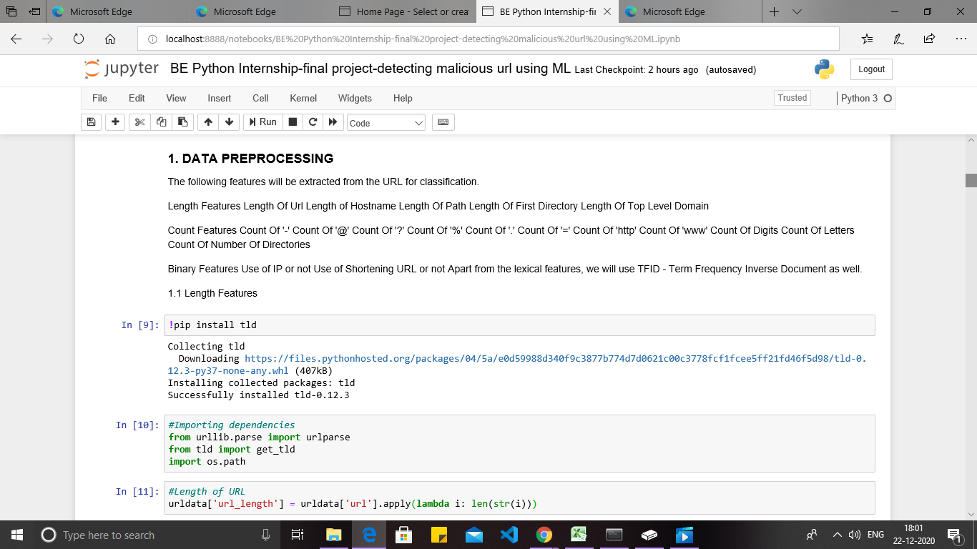

ANATOMY OF URL:

4 Parameters:

* Protocol
* Domain name
* Host
* Path

5)I am doing data preprocessing by extracting these 4 parameters and also counting the special characters like digit,symbol and letters.

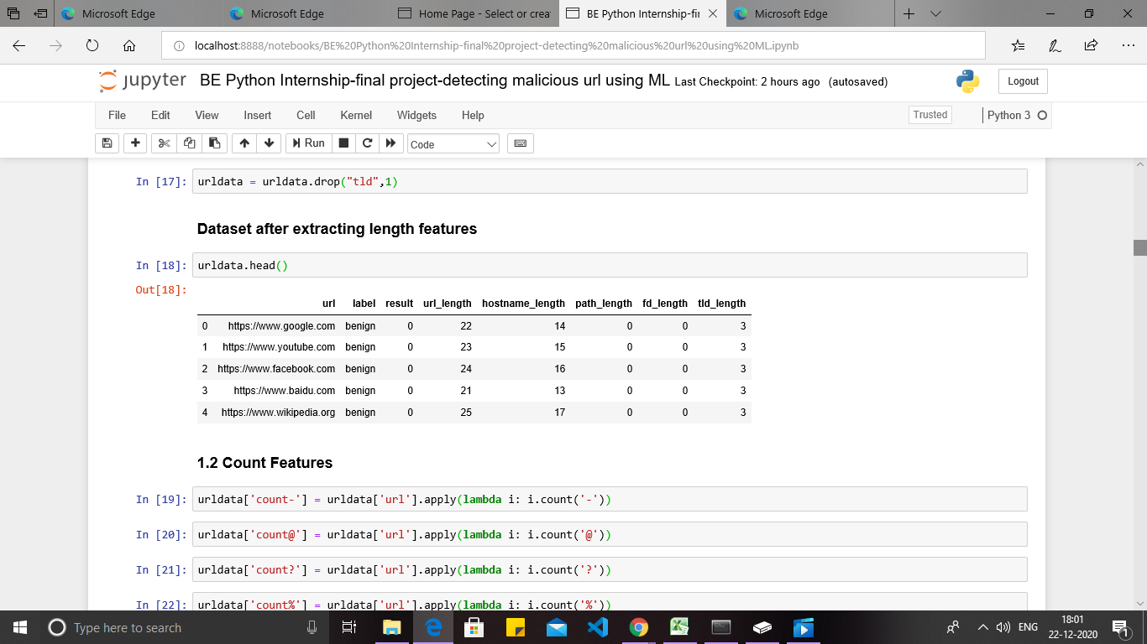

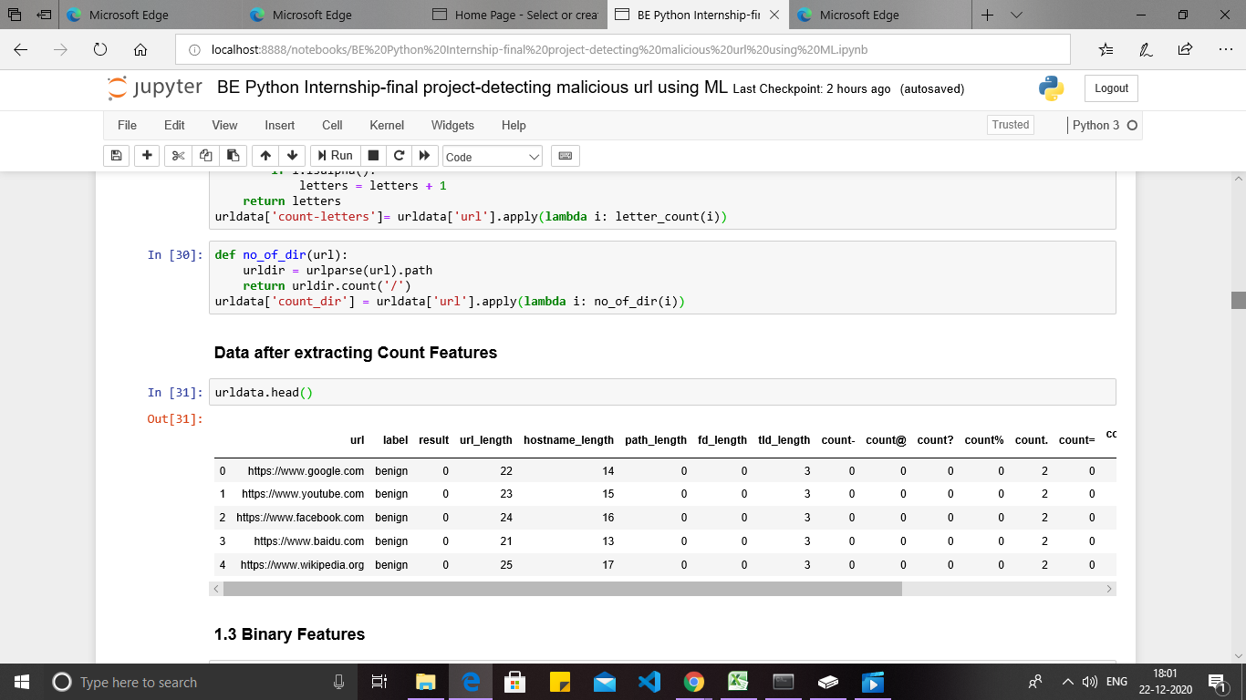

6)I am extracting binary features and shortening url and implemented with normal function.

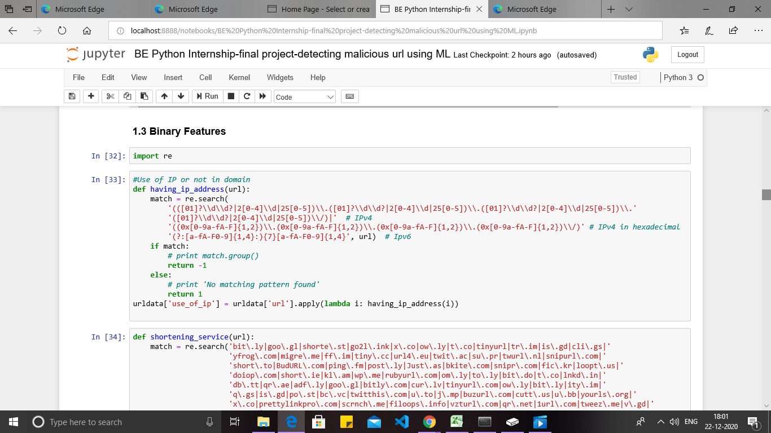

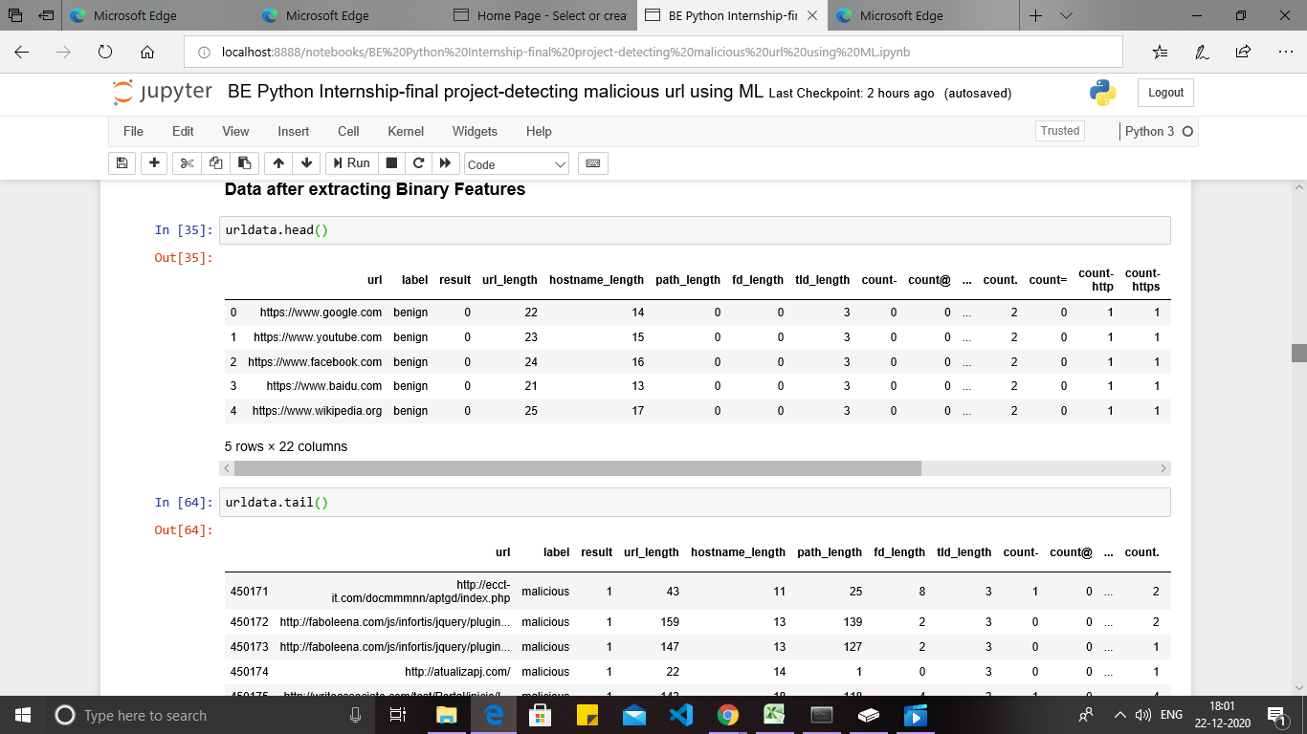

7) In addition to this , for better understanding I have used data visualization.

8)I have imported the visualization library “seaborn”

9)I have represented the result in Heatmap and Bar graph.

