# Deployment on Heroku

**Name**: Raghavi Gururajan

**Batch code**: LISUM11:30

**Submission date**:25/8/2022

**Submitted to**: Data Glacier

**Deployment procedure**

Step 1:

Develop ML model: As a part of Data analysis Internship, I have used Linear Regression for the medical insurance personal dataset

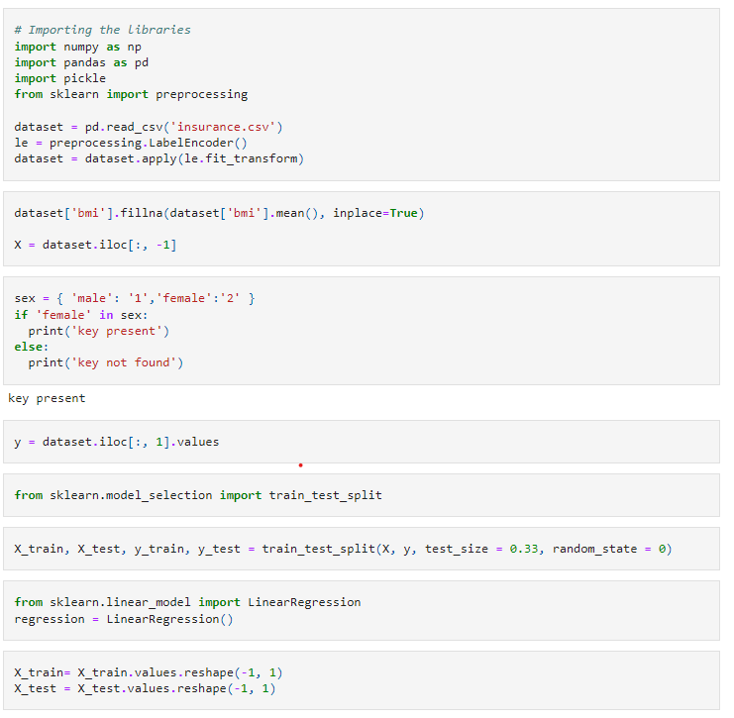

Step2:

Fitted the model with the training dataset



Step3:

Saved and loaded the model to the disk to compare the results

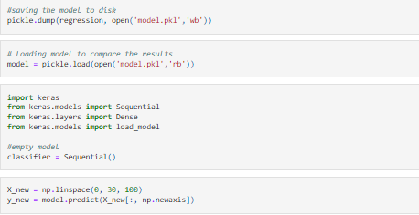

Step4: Deploy the model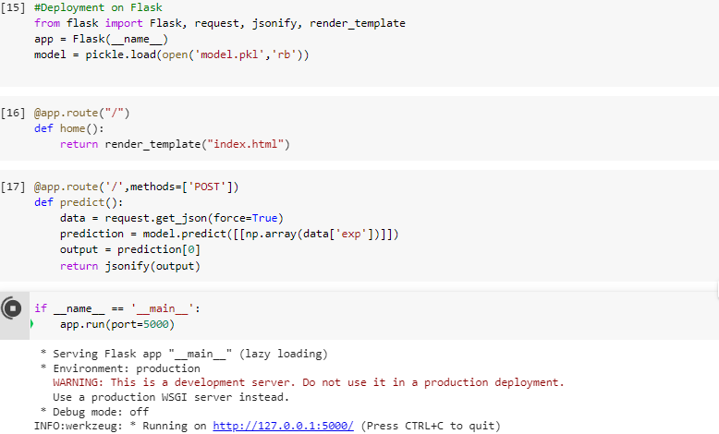

Step4:

Created an account on Heroku and uploaded the dataset

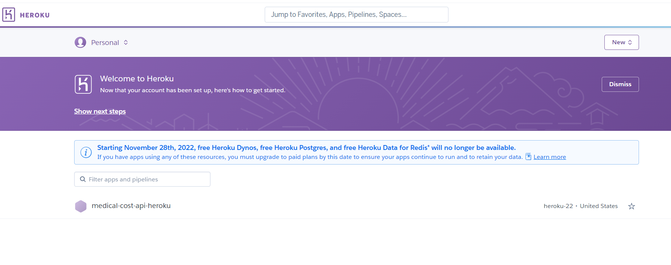

Step5:

Connected the GitHub account for the deployment

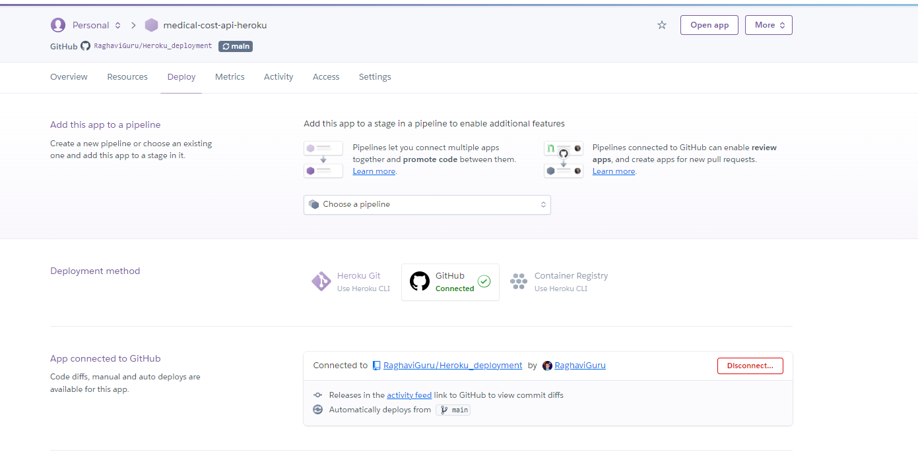

Step6:

