ET-3206 DD LABORATORY

JOURNAL
EXPERIMENT – 7

Simulation of Sequential Circuits in Verilog HDL
(3 Bit Counter)

Group No.: - ETB-B3-G9

Group Members

1. Raghavi Narayanan(12311308)

Objective:
To simulate a 3-bit Binary Counter using Verilog and verify its operation using Synopsys VCS and Verdi.
(a) To study the operation of a binary counter
(b) To verify counting sequence using simulation
(c) To observe waveform behaviour using Verdi

EDA Tools Used:
Platform: For design setup
Synopsys VCS: For compilation and simulation
Verdi: For waveform analysis and debugging

3-bit Counter – Functional Description
A Binary Counter is a sequential digital circuit that counts the number of clock pulses applied to it. A 3-bit counter can count from 0 to 7 (000 to 111) in binary.
Inputs and Output
Input Clock: i_Clock
Reset: i_Reset
Output: o_Counter[2:0]
Block Diagram:
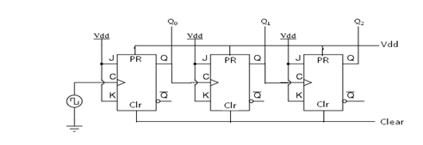
Verilog Files:
1.Design
`timescale 1ns / 1ps
//#######################
//# Synchronous counter: 3-bit counter
module counter(
output reg [2:0] o_Counter,
input wire i_Clk,
input wire i_Rst
);

always @(posedge i_Clk or posedge i_Rst)
begin
if (i_Rst)
o_Counter <= 3'b000; // reset to 0
else
o_Counter <= o_Counter + 1'b1; // increment counter
end

endmodule
2.Testbench

`timescale 1ns / 1ps
`include "counter.v" // include your main counter design

module counter_tb;

// Declare signals
wire [2:0] o_Counter;
reg i_Clock;
reg i_Reset;

// Instantiate the DUT (Design Under Test)
counter DUT (
.o_Counter(o_Counter),
.i_Clk(i_Clock),
.i_Rst(i_Reset)
);

// Clock generation
always #5 i_Clock = ~i_Clock;

// Stimulus
initial begin
// Waveform dump for Verdi
$fsdbDumpfile("novas.fsdb"); // creates waveform file
$fsdbDumpvars(0, counter_tb); // dumps all signals in this module

// Initialize signals
i_Clock = 0;
i_Reset = 0;

// Apply test cases
#10 i_Reset = 1; // assert reset
#10 i_Reset = 0; // deassert reset

// Run simulation for a while
#100;

// Monitor values in terminal
$monitor("Time=%0t | Reset=%b | Counter=%b", $time, i_Reset, o_Counter);

// End simulation
#50 $finish;
end

endmodule

Results:
RTL Block Diagram:
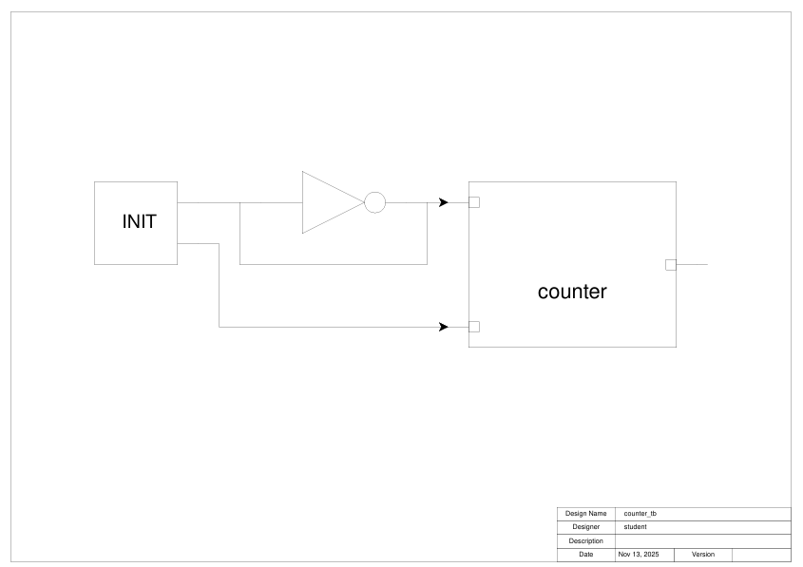

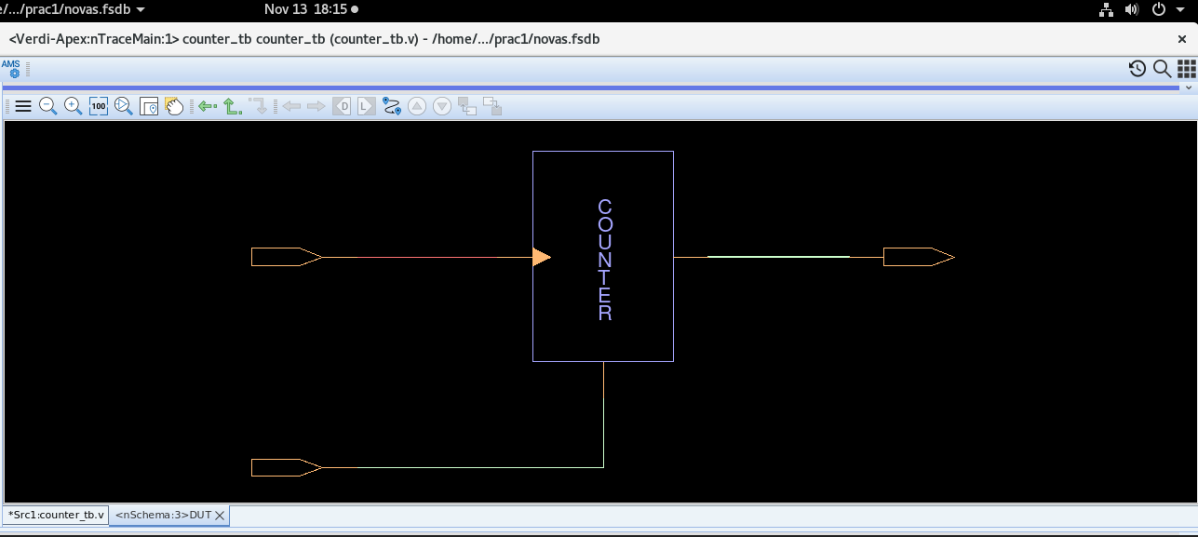
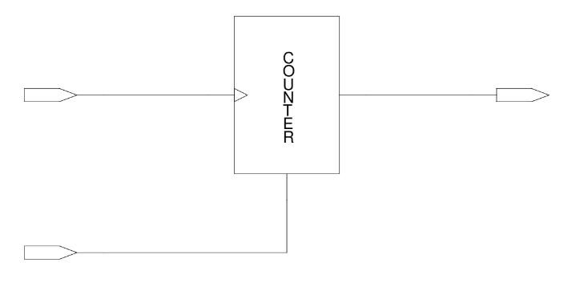
2. Waveform
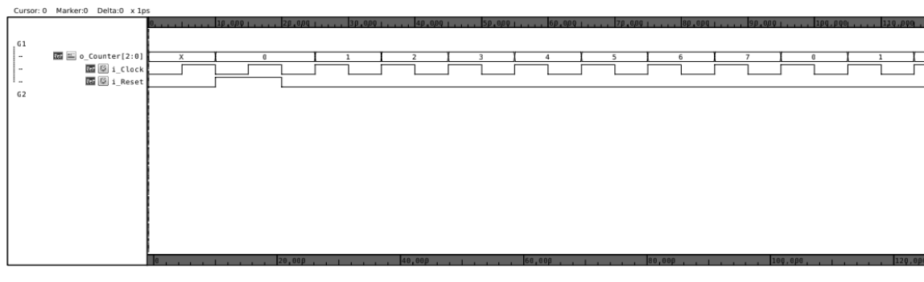

From the waveform:
On every rising edge of the clock, the counter increments
The output sequence follows:
000 → 001 → 010 → 011 → 100 → 101 → 110 → 111 → 000
When reset is HIGH, the counter output becomes 000
This confirms correct counting operation.

Clock Edge | o_Counter[2:0]
1 | 000
2 | 001
3 | 010
4 | 011
5 | 100
6 | 101
7 | 110
8 | 111
9 | 000 (Repeat)

Conclusion:
The 3-bit Binary Counter was designed in Verilog and simulated using Synopsys VCS. The waveform inspection in Verdi confirmed that the counter increased its value correctly with each clock pulse and responded properly to the reset signal. The simulation output followed the expected counting pattern, proving that the counter works correctly.

