WIKIEDAI:- Grab the ideas for projects
4th Raghavi Narayanan Electronics and Telecommunication Vishwakarma Institute Of Technology Pune, India raghavi.narayanan23@vit.edu
1st Prof Prajakta Musale
Electronics and Telecommunication Vishwakarma Institute of Technology
Pune, India
prajakta.musale@vit.edu

Abstract— In the current academic environment, engineering students face difficulty in discovering reliable and categorized project ideas across emerging technological domains. WikiEDAI is a mobile application developed using Flutter and Firebase that provides a centralized repository for engineering project ideas. The platform allows users to browse projects by domain, view detailed descriptions, and contribute new project ideas. Firebase is used for real-time data storage and file management, ensuring scalability and responsiveness. The application improves accessibility, encourages innovation, and simplifies project discovery for students and researchers.
Keywords—Flutter, Firebase, Mobile Application, Project Repository, Cloud Database

Introduction
Engineering education emphasizes practical learning through projects, yet students often struggle to identify suitable project ideas aligned with emerging technologies and industry demands. Existing platforms provide limited categorization, lack structured documentation, or require extensive searching across multiple sources. This gap highlights the need for a centralized, organized, and easily accessible system that aggregates engineering project information in one place. WikiEDAI is proposed as a solution to this problem by offering a mobile application that enables users to explore, upload, and manage engineering project ideas efficiently. Built using Flutter, the application provides a cross-platform solution with a responsive and consistent user interface. Firebase is used as the backend to support real-time data synchronization, secure storage, and scalability. WikiEDAI categorizes projects into well-defined domains, enabling users to quickly locate relevant ideas based on their interests. Additionally, the platform encourages user participation by allowing contributors to submit new projects, thereby continuously expanding the knowledge base. By combining modern mobile application development with cloud-based services, WikiEDAI enhances accessibility, improves project discovery, and fosters innovation among engineering students.

LITERATURE REVIEW

Several studies and platforms have focused on improving access to academic project resources and enhancing collaborative learning among engineering students. Traditional project repositories are often implemented as web-based portals that provide limited categorization and lack real-time interaction. These systems typically rely on static databases and manual updates, resulting in outdated content and reduced usability. Research has shown that centralized repositories significantly reduce the time required for project discovery; however, many existing solutions fail to provide a structured domain-based classification or user contribution mechanisms.
Recent advancements in mobile application development have introduced cross-platform frameworks such as Flutter, which enable rapid development of responsive and consistent user interfaces across devices. Studies indicate that Flutter-based applications outperform traditional hybrid frameworks in terms of UI rendering and development efficiency. Additionally, cloud-based backend services like Firebase have been widely adopted for academic and collaborative applications due to their scalability, real-time synchronization, and ease of integration. Firebase Firestore has been proven effective for handling structured, real-time data, while Firebase Storage offers a reliable solution for managing large media files.
Several mobile learning and academic resource applications incorporate user-generated content, but many lack proper validation, structured storage, or domain-based organization. Research on collaborative knowledge-sharing platforms emphasizes the importance of intuitive interfaces, efficient data retrieval, and secure storage to encourage user participation. Furthermore, studies on cloud-integrated educational systems highlight the advantages of real-time updates, reduced infrastructure costs, and improved accessibility.
Despite these advancements, there remains a gap in mobile-based platforms specifically designed to aggregate and organize engineering project ideas across multiple technical domains. WikiEDAI addresses this gap by combining Flutter’s cross-platform capabilities with Firebase’s real-time backend services to create a centralized, scalable, and user-friendly project repository. The proposed system builds upon existing research by integrating structured data storage, media management, and domain-specific categorization within a single mobile application.

System Architecture And Methodology
The WikiEDAI system follows a client–server architecture where the Flutter-based mobile application acts as the client and Firebase serves as the backend. The user interface is developed using Flutter widgets to ensure smooth navigation and responsiveness. Firebase Firestore is used to store structured project data such as title, description, domain, and contributor email, while Firebase Storage manages image and file uploads. When a user submits data, it is validated on the client side and then stored in Firebase. Real-time listeners enable instant updates in the project listing, ensuring consistency across users.
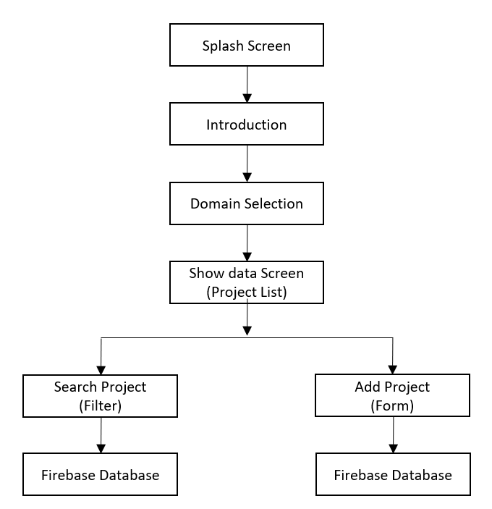
Fig. 1 Block Diagram for WIKIEDAI project

The Flutter application serves as the primary interface through which users interact with the system. User actions such as browsing projects, searching by domain, and uploading new project information are handled at the client level using Flutter widgets and state management techniques. When a user initiates the data acquisition process by submitting a new project, the application first performs client-side validation to ensure the completeness and correctness of the entered information, including project title, description, and contact details.
Once validated, the textual project data is transmitted to Firebase Firestore, a cloud-hosted NoSQL database optimized for real-time operations. Each project is stored as a structured document within a domain-specific collection, enabling efficient categorization and retrieval. For image and file uploads, the application utilizes Firebase Storage, which is specifically designed for handling large binary objects. Selected images are temporarily cached on the device and then uploaded asynchronously to Firebase Storage. Upon successful upload, Firebase generates a secure download URL for each image, which is then stored as a reference within the corresponding Firestore document. This separation of structured data and media files improves performance and ensures efficient storage management.
During data retrieval, the application queries Firestore collections based on the selected domain and listens for real-time updates using Firebase listeners. Retrieved metadata, along with image URLs, is rendered dynamically on the user interface. Images are fetched from Firebase Storage only when required, minimizing bandwidth usage and improving application responsiveness. This end-to-end pipeline ensures seamless data acquisition, secure storage, and real-time visualization of engineering project information within the WikiEDAI platform.

Results And Discussions
.
The implementation of WikiEDAI demonstrates efficient storage, retrieval, and real-time visualization of engineering project data using Flutter and Firebase. The application successfully categorizes projects into multiple domains and enables seamless browsing and searching through an intuitive user interface. Data uploaded by users, including textual information and images, is stored securely and retrieved with minimal latency. Firebase Firestore ensures real-time synchronization across devices, while Firebase Storage effectively manages media files without impacting application performance. Testing results indicate stable performance, responsive UI rendering, and reliable data consistency, validating the suitability of the chosen architecture for scalable academic information systems.

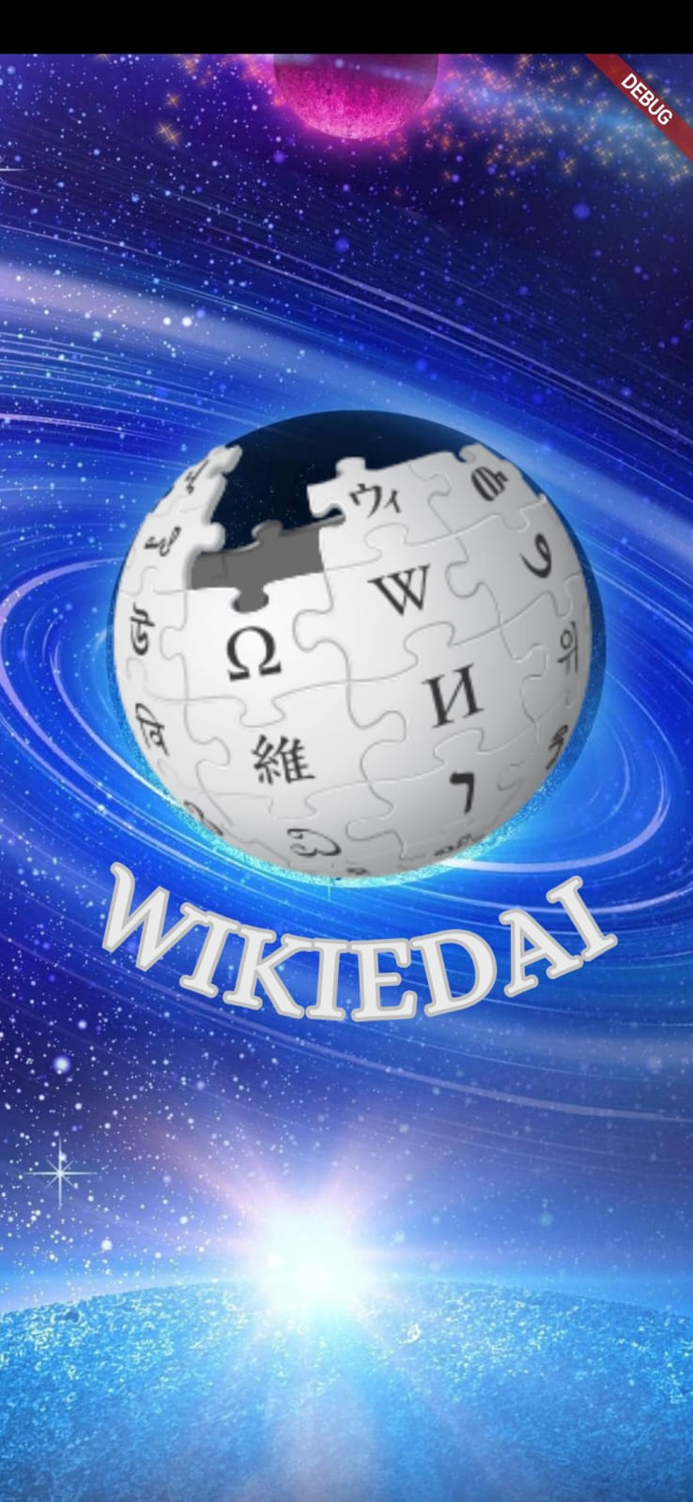
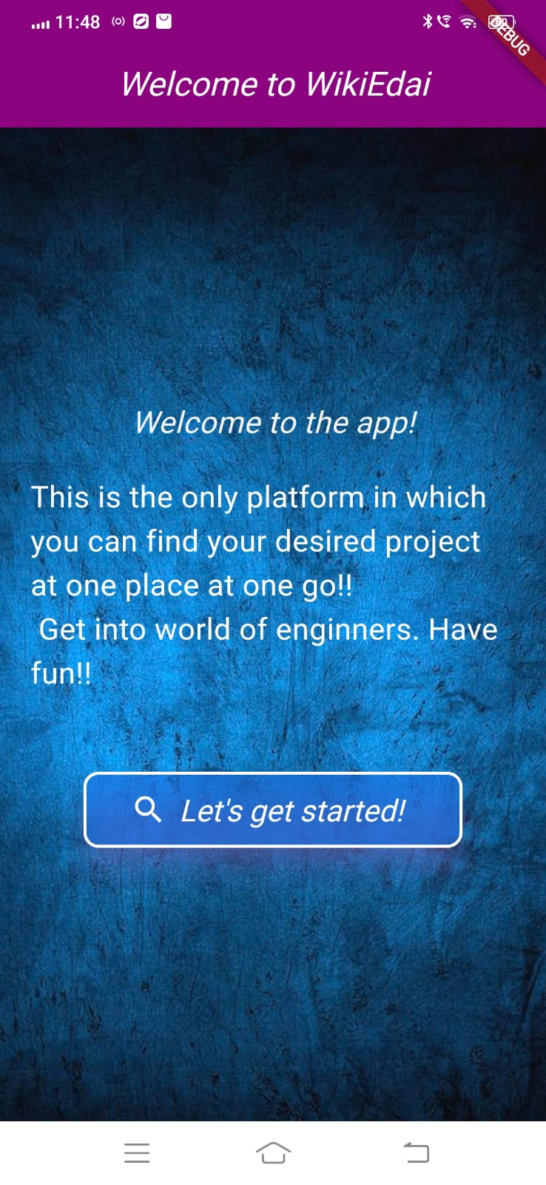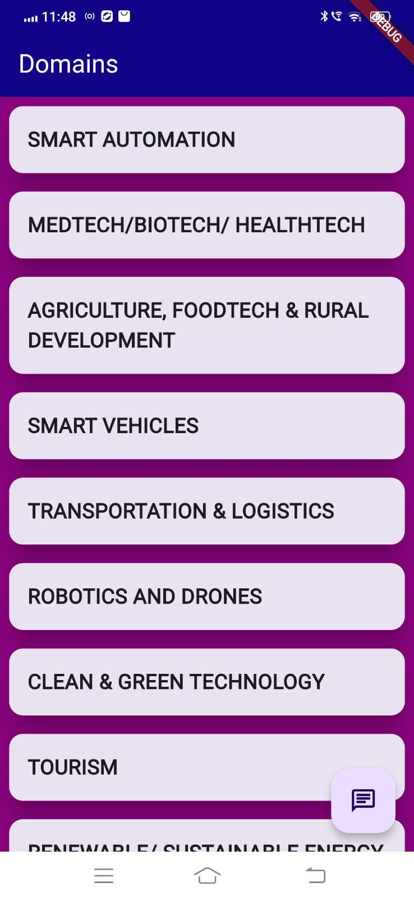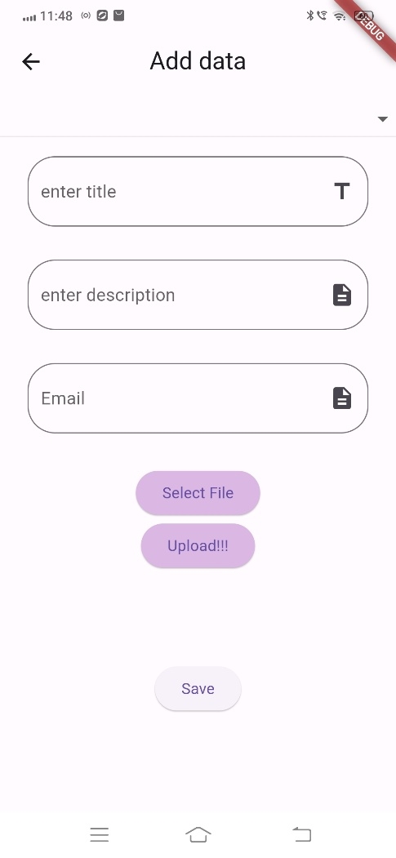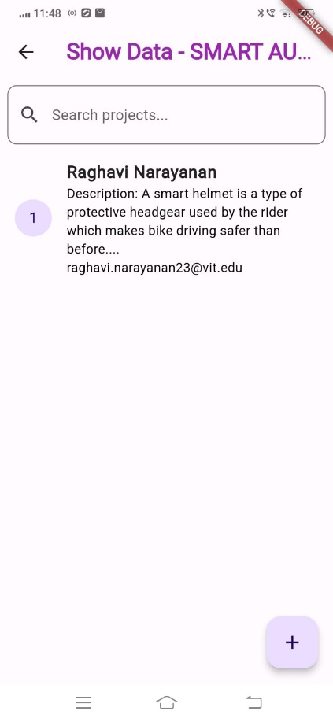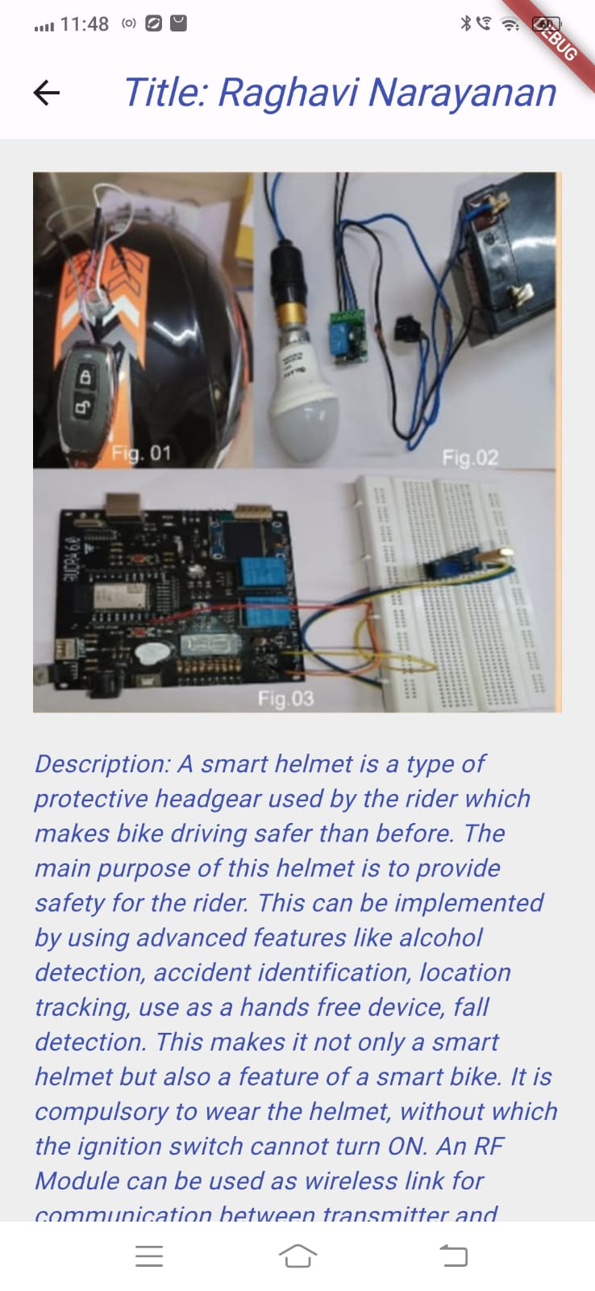

Conclusion
This research proposed an integrated framework for two of the most essential problems in Music Information Retrieval (MIR): the tasks of musical instrument identification and detect cover songs. The framework incorporated feature engineering, the use of ensemble learning, and deep neural models and showed that a single data-driven framework is able to capture the spectral–temporal richness of musical signals.

In the case of the musical instrument identification task, the use of a varied feature set including Mel-Frequency Cepstral Coefficients (MFCCs), Chroma features, spectral centroid, bandwidth, rolloff, zero-crossing rate, and RMS energy were used. When comparing models, it was shown that XGBoost was the best performing model, yielding predictions at an accuracy % of ~65–69. On average, it outperformed both Random Forests and CNNs. The ensemble models were also the best convolution of interpretability, robustness, and computational efficiency for a high-dimensional audio set of features. Strategies for dimensionality reduction, including PCA or SelectKBest, did actually deteriorate outcomes, reaffirming that the inclusion of the full spectral–temporal representation of the signals was critical for identifying differences in instrument timbre.
In the context of a cover song detection line of work, the experiments with the Cover80 dataset showed promise for similarity-based and boosting approaches, detecting music relationships across different covers of the same song. Gradient Boosting outperformed the other models, with an accuracy of 63.89% and a balanced F1-score of 0.63, being competitive to simple baselines of Random Forest and Neural Networks. Discriminatively, the analysis determined that while there was mean or moderate discriminative ability (AUC ≈ 0.63), the model predicted with overconfidence, indicating the need for improved calibration and uncertainty estimates in future systems constructing a Music Information Retrieval (MIR).

Overall, the described work presents evidence for effective uses of ensemble learning for representing structured audio features, as well as the limitation of using deep models for small sample sizes; whilst future work will establish data augmentation, features learned across varieties of modalities, and hybrid deep–ensemble architectures to define generalization and find a close to real-time performance in large applications of MIR.

References
[1] Google, Flutter Documentation, Google Developers, 2024. [Online]. Available: https://flutter.dev/docs

[2] Google, Firebase Documentation, Google Developers, 2024. [Online]. Available: https://firebase.google.com/docs

[3] A. Al-Hmouz, M. Almuhtadi, and M. Al-Shabi, “Cloud-Based Educational Systems: Design and Implementation,” International Journal of Advanced Computer Science and Applications, vol. 10, no. 6, pp. 45–52, 2019.

[4] M. Armbrust et al., “A View of Cloud Computing,” Communications of the ACM, vol. 53, no. 4, pp. 50–58, Apr. 2010.

[5] S. K. Sharma and A. Gupta, “Mobile Learning Applications Using Cloud Services,” International Journal of Computer Applications, vol. 975, no. 8887, pp. 12–16, 2018.

[6] P. Mell and T. Grance, “The NIST Definition of Cloud Computing,” National Institute of Standards and Technology, Special Publication 800-145, 2011.

[7] R. Buyya, C. S. Yeo, and S. Venugopal, “Market-Oriented Cloud Computing: Vision, Hype, and Reality,” Proceedings of the 10th IEEE International Conference on High Performance Computing and Communications, pp. 5–13, 2008.

[8] J. O’Donovan and B. Smyth, “Collaborative Knowledge Sharing Systems in Education,” IEEE Internet Computing, vol. 9, no. 3, pp. 34–41, May–June 2005.

