CS23604 – Creative and Innovative Project
Team-27

Smart Public Transport Management System-Automated Crowd Monitoring Using IoT Sensors

Team members
Vijay D (2023503579) Supervisor: Dr. S. Muthurajkumar
S.S Raghav Surya (2023503571)
Akshayaa Veena A L (2023503531)
FIRST REVIEW
TEAM-27
Title:
Smart Public Transport Management System - Automated Crowd Monitoring Using IoT Sensors
Domain:
Internet of Things (IoT), Smart Transportation Systems, Embedded Systems, Sensor Networks.
Introduction:
Smart transportation is a very important application of IoT technology attributable to its use in several urban mobility fields. Monitoring of passenger occupancy in buses for the aim of crowd management is one such application of smart sensors. Maintenance and monitoring of passenger flow plays an important role within the analysis of efficiency of any transportation system. The aim of developing Smart Public Transport Management System is to modernize the standard approach of bus capacity monitoring. The system performs the daily activities of passenger counting and crowd analysis with reduced human intervention.
Smart transportation uses modern technology to solve city travel problems. Only thirty percent of students use public buses regularly. Most students avoid buses because they cannot predict crowding levels or know when buses will arrive. Our proposed system will solve these issues using multiple types of sensors working together.
The system integrates techniques like infrared beam detection, weight sensing, GPS tracking and wireless data transmission for passenger monitoring. The system provides increased accuracy as a result of use of multiple validation methods (IR sensors, Load cells, GPS positioning, Real-time communication) for passenger counting. Occupancy levels are determined using sensor fusion algorithms and threshold-based classification methods.

Problem Statement:
Public transportation systems, especially buses, are widely used due to their affordability and accessibility. However, one of the major challenges faced by passengers and transport authorities is the lack of real-time information about bus occupancy and crowd levels. In many urban and campus transportation systems, passenger counting and crowd monitoring are still performed manually or are estimated inaccurately, leading to unreliable data.
Due to the absence of automated monitoring, passengers are unable to predict overcrowding conditions, which discourages the use of public buses. This issue is particularly evident among students, where uncertainty about bus availability and crowd density results in low adoption of public transport. Additionally, transport authorities face difficulties in efficiently managing bus schedules, optimizing capacity utilization, and responding to peak-hour congestion.
Manual methods of passenger monitoring are prone to errors, require human intervention, and cannot provide real-time updates. Environmental factors such as varying lighting conditions, passenger movement patterns, and simultaneous entry and exit further reduce accuracy when using single-sensor systems.
Therefore, there is a need for a reliable, automated, and real-time crowd monitoring system that can accurately detect passenger movement and occupancy levels in buses. Such a system should operate with minimal human intervention, use sensor-based data collection, and provide timely information to both passengers and transport administrators to improve transportation efficiency and user satisfaction.
Literature Survey:
S.No | Title | Year | Methodology | Limitation
1 | A Low-Cost IoT-Based Crowd Management System for Public Transport | 2017 | - Utilizes thin-film piezoresistive sensors integrated into seat cushions to detect binary occupancy states.  - Employs nRF24L01 RF modules for low-power mesh networking between seats and a central gateway. | - System is architecturally blind to standing passengers, leading to significant underestimation of true floor load.  - High wiring complexity increases failure points and maintenance costs within a vibrating vehicle environment.
2 | Enabling and Emerging Sensing Technologies for Crowd Management in Public Transportation Systems | 2021 | - Implements a multi-tier SALUTARY architecture using 5G New Radio (NR) for ultra-low latency data backhaul.  - Deploys heterogeneous sensor nodes to monitor station-wide and vehicle-specific passenger densities simultaneously. | - High CAPEX and OPEX requirements for 5G infrastructure and specialized hardware deployment.  - Massive data overhead creates computational bottlenecks in real-time edge processing nodes.
3 | A Bus-Scheduling Method Based on Multi-Sensor Data Fusion | 2022 | - Fuses Automated Fare Collection (AFC) data with GPS telemetry to reconstruct passenger trajectories.  - Employs probabilistic algorithms to estimate Origin-Destination (OD) matrices for transit scheduling optimization. | - Significant data leakage due to non-compliant passengers or technical failures in fare-gate validation hardware.  - Real-time accuracy is compromised by transaction latency and lack of physical verification sensors.
4 | Crowd Estimation Using Sensors for Public Transport (Buses) | 2020 | - Deploys active infrared obstacle sensors at entry/exit points for bi-directional passenger flux detection.  - Implements a sequential interrupt logic on a microcontroller to increment or decrement the total headcount | - Susceptible to cumulative drift errors caused by "tailgating" (multiple passengers breaking the beam simultaneously)  - Sensor sensitivity is highly affected by ambient light interference and physical obstructions at door frames.
5 | Empirical Study on the Accuracy and Precision of Automatic Passenger Counting in European Bus Services | 2019 | - Develops statistical regression models based on empirical boarding data to adjust raw sensor outputs  - Implements static correction factors to account for sensor occlusion during high-frequency boarding intervals | - Models are environment-specific and fail to adapt to dynamic changes in passenger behaviour or bus layouts  - Lack of hardware-level feedback means errors are corrected mathematically rather than physically validated
6 | IoT System for Monitoring and Managing Public Transport Data | 2023 | - Evaluates MQTT vs. HTTP RESTful API performance for synchronizing vehicle telemetry with cloud databases  - Focuses on Quality of Service (QoS) levels to ensure data integrity during intermittent cellular connectivity | - Treats the "Passenger Count" as a trusted input, ignoring the physical inaccuracies of the underlying sensor hardware.  - Lacks a redundant sensing layer, making the entire system vulnerable to single-point hardware failure.
7 | Movement Direction Classification Using Low-Resolution ToF Sensor and LSTM-Based Neural Network | 2025 | - Utilizes Time-of-Flight (ToF) sensors (like VL53L8CX) to create an 8x8 distance matrix for depth-based detection.  - Processes sequences through Long Short-Term Memory (LSTM) networks to distinguish entering/exiting from "random" movements | - Narrow Field of View (FoV): Standard ToF sensors require high ceiling mounting (2.5m+) to cover a bus door area effectively.  - Signal Noise: Accuracy drops significantly if passengers carry large, non-human shaped objects (e.g., large boxes) that distort the depth map.
8 | IoT-Based Smart Bus Monitoring System Using Infrared Sensors | 2018 | - IR sensor pairs are installed at bus doors to detect passenger entry and exit events.  - A microcontroller (Arduino/ESP) processes sensor signals to update passenger count.  - Count data is transmitted to a cloud platform for remote monitoring | - Simultaneous entry or exit of passengers causes miscounting.  - Reliance on a single sensing method reduces accuracy in crowded conditions.
9 | Automatic Passenger Counting Using Weight / Load Sensors | 2020 | - Load cells are mounted under bus steps or flooring to detect weight changes.  - Passenger count is estimated by analysing incremental weight variations.  - Threshold-based logic is used to identify boarding and alighting events. | - Passenger luggage and body-weight variation affect accuracy.  - Cannot reliably distinguish multiple passengers boarding at the same time.
10 | A Passenger Detection and Action Recognition System for Public Transport Vehicles | 2024 | - Uses vision system with cameras mounted on vehicle interiors to detect and count passengers.  - Proposes a cross-camera CNN structure to recognize passenger poses and actions.  - Implements a region prediction algorithm to avoid double counting from overlapping camera views. | - Relies on camera hardware and vision processing, which increases system cost and complexity compared to simple sensors.  - Lighting/occlusion conditions within buses can affect accuracy of detection.  - High computational demand for CNN inference and real-time video processing

Research gap:
Previous studies have explored various approaches, including IR sensors, load cells, ultrasonic sensors, Time-of-Flight (ToF) sensors, and vision-based systems, to detect passenger boarding and alighting events. While these studies demonstrate the potential of sensor-based monitoring, they exhibit several limitations. Systems relying on a single type of sensor often struggle with accuracy under crowded conditions, especially when multiple passengers enter or exit simultaneously. Low-cost sensors such as IR pairs or load cells are prone to errors caused by luggage, varying passenger heights, and standing passengers, whereas vision-based methods, though more accurate, are computationally intensive and expensive, limiting their practical deployment in real-time applications.
Moreover, many existing solutions either focus on simulated environments or are constrained to partial implementations, lacking a fully integrated system that combines multiple low-cost sensors with real-time data processing and IoT-based cloud monitoring. There is, therefore, a clear need for a robust, low-cost, multi-sensor IoT-based passenger counting system that can provide accurate and reliable estimates across diverse bus routes and passenger scenarios. The proposed system aims to address these gaps by integrating IR sensors and load cells with an ESP32 microcontroller, enabling real-time counting, crowd status indication, and cloud-based monitoring, while accounting for the limitations observed in previous studies.
Objective:
1. Detection of passenger movement in the crowded bus environment with entry and exit counting.
2. Extraction of real-time occupancy data helpful for crowd management and passenger information.
3. Effective monitoring of passenger density in buses during peak hours.
4. Machine-driven update to the Database without having any human intervention.
Data description:

- Passenger Data: Entry count, exit count, and total occupancy of passengers in the bus.
- Sensor Data: Infrared sensor readings, load cell weight values, and sensor trigger timestamps.
- Location Data: GPS coordinates, route number, and real-time bus location updates.
- Crowd Level Classification Data: Occupancy thresholds, crowd density levels (low, medium, high), and alert conditions.
- System Monitoring Data: Sensor accuracy logs, data transmission status, and real-time update intervals.
- Predictive Analytics Data: Forecasted passenger counts, estimated arrival times (ETA), and expected crowd density based on historical trends and seasonal patterns.

Architecture diagram: 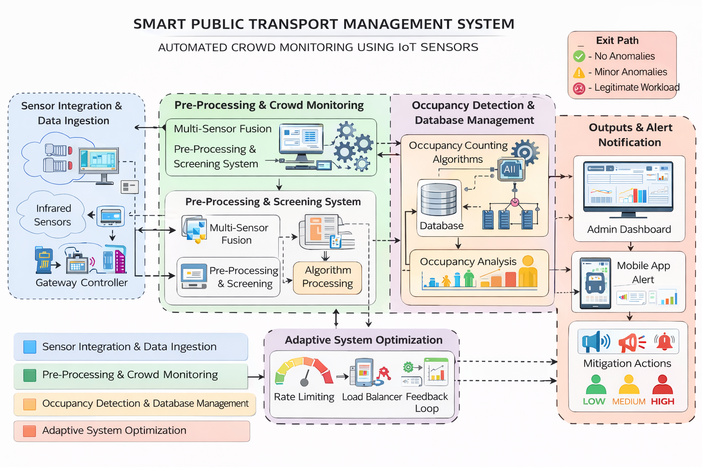
Modules:
- Sensor Integration & Data Ingestion:
- Collects real-time data from infrared sensors and load cells installed in the bus.
- Gathers passenger entry/exit events, weight measurements, and sensor trigger signals.
- Transfers raw sensor data to the gateway controller for further processing.

- Pre-Processing & Crowd Monitoring:
- Multi-Sensor Fusion Module: Combines IR sensor data and load cell readings to improve accuracy.
- Pre-Processing & Screening System: Filters noise caused by vibrations, luggage, or sensor errors.
- Data Validation Engine: Validates passenger movement data to avoid false counts.
- Algorithm Processing Unit: Prepares clean data for occupancy calculation.

- Occupancy Detection & Analysis:
- Occupancy Counting Algorithms: Calculates passenger count using entry and exit data.
- Database Management Module: Stores real-time and historical occupancy data.
- Occupancy Analysis Module: Classifies crowd levels as Low, Medium, or High based on thresholds.
- Capacity Evaluation Engine: Compares current occupancy with maximum bus capacity.

- Real-Time Monitoring & Alert System:
- Admin Dashboard Module: Displays live occupancy status and bus utilization statistics.
- Mobile Application Alert Module: Provides real-time crowd level updates to passengers.
- Notification Engine: Sends alerts during overcrowding or peak hours.

- Adaptive System Optimization & Feedback:
- Threshold Adjustment Module: Dynamically adjusts crowd level thresholds based on usage patterns.
- Performance Monitoring Module: Monitors sensor accuracy and system response time.
- Feedback Loop: Continuously refines detection logic using historical passenger data.

Tools Used:
Programming Language:
- Arduino C/C++: For programming the microcontroller and interfacing sensors.
- Python: For backend processing, data handling, and server-side communication.
Development Environment:
- Arduino IDE: For writing and uploading microcontroller code.
- Android Studio: For developing the mobile application interface.
- Ubuntu OS: For server-side deployment and backend services.
Libraries and Frameworks:
Sensor Interfacing & Data Processing
  - Arduino Sensor Libraries: For interfacing IR sensors and load cells.
  - HX711 Library: For load cell signal amplification and weight measurement.
  - PySerial: For serial communication between Arduino and server.
  - Pandas: For processing and storing passenger occupancy data.

Visualization & Application
  - Android SDK: For building user-friendly mobile application interfaces.
  - Matplotlib: For backend data visualization and occupancy analysis charts.

Cloud & Networking Services:
  - Wi-Fi / GSM Modules: For wireless data transmission.
  - REST APIs: For real-time data communication between server and mobile app.
Methods:
- Multi-Sensor Fusion & Threshold-Based Analysis
- Combines infrared sensor readings and load cell weight data to improve passenger counting accuracy.
- Uses predefined occupancy thresholds to determine crowd levels (Low, Medium, High)..
2. Entry–Exit Detection Using Infrared Beam Interruption
- Detects passenger entry and exit events based on sequential IR sensor activation.
- Applies logical rules to distinguish between boarding and alighting passengers.

3. Weight Validation Using Load Cell Analysis
- Validates passenger count using load cell weight changes.
- Filters false detections caused by luggage or sensor noise.

- Real-Time Occupancy Calculation & Update
- Continuously updates total passenger count using entry and exit data.
- Transmits occupancy information to the server and mobile application in real time.
- Adaptive Threshold Adjustment & Alert Mechanism
- Adjusts crowd level thresholds dynamically based on historical passenger data.
- Triggers alerts and notifications during overcrowding or peak hours.

Timeline:
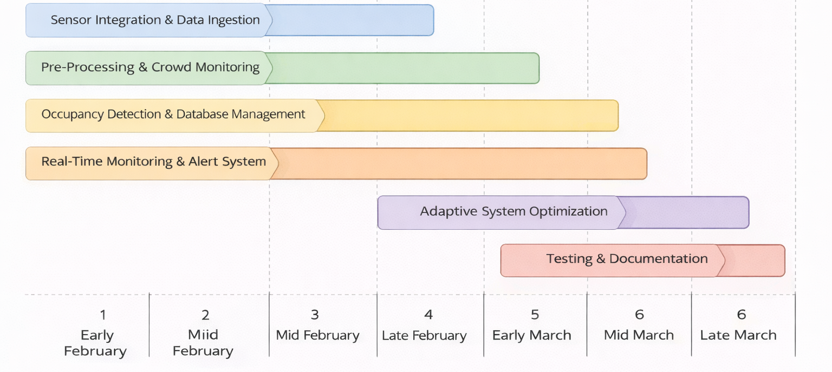

References:
[1] S. M. K. et al., "A Low-Cost IoT-Based Crowd Management System for Public Transport," 2017.
[2] A. Author et al., "Enabling and Emerging Sensing Technologies for Crowd Management in Public Transportation Systems," 2021.
[3] B. Author et al., "A Bus-Scheduling Method Based on Multi-Sensor Data Fusion," 2022.
[4] C. Author et al., "Crowd Estimation Using Sensors for Public Transport (Buses)," 2020.
[5] D. Author et al., "Empirical Study on the Accuracy and Precision of Automatic Passenger Counting in European Bus Services," 2019.
[6] E. Author et al., "IoT System for Monitoring and Managing Public Transport Data," 2023.
[7] F. Author et al., "Movement Direction Classification Using Low-Resolution ToF Sensor and LSTM-Based Neural Network," 2025.
[8] Daniel Lale, Claudia Borzea, Sorina Gogoneață, Cristian Nechifor, Mirela Vasile, Filip Niculescu, "IoT-Based Smart Bus Monitoring System Using Infrared Sensors," 2018.
[9] A. Author et al., "Automatic Passenger Counting Using Weight / Load Sensors," 2020.
[10] Huei-Yung Lin, Shih-Feng Kao, Chieh-Chih Wang, "A Passenger Detection and Action Recognition System for Public Transport Vehicles," 2024

