**CSC 490**

**BEIRUT MUNICIPALITY PHASE 2**

**By SpeedDev**

A REPORT submitted to DR. IBRAHIM ALBITAR in partial fulfillment of the requirements for the course “CSC490: Software Engineering” in Computer Science

Adnan Kabbani (202202088)

Rawad Tarhini (202202455)

Ragheed Ghanem (202204199)

Sireen Badawi (202204065)

4/1/2024

*This page was intentionally left blank.*

***Table of Contents:***

I. Introduction.................................................................................................................................................4

II. Software Architecture................................................................................................................................5

III. Software Interactions...............................................................................................................................6

IV. Software Components............................................................................................................................15

V. Software Structure...................................................................................................................................31

VI. Conclusion.............................................................................................................................................34

**1. Introduction**

The Municipality Management System (MMS) isn't just a proposal; it's a gateway to a future where residents enjoy efficient public services. To bring this vision to life, we designed a process that prioritized both user-friendliness and efficiency.

The main process was crafting use cases and activity diagrams. These detailed blueprints weren't for a generic user, but for the various stakeholders who interact with the system: residents, municipal staff, and administrators. Each diagram mapped out the key functions and interactions each group would have with the MMS. Imagine a resident wanting to apply for a permit online. The use case would detail the steps involved, ensuring a clear and intuitive experience.

Furthermore, a class diagram was created to map out the different entities within the MMS. This diagram defined the various components, such as resident data, permit applications, and processing stages. By ensuring a logical and organized foundation, the class diagram not only streamlined the initial development but also facilitated future maintenance and updates. Imagine adding a new feature for online park reservations, the class diagram would serve as a guide, ensuring the new functionality seamlessly integrates with the existing system.

But optimization didn't stop there. We also developed sequence diagrams, allowing us to zoom in on key scenarios. These diagrams outlined crucial processes, such as resident bill payment and issue reporting by municipal staff. By detailing each step, we were able to pinpoint potential constraints and inefficiencies.

In essence, the MMS design process wasn't just about creating software; it was about creating a gateway to a more efficient and resident-centric future. By considering every user interaction and internal component, we ensured the MMS would be a bridge to a new era of public services.

**2. Software Architecture**

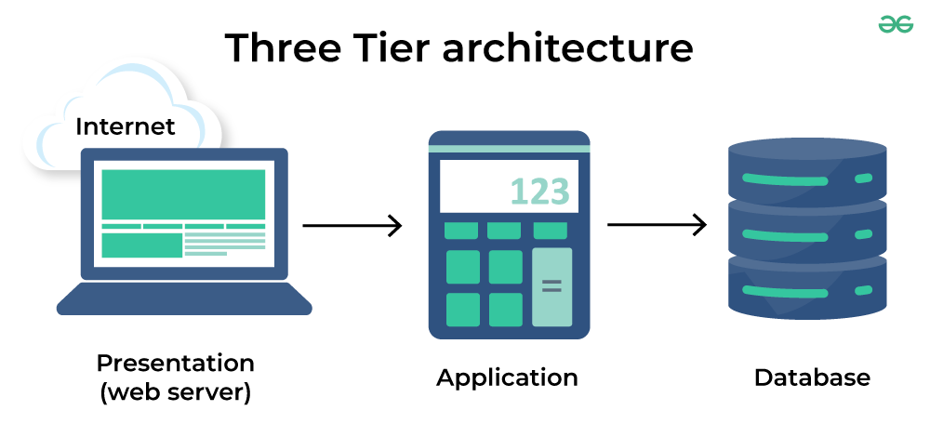

The Municipality Management System (MMS) utilizes a three-tier architecture diagram to illustrate its major components. This architecture separates the system into distinct layers for presentation, processing, and data storage, offering several advantages like scalability and maintainability.

**1. Presentation Tier:**

The web server forms the heart of this layer, acting as the bridge between users and the application tier. It interprets user input and transmits requests to the application server for processing the necessary actions.

**2. Application Tier:**

This core layer houses the system's functionalities. Billing, issue reporting, information portals, and administrative tools are some key components residing here. These components work together and interact with the data tier to deliver a comprehensive service experience for both residents and municipal staff.

**3. Data Tier:**

The data tier is the foundation, holding the database that stores all critical information. Resident data, municipal services, transactions, and other relevant details are securely managed within this tier. Here, the system ensures smooth and efficient operation by effectively organizing and managing this data.

**3. Software Interactions**

In this section, the interactions of various stakeholders with the Municipality Management System will be thoroughly described, providing insights into the functioning of our system.

**Selected Actors:**

Resident

Municipal Staff

Administrator

Contractor

Service Provider

Accompanying System:

Banking System

**1. Resident Use Case Diagram:**

The primary user of the Municipality Management System is the residents of the municipality.

Residents can utilize the system to access municipal services, pay bills, report issues, and gather information about various municipal activities and services. This involves logging into the system using their credentials and navigating through the interface to access the desired functionalities. They can browse available municipal services, review detailed information about each service, and submit service requests as needed. The system provides confirmation messages and unique reference numbers for submitted requests, allowing residents to track the status of their requests over time.

In addition to service requests, residents can use the system to pay bills securely and efficiently. They can view their billing information, make payments online, and receive confirmation of successful transactions. Furthermore, residents have the capability to report issues such as infrastructure problems or public safety concerns through the system. They can provide details about the issue, track its progress, and receive updates on its resolution.

Moreover, residents can access information about municipal affairs, including announcements, events, and updates on various services. The system may provide personalized recommendations based on residents' preferences and interactions, enhancing their overall experience.

Overall, the use case for residents within the MSMS revolves around providing them with convenient access to municipal services, efficient management of requests and payments, and timely information to stay engaged with municipal affairs.

(Diagram on next page)

**Resident Use-case Diagram:**

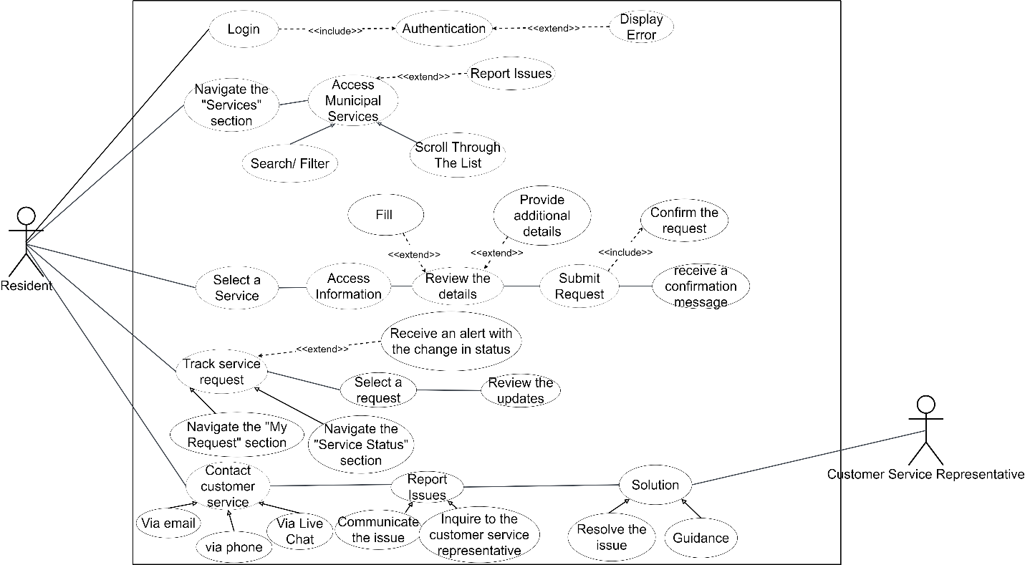

**2. Administrator:**

Within the Municipality Management System (MSMS), administrators play a crucial role in overseeing system operations, managing user accounts, configuring settings, and ensuring the system's security and performance. The use case for administrators encompasses a range of functions aimed at facilitating their administrative tasks and responsibilities.

Administrators have the authority to create and manage user accounts within the system. This involves creating new user accounts by inputting essential details such as usernames, email addresses, and assigned roles. They can also update existing user account information, including modifying user details and adjusting permissions as needed. Additionally, administrators can deactivate or suspend user accounts and delete accounts when necessary, ensuring proper management of user access.

Furthermore, administrators are responsible for configuring system settings to tailor the system according to the municipality's requirements. They can adjust settings such as language preferences, time zones, and default views to optimize system functionality. Administrators may also customize system templates and notifications to align with the municipality's branding guidelines and communication standards.

Another critical function of administrators is managing access controls and permissions within the system. They define access levels and specify permissions for different user roles to ensure appropriate access restrictions. Administrators can set up workflows and approval processes to streamline various tasks and actions within the system, enhancing operational efficiency and accountability.

Moreover, administrators monitor system performance and security, ensuring data integrity and safeguarding against potential threats. They may receive alerts and notifications regarding system issues or anomalies, taking proactive measures to address them promptly. Additionally, administrators may generate reports and analytics to gain insights into system usage and performance metrics, supporting informed decision-making and continuous improvement efforts.

Overall, the use case for administrators within the MSMS revolves around effective management of user accounts, configuration of system settings, enforcement of access controls, and maintenance of system security and performance. Their actions are essential for ensuring the smooth operation and optimal utilization of the MSMS to support municipal operations and serve residents efficiently.

**Administrator Use-case Diagram:**

**3. Service Provider:**

Within the Municipality Management System (MSMS), service providers play a crucial role in managing their service offerings and interacting with the system to ensure smooth service delivery to residents. The use case for service providers encompasses various functions aimed at updating, adding, and maintaining services within the system, as well as facilitating communication and collaboration with municipal staff and residents.

Service providers initiate their interaction with the MSMS by logging in using their designated credentials, which are authenticated by the system to ensure secure access to the platform's functionalities. Upon successful authentication, service providers are presented with options tailored for managing their service offerings.

These options include updating the availability of services, adding new services, and maintaining existing ones. Service providers can retrieve and display a comprehensive list of their current services within the system, assisting them in identifying which services require updates or additions.

Upon selecting a specific service for update or addition, the system presents a user-friendly form or interface that allows service providers to input or modify relevant details of the selected service. This may include details such as availability, pricing, description, or any other pertinent information necessary for residents to understand and access the service.

After making the desired changes, service providers validate the provided information to ensure accuracy and consistency. Upon successful validation, the system updates the service database with the modified or new service details, ensuring that residents have access to up-to-date and accurate information about available services.

In cases where service providers encounter technical difficulties or require additional assistance, they have the option to contact system support for timely resolution of issues, ensuring uninterrupted service delivery and resident satisfaction.

Once all necessary updates or additions are completed, service providers securely log out of the MSMS, safeguarding system access and data integrity in compliance with security protocols and standards.

Overall, the use case for service providers within the MSMS revolves around managing their service offerings effectively, ensuring accurate and up-to-date information for residents, and facilitating seamless communication and collaboration with municipal staff and residents to deliver quality services and enhance the resident experience.

**Contractor Use-case Diagram:**

**4. Customer Services**

Within the Municipality Management System (MSMS), customer service representatives play a pivotal role in handling resident inquiries, addressing issues, and providing assistance to ensure a positive user experience. The use case for customer service representatives encompasses a variety of functions aimed at effectively managing resident interactions and resolving inquiries in a timely and satisfactory manner.

Customer service representatives begin by logging into the MSMS using their authorized credentials, thereby gaining access to the system's functionalities tailored for handling inquiries. Upon authentication, they are presented with a dashboard that displays incoming inquiries queued for handling, prioritized based on urgency or chronological order.

The representatives select an inquiry from the queue to address, considering factors such as the nature of the issue and resident's needs. They then retrieve detailed information about the selected inquiry from the system, including relevant resident details and previous interactions.

Engaging in communication with the resident, customer service representatives gather additional information, ask clarifying questions, and provide guidance or solutions to address the resident's concerns or requests effectively. They may also escalate inquiries to specialized teams or supervisors when necessary, ensuring that complex issues receive appropriate attention and resolution.

Throughout the process, customer service representatives update the system with relevant details regarding the inquiry's status and resolution, maintaining an accurate record of resident interactions and issue resolutions. This ensures transparency and accountability in handling resident inquiries and facilitates tracking and follow-up on ongoing issues.

Once the inquiry handling process is completed, representatives securely log out of the MSMS to safeguard system access and data integrity, ensuring compliance with security protocols and standards.

Overall, the use case for customer service representatives within the MSMS revolves around providing timely and effective assistance to residents, addressing inquiries and issues, and maintaining accurate records to support quality service delivery and user satisfaction. Their actions are essential for fostering positive resident interactions and ensuring the MSMS effectively meets the needs of its users.

**Customer services representator Use-case Diagram:**

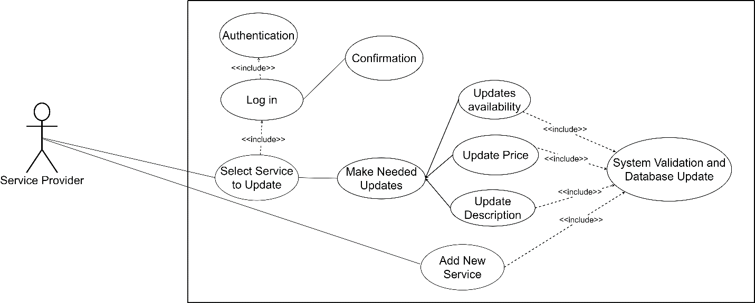

**4. Software Components**

This section provides an overview of the software components that constitute the Municipality Management System with activity diagrams.

**Resident:**

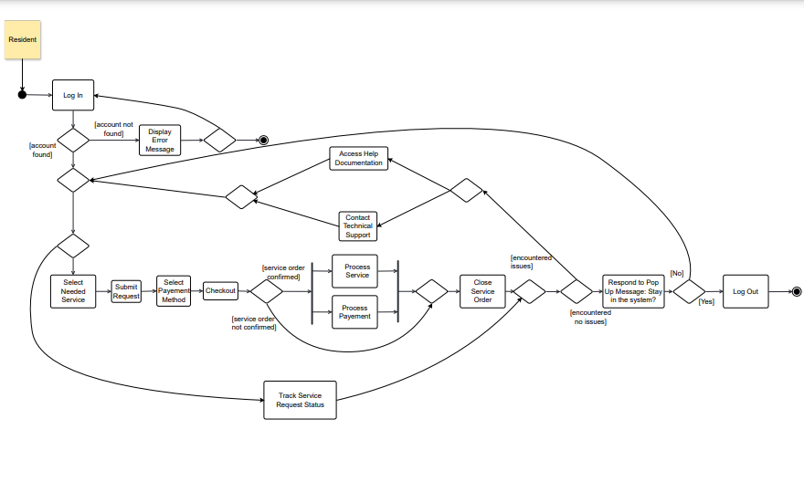

Residents accessing municipal website to select services begin with the login process to the Municipality Management System. Here, the resident enters their credentials, comprising their username or email and password. The system then validates these credentials, redirecting the resident to the dashboard or homepage upon successful authentication. However, if the authentication fails, the system displays an error message, prompting the resident to retry.

Once logged in, the resident proceeds to browse the available municipal services within the system. Navigating to the "Services" section, the system retrieves and presents a comprehensive list of these services. The resident can then scroll through the options or utilize search and filter functionalities to find specific services of interest. Should the desired service not be readily found, the resident has the option to contact customer support for assistance.

Upon selecting a particular service from the list, the system provides detailed information about it, including descriptions, requirements, and eligibility criteria. The resident carefully reviews these details to ensure alignment with their needs. Optionally, if further details or preferences need to be provided, the system may present a form or questionnaire for the resident to complete with relevant information.

After finalizing the service selection and any additional details, the resident proceeds to submit the service request. Upon confirmation, the system records the request along with any provided details, issuing a confirmation message to the resident. Furthermore, the system generates a unique reference number for the service request, facilitating tracking purposes.

Subsequently, the resident may track the status of their service request by navigating to the "My Requests" or "Service Status" section of the system. Here, the system retrieves and displays a list of the resident's submitted service requests. Clicking on a specific request provides the resident with real-time updates on its status and progress. Additionally, the system may issue notifications or alerts regarding any changes in the status of the requests.

If the resident encounters any issues throughout this process, they have the option to contact customer support for assistance. The system provides multiple channels for communication, such as phone, email, or live chat. The resident communicates their issue or inquiry to the customer support representative, who then assists in resolving the issue or provides necessary guidance. Upon resolution, the resident can continue with their service request or other actions within the system.

**Administrator:**

Create New User Accounts: The administrator begins the process by selecting the option to create a new user account within the system. Subsequently, the system prompts the administrator to input essential details like the username, email address, and assigned role for the new user. Once the administrator enters the required information, they submit it to the system. The system then validates the provided data and proceeds to create the new user account in the system's database. Upon successful creation, a confirmation message is displayed to the administrator, affirming the addition of the new user account.

Update Existing User Account Information: To update existing user account details, the administrator first selects the appropriate option within the system. The system responds by presenting a list of current user accounts available for modification. From this list, the administrator selects the user account they wish to update. Once selected, the system displays the current details associated with the chosen user account. The administrator can then proceed to make the necessary modifications, such as adjusting the user's name, contact information, or permissions. After completing the updates, the system validates the changes before updating the user account with the new information. Upon successful completion, a confirmation message is provided to the administrator, confirming the successful update of the user account.

Deactivate or Suspend User Accounts: When the administrator needs to deactivate or suspend user accounts, they initiate the process by selecting the corresponding option in the system. Subsequently, the system presents a list of existing user accounts for the administrator to review. The administrator then selects one or more user accounts that they wish to deactivate or suspend. Upon selection, the system prompts the administrator to confirm the action. Once confirmed, the system proceeds to update the status of the selected user account(s) accordingly, marking them as deactivated or suspended. A confirmation message is then displayed to the administrator, confirming the successful completion of the deactivation or suspension process.

Delete User Accounts: To delete user accounts from the system, the administrator first accesses the option to delete accounts. The system responds by displaying a list of current user accounts for the administrator to choose from. The administrator then selects one or more user accounts that they want to delete. Upon selection, the system prompts the administrator to confirm the deletion action. Once confirmed, the system permanently removes the selected user account(s) from the system's database. A confirmation message is then displayed to the administrator, confirming the successful deletion of the user account(s).

Reset Passwords for User Accounts: When the administrator needs to reset passwords for user accounts, they begin by selecting the option to reset passwords within the system. The system presents a list of existing user accounts for the administrator to choose from. The administrator selects the user account(s) for which they wish to reset the password. Depending on the system's configuration, the system may either generate a temporary password or prompt the administrator to input a new password for the selected user account(s). Once the new password is confirmed, the system updates the user account(s) with the new password information. A confirmation message is then displayed to the administrator, confirming the successful password reset for the selected user account(s).

Manage System Settings:

Configure System Settings: To configure system settings, the administrator accesses the dedicated section within the system. Upon accessing this section, the system presents various configuration options such as language preferences, time zone settings, and default view options. The administrator selects the desired settings and adjusts according to the municipality's requirements. Once the changes are made, the system saves the updated configuration settings, ensuring that the system operates according to the specified parameters. A confirmation message is displayed to the administrator, confirming the successful update of system settings.

Customize System Templates and Notifications: When customizing system templates and notifications, the administrator navigates to the corresponding customization section within the system. Here, the system provides options to modify templates, email notifications, or automated messages used within the platform. The administrator makes the necessary changes to the templates or notification settings, tailoring them to better suit the municipality's needs or branding guidelines. After completing the customization process, the system saves the updated settings, ensuring that the customized templates and notifications are applied across the system. A confirmation message is then displayed to the administrator, acknowledging the successful customization.

Set up Access Controls and Permissions: To set up access controls and permissions, the administrator accesses the relevant section within the system. Here, the system displays options for defining access controls and specifying permissions for different user roles within the platform. The administrator selects the roles and configures their respective permissions, ensuring that users have appropriate access levels based on their roles and responsibilities. Once the access controls and permissions are configured, the system saves the settings, enforcing the specified access restrictions throughout the system. A confirmation message is presented to the administrator, confirming the successful setup of access controls and permissions.

Define Workflows and Approval Processes: When defining workflows and approval processes, the administrator navigates to the designated workflow management section within the system. Here, the system provides options to create new workflows or modify existing ones to streamline various processes within the municipality. The administrator designs workflows that outline the sequence of tasks and approvals required for specific actions or requests. After defining the workflows and approval processes, the system saves the configurations, ensuring that the defined workflows are implemented effectively across the system. A confirmation message is then displayed to the administrator, confirming the successful definition of workflows and approval processes.

**Customer Service Handling Resident Inquiries:**

To handle resident inquiries effectively, the customer service representative follows a series of steps within the municipality management system: Log in to the System: The customer service representative initiates the process by logging in to the municipality management system using their authorized credentials.

Authenticate Credentials: The system verifies the representative's credentials to ensure secure access to the system's functionalities.

Dashboard Presentation: Upon successful authentication, the system presents a dashboard specifically designed for customer service representatives. This dashboard displays incoming inquiries that are queued for handling.

Select Inquiry from Queue: The representative selects an inquiry from the queue to address. This selection is typically based on the priority or chronological order of incoming inquiries.

Retrieve Detailed Information: Once an inquiry is selected, the system retrieves and displays detailed information about the selected inquiry. This information includes relevant resident details, the nature of the issue or inquiry, and any previous interactions with the resident.

Communicate with Resident: The representative engages in communication with the resident to gather more information or help regarding the inquiry. This may involve asking clarifying questions, providing guidance, or offering solutions to the resident's issue.

Resolve Inquiry: Based on the information gathered and the assistance provided, the representative works to resolve the inquiry effectively. This may involve taking specific actions within the system to address the resident's concerns or requests.

Escalate Inquiry (if needed): In cases where the inquiry requires specialized expertise or further escalation, the representative has the option to escalate the inquiry to a specialized team or supervisor within the organization. This ensures that complex issues receive appropriate attention and resolution.

Update System and Record Resolution: After resolving the inquiry or escalating it as necessary, the representative updates the system with relevant details regarding the inquiry's status and resolution. This ensures that the system maintains an accurate record of resident interactions and issue resolutions.

Log out of the System: Once the inquiry handling process is completed, the representative logs out of the municipality management system to ensure the security of system access and data.

**Service Provider Managing Services:**

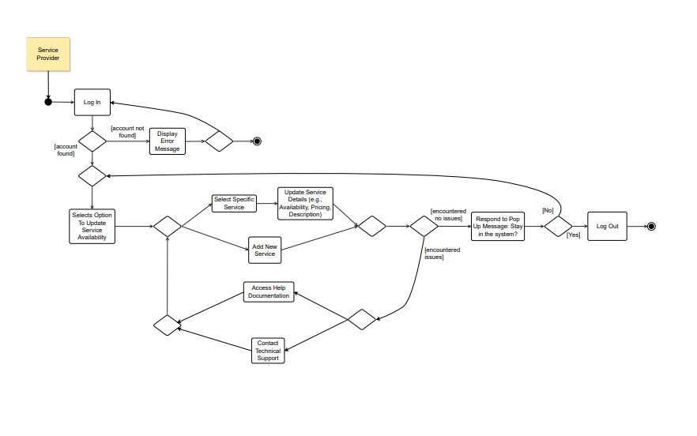

When a service provider interacts with the municipality management system to manage their service offerings, they undertake several actions within the system:

1. **Log in to the System:** The service provider initiates the process by logging in to the municipality management system using their designated credentials.

2. **Authenticate Credentials:** The system verifies the authenticity of the service provider's credentials to ensure secure access to the system's functionalities.

3. **Options Presentation**: Upon successful authentication, the system presents various options tailored for managing service offerings to the service provider. These options encompass tasks related to updating, adding, or removing services.

4. **Select Option to Update Service Availability:** The service provider selects the specific option within the system to update the availability of their services.

5. **Retrieve and Display Current Services**: The system retrieves and displays a comprehensive list of the services currently offered by the service provider. This list assists the provider in identifying which services require updates or additions.

6.**Select Service for Update/Addition:** The provider selects a particular service from the list to either update its existing details or add a new service to the system

7. **Update Service Details:** The service provider updates the necessary details of the service, such as availability, pricing, description, or any other pertinent information.

8. **Validate and Update Service Database**: After making the desired changes, the system validates the provided information to ensure accuracy and consistency. Upon successful validation, the system updates the service database with the modified or new service details.

9. **Contact System Support (if needed):** In cases where the service provider encounters technical difficulties or requires additional assistance, they have the option to contact system support for timely resolution of issues

10. **Log out of the System:** Once all necessary updates or additions are completed, the service provider securely logs out of the municipality management system to safeguard system access and data integrity.

**Sequence Diagrams:**

Note that only 2 scenarios were selected to portray the flow of action across the Municipality System.

1: An administrator of the Municipality Management System (MSMS) receives a request from the mayor's office to update the system settings in preparation for an upcoming public event in the municipality.

**Action Flow: **

1. **Log into MSMS System:** The administrator logs into the MSMS system using their authorized credentials.

2. **Authenticate Credentials:** Upon logging in, the system verifies the administrator's credentials for secure access.

3. **Access System Settings:** The administrator navigates to the system settings section within the MSMS dashboard.

4. **Select Event Configuration:** Within the system settings, the administrator selects the option to configure settings related to the upcoming public event.

5. **Update Language Preferences:** The administrator adjusts language preferences to ensure that system notifications and messages are displayed in the appropriate language for the event attendees.

6. **Set Time Zone:** They set the time zone to match the local time zone of the municipality where the event will take place, ensuring accurate scheduling and coordination.

7. **Customize Default View Options:** The administrator customizes the default view options to highlight event-related features and functionalities for easy access by municipal staff and residents.

8. **Save Configuration Changes:** After making the necessary adjustments, the administrator saves the updated system settings to apply the changes across the MSMS platform.

9. **Notify Mayor's Office:** The administrator sends a notification to the mayor's office, informing them that the system settings have been successfully updated for the upcoming public event.

10. **Log Out:** Once the configuration process is complete, the administrator securely logs out of the MSMS system to ensure the security of system access and data.

(Sequence Diagram on next page)

2: A resident notices that several streetlights in their neighborhood are not functioning properly, posing a safety risk for pedestrians and drivers. They decide to contact the municipality's customer service department to report the issue.

**Action Flow:**

1. **Log into MSMS System:** The customer service representative logs into the MSMS system using their authorized credentials.

2. **Authenticate Credentials:** Upon logging in, the system verifies the representative's credentials for secure access.

3. **Access Customer Service Dashboard:** The representative accesses the customer service dashboard, where they see incoming inquiries queued for handling.

4. **Select Inquiry from Queue:** They identify the inquiry regarding the malfunctioning streetlights and select it to address.

5. **Retrieve Inquiry Details:** The system retrieves and displays detailed information about the streetlight issue, including the location and nature of the problem.

6. **Communicate with Resident:** The representative contacts the resident to gather more information about the issue, including the specific locations of the malfunctioning streetlights and any safety concerns.

7. **Resolve Inquiry:** After gathering necessary details, the representative logs the inquiry in the system and assigns it to the appropriate municipal department responsible for streetlight maintenance.

8. **Escalate Inquiry (if needed):** If the issue requires urgent attention, the representative may escalate the inquiry to a supervisor or higher authority for expedited resolution.

9. **Update System and Record Resolution:** They update the system with the details of their communication with the resident and the actions taken to address the streetlight problem. Any escalation is also recorded in the system.

10. **Notify Resident:** The resident is informed that their inquiry has been received and is being addressed by the municipality.

11. **Log Out:** Once the inquiry handling process is complete, the representative logs out of the MSMS system to ensure the security of system access and data.

(Sequence Diagram on next page)

**5. Software Structure**

The software structure of the Municipality Management System defines the relationships between various classes and entities within the system.

Resident:

Each Resident is associated with precisely one Profile, which contains personal information such as their full name, address, and contact details. This one-to-one relationship ensures that each Resident has a unique profile to manage their information within the system.

Profiles can be linked to one or more Services offered by the municipality. This means that a Resident may avail themselves of multiple services provided by the municipality, and these services are managed within their Profile. Conversely, each Service can be associated with multiple Residents, allowing for a many-to-many relationship between Residents and Services, reflecting the diverse needs of the community.

Furthermore, Residents may have one or more Bills associated with their account, representing financial obligations such as utility bills or property taxes. In this case, each Bill is uniquely tied to a single Resident, ensuring accurate billing and financial management within the system.

Lastly, Residents can report one or more Issues to the municipality, such as infrastructure problems or public safety concerns. Each reported Issue is linked to a specific Resident, enabling efficient tracking and resolution of reported issues. This one-to-many relationship between Residents and Issues ensures that each reported concern is attributed to the corresponding Resident for accountability and follow-up purposes within the MSMS.

Administrator:

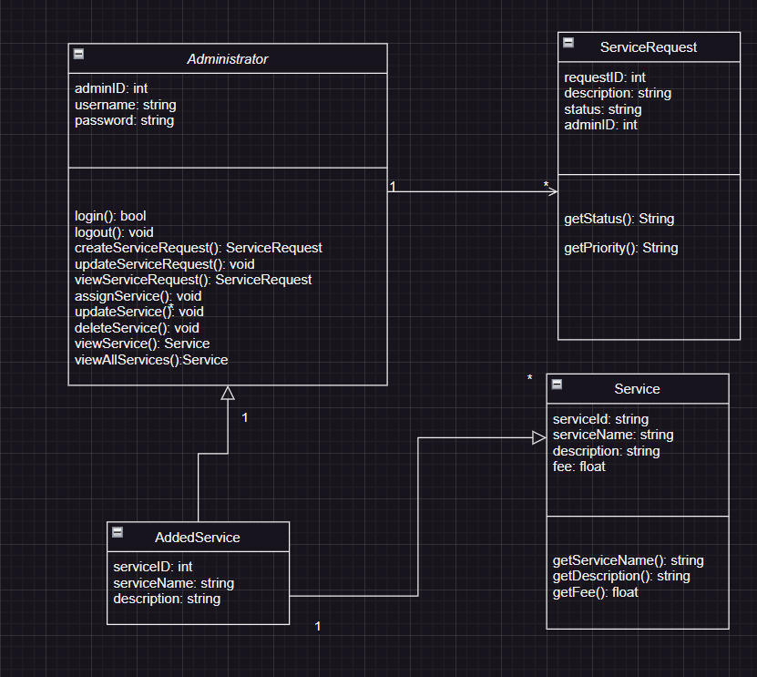

The Administrator class diagram encapsulates the essential functionalities and relationships pertinent to administrative tasks within the Municipality Management System (MSMS). At its core, the Administrator class serves as the orchestrator of system operations, facilitating user authentication and management, service request handling, and service management. Through the login() and logout() methods, administrators can securely access and exit the system, ensuring controlled access to system functionalities. Additionally, administrators can create, update, view, and manage service requests using methods such as createServiceRequest(), updateServiceRequest(), and viewServiceRequest(). The assignService() method enables administrators to allocate services to residents, while updateService() and deleteService() methods facilitate the modification and removal of existing services. Moreover, administrators can view individual service details using viewService() and retrieve a comprehensive list of all services through viewAllServices(). This class diagram embodies the administrative backbone of the MSMS, empowering administrators with the tools necessary to oversee system operations and efficiently manage municipal services.

**6. Conclusion**

As the project design phase ends, we can reflect on the intricate process of bringing ideas to life. The design phase is a critical step in the project development cycle, where a clear understanding of the problem at hand is established, and solutions are proposed.

In the next phase of the project, these design specifications will serve as a blueprint for the development of the Municipality Management System. With careful attention to detail and adherence to best practices, we aim to create a system that enhances the efficiency of municipal services and improves the overall experience for residents.