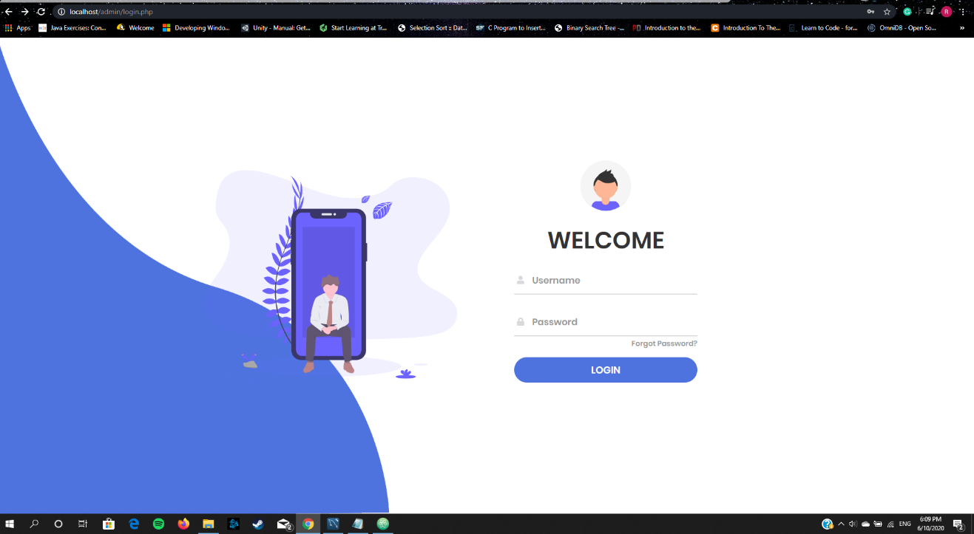

Login page: 3 different user can login Admin and 2 employee One has the responsibility to package the items to give them to the driver than to the customer to their address and the Second has the responsibility to package the items to give them to the customer in the store.

Admin Page:

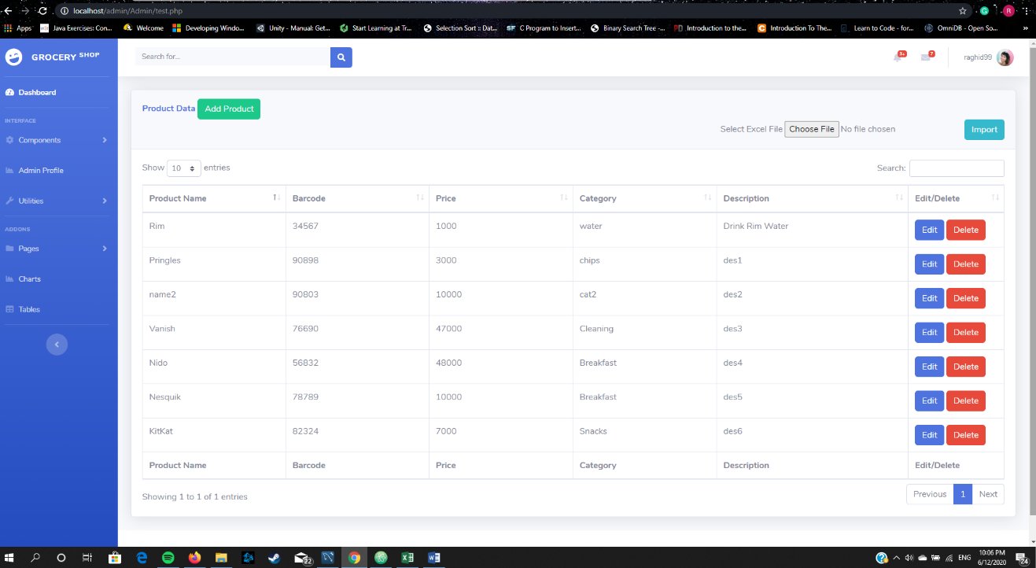

The admin can add the items data one by one or he can import the items data from an excel sheet and it will be directly added to the database, also he can edit or delete any item shown.

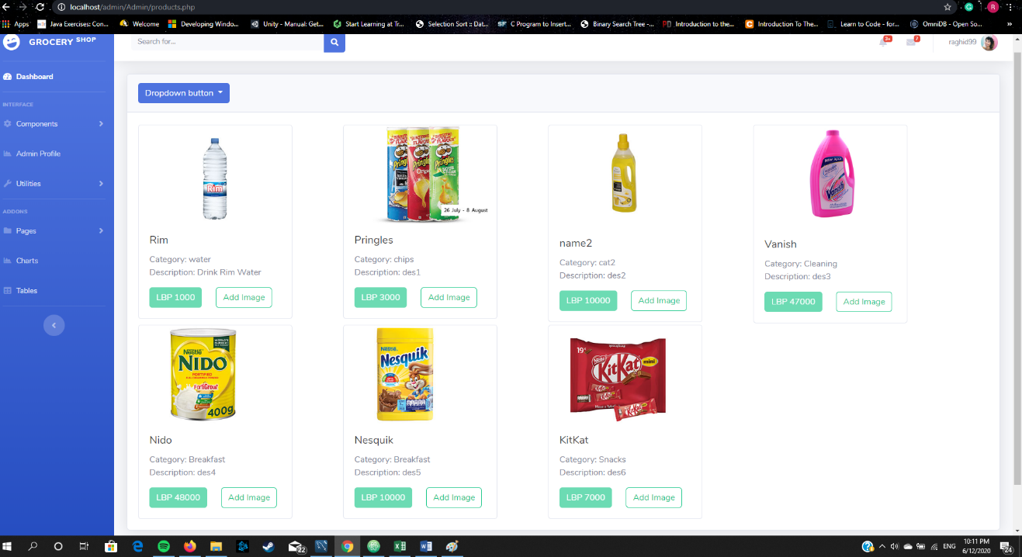

In the product view page the admin can see all the information about the items also he can add an image if an item doesn’t have one.

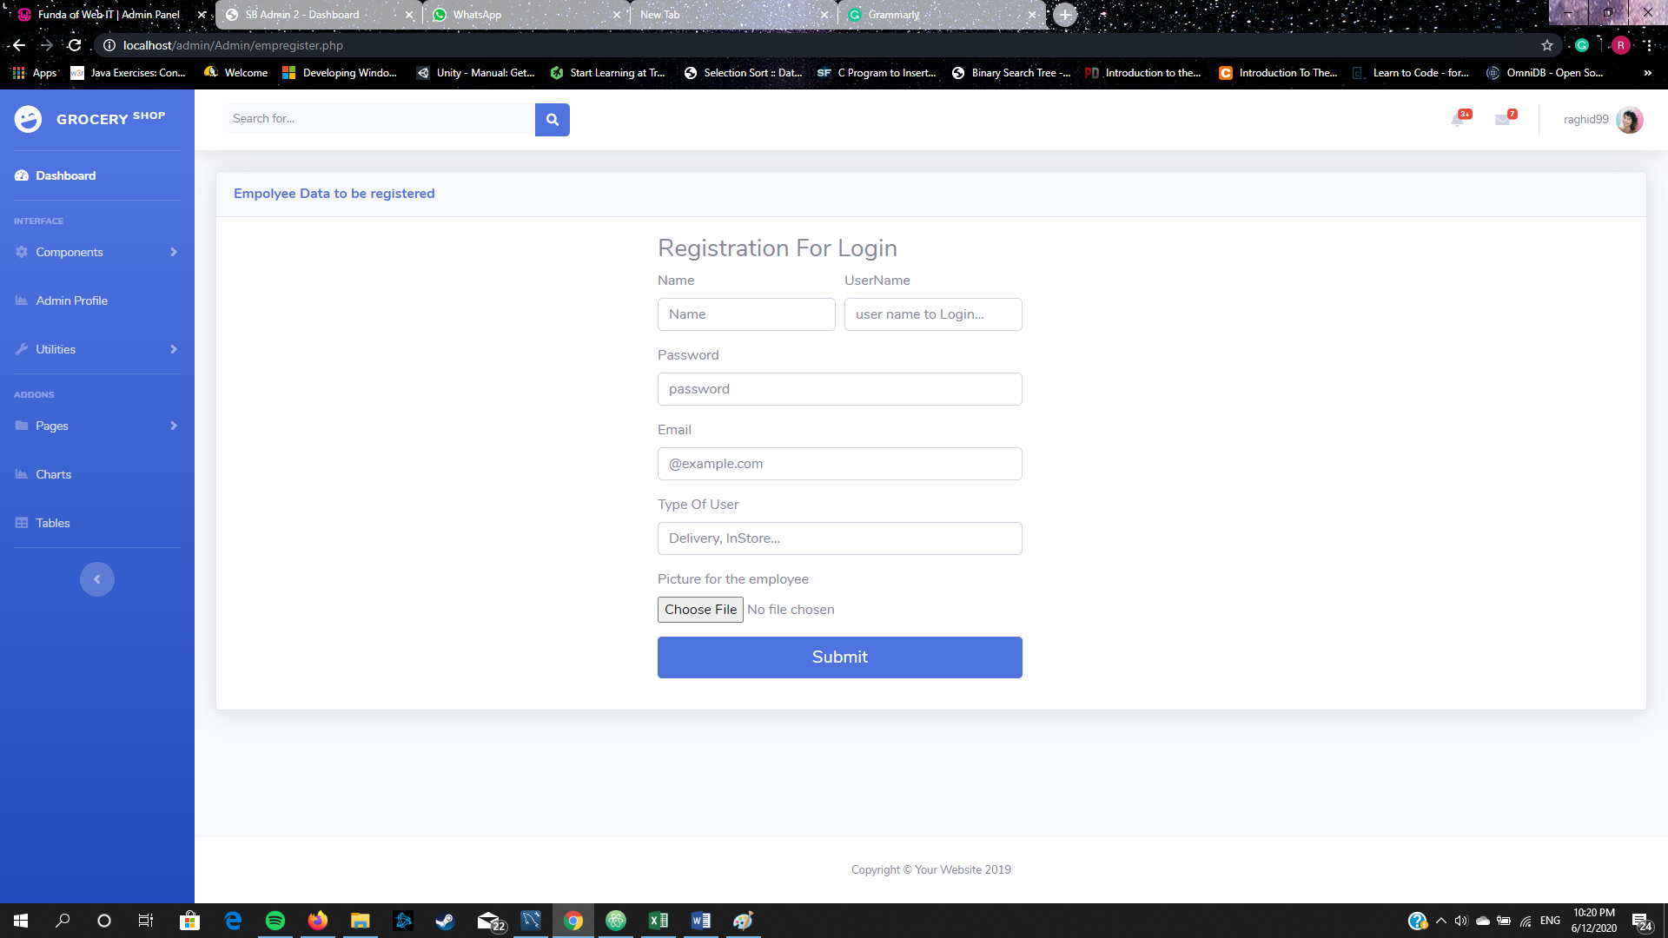

The admin can register knew employee accounts with there roles.

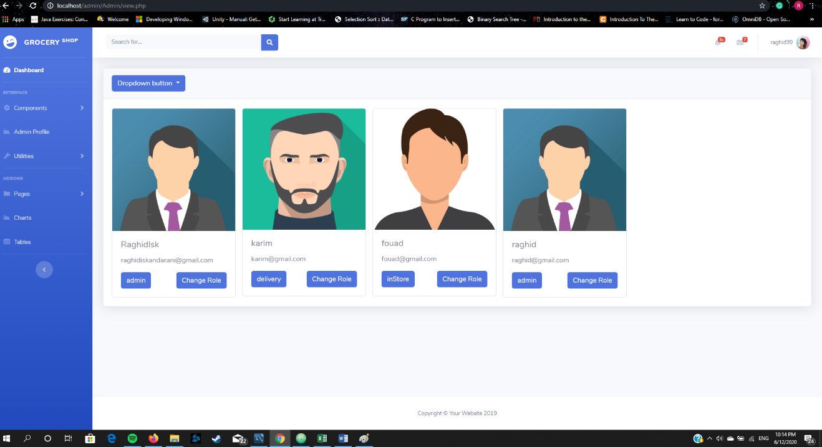

In the employee view the admin can see the employee data also he can change their roles.

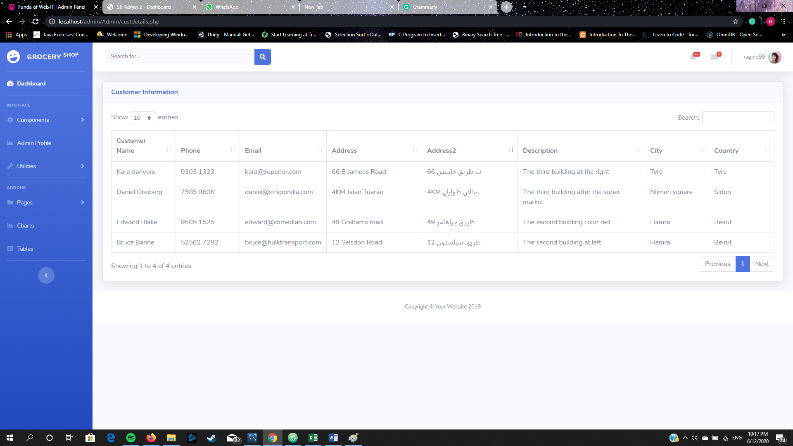

Fetching customer data (names, emails, phone and addresses) in the Admin panel.

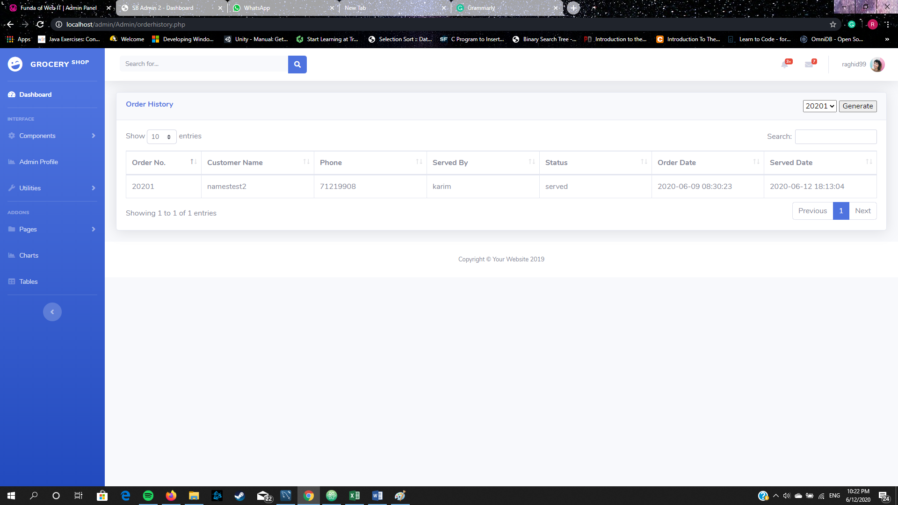

Order history with showing the name of the employee who served this order and the date.

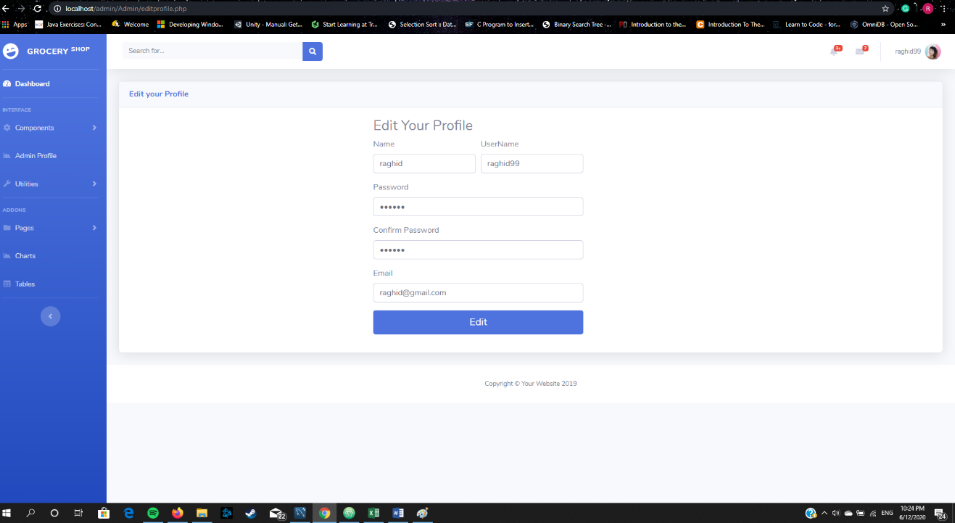

The Admin can edit his profile and change his password.

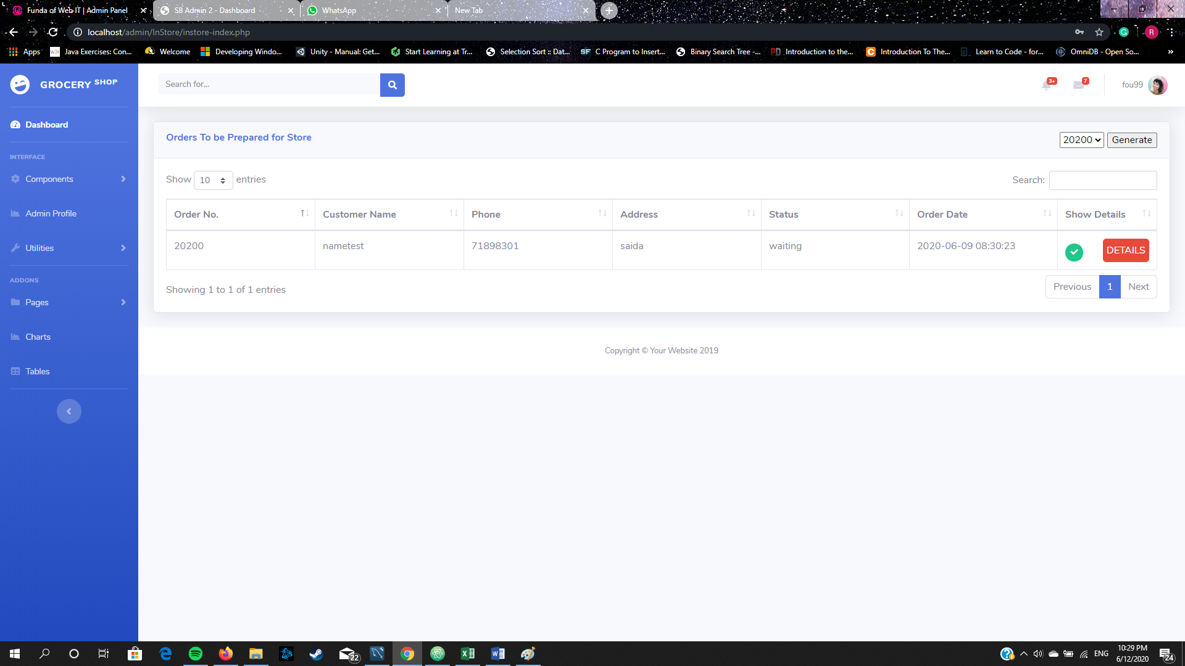

Here we logged in to the employee account who’s responsible in packaging the items and give them to the customer who’s waiting in the store.

If he clicked on “DETAILS”

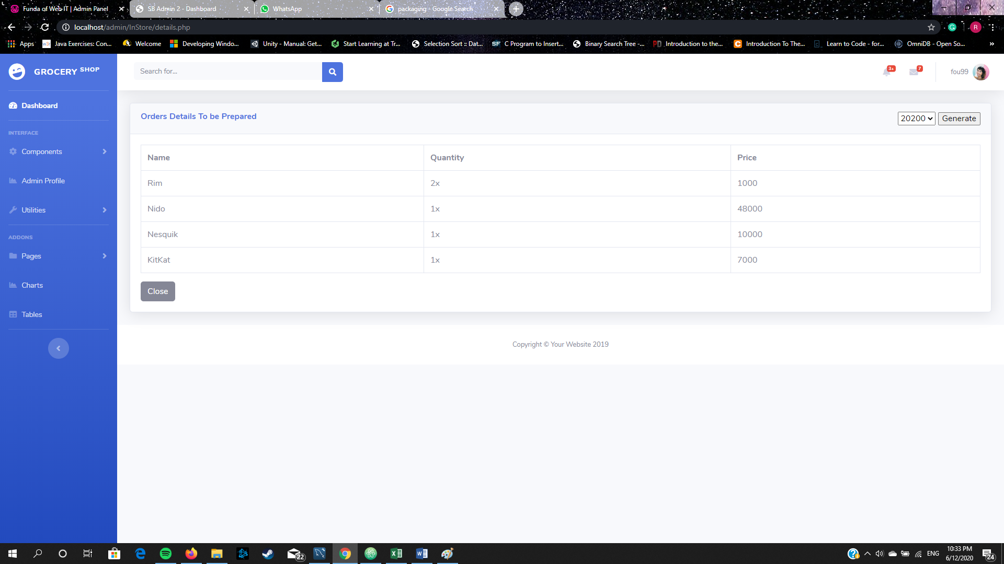

Now he can see the order details to start packaging it.

Also if he clicked on “Generate” an invoice will exported as pdf showing the name of the customer and the total price.

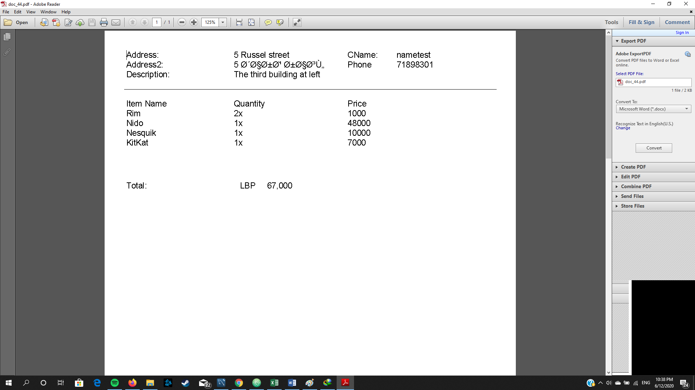

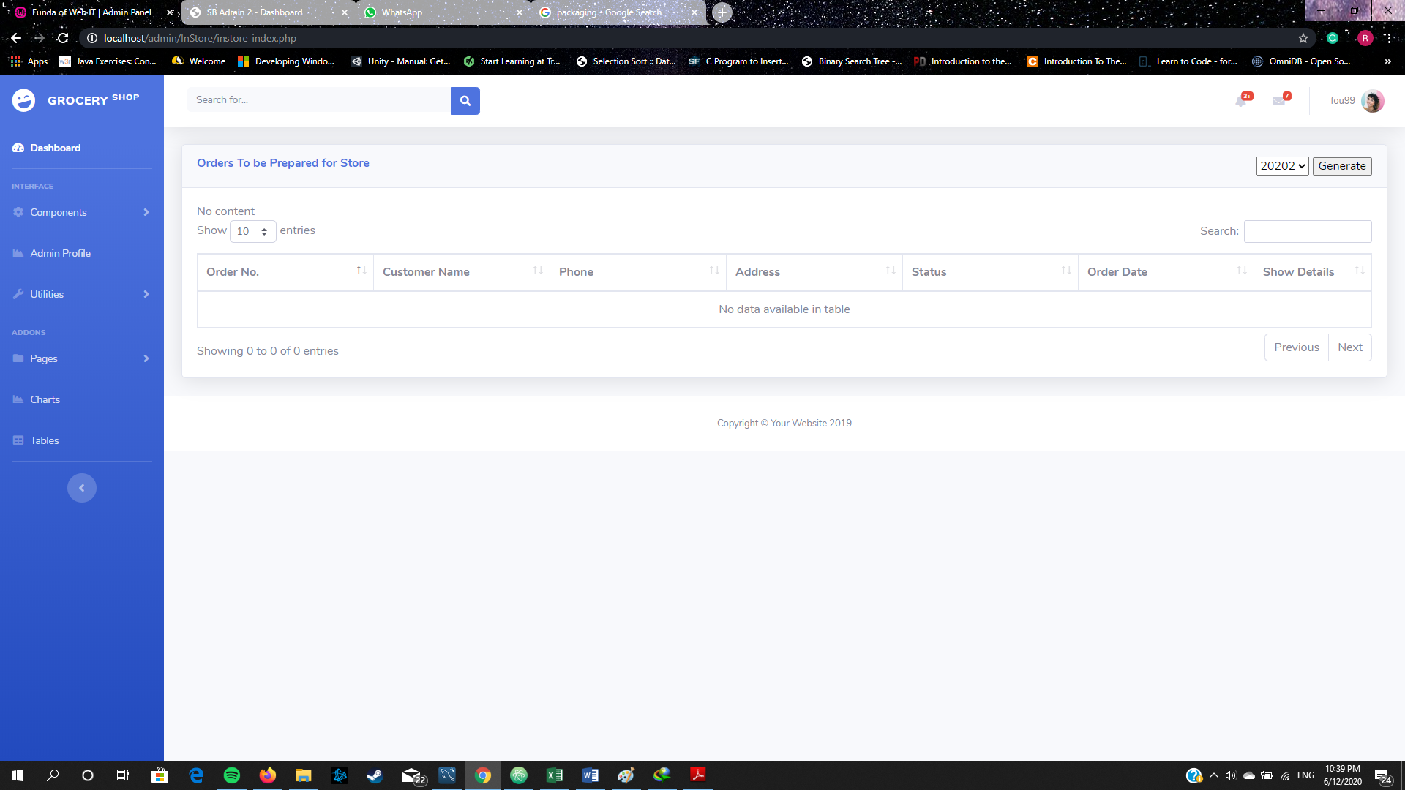

When the employee finish his package he must click the green check and that will indicate that the order served by him (that what we saw in the admin panel in order history).

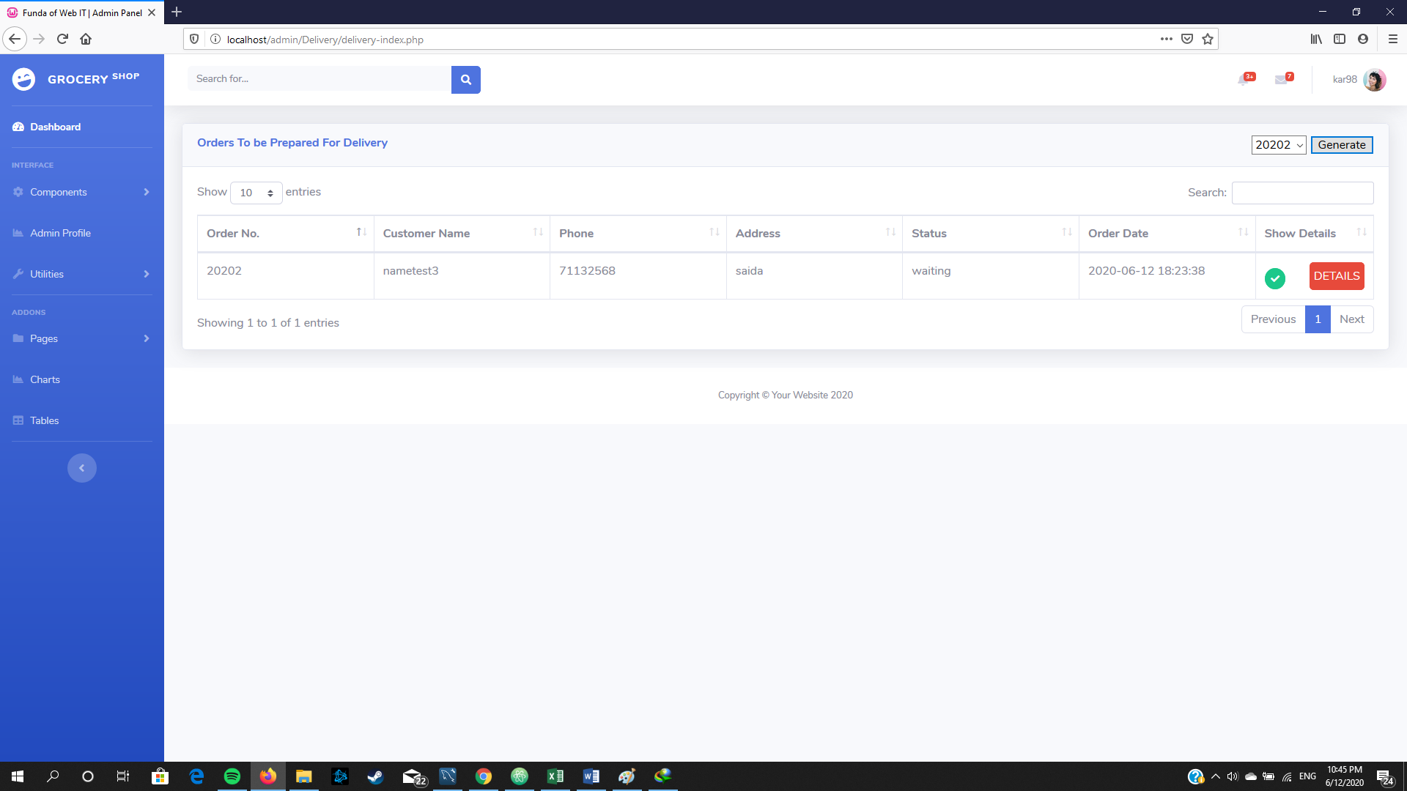

Here we logged in to the employee account who’s responsible in packaging the items and give them to the driver than to the customer address (as shown in the invoice below).

If he clicked on “DETAILS”

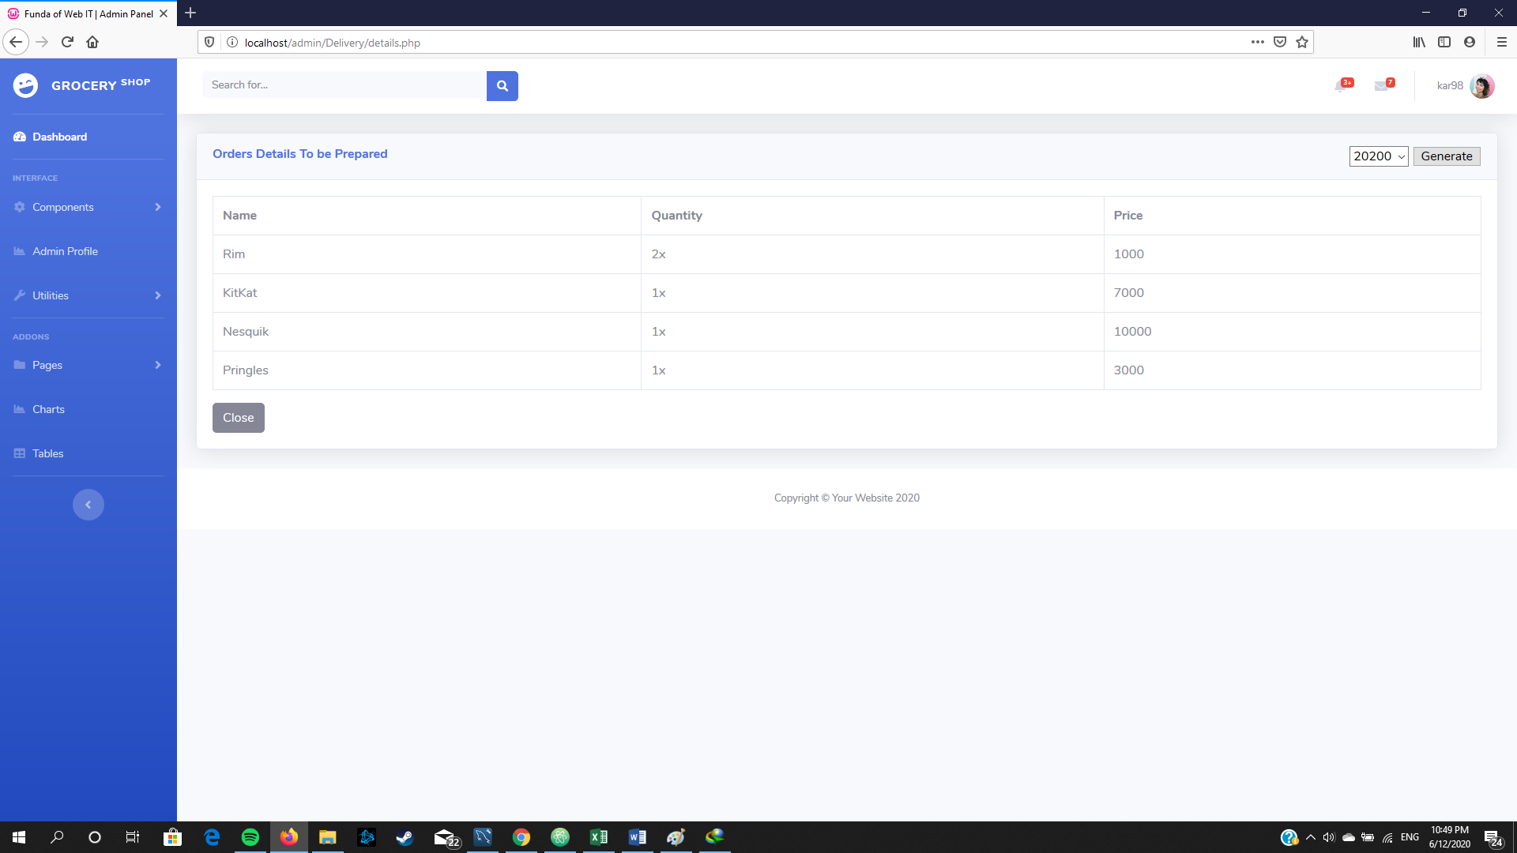

Now he can see the order details to start packaging it.

Also if he clicked on “Generate” an invoice will exported as pdf showing the name of the customer and the total price.

