https://lh3.googleusercontent.com/cm/AGPWSu_ZU66Pilwi2pYMjwZWu0ZSPXiZfIUWj6X9T8HpAWlkLjznmjZEE2g23LJYk6YH8Bbwlw=s40-p

|  |  |  |  |  |
| --- | --- | --- | --- | --- |
| |  | | --- | | Bookmate Info | | Mon, Sep 9, 10:36 PM (13 hours ago) |  | https://mail.google.com/mail/u/0/images/cleardot.gif  https://mail.google.com/mail/u/0/images/cleardot.gif |
| |  | | --- | | to me, Arth, Pavithra  https://mail.google.com/mail/u/0/images/cleardot.gif | | | |

We unfortunately do not, I am sorry

On Mon, Sep 9, 2024 at 12:02 PM Suresh Kori <[suresh.kori@avetoconsulting.com](mailto:suresh.kori@avetoconsulting.com)> wrote:

Hello Arth

Hope you are doing well

Question, do you know any firm in India, who understands this?

My auditor is categorically saying taxes need to be paid in US.

However, I tend to agree to your explanation..

If you know tax consultant/[auditor.in](http://auditor.in/) India who understands your explanation,.i would like to connect. Let.me know

Regards

Suresh

Sent from Mobile Device

On Wed, 3 Apr 2024, 19:19 Arth P, <[arth@trybookmate.com](mailto:arth@trybookmate.com)> wrote:

You cannot pay in US as foreign owner and has to be paid in India

On Tue, 2 Apr 2024 at 12:43 PM, Suresh Kori <[suresh.kori@avetoconsulting.com](mailto:suresh.kori@avetoconsulting.com)> wrote:

Arth, One last question before we proceed

In our context, Is it that paying taxes in US is NOT mandatory, but can be paid OR We cannot pay in US and has to be paid in India

Regards

Suresh

Sent from Mobile Device

On Tue, 26 Mar 2024, 19:18 Arth P, <[arth@trybookmate.com](mailto:arth@trybookmate.com)> wrote:

Hi Suresh,

It's an important distinction between just a "disregarded entity" and a "foreign-owned disregarded entity". You still need to file here but do not need to pay here, which also doesn't require putting full financials on the forms. You will also still owe state franchise tax, just not state income tax because Delaware doesn't charge state income unless physically operating there.

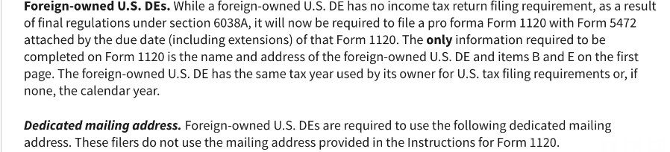

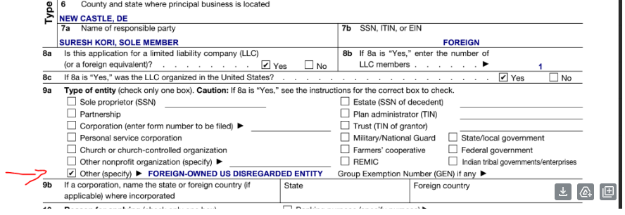

In summary, your LLC won't need to pay here, according to this information.

Kind regards,

Arth

--------  
*Information available online*

Should Foreign Owned US Disregarded entity pay taxes in US or just need to file returns

A foreign-owned U.S. disregarded entity has specific tax filing requirements but generally does not pay taxes directly. Here's how it works:

1. **Disregarded Entity Status**: A disregarded entity is typically a single-member LLC (Limited Liability Company) that is not considered separate from its owner for tax purposes. For U.S. tax purposes, its income, deductions, and credits are reported on the owner's tax return.
2. **Filing Requirements**:
   * **Form 5472**: The foreign owner must file Form 5472 to report certain transactions between the disregarded entity and its foreign owner or other related parties. This form is used to provide information about the foreign owner's activities and financial transactions with the disregarded entity.
   * **Form 1120**: The disregarded entity itself must file Form 1120, U.S. Corporation Income Tax Return, solely to report the Form 5472 information. However, it generally does not have to pay U.S. federal income taxes directly since the income is reported on the foreign owner's tax return.
3. **Income Reporting**: The foreign owner of the disregarded entity is responsible for reporting the income of the entity on their tax return, according to their country's tax laws and any applicable tax treaties.
4. **State Taxes**: Depending on the state where the disregarded entity operates, there may be state-level tax obligations or filing requirements, which can vary.

In summary, while the disregarded entity itself doesn’t pay taxes directly, it has filing obligations to report transactions and provide transparency about its operations. The foreign owner needs to ensure compliance with both U.S. federal tax requirements and the tax rules of their home country.