
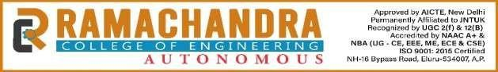

NEW-GEN AI PROJECT

A project report submitted in partial fulfillment of the requirements of II year II –Semester of
BACHELOR OF TECHNOLOGY
In
ELECTRONICS AND COMMUNICATION ENGINEERING

M. N.V. RAGHU RAM (24ME1A04H4)
B. KARTHIK (25ME5A0415)
SIRIGIRI MAHESH (24ME1A04I7)
V.RAMU (24ME1A04J8)
PI.PRUDHVI(24ME1A04H7)

DEPARTMENT OF ELECTRONICS AND COMMUNICATION ENGINEERING
RAMACHANDRA COLLEGE OF ENGINEERING (AUTONOMOUS)
(Approved by AICTE, Affiliated to JNTUK, Kakinada) Accredied by NBA, NAAC A+ NH-16 Bypass, Vatluru(V), Eluru – 534007, Eluru Dist., A.P

2025-2026



CERTIFICATE

This is to certify that the “NEW GEN-AI PROJECT REPORT” submitted by
M. DIVYA SATHVIKA (24ME1A04G3), MD. KARISHMA (24ME1A04G5), K. POORNA SANDHYA (24ME1A04F8), CH. HAPPY EVANGELIN
(24ME1A04J5) the project done by and submitted during 2025-2026 academic year in partial fulfilment of the requirements in Electronics and Communication Engineering to the Ramachandra College of Engineering, Eluru affiliated to JNTUK, Kakinada is a record of bonafide work carried out during the AY 2025-26.

Under the Guidance of : Head of the department

Mr. P. Pavan Kumar , Dr.B.Raghavaiah
Trainer

Training co-ordinators Mrs. A. N. L. Harisha Mr. Y. Naveen Kumar

Index

S.No | Contents | Page No
1. | Abstract | 1
2. | Introduction | 2
3. | Proposed System | 3
4. | Methodology | 4-5
5. | Software Environment | 6-7
6. | Implementation | 8
7. | Code | 9-11
8. | Results | 12-14
9. | Conclusion | 15

Abstract

In today’s competitive job market, creating a well-structured and professional resume is very important for job seekers. Many candidates face difficulties in identifying weaknesses in their resumes and improving the content to meet industry standards. The proposed project, AI Resume Analyzer and Improver, aims to solve this problem by using Generative Artificial Intelligence to automatically evaluate and enhance resumes. The system allows users to upload their resume and receive intelligent feedback on the quality and effectiveness of their resume content.

The system is developed using the Python programming language and provides a user-friendly interface for uploading resumes. The application extracts text from the uploaded resume and processes it using a Generative AI model. The AI analyzes the resume based on various parameters such as clarity, structure, skills representation, and professional language. Based on this analysis, the system generates a resume score, identifies weak areas, and provides suggestions for improvement.

Additionally, the system improves the quality of resume content by rewriting weak bullet points in a more professional and impactful manner. This helps users present their skills and achievements more effectively. The proposed solution demonstrates how Generative AI can assist individuals in improving their resumes and increasing their chances of success in job applications. The project highlights the practical application of AI in career development and intelligent document analysis.

Introduction

In the present digital world, job opportunities are increasing rapidly, and competition among job seekers is also growing significantly. A resume plays a crucial role in presenting a candidate’s qualifications, skills, achievements, and experience to potential employers. It serves as the first impression that recruiters have about a candidate. Therefore, having a clear, well-structured, and professional resume is very important for increasing the chances of getting shortlisted for job interviews. However, many students and fresh graduates find it difficult to prepare an effective resume because they may not know the proper format, industry standards, or the best way to describe their skills and achievements.

In recent years, Artificial Intelligence has emerged as a powerful technology that can analyze large amounts of textual data and generate meaningful insights. Generative AI models are capable of understanding natural language and producing human-like responses. These models can be used in various applications such as text generation, content improvement, document analysis, and automated feedback systems. By applying Generative AI techniques, it is possible to analyze resume content automatically and provide useful suggestions to improve the quality, structure, and clarity of the document.

The proposed project, AI Resume Analyzer and Improver, is developed using the Python programming language and utilizes Generative AI to analyze and enhance resumes. The system allows users to upload their resume in digital format, after which the application extracts the textual content from the resume. The extracted information is then analyzed by the AI model to evaluate the overall quality of the resume. Based on this analysis, the system generates a resume score, identifies weak areas, and provides suggestions for improvement. Additionally, the system rewrites weak bullet points in a more professional and impactful way. This project demonstrates how Generative AI can be used as an intelligent tool to help individuals create better resumes and improve their chances of success in job applications.

Proposed System

The proposed system aims to develop an intelligent resume analysis tool using Python and Generative Artificial Intelligence. The system is designed to help users improve the quality of their resumes by providing automated analysis and suggestions. In this system, the user uploads a resume file through a simple user interface. The application then processes the uploaded resume and extracts the textual content using Python-based text extraction techniques. This extracted data becomes the input for the Generative AI model.

After extracting the resume content, the system analyzes the information using a Generative AI model. The AI model evaluates the resume based on various factors such as clarity of content, presentation of skills, use of professional language, and overall structure of the resume. Based on this analysis, the system generates a resume score and identifies areas where improvements are needed. The system also provides useful suggestions that help the user enhance the quality and effectiveness of the resume.

Additionally, the proposed system includes an improvement feature where weak or simple bullet points in the resume are rewritten into more professional and impactful statements using Generative AI techniques. This helps users present their achievements and skills in a better and more professional manner. The overall system is implemented using Python, which manages both the user interface and backend processing. By combining resume analysis and AI-based content improvement, the system provides an intelligent solution for creating stronger and more effective resumes.

Methodology

The AI Resume Analyzer and Improver system is developed to automatically analyze resumes and provide intelligent suggestions for improvement using Generative Artificial Intelligence. The system uses Python to process uploaded resume files and extract useful information from them. After extracting the resume content, the system analyzes the text and generates feedback such as resume score, improvement suggestions, and rewritten professional bullet points. The methodology is divided into several phases to ensure efficient system development and operation.
1. Requirement Analysis
In this phase, the requirements of the system are identified. The main objective of the system is to analyze resumes automatically and provide suggestions to improve their quality. The system should allow users to upload resume files in PDF format. After uploading the resume, the system should extract the textual information and evaluate the content. The system should also provide a resume score, highlight weak areas, and suggest improvements to make the resume more professional and effective.
2. System Design
In this phase, the overall structure of the system is designed. The system mainly consists of two components: the user interface and the backend processing system. The user interface allows users to upload their resumes and start the analysis process. The backend system processes the uploaded file, extracts the resume text, and sends it to the Generative AI model for analysis. The AI model then evaluates the resume and generates useful feedback based on the content.
3. Frontend Development
The user interface of the system is developed using Python-based frameworks that allow users to interact with the application easily. The interface provides options to upload the resume file and start the analysis process. The interface is designed to be simple and user-friendly so that users can easily upload their resumes and view the analysis results without any difficulty.

4. Backend Development
The backend of the system is implemented using the Python programming language. The backend processes the uploaded resume file and extracts the textual information using Python libraries such as pdfplumber. The extracted text is then analyzed using Generative AI techniques to evaluate the quality of the resume and identify areas that need improvement.
The backend also processes the resume content to identify weak bullet points and unclear descriptions. These sections are then rewritten using the AI model to produce more professional and impactful statements.
5. Resume Analysis Process
In this phase, the Generative AI model analyzes the extracted resume text and evaluates different aspects such as clarity, structure, skills representation, and use of professional language.
• The system generates a resume score based on the overall quality of the resume.
• It identifies weak sections that require improvement.
• The system suggests improvements to make the resume more effective.
• Weak bullet points are rewritten into more professional and impactful statements.
This process helps users understand the strengths and weaknesses of their resumes.
6. Testing and Output
In the testing phase, the system is tested with different resume files to ensure that the application functions correctly. The extracted resume text is verified to ensure accurate analysis. The final output displays the resume score, improvement suggestions, and rewritten bullet points. These results help users improve their resumes and increase their chances of getting selected for job opportunities.

Software Environment

Software Environment
The software environment plays an important role in the development and successful execution of the AI Resume Analyzer and Improver system. Various software tools, programming languages, and libraries are used to design, develop, and run the application efficiently. These technologies help in building the user interface, processing uploaded resume files, analyzing resume content using Generative Artificial Intelligence, and displaying the results to the user.
1. Python
Python is the primary programming language used in the development of this project. It is a high-level, interpreted programming language that is widely used for web development, artificial intelligence, automation, and data processing. Python provides simple syntax and powerful libraries that make the development process easier and faster. In this project, Python is used to implement both the frontend and backend logic of the application. It handles resume file processing, text extraction, communication with the Generative AI model, and generation of analysis results such as resume score, improvement suggestions, and rewritten bullet points.
2. Streamlit Framework
Streamlit is a Python-based framework used to develop the user interface of the application. It allows developers to create interactive web applications using only Python code without requiring HTML, CSS, or JavaScript. In this project, Streamlit provides an interface where users can upload their resume files and start the analysis process. The framework also displays the generated results such as resume score, suggestions, and improved bullet points in a clear and user-friendly format.
3. PDFPlumber Library
PDFPlumber is a Python library used for extracting text from PDF documents. In this project, the resume is uploaded in PDF format, and PDFPlumber is used to read the file and extract the textual content from it. The extracted text is then processed by the Python program and sent to the Generative AI model for analysis. This library plays an important role in converting the resume document into usable text data for the resume analysis process.

4. Visual Studio Code
Visual Studio Code is the integrated development environment (IDE) used to write, edit, and manage the program code for this project. It provides several useful features such as syntax highlighting, debugging tools, extensions, and version control support. These features help developers write clean and organized code efficiently. Visual Studio Code also supports Python extensions that make coding, testing, and debugging easier during the development phase.

5. Web Browser
A web browser such as Google Chrome or Microsoft Edge is used to run and test the application. The browser allows users to interact with the system through the graphical user interface. Users can upload their resume files, start the analysis process, and view the generated results directly on the browser screen.

6. Operating System
The project can run on different operating systems such as Windows, Linux, or macOS. In this project, the Windows operating system is used for development and testing purposes. The operating system provides the platform required to install software tools, run the Python environment, and execute the application smoothly.

Implementation

The implementation of the AI Resume Analyzer and Improver system is carried out using the Python programming language and Generative Artificial Intelligence techniques. The system is designed to analyze resumes automatically and provide suggestions for improvement. The implementation mainly includes resume file uploading, text extraction, AI-based analysis, and result generation.

In the first stage, a simple user interface is created that allows users to upload their resume files in PDF format. Once the resume is uploaded, the system processes the document and extracts the textual content from the file using Python libraries. The extracted text contains important information such as skills, education, and experience mentioned in the resume.

After extracting the text, the system sends the resume content to a Generative AI model for analysis. The AI model evaluates the resume and generates a resume score along with suggestions for improvement. It also identifies weak bullet points and rewrites them in a more professional way. Finally, the system displays the analysis results to the user, including the resume score and improvement suggestions.

Code

import streamlit as st
import PyPDF2

# ---------- Extract text from PDF ----------
def extract_text_from_pdf(pdf_file):
reader = PyPDF2.PdfReader(pdf_file)
text = ""

for page in reader.pages:
if page.extract_text():
text += page.extract_text()

return text

# ---------- Calculate Resume Score ----------
def calculate_score(text):
score = 0
text = text.lower()

keywords = ["education", "skills", "project", "internship", "experience"]

for word in keywords:
if word in text:
score += 20

if len(text) > 1000:
score += 10

return min(score, 100)

# ---------- Suggestions ----------
def suggest_improvements(text):
suggestions = []
text = text.lower()

if "objective" not in text:
suggestions.append("Add career objective section")

if "project" not in text:
suggestions.append("Add at least one project")

if "skills" not in text:
suggestions.append("Mention technical skills clearly")

if len(text) < 800:
suggestions.append("Resume content is too short")

return suggestions

# ---------- Rewrite bullet points ----------
def rewrite_bullets(text):
lines = text.split("\n")
improved = []

for line in lines:
if len(line.strip()) > 20:
improved.append("✔ Successfully worked on: " + line.strip())

return improved[:5]

# ---------- STREAMLIT UI ----------

st.title("Resume Analyzer & Improver")

uploaded_file = st.file_uploader("Upload your Resume (PDF)", type=["pdf"])

if uploaded_file is not None:

text = extract_text_from_pdf(uploaded_file)

st.subheader("Resume Score")
score = calculate_score(text)
st.write(score, "/ 100")

st.subheader("Suggestions")

suggestions = suggest_improvements(text)

if suggestions:
for s in suggestions:
st.write("•", s)
else:
st.write("Your resume looks good!")

st.subheader("Improved Bullet Points")

bullets = rewrite_bullets(text)

for b in bullets:
st.write(b)

cd OneDrive\Desktop\GEN_AI_4H4\Resume.py

python -m streamlit run resumecode.py

python -m streamlit run resumecode.py

Results

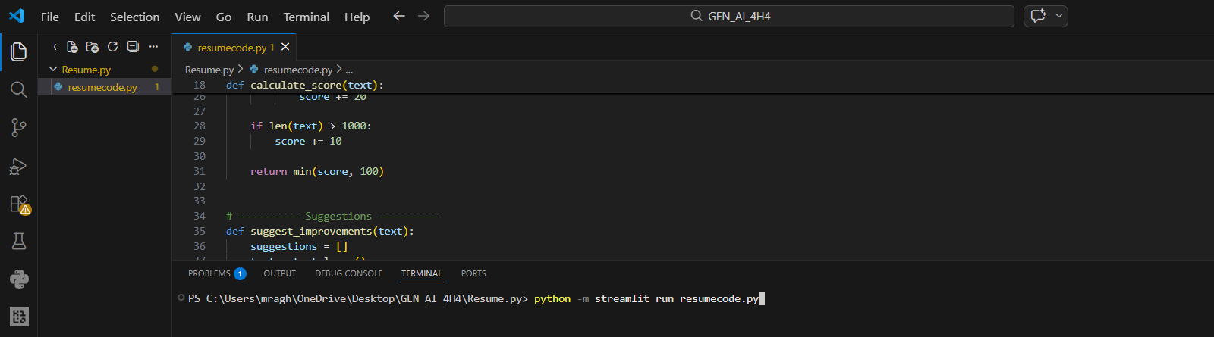

1. Project Development Environment
This project was developed using Python programming language in the Visual Studio Code (VS Code) development environment. Required libraries such as Streamlit and PyPDF2 were installed to build the application. Streamlit was used to create a simple web interface where users can upload their resumes, and PyPDF2 was used to extract text content from the uploaded PDF files.

2. Writing the Program in VS Code
The project code was written in a Python file named resumecode.py. The program includes several functions that perform different tasks. The first function extracts text from the uploaded resume file using the PyPDF2 library. The second function analyzes the extracted text and calculates a resume score based on the presence of important keywords such as education, skills, projects, internship, and experience. Additional functions were implemented to suggest improvements and rewrite bullet points in a more professional manner.

3. Running the Application
After writing the code, the application was executed in the terminal using the Streamlit command. The command used to run the application is:
python -m streamlit run resumecode.py
Once the command is executed, Streamlit automatically starts a local web server and generates a link (localhost). This link opens the application in the browser, where the user can interact with the Resume Analyzer system.

4. Uploading the Resume
The user uploads a resume in PDF format through the upload interface provided on the web page. Once the resume is uploaded, the system reads the file and extracts all the textual content from the PDF document. The extracted text becomes the input for the analysis process.

5. Resume Analysis Process
After extracting the text, the program analyzes the resume by checking for important sections such as education, skills, projects, internship, and experience. Each detected keyword increases the overall resume score. The system also evaluates the length of the resume to determine whether sufficient information is provided. Based on this analysis, a resume score out of 100 is calculated.

6. Generating Suggestions
The application then generates improvement suggestions based on the missing sections in the resume. For example, if the resume does not contain a career objective, project information, or technical skills, the system recommends adding these sections. These suggestions help users enhance the quality of their resumes and make them more suitable for job applications.

7. Improving Bullet Points
The system also rewrites certain lines from the resume into more professional bullet points. This feature improves the clarity and impact of the resume by presenting information in a structured and achievement-oriented format.

8. Displaying the Results
Finally, the system displays the results on the web interface. The output includes:
- Resume Score
- Suggested Improvements
- Improved Bullet Points
This allows users to quickly understand the strengths and weaknesses of their resumes and make necessary modifications.

9. Final Outcome
The Resume Analyzer & Improver application successfully analyzes uploaded resumes and provides meaningful feedback to users. It helps students and job seekers improve their resumes by identifying missing sections, enhancing bullet points, and providing an overall resume score. The project demonstrates how artificial intelligence-based analysis can assist users in creating stronger and more professional resumes.

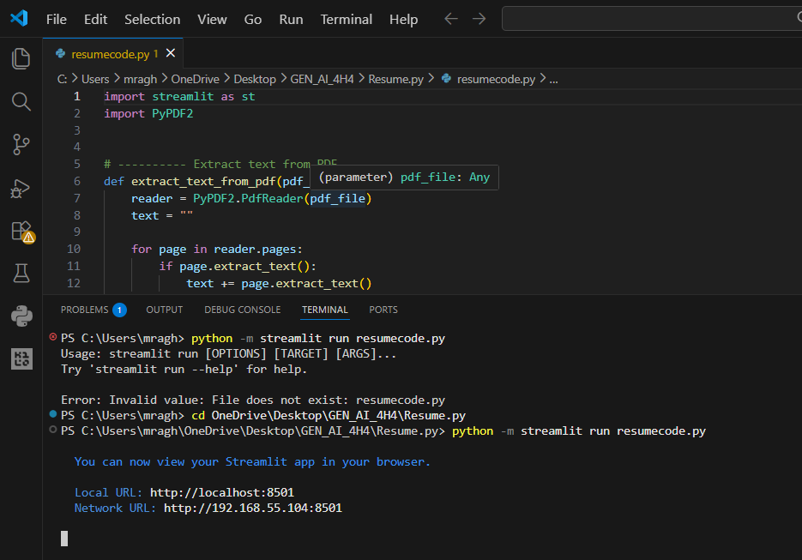

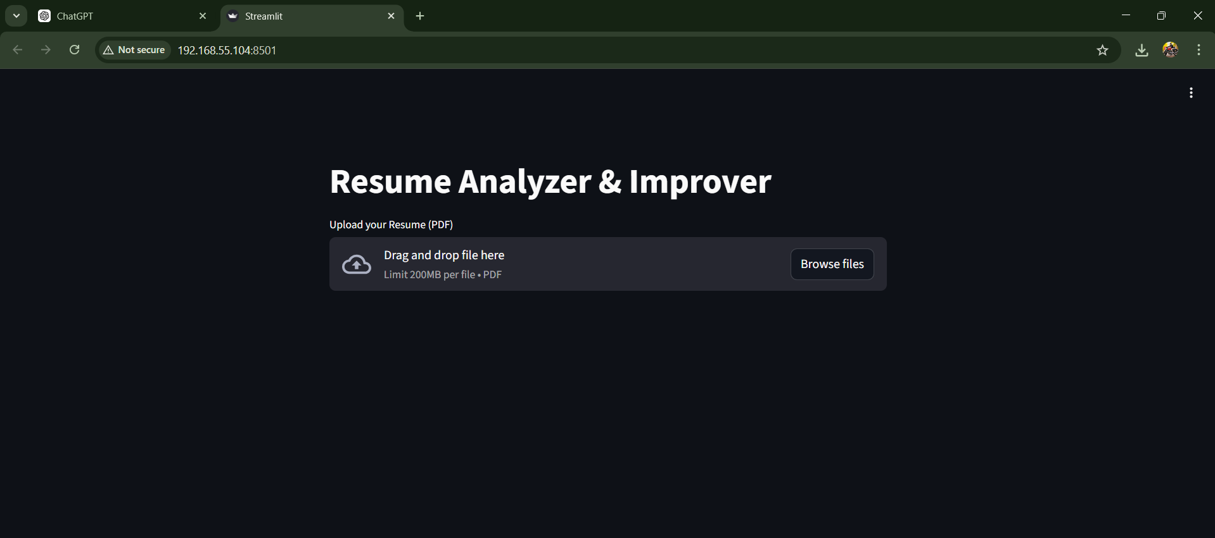

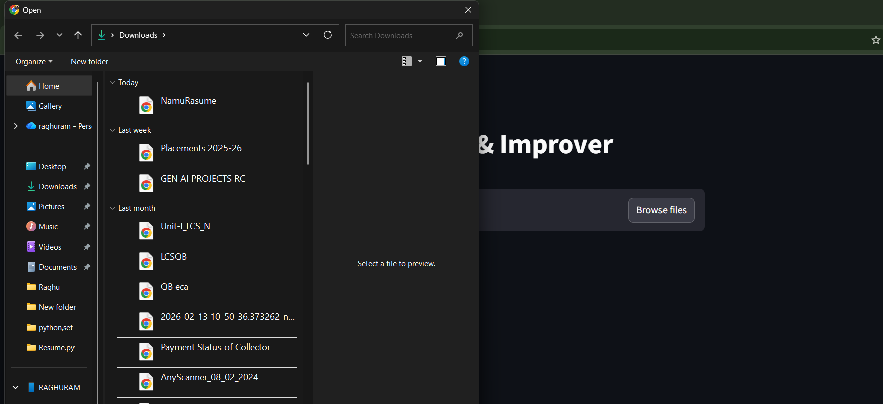

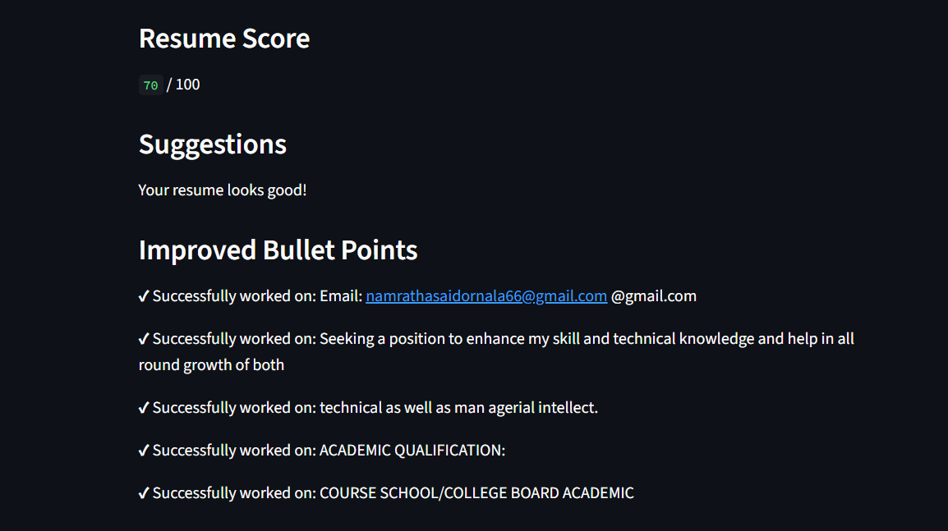
Conclusion

The Resume Analyzer & Improver project was successfully developed to help users evaluate and improve their resumes using artificial intelligence techniques. The system allows users to upload their resumes in PDF format and automatically analyzes the content to identify important sections such as education, skills, projects, internship, and experience. Based on this analysis, the application calculates a resume score and provides useful suggestions for improvement.

The project also helps users enhance their resumes by rewriting certain bullet points in a more professional and structured format. The application was implemented using Python with the help of Streamlit for creating the user interface and PyPDF2 for extracting text from PDF documents. These technologies enabled the development of a simple, interactive, and user-friendly web application.

Overall, the project demonstrates how artificial intelligence and natural language processing techniques can be used to assist job seekers in improving the quality of their resumes. By providing instant feedback and recommendations, the system helps users create more effective resumes that increase their chances of securing job opportunities. This project also highlights the practical application of AI in real-world career development tools.

‘

