**JAVAFX PROGRAMS**

**WEEK 1 And WEEK 2:**

**1.First JAVAFX APPLICATION:**

import javafx.application.*;

import javafx.scene.*;

import javafx.stage.*;

import javafx.scene.layout.*;

import javafx.scene.shape.*;

import javafx.scene.paint.*;

public class FirstJavaFXApp extends Application{

public void init(){

System.out.println("From init() Method");

}

public void start(Stage st) throws Exception{

System.out.println("From Start() method");

Group g=new Group();

Scene s=new Scene(g,500,700);

s.setFill(Color.RED);

st.setTitle("JavaFX Virtual Cinema-More Rich");

st.setScene(s);

st.show();

}

public void stop(){

System.out.println("From stop() method");

System.out.println("Thank You Watch My Movie Again");

}

public static void main(String[]args){

System.out.println("From main() method");

launch(args);

}

}

**Output:**

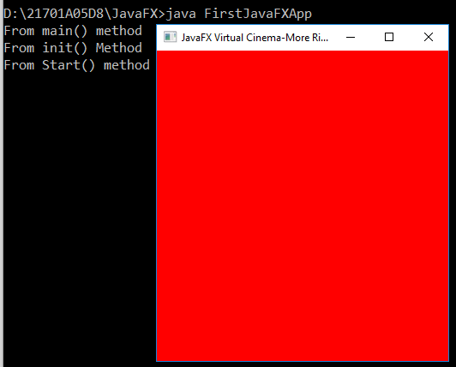

**2.Lines And Triangle**

import javafx.application.*;

import javafx.scene.*;

import javafx.stage.*;

import javafx.scene.layout.*;

import javafx.scene.paint.*;

import javafx.scene.shape.*;

public class LinesTriangleFX extends Application{

public void init(){

System.out.println("From init() method");

}

public void start(Stage st) throws Exception{

System.out.println("From Start() method");

Line l=new Line(100,100,200,100);

Line l1,l2,l3;

l1=new Line(100,500,200,500);

l2=new Line(150,200,100,500);

l3=new Line(150,200,200,500);

Group g=new Group(l,l1,l2,l3);

Scene s=new Scene(g,500,700);

s.setFill(Color.RED);

st.setTitle("Lines And Triangle");

st.setScene(s);

st.show();

}

public void stop(){

System.out.println("from stop() method");

}

public static void main(String[]args){

System.out.println("from Main() method");

launch(args);

}

}

**Output:**

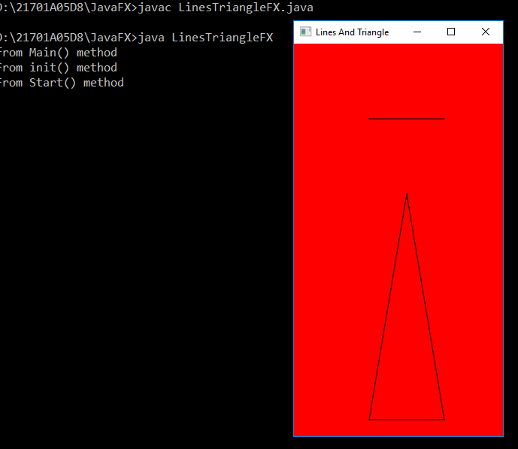

**3.JavaFXShapes**

import javafx.application.*;

import javafx.scene.*;

import javafx.stage.*;

import javafx.scene.layout.*;

import javafx.scene.shape.*;

import javafx.scene.paint.*;

public class JavaFXShapes extends Application{

public void init(){

System.out.println("From init() method");

}

public void start(Stage st) throws Exception{

System.out.println("from start() method");

Circle c;

Rectangle r,r1;

Ellipse e;

c=new Circle(120,100,50);

c.setFill(Color.BLUE);

r=new Rectangle(70,170,70,50);

r.setFill(Color.RED);

r1=new Rectangle(70,250,70,50);

r1.setArcWidth(30);

r1.setArcHeight(25);

r1.setFill(Color.GREEN);

e=new Ellipse(120,400,100,50);

e.setFill(Color.YELLOW);

Group g=new Group(c,r,r1,e);

Scene s=new Scene(g,700,900);

s.setFill(Color.ORANGE);

st.setScene(s);

st.setTitle("JavaFX Shapes");

st.show();

}

public void stop(){

System.out.println("from main() method");

}

public static void main(String[]args){

System.out.println("From main() method");

launch(args);

}

}

**Output:**

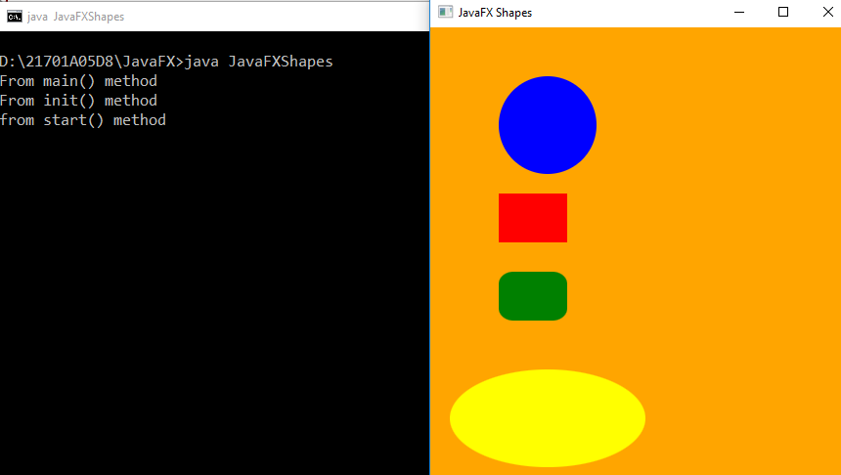

**4.Labels**

import javafx.application.*;

import javafx.scene.*;

import javafx.stage.*;

import javafx.scene.layout.*;

import javafx.scene.control.*;

import javafx.geometry.*;

import javafx.scene.paint.*;

public class LabelFX extends Application{

public void start(Stage st)throws Exception{

FlowPane fp=new FlowPane();

Label l1=new Label("AITS rajampeta");

Label l2=new Label("AITS tirupathi");

Label l3=new Label("AITS kadapa");

Label l4=new Label("AITS hyd");

fp.getChildren().addAll(l1,l2,l3,l4);

fp.setAlignment(Pos.CENTER_RIGHT);

Label l5=new Label("ANNAMACHARYA INSTITUTE OF TECHNOLOGY AND SCIENCES");

Label l6=new Label("ANNAMACHARYA");

fp1.getChildren().addAll(l5,l6);

fp1.setAlignment(Pos.BOTTOM_CENTER);

Scene s=new Scene(fp,fp1,300,300);

st.setScene(s);

st.setTitle("javafx label demostration");

st.show();

}

public static void main(String args[]){

launch(args);

}

}

**Output:**

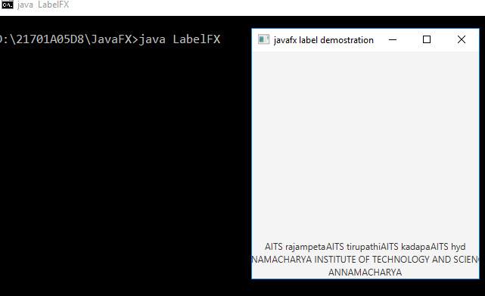

**5.Buttons**

**import javafx.application.*;**

**import javafx.stage.*;**

**import javafx.scene.*;**

**import javafx.scene.layout.*;**

**import javafx.scene.control.*;**

**import javafx.event.*;**

**import javafx.scene.shape.*;**

**import javafx.scene.paint.*;**

**import javafx.geometry.*;**

**public class FlagButton extends Application{**

**Button in,sr,pk,us,cd,exit;**

**FlowPane fp;**

**Label l;**

**Scene s;**

**public void init(){**

**System.out.println("from init() method");**

**in=new Button("INDIA");**

**sr=new Button("SRI LANKA");**

**pk=new Button("Pakistan");**

**us=new Button("USA");**

**cd=new Button("CANADA");**

**exit=new Button("EXIT");**

**l=new Label("Flag Displayed");**

**fp=new FlowPane();**

**fp.setAlignment(Pos.CENTER);**

**fp.getChildren().addAll(in,sr,pk,us,cd,exit,l);**

**s=new Scene(fp,500,500);**

**}**

**public void start(Stage st){**

**System.out.println("From start() method");**

**in.setOnAction(new EventHandler<ActionEvent>(){**

**public void handle(ActionEvent ae){**

**l.setText("India Clicked");**

**}**

**});**

**sr.setOnAction(new EventHandler<ActionEvent>(){**

**public void handle(ActionEvent ae){**

**l.setText("Sri Lanka Clicked");**

**}**

**});**

**pk.setOnAction(new EventHandler<ActionEvent>(){**

**public void handle(ActionEvent ae){**

**l.setText("Pakistan Clicked");**

**}**

**});**

**cd.setOnAction(new EventHandler<ActionEvent>(){**

**public void handle(ActionEvent ae){**

**l.setText("canada Clicked");**

**}**

**});**

**us.setOnAction(new EventHandler<ActionEvent>(){**

**public void handle(ActionEvent ae){**

**l.setText("USA Clicked");**

**}**

**});**

**exit.setOnAction(new EventHandler<ActionEvent>(){**

**public void handle(ActionEvent ae){**

**Platform.exit();**

**}**

**});**

**st.setTitle("Flogs and Maps");**

**st.setScene(s);**

**st.show();**

**}**

**public void stop(){**

**System.out.println("From Stop() method");**

**}**

**public static void main(String[]args){**

**System.out.println("From main() method");**

**launch(args);**

**}**

**}**

**Output:**

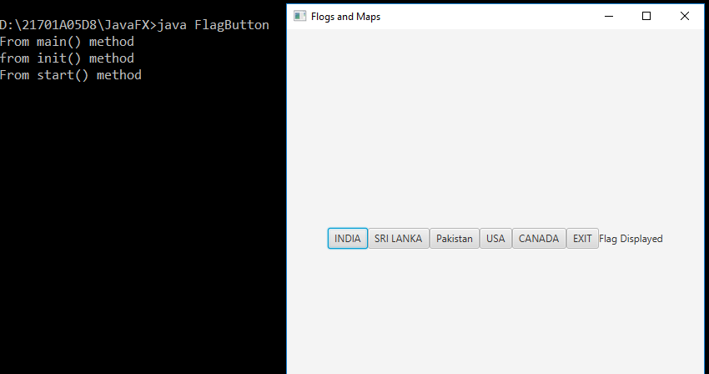

**6.Canvas:**

**import javafx.application.*;**

**import javafx.scene.*;**

**import javafx.stage.*;**

**import javafx.scene.control.*;**

**import javafx.scene.canvas.*;**

**import javafx.scene.layout.*;**

**import javafx.event.*;**

**import javafx.geometry.*;**

**import javafx.scene.shape.*;**

**import javafx.scene.paint.*;**

**import javafx.scene.text.*;**

**public class CanvasDemo extends Application{**

**GraphicsContext gc;**

**Canvas c;**

**Color[] colors={Color.RED,Color.GREEN,Color.BLUE,Color.BLACK,Color.PURPLE,Color.ORANGE};**

**Button b;**

**Scene s;**

**FlowPane fp;**

**int colorIdx=0;**

**public void init(){**

**System.out.println("from init method");**

**c=new Canvas(400,400);**

**gc=c.getGraphicsContext2D();**

**fp=new FlowPane();**

**b= new Button("Lets Change the color");**

**fp.setAlignment(Pos.CENTER);**

**fp.getChildren().addAll(c,b);**

**s=new Scene(fp,500,500);**

**}**

**public void start(Stage st){**

**gc.strokeLine(0,0,200,300);**

**gc.strokeOval(100,100,200,200);**

**gc.strokeRect(0,200,50,200);**

**gc.fillOval(0,0,20,20);**

**gc.fillRect(100,320,300,40);**

**gc.fillText("Working on Canvas",50,50);**

**b.setOnAction(new EventHandler<ActionEvent>(){**

**public void handle(ActionEvent ae){**

**gc.setStroke(colors[colorIdx]);**

**gc.setFill(colors[colorIdx]);**

**gc.strokeLine(0,0,200,200);**

**gc.strokeOval(100,100,200,200);**

**gc.strokeRect(0,200,50,200);**

**gc.fillOval(0,0,20,20);**

**gc.fillRect(100,320,300,40);**

**gc.fillText("Working on Canvas",50,50);**

**colorIdx++;**

**if(colorIdx==colors.length){**

**colorIdx=0;**

**}**

**}**

**});**

**st.setTitle("Drawing Directly on Canvas ");**

**st.setScene(s);**

**st.show();**

**}**

**}**

**Output:**

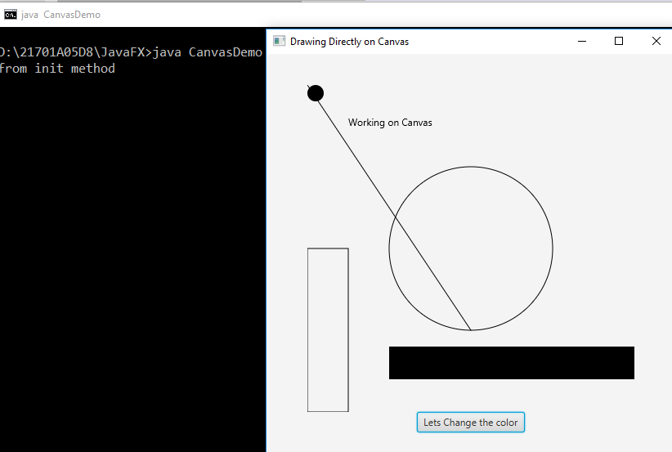

**7.Arcs**

import javafx.application.Application;

import javafx.scene.Group;

import javafx.scene.Scene;

import javafx.stage.Stage;

import javafx.scene.shape.Arc;

import javafx.scene.shape.ArcType;

public class ArcFX extends Application{

public void init(){

System.out.println("from init method");

}

public void start(Stage st){

System.out.println("from start method()");

Arc ar=new Arc();

ar.setCenterX(100);

ar.setCenterY(200);

ar.setRadiusX(50);

ar.setRadiusY(150);

ar.setStartAngle(130);

ar.setLength(100);

ar.setType(ArcType.OPEN);

Group g=new Group(ar);

Scene s=new Scene(g,200,300);

st.setTitle("Arcs");

st.setScene(s);

st.show();

}

public void stop(){

System.out.println("from stop method");

}

public static void main(String[]args){

System.out.println("from main() method");

launch(args);

}

}

**Output:**

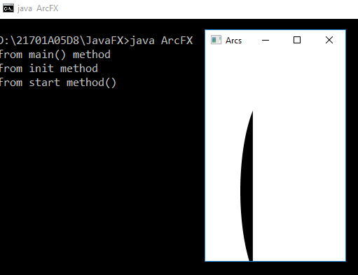

**WEEK 3:**

**8.ImageFxDemo**

import javafx.application.*;

import javafx.stage.*;

import javafx.scene.*;

import javafx.scene.layout.*;

import javafx.scene.control.*;

import javafx.scene.image.*;

import javafx.geometry.*;

public class ImageFXDemo extends Application{

Image i;

ImageView iv;

FlowPane fp;

Scene s;

public void init(){

System.out.println("from init() method");

i=new Image("https://static.toiimg.com/thumb/msid-94540478,imgsize-18682,width-400,resizemode-4/94540478.jpg");

iv=new ImageView(i);

iv.setFitWidth(300);

iv.setFitHeight(200);

iv.setPreserveRatio(true);

iv.setSmooth(true);

fp=new FlowPane();

fp.getChildren().addAll(iv);

fp.setAlignment(Pos.CENTER);

s=new Scene(fp,500,500);

}

public void start(Stage st){

System.out.println("From Start method");

st.setTitle("Satya Shodhana");

st.setScene(s);

st.show();

}

public static void main(String[]args){

System.out.println("from main method");

launch(args);

}

}

**Output:**

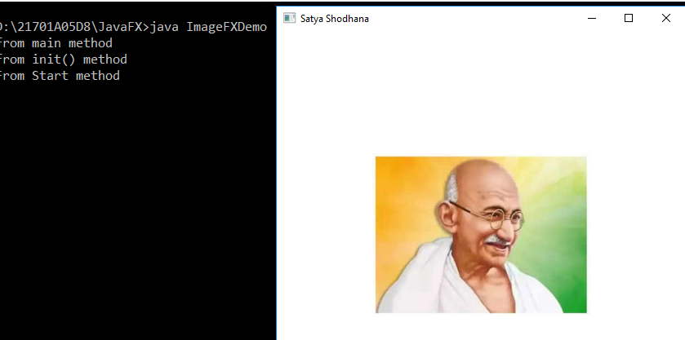

**9.ImageLabelFxDemo**

import javafx.application.*;

import javafx.stage.*;

import javafx.scene.*;

import javafx.scene.layout.*;

import javafx.scene.control.*;

import javafx.scene.image.*;

import javafx.geometry.*;

public class ImageLabelFX extends Application{

Image i1,i2;

ImageView iv1,iv2;

Label l1,l2;

FlowPane fp;

Scene s;

public void init(){

System.out.println("From init() method");

i1=new Image("https://aitsrajampet.ac.in/images/event/AA-Rating/AITS-Rajampet-Secures-AA-Rating-by-IIT-IISc-NPTEL.jpg",300,200,true,true);

i2=new Image("https://s3.amazonaws.com/s3.timetoast.com/public/uploads/photo/7961349/image/a7a01483b1685ee33122f34559d2ab7b",300,200,true,true);

iv1=new ImageView(i1);

iv2=new ImageView(i2);

l1=new Label("Vidwan Sarvatra pujyathe",iv1);

l2=new Label("Creator of java programming language",iv2);

l1.setContentDisplay(ContentDisplay.TOP);

l2.setContentDisplay(ContentDisplay.BOTTOM);

fp=new FlowPane();

fp.setAlignment(Pos.CENTER);

fp.getChildren().addAll(l1,l2);

s=new Scene(fp,700,700);

}

public void start(Stage st){

System.out.println("from start method");

st.setScene(s);

st.setTitle("AITS and JamesGosling");

st.show();

}

public static void main(String[]args){

System.out.println("from main method");

launch(args);

}

}

**Output:**

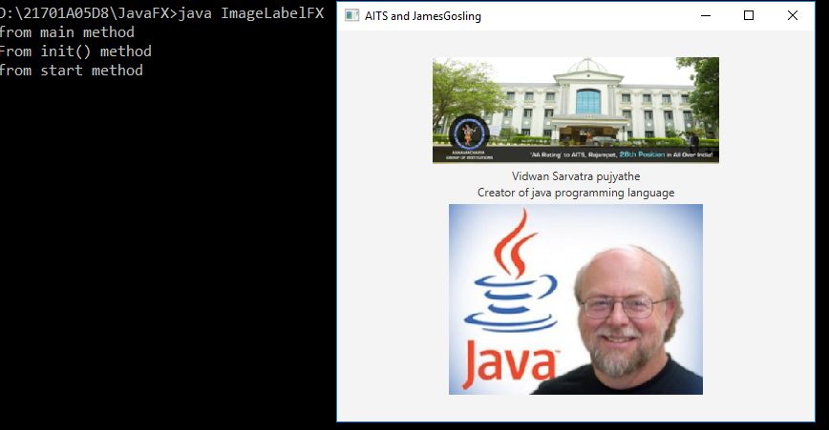

**10.ImageButtonFXDemo**

**import javafx.application.*;**

**import javafx.stage.*;**

**import javafx.scene.*;**

**import javafx.scene.layout.*;**

**import javafx.scene.control.*;**

**import javafx.scene.image.*;**

**import javafx.event.*;**

**import javafx.geometry.*;**

**public class ImageButtonFXDemo extends Application{**

**Image i1,i2,i3,i4,i5,i6;**

**ImageView iv1,iv2,iv3,iv4,iv5,iv6;**

**Button b1,b2,b3,b4,b5,b6;**

**Label l;**

**FlowPane fp;**

**Scene s;**

**public void init(){**

**System.out.println("from init() method");**

**i1=new Image("https://cdn.cdnlogo.com/logos/y/94/youtube.png",50,50,true,true);**

**i2=new Image("https://i0.wp.com/logotaglines.com/wp-content/uploads/2021/11/PhonePe-Logo-Tagline-Slogan-Owner-Founder.jpg?fit=640%2C640&ssl=1",50,50,true,true);**

**i3=new Image("https://helpdeskgeek.com/wp-content/pictures/2022/01/image-112.jpeg",50,50,true,true);**

**i4=new Image("https://www.freepnglogos.com/uploads/whatsapp-png-image-9.png",50,50,true,true);**

**i5=new Image("https://cdn-icons-png.flaticon.com/512/281/281769.png",50,50,true,true);**

**i6=new Image("https://www.shutterstock.com/image-vector/on-off-power-vector-icon-260nw-1588647178.jpg",50,50,true,true);**

**iv1=new ImageView(i1);**

**iv2=new ImageView(i2);**

**iv3=new ImageView(i3);**

**iv4=new ImageView(i4);**

**iv5=new ImageView(i5);**

**iv6=new ImageView(i6);**

**b1=new Button("Entertainment",iv1);**

**b2=new Button("Money and money",iv2);**

**b3=new Button("Connects virtually",iv3);**

**b4=new Button("Fackbook Postman",iv4);**

**b5=new Button("Google pigeon",iv5);**

**b6=new Button("Take Rest",iv6);**

**b1.setContentDisplay(ContentDisplay.TOP);**

**b2.setContentDisplay(ContentDisplay.TOP);**

**b3.setContentDisplay(ContentDisplay.TOP);**

**b4.setContentDisplay(ContentDisplay.TOP);**

**b5.setContentDisplay(ContentDisplay.TOP);**

**b6.setContentDisplay(ContentDisplay.TOP);**

**l=new Label("Click on app");**

**fp=new FlowPane();**

**fp.getChildren().addAll(b1,b2,b3,b4,b5,b6,l);**

**fp.setAlignment(Pos.CENTER);**

**s=new Scene(fp,1000,1000);**

**}**

**public void start(Stage st){**

**System.out.println("from start method");**

**b1.setOnAction(new EventHandler<ActionEvent>(){**

**public void handle(ActionEvent ae){**

**l.setText("Youtube selected");**

**}**

**});**

**b2.setOnAction(new EventHandler<ActionEvent>(){**

**public void handle(ActionEvent ae){**

**l.setText("Phonepay selected");**

**}**

**});**

**b3.setOnAction(new EventHandler<ActionEvent>(){**

**public void handle(ActionEvent ae){**

**l.setText("teams selected");**

**}**

**});**

**b4.setOnAction(new EventHandler<ActionEvent>(){**

**public void handle(ActionEvent ae){**

**l.setText("Whatsapp selected");**

**}**

**});**

**b5.setOnAction(new EventHandler<ActionEvent>(){**

**public void handle(ActionEvent ae){**

**l.setText("gmail selected");**

**}**

**});**

**b6.setOnAction(new EventHandler<ActionEvent>(){**

**public void handle(ActionEvent ae){**

**l.setText("powerOff selected");**

**Platform.exit();**

**}**

**});**

**st.setScene(s);**

**st.setTitle("My favourite Apps");**

**st.show();**

**}**

**public static void main(String[]args){**

**System.out.println("from main method");**

**launch(args);**

**}**

**}**

**Output:**

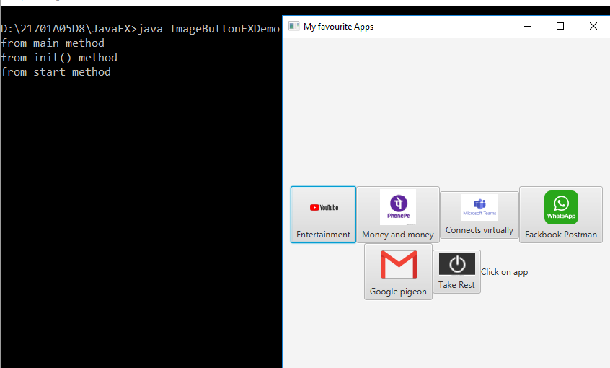

**WEEK 4:**

**11.RadioButtons**

**import javafx.application.*;**

**import javafx.stage.*;**

**import javafx.scene.*;**

**import javafx.scene.control.*;**

**import javafx.scene.control.RadioButton;**

**import javafx.scene.layout.*;**

**import javafx.scene.image.*;**

**import javafx.geometry.*;**

**import javafx.event.*;**

**public class RadioButtonDemo extends Application{**

**RadioButton rb1,rb2,rb3,rb4,rb5;**

**ToggleGroup tg;**

**Image i1,i2,i3,i4,i5;**

**ImageView iv1,iv2,iv3,iv4,iv5;**

**Label l;**

**FlowPane fp;**

**Scene s;**

**public void init(){**

**rb1=new RadioButton("Walk");**

**rb2=new RadioButton("Bicycle");**

**rb3=new RadioButton("Car");**

**rb4=new RadioButton("Train");**

**rb5=new RadioButton("Aeroplane");**

**tg=new ToggleGroup();**

**rb1.setToggleGroup(tg);**

**rb2.setToggleGroup(tg);**

**rb3.setToggleGroup(tg);**

**rb4.setToggleGroup(tg);**

**rb5.setToggleGroup(tg);**

**l=new Label("Select a Travel plan");**

**i1=new Image("https://encrypted-tbn0.gstatic.com/images?q=tbn:ANd9GcRcWeVXBV7-7D97VFtQNTbK4r6SY-z2pMIWJZN-9W3J0-SDfOI6zBYQ0bepoqLQ71MB_eE&usqp=CAU",200,200,true,true);**

**i2=new Image("https://m.media-amazon.com/images/W/IMAGERENDERING_521856-T1/images/I/41MrXjJQa8L._SY300_SX300_QL70_ML2_.jpg",200,200,true,true);**

**i3=new Image("https://www.lamborghini.com/sites/it-en/files/DAM/lamborghini/facelift_2019/model_gw/urus/2022/08_19_urus_perf/gate_urus_og.jpg",200,200,true,true);**

**i4=new Image("https://m.media-amazon.com/images/W/IMAGERENDERING_521856-T1/images/I/61TAw0+IWZL._SL1500_.jpg",200,200,true,true);**

**i5=new Image("https://www.shutterstock.com/image-photo/commercial-passenger-plane-flies-above-260nw-1661785048.jpg",200,200,true,true);**

**iv1=new ImageView(i1);**

**iv2=new ImageView(i2);**

**iv3=new ImageView(i3);**

**iv4=new ImageView(i4);**

**iv5=new ImageView(i5);**

**fp=new FlowPane(20,20);**

**fp.setAlignment(Pos.CENTER);**

**fp.getChildren().addAll(rb1,rb2,rb3,rb4,rb5,l);**

**s=new Scene(fp,500,500);**

**}**

**public void start(Stage st){**

**rb1.setOnAction(new EventHandler<ActionEvent>(){**

**public void handle(ActionEvent ae){**

**l.setGraphic(iv1);**

**l.setText("By Walk");**

**}**

**});**

**rb2.setOnAction(new EventHandler<ActionEvent>(){**

**public void handle(ActionEvent ae){**

**l.setGraphic(iv2);**

**l.setText("Bicycle");**

**}**

**});**

**rb3.setOnAction(new EventHandler<ActionEvent>(){**

**public void handle(ActionEvent ae){**

**l.setGraphic(iv3);**

**l.setText("By Car");**

**}**

**});**

**rb4.setOnAction(new EventHandler<ActionEvent>(){**

**public void handle(ActionEvent ae){**

**l.setGraphic(iv4);**

**l.setText("By Train");**

**}**

**});**

**rb5.setOnAction(new EventHandler<ActionEvent>(){**

**public void handle(ActionEvent ae){**

**l.setGraphic(iv5);**

**l.setText("By flight");**

**}**

**});**

**st.setTitle("Select travel plan to come to college");**

**st.setScene(s);**

**st.show();**

**}**

**public static void main(String[]args){**

**launch(args);**

**}**

**}**

**Output:**

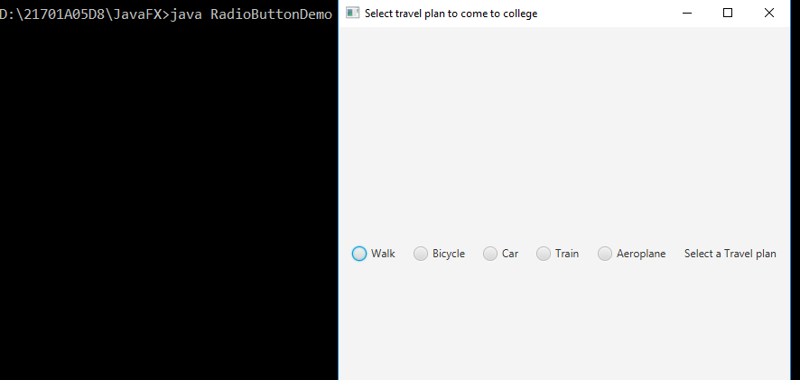

**12.CheckBox**

**import javafx.application.*;**

**import javafx.stage.*;**

**import javafx.scene.*;**

**import javafx.scene.layout.*;**

**import javafx.scene.control.*;**

**import javafx.event.*;**

**import javafx.geometry.*;**

**public class CheckBoxFXDemo extends Application{**

**Label l1,l2;**

**CheckBox c[];**

**Button confirm;**

**FlowPane fp;**

**VBox v;**

**Scene s;**

**Separator se;**

**static String str=" ";**

**public void init(){**

**l1=new Label("please select interested languages");**

**l2=new Label();**

**confirm=new Button("confirm");**

**c=new CheckBox[7];**

**c[0]=new CheckBox("java");**

**c[0].setSelected(true);**

**c[1]=new CheckBox("python");**

**c[1].setSelected(true);**

**c[2]=new CheckBox("go");**

**c[3]=new CheckBox("rust");**

**c[4]=new CheckBox("kotlin");**

**c[5]=new CheckBox("Scale");**

**c[6]=new CheckBox("C");**

**c[6].setIndeterminate(true);**

**se=new Separator();**

**se.setMaxWidth(500);**

**fp=new FlowPane(20,20);**

**fp.setAlignment(Pos.CENTER);**

**for(int i=0;i<7;i++)**

**fp.getChildren().add(c[i]);**

**v=new VBox();**

**v.setSpacing(30);**

**v.setAlignment(Pos.CENTER);**

**v.getChildren().addAll(l1,fp,se,confirm,l2);**

**}**

**public void start(Stage st){**

**confirm.setOnAction((ae)->{**

**str="";**

**for(int i=0;i<7;i++){**

**if(c[i].isSelected()){**

**str+=c[i].getText()+" ";**

**}**

**}**

**l2.setText("Your languages="+str);**

**});**

**s=new Scene(v,1000,1000);**

**st.setScene(s);**

**st.setTitle("Intelligent Programmer languages");**

**st.show();**

**}**

**public static void main(String[]args){**

**launch(args);**

**}**

**}**

**Output:**

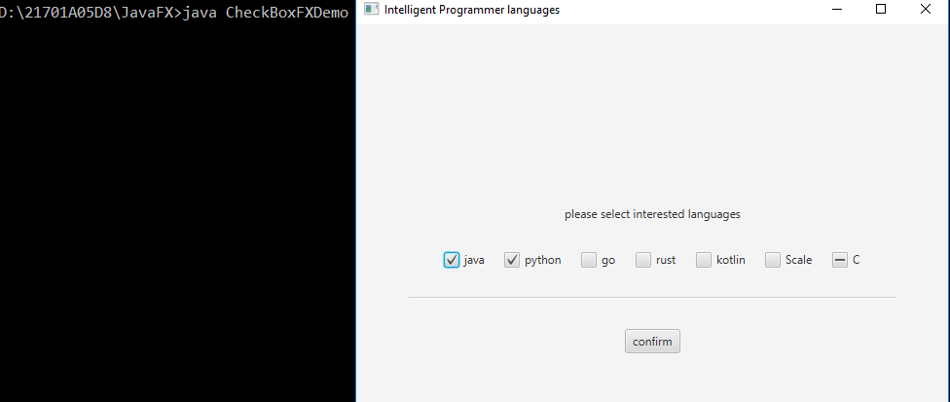

**13.textField**

**import javafx.application.*;**

**import javafx.stage.*;**

**import javafx.scene.*;**

**import javafx.scene.layout.*;**

**import javafx.event.*;**

**import javafx.scene.control.*;**

**import javafx.scene.control.TextField;**

**import javafx.geometry.*;**

**public class TextFieldDemo extends Application{**

**Label l,res;**

**TextField tf;**

**Button b;**

**FlowPane fp;**

**VBox v;**

**Scene s;**

**public void init(){**

**l=new Label("Paro Search Engine");**

**tf=new TextField();**

**b=new Button("Search");**

**res=new Label();**

**v=new VBox();**

**v.setSpacing(30);**

**v.setAlignment(Pos.CENTER);**

**tf.setPrefColumnCount(10);**

**tf.setPromptText("ask me");**

**v.getChildren().addAll(l,tf,b,res);**

**}**

**public void start(Stage st) throws Exception{**

**tf.setOnAction(new EventHandler<ActionEvent>(){**

**public void handle(ActionEvent ae){**

**res.setText("Search String:"+tf.getText());**

**}**

**});**

**b.setOnAction(new EventHandler<ActionEvent>(){**

**public void handle(ActionEvent ae){**

**res.setText("Search String:"+tf.getText());**

**}**

**});**

**s=new Scene(v,500,500);**

**st.setTitle("My Search Engine");**

**st.setScene(s);**

**st.show();**

**}**

**public static void main(String[]args){**

**launch(args);**

**}**

**}**

**Output:**

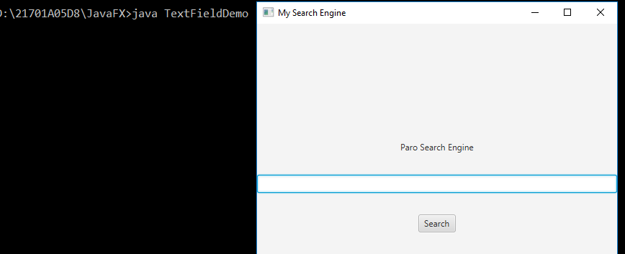

**14.Arithmetic operations**

**import javafx.application.*;**

**import javafx.scene.*;**

**import javafx.stage.*;**

**import javafx.scene.control.*;**

**import javafx.scene.layout.*;**

**import javafx.scene.control.TextField;**

**import javafx.event.*;**

**import javafx.geometry.*;**

**import javafx.scene.paint.*;**

**import javafx.collections.*;**

**public class ArithmeticOperations extends Application{**

**Label l1,l2,l3;**

**Button b1,b2,b3,b4,b5,b6;**

**TextField t1,t2,t3;**

**GridPane gp;**

**Scene s;**

**public void init(){**

**l1=new Label("Enter Number1");**

**l2=new Label("Entet Number2");**

**l3=new Label("Result");**

**t1=new TextField();**

**t2=new TextField();**

**t3=new TextField();**

**b1=new Button("Add");**

**b2=new Button("Subtract");**

**b3=new Button("Multiply");**

**b4=new Button("Divide");**

**b6=new Button("Power");**

**b5=new Button("Modulo");**

**gp=new GridPane();**

**gp.setVgap(25);**

**gp.setHgap(25);**

**gp.setAlignment(Pos.CENTER);**

**gp.add(l1,0,0);**

**gp.add(t1,1,0);**

**gp.add(l2,0,1);**

**gp.add(t2,1,1);**

**gp.add(l3,0,2);**

**gp.add(t3,1,2);**

**gp.add(b1,0,3);**

**gp.add(b2,1,3);**

**gp.add(b3,0,4);**

**gp.add(b4,1,4);**

**gp.add(b5,0,5);**

**gp.add(b6,1,5);**

**}**

**public void start(Stage st)throws Exception{**

**s=new Scene(gp,500,500);**

**b1.setOnAction((ae)->{**

**String str1=t1.getText();**

**String str2=t2.getText();**

**int n1=Integer.parseInt(str1);**

**int n2=Integer.parseInt(str2);**

**int n3=n1+n2;**

**t3.setText(" "+n3);**

**}**

**);**

**b2.setOnAction((ae)->{**

**String str1=t1.getText();**

**String str2=t2.getText();**

**int n1=Integer.parseInt(str1);**

**int n2=Integer.parseInt(str2);**

**int n3=n1-n2;**

**t3.setText(" "+n3);**

**}**

**);**

**b3.setOnAction((ae)->{**

**String str1=t1.getText();**

**String str2=t2.getText();**

**int n1=Integer.parseInt(str1);**

**int n2=Integer.parseInt(str2);**

**int n3=n1*n2;**

**t3.setText(" "+n3);**

**}**

**);**

**b4.setOnAction((ae)->{**

**String str1=t1.getText();**

**String str2=t2.getText();**

**int n1=Integer.parseInt(str1);**

**int n2=Integer.parseInt(str2);**

**double n3=(double)n1/n2;**

**t3.setText(" "+n3);**

**}**

**);**

**b5.setOnAction((ae)->{**

**String str1=t1.getText();**

**String str2=t2.getText();**

**int n1=Integer.parseInt(str1);**

**int n2=Integer.parseInt(str2);**

**int n3=n1%n2;**

**t3.setText(" "+n3);**

**}**

**);**

**b6.setOnAction((ae)->{**

**String str1=t1.getText();**

**String str2=t2.getText();**

**double base=Double.parseDouble(str1);**

**double power=Double.parseDouble(str2);**

**double n3=Math.pow(base,power);**

**t3.setText(" "+n3);**

**}**

**);**

**st.setTitle("Arithmetic Operations");**

**st.setScene(s);**

**st.show();**

**}**

**public static void main(String[]args){**

**launch(args);**

**}**

**}**

**Output:**

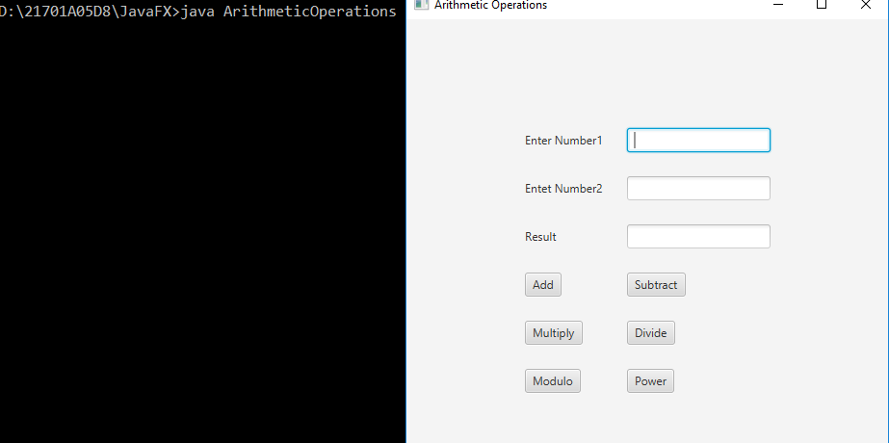

**14.Arithmetic Operations**

**import javafx.application.*;**

**import javafx.scene.*;**

**import javafx.stage.*;**

**import javafx.scene.control.*;**

**import javafx.scene.layout.*;**

**import javafx.scene.control.TextField;**

**import javafx.event.*;**

**import javafx.geometry.*;**

**import javafx.scene.paint.*;**

**import javafx.collections.*;**

**public class ArithmeticOperations1 extends Application{**

**Label l1,l2,l3;**

**Button b1,b2,b3,b4,b5,b6;**

**TextField t1,t2,t3;**

**GridPane gp;**

**Scene s;**

**public void init(){**

**l1=new Label("Enter Number1");**

**l2=new Label("Entet Number2");**

**l3=new Label("Result");**

**t1=new TextField();**

**t2=new TextField();**

**t3=new TextField();**

**b1=new Button("Add");**

**b2=new Button("Subtract");**

**b3=new Button("Multiply");**

**b4=new Button("Divide");**

**b6=new Button("Power");**

**b5=new Button("Modulo");**

**gp=new GridPane();**

**gp.setVgap(25);**

**gp.setHgap(25);**

**gp.setAlignment(Pos.CENTER);**

**gp.add(l1,0,0);**

**gp.add(t1,1,0);**

**gp.add(l2,0,1);**

**gp.add(t2,1,1);**

**gp.add(l3,0,2);**

**gp.add(t3,1,2);**

**gp.add(b1,0,3);**

**gp.add(b2,1,3);**

**gp.add(b3,0,4);**

**gp.add(b4,1,4);**

**gp.add(b5,0,5);**

**gp.add(b6,1,5);**

**}**

**public void start(Stage st)throws Exception{**

**s=new Scene(gp,500,500);**

**b1.setOnAction((ae)->{**

**if(t1.getText().isEmpty()||t2.getText().isEmpty()){**

**if(t1.getText().isEmpty()){**

**t1.setPromptText("Please Enter Number1");**

**}**

**if(t2.getText().isEmpty()){**

**t2.setPromptText("Please Enter Number2");**

**}**

**}**

**else{**

**String str1=t1.getText();**

**String str2=t2.getText();**

**int n1=Integer.parseInt(str1);**

**int n2=Integer.parseInt(str2);**

**int n3=n1+n2;**

**t3.setText(" "+n3);**

**}**

**}**

**);**

**b2.setOnAction((ae)->{**

**if(t1.getText().isEmpty()||t2.getText().isEmpty()){**

**if(t1.getText().isEmpty()){**

**t1.setPromptText("Please Enter Number1");**

**}**

**if(t2.getText().isEmpty()){**

**t2.setPromptText("Please Enter Number2");**

**}**

**}**

**else{**

**String str1=t1.getText();**

**String str2=t2.getText();**

**int n1=Integer.parseInt(str1);**

**int n2=Integer.parseInt(str2);**

**int n3=n1-n2;**

**t3.setText(" "+n3);**

**}**

**}**

**);**

**b3.setOnAction((ae)->{**

**if(t1.getText().isEmpty()||t2.getText().isEmpty()){**

**if(t1.getText().isEmpty()){**

**t1.setPromptText("Please Enter Number1");**

**}**

**if(t2.getText().isEmpty()){**

**t2.setPromptText("Please Enter Number2");**

**}**

**}**

**else{**

**String str1=t1.getText();**

**String str2=t2.getText();**

**int n1=Integer.parseInt(str1);**

**int n2=Integer.parseInt(str2);**

**int n3=n1*n2;**

**t3.setText(" "+n3);**

**}**

**}**

**);**

**b4.setOnAction((ae)->{**

**if(t1.getText().isEmpty()||t2.getText().isEmpty()){**

**if(t1.getText().isEmpty()){**

**t1.setPromptText("Please Enter Number1");**

**}**

**if(t2.getText().isEmpty()){**

**t2.setPromptText("Please Enter Number2");**

**}**

**}**

**else{**

**String str1=t1.getText();**

**String str2=t2.getText();**

**int n1=Integer.parseInt(str1);**

**int n2=Integer.parseInt(str2);**

**double n3=(double)n1/n2;**

**t3.setText(" "+n3);**

**}**

**}**

**);**

**b5.setOnAction((ae)->{**

**if(t1.getText().isEmpty()||t2.getText().isEmpty()){**

**if(t1.getText().isEmpty()){**

**t1.setPromptText("Please Enter Number1");**

**}**

**if(t2.getText().isEmpty()){**

**t2.setPromptText("Please Enter Number2");**

**}**

**}**

**else{**

**String str1=t1.getText();**

**String str2=t2.getText();**

**int n1=Integer.parseInt(str1);**

**int n2=Integer.parseInt(str2);**

**int n3=n1%n2;**

**t3.setText(" "+n3);**

**}**

**}**

**);**

**b6.setOnAction((ae)->{**

**if(t1.getText().isEmpty()||t2.getText().isEmpty()){**

**if(t1.getText().isEmpty()){**

**t1.setPromptText("Please Enter Number1");**

**}**

**if(t2.getText().isEmpty()){**

**t2.setPromptText("Please Enter Number2");**

**}**

**}**

**else{**

**String str1=t1.getText();**

**String str2=t2.getText();**

**double base=Double.parseDouble(str1);**

**double power=Double.parseDouble(str2);**

**double n3=Math.pow(base,power);**

**t3.setText(" "+n3);**

**}**

**}**

**);**

**st.setTitle("Arithmetic Operations");**

**st.setScene(s);**

**st.show();**

**}**

**public static void main(String[]args){**

**launch(args);**

**}**

**}**

**Output:**

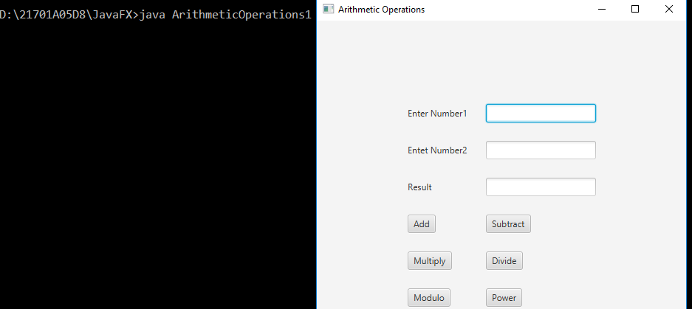

**WEEK 6**

**15.ListView**

**import javafx.application.*;**

**import javafx.scene.*;**

**import javafx.stage.*;**

**import javafx.scene.control.*;**

**import javafx.scene.layout.*;**

**import javafx.scene.control.TextField;**

**import javafx.event.*;**

**import javafx.geometry.*;**

**import javafx.scene.paint.*;**

**import javafx.collections.*;**

**public class ListViewDemo extends Application{**

**ListView<String>lv;**

**ScrollPane sp;**

**Label l;**

**Button b;**

**Scene s;**

**FlowPane fp;**

**public void init(){**

**l=new Label();**

**b=new Button("Find your Hobbies");**

**lv=new ListView<String>();**

**ObservableList<String> items=FXCollections.observableArrayList("OTT","Competitive Programming Languages","Learning Music","App Development","Nature Learner","Games","Watching tv serials","Social Media");**

**lv.setItems(items);**

**lv.setPrefSize(400,400);**

**lv.getSelectionModel().setSelectionMode(SelectionMode.MULTIPLE);**

**sp=new ScrollPane(lv);**

**sp.setPrefViewportWidth(300);**

**sp.setPrefViewportHeight(300);**

**sp.setPannable(true);**

**fp=new FlowPane(20,20);**

**fp.getChildren().addAll(sp,b,l);**

**fp.setAlignment(Pos.CENTER);**

**}**

**public void start(Stage st)throws Exception{**

**b.setOnAction(new EventHandler<ActionEvent>(){**

**public void handle(ActionEvent ae){**

**String setItems=" ";**

**ObservableList<String> item=lv.getSelectionModel().getSelectedItems();**

**for(int i=0;i<item.size();i++)**

**setItems="\n"+item.get(i);**

**l.setText(" "+setItems);**

**}**

**});**

**s=new Scene(fp,500,500);**

**st.setScene(s);**

**st.setTitle("Find your hobbies");**

**st.show();**

**}**

**public static void main()**

**}**

**Output:**

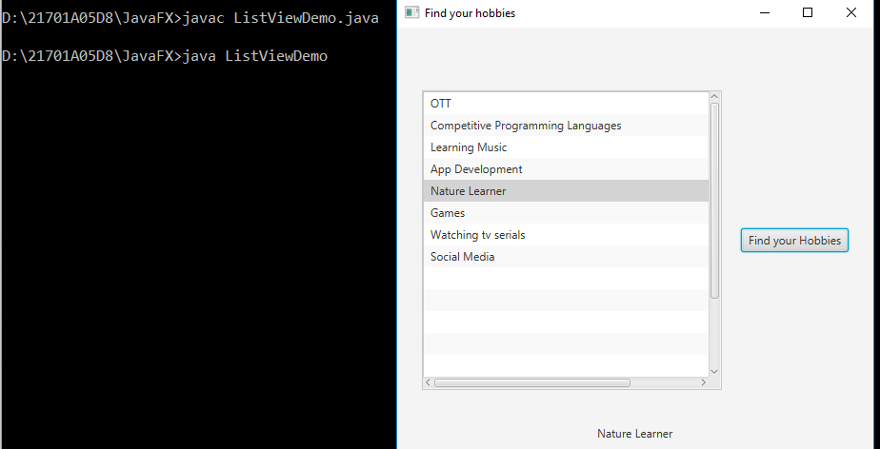

**16.ComboBox:**

import javafx.application.*;

import javafx.stage.*;

import javafx.scene.*;

import javafx.event.*;

import javafx.scene.control.*;

import javafx.scene.layout.*;

import javafx.geometry.*;

import javafx.collections.*;

public class ComboBoxDemo extends Application{

ComboBox<String> cb;

Label l;

Scene s;

FlowPane fp;

public void init(){

l=new Label("Select Branch from ComboBox");

cb=new ComboBox<String>();

ObservableList<String> items=FXCollections.observableArrayList("CSE","ECE","EEE","ME","CE","AIDS","AIML");

cb.setItems(items);

cb.setValue("Branch");//public void setValue(String str)

fp=new FlowPane(30,30);

fp.getChildren().addAll(cb,l);

fp.setAlignment(Pos.CENTER);

}

public void start(Stage st) throws Exception{

cb.setOnAction(new EventHandler<ActionEvent>(){

public void handle(ActionEvent ae){

String str=cb.getValue();

l.setText("My Branch is :"+str);

}

});

s=new Scene(fp,500,500);

st.setScene(s);

st.setTitle("Know your branch");

st.show();

}

public static void main(String[] args){

launch(args);

}

}

**Output:**

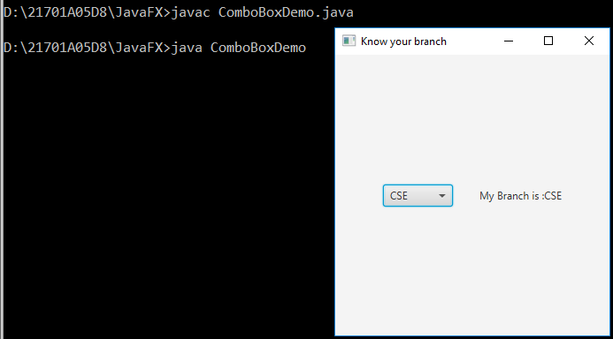

**17.Tree View Component:**

import javafx.application.*;

import javafx.stage.*;

import javafx.scene.*;

import javafx.scene.control.*;

import javafx.scene.layout.*;

import javafx.event.*;

import javafx.geometry.*;

import javafx.beans.value.*;

public class TreeViewComponent extends Application{

Label l1,l2;

FlowPane fp;

TreeView<String> cview;

TreeItem<String>India,AP,TN,TG,KA,KE,KDP,CTR,ATP,KNL,RJPT,TPT,NDL,CNI,BNGU,TIRU,HYD,AITS,TDP,PDTR,NE;

Scene s;

public void init(){

India=new TreeItem<String>("India");

AP=new TreeItem<String>("Andhra Pradesh");

TN=new TreeItem<String>("Tamil Nadu");

TG=new TreeItem<String>("Telangana");

KA=new TreeItem<String>("Karnataka");

KE=new TreeItem<String>("Kerala");

KDP=new TreeItem<String>("Kadapa");

CTR=new TreeItem<String>("Chittor");

ATP=new TreeItem<String>("Anantapur");

KNL=new TreeItem<String>("Kurnool");

NE=new TreeItem<String>("Nellore");

RJPT=new TreeItem<String>("Rajampet");

TPT=new TreeItem<String>("Tirupati");

NDL=new TreeItem<String>("Nandyal");

TDP=new TreeItem<String>("Tadipatri");

CNI=new TreeItem<String>("Chennai");

BNGU=new TreeItem<String>("Bengaluru");

TIRU=new TreeItem<String>("Tiruvantapuramu");

HYD=new TreeItem<String>("Hyderabad");

AITS=new TreeItem<String>("AITS");

PDTR=new TreeItem<String>("Proddatur");

India.getChildren().addAll(AP,TN,TG,KA,KE);

AP.getChildren().addAll(KDP,CTR,ATP,KNL,NE);

KDP.getChildren().addAll(RJPT,PDTR);

RJPT.getChildren().add(AITS);

CTR.getChildren().add(TPT);

ATP.getChildren().add(TDP);

KNL.getChildren().add(NDL);

TN.getChildren().add(CNI);

KA.getChildren().add(BNGU);

KE.getChildren().add(TIRU);

TG.getChildren().add(HYD);

l1=new Label("Selected Location ");

l2=new Label("Selected Location path");

cview=new TreeView<String>(India);

fp=new FlowPane(20,20);

fp.getChildren().add(cview);

fp.getChildren().addAll(l1,l2);

fp.setAlignment(Pos.CENTER);

}

public void start(Stage st)throws Exception{

MultipleSelectionModel<TreeItem<String>>

cvmodel=cview.getSelectionModel();

cvmodel.selectedItemProperty().addListener(

(changed,oldVal,newVal)->{

if(newVal!=null){

String path=newVal.getValue();

TreeItem<String> tmp=newVal.getParent();

l1.setText("Selected Location:"+path);

while(tmp!=null){

path=tmp.getValue()+"->"+path;

tmp=tmp.getParent();

l2.setText("Selected Path:"+path);

}

}

});

s=new Scene(fp,300,300);

st.setTitle("Country View");

st.setScene(s);

st.show();

}

public static void main(String[]args){

launch(args);

}

}

**Output:**

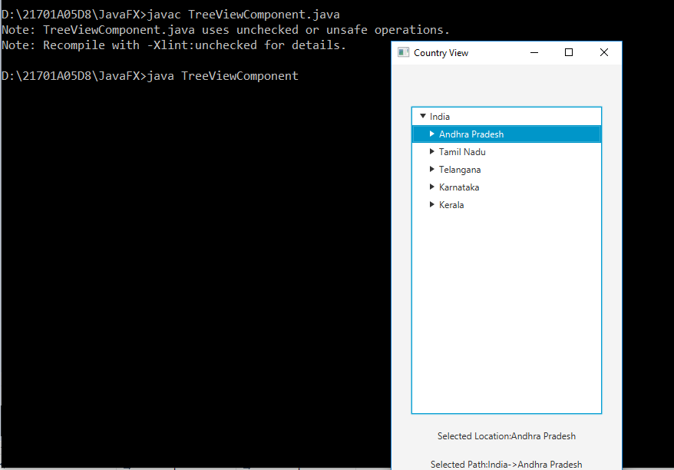

**Week-8:**

**19.a.Creating a table from JDBC Application:**

import java.sql.*;

public class JDBCCreate{

public static void main(String[]args){

String jdbcDriver="oracle.jdbc.driver.OracleDriver";

String jdbcUrl="jdbc:oracle:thin:@localhost:1521:xe";

String user="system";

String pass="admin";

Connection conn=null;

Statement stmt=null;

try{

Class.forName(jdbcDriver);

System.out.println("Connecting to database");

conn=DriverManager.getConnection(jdbcUrl,user,pass);

System.out.println("CREATING DATABASE");

stmt=conn.createStatement();

if(stmt!=null){

System.out.println("Connection Established");

String cquery="Create table AITSCSE1(rnum varchar(20),name varchar(20),designation varchar(25))";

int i=stmt.executeUpdate(cquery);

System.out.println("Table created");

}

}

catch(ClassNotFoundException e){

e.printStackTrace();

}

catch(SQLException e){

e.printStackTrace();

}

}

}

**Output:**

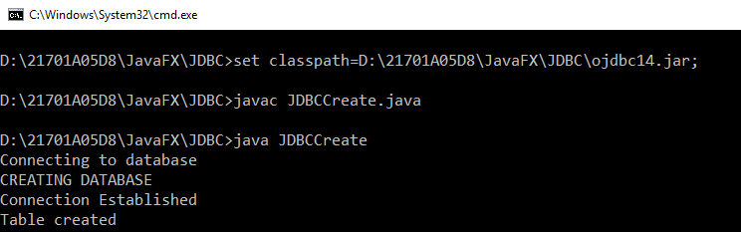

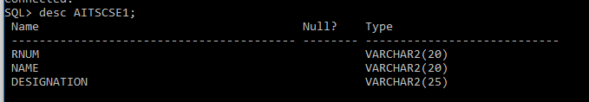

**b.Inserting into table:**

import java.sql.*;

public class JDBCInsert{

public static void main(String []args){

try{

Class.forName("oracle.jdbc.driver.OracleDriver");

Connection conn=DriverManager.getConnection("jdbc:oracle:thin:@localhost:1521:XE","system","admin");

Statement stmt=conn.createStatement();

String iQuery="insert into AITSCSE1 values('aits947','ram','web developer')";

int i=stmt.executeUpdate(iQuery);

if(i>0){

System.out.println(i+"Row inserted");

}

else{

System.out.println("No row is inserted,operation unsuccessfull");

}

}

catch(ClassNotFoundException e){

e.printStackTrace();

}

catch(SQLException e){

e.printStackTrace();

}

}

}

**Output:**

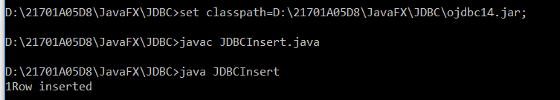

SQL> select * from AITSCSE1;

RNUM NAME DESIGNATION

-------------------- -------------------- -------------------------

aits945 m Harsha Associate Engineer

aits946 rahul programmer

aits947 ram web developer

**c.Updating database:**

import java.sql.*;

public class JDBCUpdate{

public static void main(String []args){

try{

Class.forName("oracle.jdbc.driver.OracleDriver");

Connection conn=DriverManager.getConnection("jdbc:oracle:thin:@localhost:1521:XE","system","admin");

Statement stmt=conn.createStatement();

String iQuery="update aitscse set designation='Associate Professor' where rnum='aits551'";

int i=stmt.executeUpdate(iQuery);

if(i>0){

System.out.println(i+"Row updated");

}

else{

System.out.println("No row is updated,operation unsuccessfull");

}

}

catch(ClassNotFoundException e){

e.printStackTrace();

}

catch(SQLException e){

e.printStackTrace();

}

}

}

**Output:**

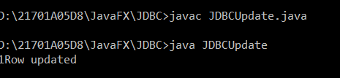

SQL> select * from AITSCSE1;

RNUM NAME DESIGNATION

-------------------- -------------------- -------------------------

aits945 m Harsha Associate Professor

aits946 rahul programmer

aits947 ram web developer

**d.Delete From databse:**

import java.sql.*;

public class JDBCDelete{

public static void main(String []args){

try{

Class.forName("oracle.jdbc.driver.OracleDriver");

Connection conn=DriverManager.getConnection("jdbc:oracle:thin:@localhost:1521:XE","system","admin");

Statement stmt=conn.createStatement();

String iQuery="Delete from aitscse where rnum='aits979'";

int i=stmt.executeUpdate(iQuery);

if(i>0){

System.out.println(i+"Row deleted");

}

else{

System.out.println("No row is deleted,operation unsuccessfull");

}

}

catch(ClassNotFoundException e){

e.printStackTrace();

}

catch(SQLException e){

e.printStackTrace();

}

}

}

**Output:**

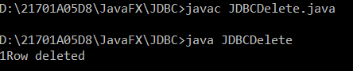

SQL> select * from AITSCSE1;

RNUM NAME DESIGNATION

-------------------- -------------------- -------------------------

aits945 m Harsha Associate Professor

aits946 rahul programmer

**e.selecting:**

import java.sql.*;

public class JDBCSelect{

public static void main(String []args){

try{

Class.forName("oracle.jdbc.driver.OracleDriver");

Connection conn=DriverManager.getConnection("jdbc:oracle:thin:@localhost:1521:XE","system","admin");

Statement stmt=conn.createStatement();

String sQuery="select * from aitscse";

ResultSet rs=stmt.executeQuery(sQuery);

int i=1;

while(rs.next()){

System.out.println("Aits CSE student:"+i);

System.out.println("*********");

System.out.println("Id:"+rs.getString("rnum")+"\t");

System.out.println("Name:"+rs.getString("name")+"\t");

System.out.println("Designation:"+rs.getString("designation")+"\n");

i++;

}

}

catch(ClassNotFoundException e){

e.printStackTrace();

}

catch(SQLException e){

e.printStackTrace();

}

}

}

**Output:**

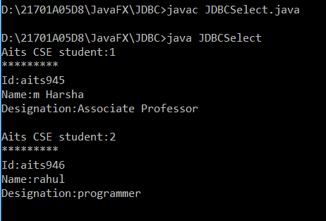

**20.Inserting N rows:**

import java.sql.*;

import java.util.*;

class INSERTNRows{

public static void main(String[]args){

try{

Class.forName("oracle.jdbc.driver.OracleDriver");

Connection conn=DriverManager.getConnection("jdbc:oracle:thin:@localhost:1521:XE","system","admin");

PreparedStatement pstmt=conn.prepareStatement("INSERT into aitscse1 values(?,?,?)");

int i=0;

Scanner input=new Scanner(System.in);

//System.out.println("Enter how namy recors do u want to insert:");

//int n=input.nextInt();

while(i<3){

System.out.println("Enter Record "+i);

System.out.println("Enter id:");

String id=input.nextLine();

System.out.println("Enter name:");

String name=input.nextLine();

System.out.println("Enter Designation:");

String des=input.nextLine();

pstmt.setString(1,id);

pstmt.setString(2,name);

pstmt.setString(3,des);

pstmt.executeQuery();

i++;

}

}

catch(ClassNotFoundException e){

e.printStackTrace();

}

catch(SQLException e){

e.printStackTrace();

}

}

}

**Output:**

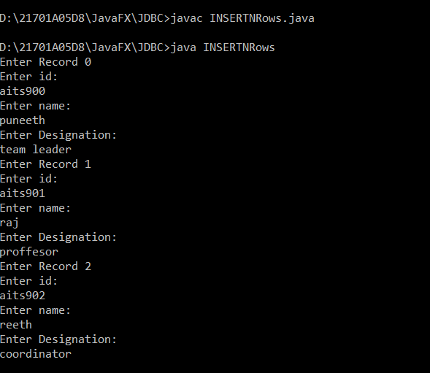

SQL> select * from AITSCSE1;

RNUM NAME DESIGNATION

-------------------- -------------------- -------------------------

aits945 m Harsha Associate Professor

aits946 rahul programmer

aits902 reeth coordinator

aits900 puneeth team leader

aits901 raj proffesor