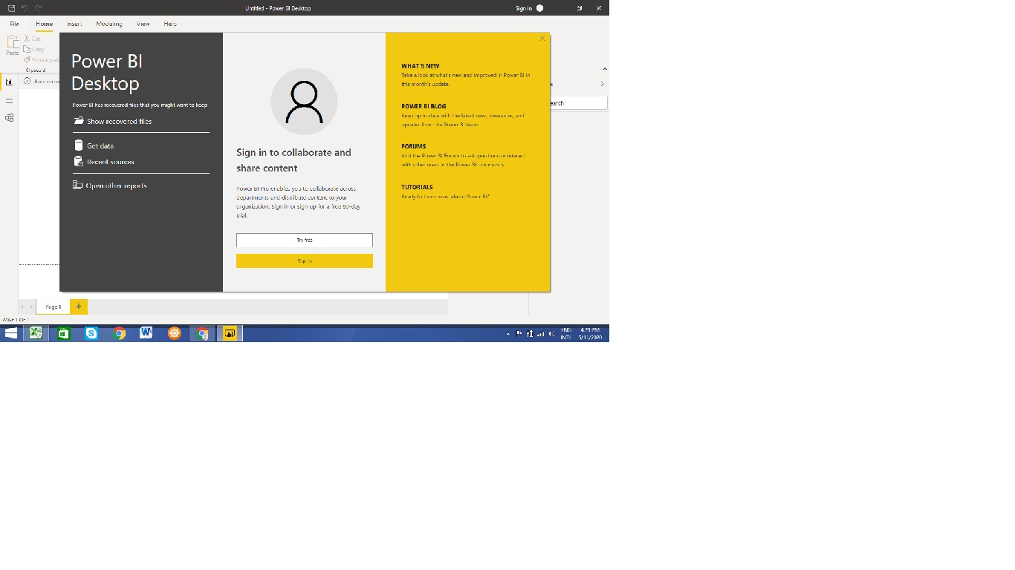

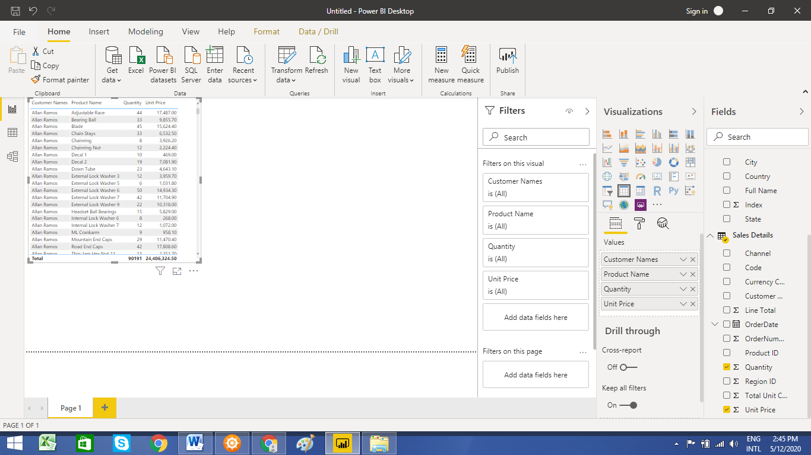

What is Power BI Desktop???
Power BI Desktop is a free application you install on your local computer that lets you connect to, transform, and visualize your data. ... Most users who work on business intelligence projects use Power BI Desktop to create reports, and then use the Power BI service to share their reports with others.
Usually we get this version for FREE, atleast for a month, until we purchase one.

What is Power BI Pro???
Power BI Pro is an individual user license that lets users read and interact with reports and dashboards that others have published to the Power BI service. Users with this license type can share content and collaborate with other Power BI Pro users.
Its $9.99 per month or we can even buy license for a year.

What is Power BI Premium???
With Premium, anyone, whether they're inside or outside your organization can view your Power BI content including paginated and interactive reports without purchasing individual licenses. Premium enables widespread distribution of content by Pro users without requiring Pro licenses for recipients who view the content.
Premium is $4,995 per year license cost.

