**1Q. Draw a USE-CASE diagram for Online Voting System using CASE tools**

***Aim:*** To draw a use case diagram for online voting system using case tools.

***Software Used:*** Umbrello.

***Diagram:***

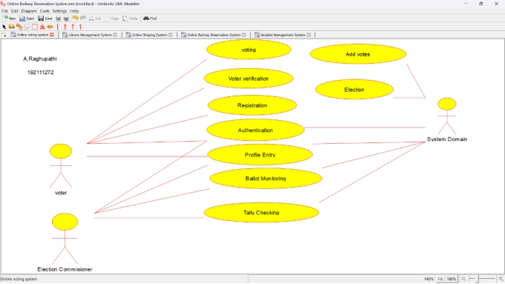

**Result:** Drawing a use case diagram for online voting system was completed successfully.