CLASS ACTIVITY

1.C to F Unit converters (Fahrenheit to Celsius and vice versa)

Step 1: Start

Step 2: Input enter the temperature to get c

Step 3: Give K= 273 +C

Step 4: Formula as F=(C\* 9)/ 5+32

Step 5: Print the temperature in Fahrenheit

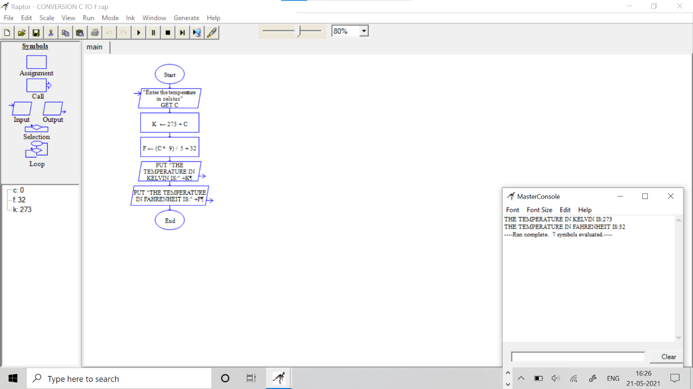

F to C conversion

Step 1: Start

Step 2: Input enter the temperature get F

Step 3: Give 273-F = C

Step 4: Formula 5/9 \*K – 32 = C

Step 5: Print the temperature in celsius

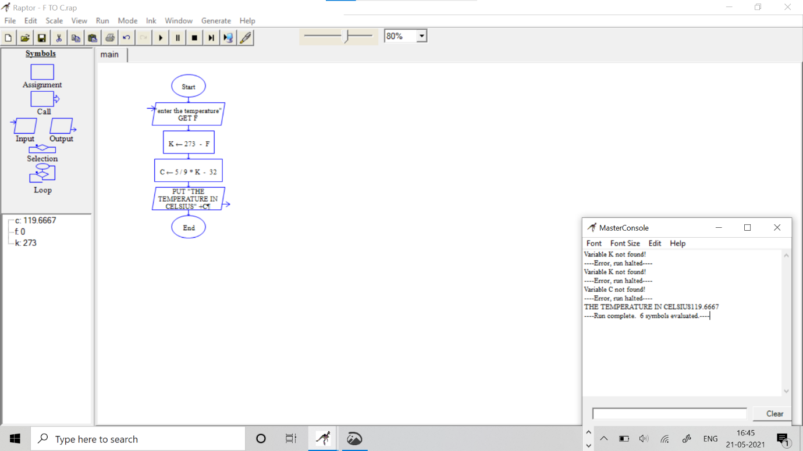

2. Simple Interest

Step 1: Start

Step 2: Input the values of principal , rate% , Time period

Step 3: Use the formula ci = (p\*r\*N)/100

Step 4: Print simple Interest is +

Step 5: End

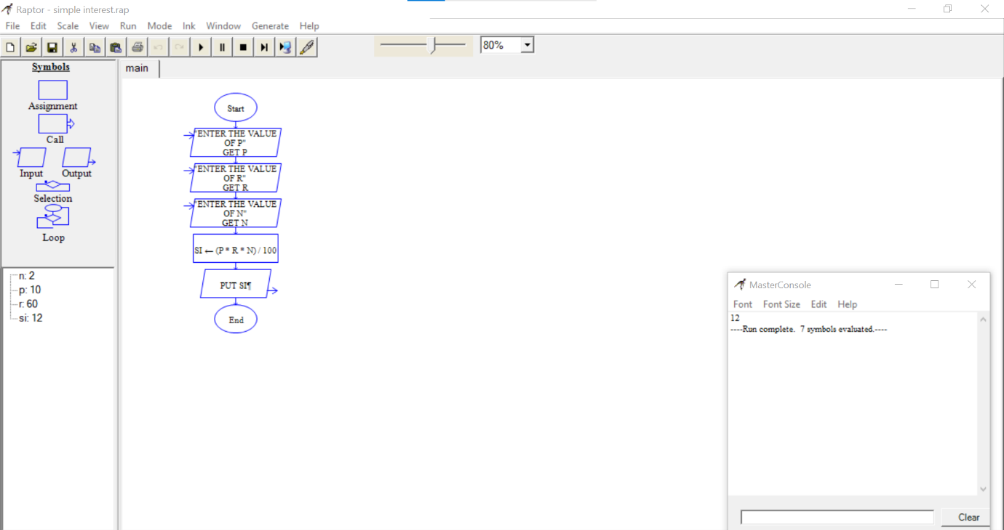

Compound Interest

Step 1: Start

Step 2: Input the values of principal , rate% , Time period

Step 3: Use the formula ci = p\*(1+r/100)^n

Step 4: Print compound Interest is +Compound Interest

Step 5: End

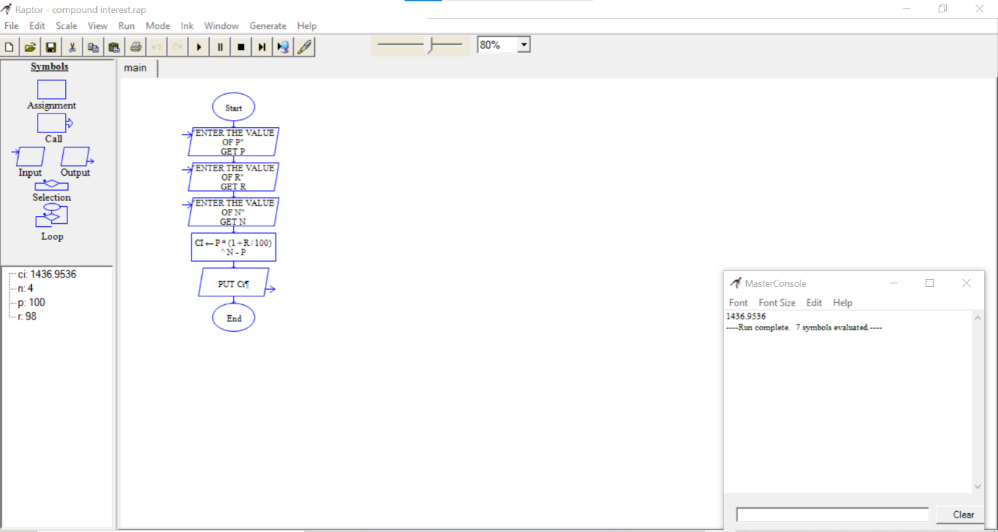

3. Multiplication Tables

Step 1: Start

Step 2: Input the number for which the multiplication table is to be generated

Step 3: Input the end value until which the table has to be generated

Step 4: Repeat from I = 1 to end

Step 5: Display the table values in the given output format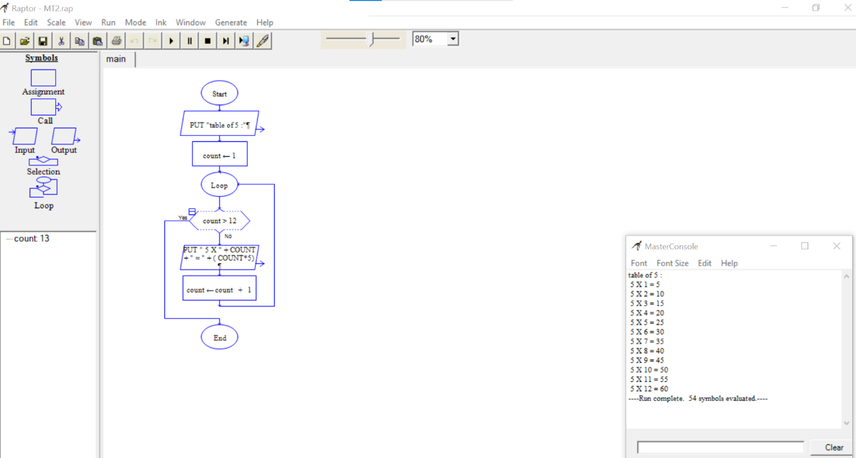

4. GCD of 2 Numbers

Step 1: Start

Step 2: Input two numbers A & B

Step 3: put the first number as A and second number as B

Step 4: Assign i to 1

Step 5: Start a loop repeat steps 6 to 7 until i>A & i>B

Step 6: Use a statement block A%i = 0 and B%i=0

Step 7: Put I as I +1

Step 8: Print GCD of 2 Numbers is +gcd

Step 9: End

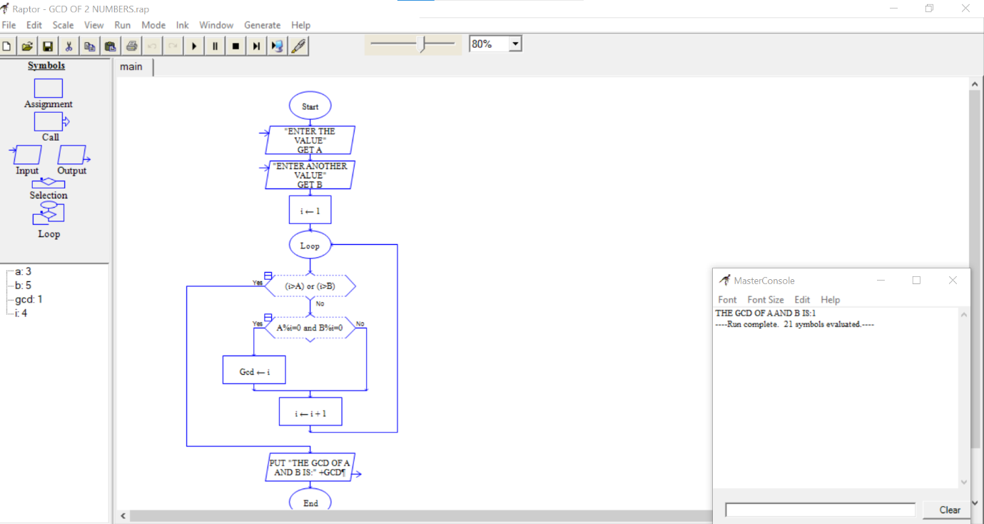

5. Fibonacci Number Generation

Step 1: Start

Step 2: Enter the value of N

Step 3: Take variables f0 , f1

Step 4: Set f0 = 0 , f1 = 1

Step 5: Start a loop repeat 6 , 7 , 8 steps : N=0

Step 6: f2 = f1 +f0

Step 7: set f1 = f2= f0

Step 8: set N = N-1

Step 9: End

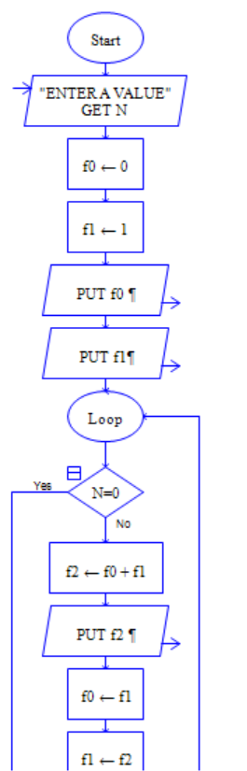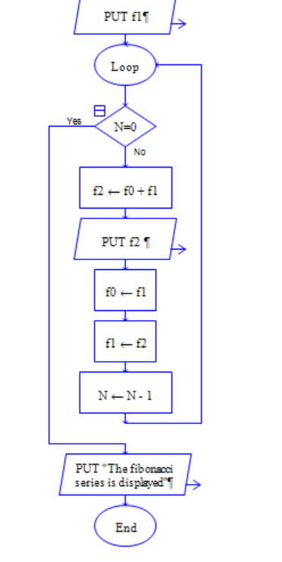

7 & 8 Minimum, Maximum of n numbers

Step 1: Start

Step 2: use variables high , low , and sum

Step 3: Read the count of numbers as n

Step 4: Set high = a , low = a , sum = a and i= 1

Step 5: Repeat steps 6 to 10 while i=n

Step 6: Read the number as c

Step 7: Set Sum = sum + c

Step 8: If c>high set High = c

Step 9: If low>c then set low = c

Step 10: set i=i+1

Step 11: Avg = sum/n

Step 12: Put the highest number , the lowest number and avg of numbers

Step 13: End

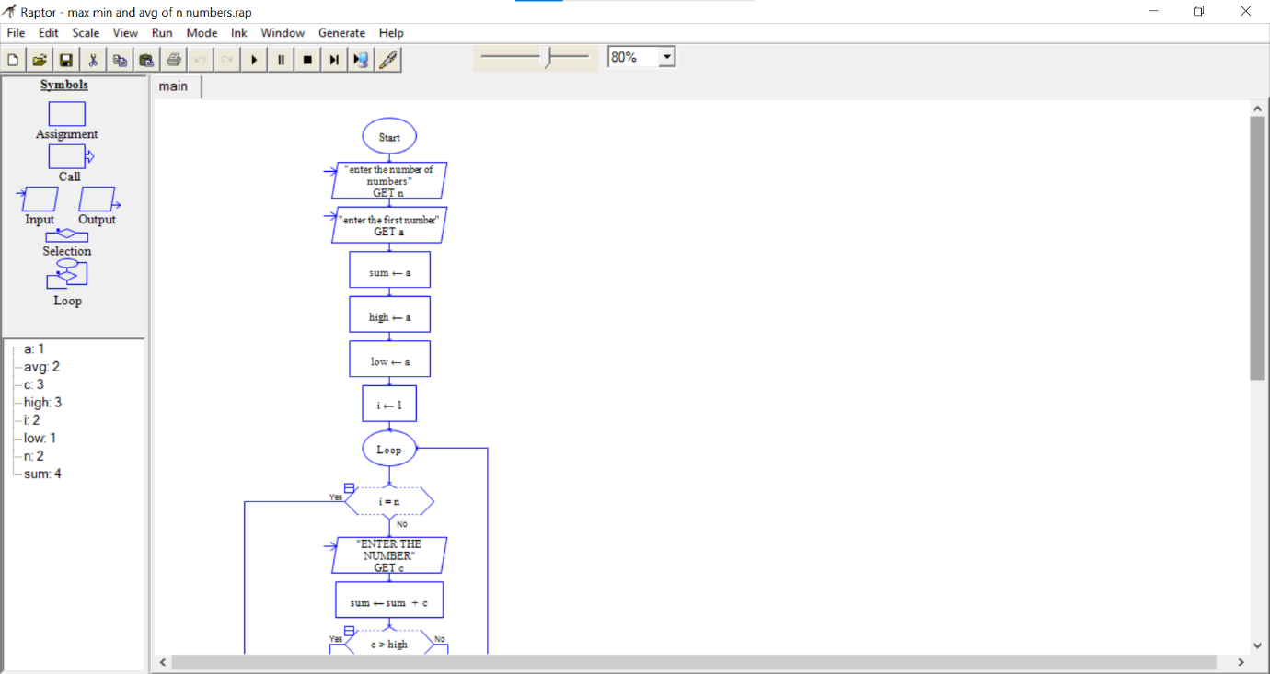

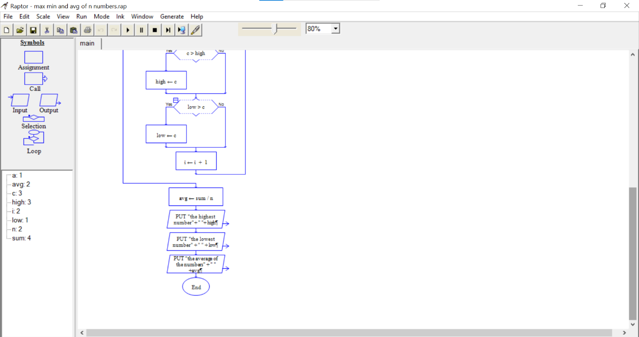

9. Linear Search

Step 1: Start

Step 2: Set i to 1

Step 3: If i>n then go to step 8

Step 4: If A[i] = x then go to the step 7

Step 5: Set i to i+1

Step 6: Go to step 3

Step 7: print element x found at index i and go to step 9

Step 8: print element not found

Step 9: End

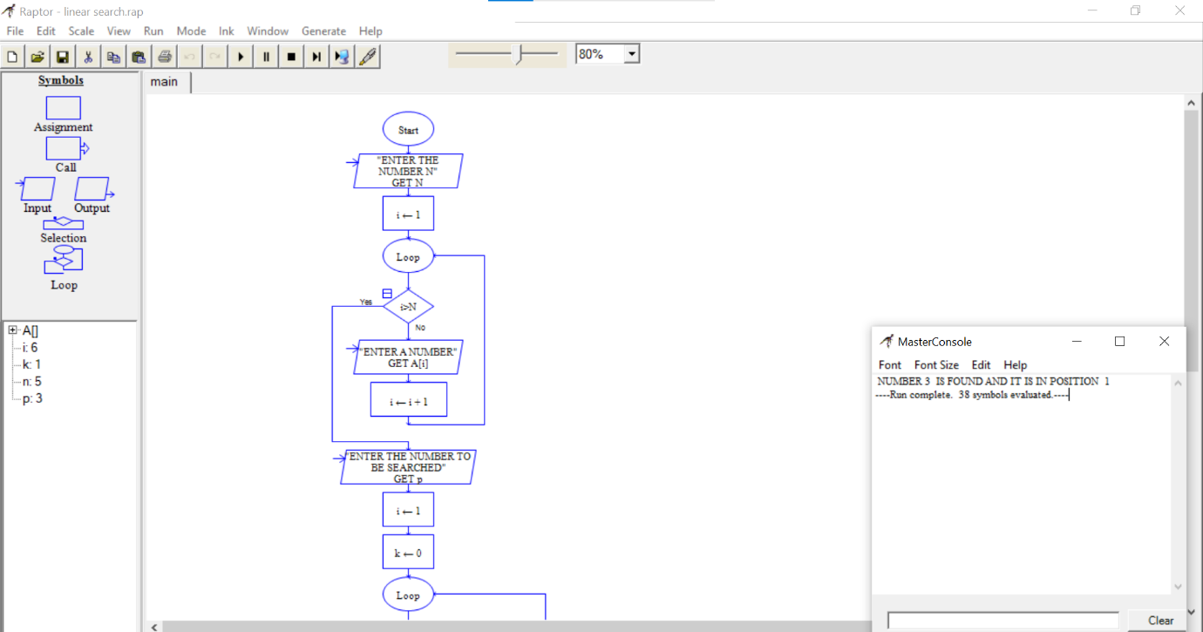

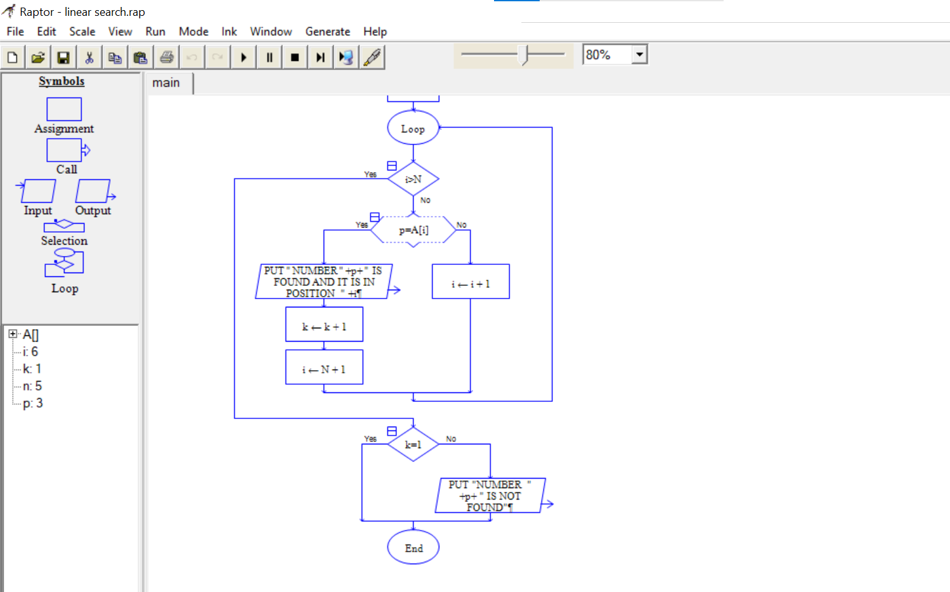

10. Binary search

(10) Binary Search ALGORITHM:

Step-1: START

Step- 2: input enter size of array

Step-3: Until count>n input: enter count number get scores[count] assignment: count=count+1

Step-4: if count>n

Step-5: Input number to be searched to get target.

Step-6: If scores[count]=target

Step-7: low 1

Step-8: high n

Step-9: if low>high

Step-10: test floor (low+ high/2)

Step-11: scores[test]>target

Step-12: scores[low]=target

Step-13: output

