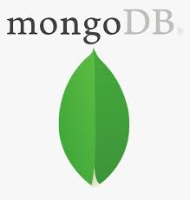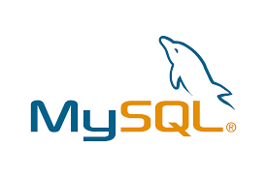

Eureka Server

MySQL

Mongo Db

API

Gateway

3rd Party API

Mongo Db

password

email

Crud

Register

login

Register

login

User

Authentication

Service

Favorite

Movie

Service

Recommended

Movie

Service

Feign

Client

Movie

Service