Market Research Report: Global Electric Vehicle (EV) Industry

1. Executive Summary
The global Electric Vehicle (EV) industry is undergoing rapid transformation driven by sustainability goals, technological innovation, and regulatory support. This report provides an in-depth analysis of the EV market, including industry structure, SWOT analysis, competitive dynamics, target customers, and emerging trends.

2. Industry Overview
The EV industry includes battery electric vehicles (BEVs), plug-in hybrid electric vehicles (PHEVs), and hybrid electric vehicles (HEVs). Governments worldwide are promoting EV adoption to reduce carbon emissions and dependence on fossil fuels. Advances in lithium-ion batteries and economies of scale have significantly reduced production costs, accelerating market growth.

3. Market Size and Growth
Global EV sales have increased exponentially over the past five years. Rising fuel prices, stricter emission regulations, and increased consumer awareness are key growth drivers. The market is expected to maintain double-digit growth rates through 2030.
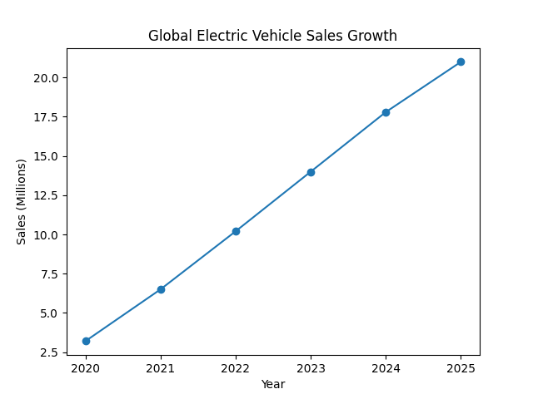

4. Target Audience Analysis
The EV market serves a diverse customer base:
• Private Consumers – Urban and suburban buyers seeking environmentally friendly transportation.
• Corporate Fleets – Logistics, delivery, and corporate mobility providers focusing on cost reduction.
• Ride-Sharing Services – Companies adopting EVs to lower operating costs and emissions.
• Government & Public Transport – Municipal fleets and public transit agencies transitioning to clean energy.
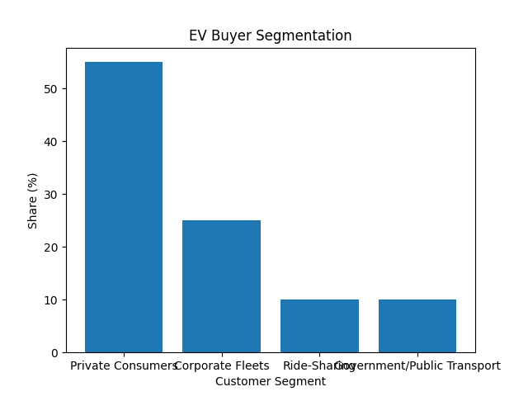

5. SWOT Analysis
Strengths:
• Zero tailpipe emissions
• Lower maintenance and fuel costs
• Strong government incentives
• Technological innovation
Weaknesses:
• High initial purchase price
• Charging infrastructure limitations
• Battery recycling challenges
Opportunities:
• Expansion in emerging markets
• Development of solid-state batteries
• Integration with renewable energy
• Autonomous and connected vehicle technologies
Threats:
• Intense competition and price wars
• Raw material supply constraints
• Policy and subsidy uncertainty
• Consumer range anxiety

6. Competitive Landscape
Competition in the EV market is intense, involving both traditional automakers and new entrants. Tesla leads in innovation and brand recognition, BYD dominates the Chinese market, while Volkswagen and Hyundai-Kia leverage global manufacturing capabilities. Competitive factors include pricing, battery range, charging ecosystem, and brand trust.
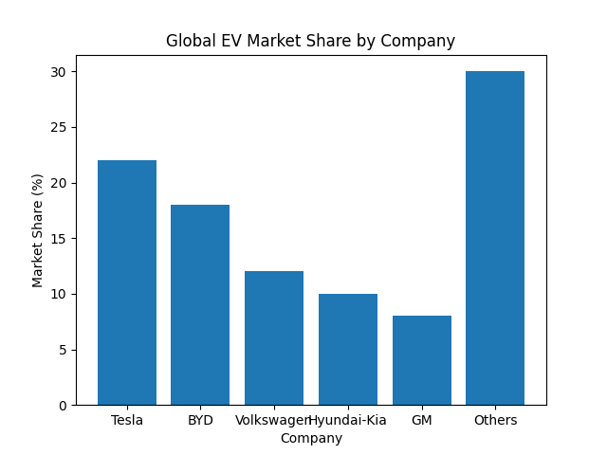

7. Market Trends
Key trends shaping the EV industry include:
• Declining battery costs and improved energy density
• Expansion of fast-charging networks
• Growing adoption of EVs in commercial fleets
• Strategic partnerships between automakers and tech firms
• Increased focus on sustainability and circular economy models

8. Challenges and Risks
Despite strong growth, the EV industry faces challenges such as supply chain disruptions, limited access to critical minerals, infrastructure gaps in developing regions, and consumer concerns over vehicle range and resale value.

9. Future Outlook
The EV industry is expected to play a central role in the future of transportation. Companies investing in innovation, scalable production, and charging infrastructure will be best positioned to capture long-term value.

10. Conclusion
In conclusion, the Electric Vehicle industry presents significant growth opportunities despite existing challenges. Strategic investments, supportive policies, and technological advancements will continue to drive the market forward.

