**Name:** B. Nageswar

**Reg-No**: 192372005

17.Illustrate the deadlock avoidance concept by simulating Banker’s algorithm with C.

**Aim**

The goal of the Banker's Algorithm is to prevent deadlock by allocating system resources to processes in a safe manner, ensuring that no set of processes gets stuck indefinitely waiting for resources.

**Banker’s Algorithm**

1. **Input**:
   * Available[]: Number of available instances for each resource.
   * Maximum[][]: Maximum resource demand for each process.
   * Allocation[][]: Currently allocated resources for each process.
   * Need[][]: Remaining resource needs (Need[i][j] = Maximum[i][j] - Allocation[i][j]).
2. **Steps**:
   * Compute the Need matrix.
   * Check if a safe sequence exists:
     + For each process, verify if its resource Need can be satisfied using Available.
     + If yes, simulate allocation and proceed to the next process.
   * If all processes can execute in some sequence without running out of resources, the state is **safe**; otherwise, it’s unsafe.

**Procedure**

1. Input the number of processes and resources.
2. Enter the Available, Maximum, and Allocation matrices.
3. Calculate the Need matrix.
4. Run the safety algorithm to find a safe sequence.
5. If a safe sequence is found, display it; otherwise, declare the state unsafe.

### Code:

### #include <stdio.h>

### #include <stdbool.h>

### int main() {

### int n, m, i, j, k;

### printf("Enter number of processes: ");

### scanf("%d", &n);

### printf("Enter number of resources: ");

### scanf("%d", &m);

### int Allocation[n][m], Maximum[n][m], Need[n][m], Available[m];

### printf("Enter Allocation matrix:\n");

### for (i = 0; i < n; i++)

### for (j = 0; j < m; j++)

### scanf("%d", &Allocation[i][j]);

### printf("Enter Maximum matrix:\n");

### for (i = 0; i < n; i++)

### for (j = 0; j < m; j++)

### scanf("%d", &Maximum[i][j]);

### printf("Enter Available resources:\n");

### for (j = 0; j < m; j++)

### scanf("%d", &Available[j]);

### for (i = 0; i < n; i++)

### for (j = 0; j < m; j++)

### Need[i][j] = Maximum[i][j] - Allocation[i][j];

### bool Finish[n];

### for (i = 0; i < n; i++)

### Finish[i] = false;

### int SafeSequence[n], work[m];

### for (j = 0; j < m; j++)

### work[j] = Available[j];

### int count = 0;

### while (count < n) {

### bool found = false;

### for (i = 0; i < n; i++) {

### if (!Finish[i]) {

### for (j = 0; j < m; j++)

### if (Need[i][j] > work[j])

### break;

### if (j == m) {

### for (k = 0; k < m; k++)

### work[k] += Allocation[i][k];

### SafeSequence[count++] = i;

### Finish[i] = true;

### found = true;

### }

### }

### }

### if (!found) {

### printf("System is in an unsafe state.\n");

### return 0;

### }

### }

### printf("System is in a safe state.\nSafe sequence is: ");

### for (i = 0; i < n; i++)

### printf("%d ", SafeSequence[i]);

### printf("\n");

### return 0;

### }

**Result**

1. The system checks if a safe sequence exists.
2. If found, it displays the safe sequence (e.g., 0 2 1 3).
3. If not, it reports that the system is in an unsafe state.

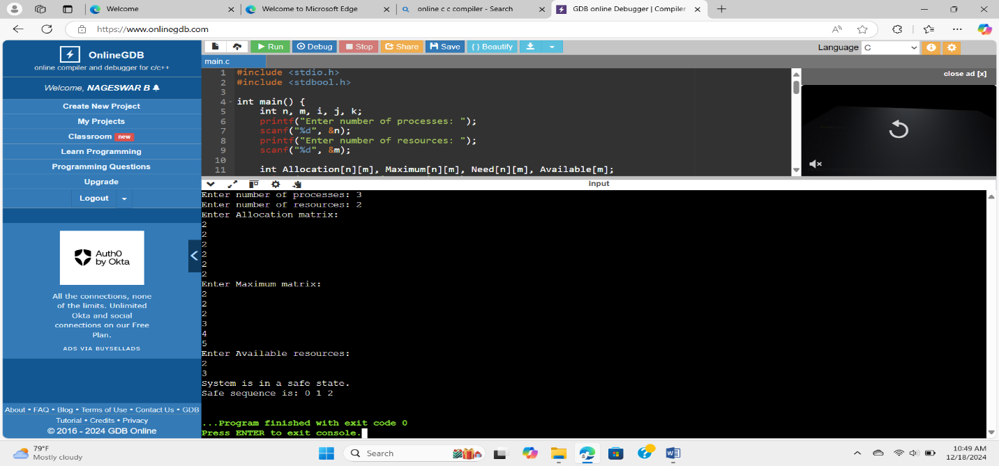**Output:**