Newsheadlines_text_analysis.R
Raghu
Sun Jan 22 15:31:34 2017
## =============================================================
## News Headlines as predictors of Flex company stock movement:
## Using Unigrams, Bigrams, Trigrams, and Fourgrams
## Raghu Kowshik
## Sunday, January 22, 2016
## =============================================================
## INTRODUCTION
## This project attempts to predict Flex (NASDAQ: FLEX) company stock movement
## using a variety of R tools including RWeka, tm, and glmnet packages.
## The folloiwng packages will be loaded using the install.packages utility in RStudio
## and the library command.
library(NLP)
library(tm)
library(RWeka)
library(magrittr)
library(Matrix)
library(glmnet)
## Loading required package: foreach
## Loaded glmnet 2.0-5
library(ROCR)
## Loading required package: gplots
##
## Attaching package: 'gplots'
## The following object is masked from 'package:stats':
##
## lowess
library(ggplot2)
##
## Attaching package: 'ggplot2'
## The following object is masked from 'package:NLP':
##
## annotate
library(pROC)
## Type 'citation("pROC")' for a citation.
##
## Attaching package: 'pROC'
## The following object is masked from 'package:glmnet':
##
## auc
## The following objects are masked from 'package:stats':
##
## cov, smooth, var
## The tm package was used for text processing and creating a
## document-term matrix (dtm) of news headlines.
## The glmnet package was used to perform logistic regression modelling.
## The ROCR package was used to generate ROC curves and assess performance
## using area under curve (AUC).
## The RWeka package was used to perform a variety of
## text processing tasks including NGramTokenizing.
## ============================================================
## OBTAINING THE DATA
## Data were down loaded from two sources, newsmax.com and Nasdaq.com, to an MS Excel file.
## The two data chunks were merged to form a single data file in csv format.
## The dataset contains 175 observations, over a 13 month period.
## Each observation consis of the following variables:
## date, close, volume, open, high, low.
## The newsmax.com headlines consisted of 20 headlines per day.
## After mergibg the two data sets, the data set named "headlimes" has the following variables:
## date, close, volume, open, high, ha1, hl2, hl3, hl4, hl5, hl6, hl7, hl8, hl9, hl10,
## hl11, hl12, hl13, hl14, hl15, hl16, hl17, hl18, hl19, hl20.
## ============================================================
## FEATURE ENGINEERING
## Bfore importing the dataset into RStudio, a feature was added to the Excel file.
## A new variable called "label" was added. The "label" variable was assigned
## binary values 0 or 1. If the stock value at close was less than the open value,
## then the variable "label" was assigned 0, if the stock value at close was
## greater than or equal to the open value, then the variable "label" was assigned a 1.
## The final data set"headlines" has the following variables:
## date, close, volume, open, high, label, ha1, hl2, hl3, hl4, hl5, hl6, hl7, hl8, hl9, hl10,
## hl11, hl12, hl13, hl14, hl15, hl16, hl17, hl18, hl19, hl20.
## 0: load csv data into R data frame
headlines <- read.csv(file="headlines.csv", stringsAsFactors = FALSE)
## ============================================================
## DATA WRANGLING: Pre-processing
## The following data cleanup steps were performed.
# 1: Make "Date" column a date object
headlines$date <- as.Date(headlines$date)
# 2: Remove unused variables
headlines$volume = NULL
headlines$high = NULL
headlines$low = NULL
headlines$close = NULL
headlines$open = NULL
# 3: Combine headlines into one text group for each day and add sentence separation.
headlines$all <- paste(headlines$hl1, headlines$hl2, headlines$hl3, headlines$hl4,
headlines$hl5, headlines$hl6, headlines$hl7, headlines$HL8,
headlines$hl9, headlines$hl10, headlines$hl11, headlines$hl12,
headlines$hl13, headlines$hl14, headlines$hl15, headlines$hl16,
headlines$hl17, headlines$hl18, headlines$hl19, headlines$hl20,
sep=" <s> ")
# 4: Get rid of all punctuation except headline separators
headlines$all <- gsub("([<>])|[[:punct:]]", "\\1", headlines$all)
# 5: Reduce to only the three columns we need.
headlines <- headlines[, c('date', 'label', 'all')]
## Via a corpus object, using the "tm" package, text headlines are converted into a document-term matrix
## Each row of the document-term matrix will be the combined headlines for each day.
## Columns will be frequency counts of unigrams.
## The control object will tell the DocumentTermMatrix() function
## what to do with the text before converting to a term matrix.
## Punctuation and numbers are removed, everything is converted to lowercase, and
## common English words are removed.
control_c <- list(
removeNumbers = TRUE,
tolower = TRUE,
# exclude stopwords and headline tokens
stopwords = c(stopwords(kind = 'SMART'), '<s>'))
dtm <- Corpus(VectorSource(headlines$all)) %>%
DocumentTermMatrix(control=control_c)
## =======================================================
## DATA SET PREPARATION
## Using a date as an index marker, divide the dataset into two: train and test.
## Select the index so that approximately 70% of the data can be used for training and 30% for testing.
split_index <- headlines$date <= '2016-09-30'
ytrain <- as.factor(headlines$label[split_index])
xtrain <- Matrix(as.matrix(dtm)[split_index, ], sparse=TRUE)
ytest <- as.factor(headlines$label[!split_index])
xtest <- Matrix(as.matrix(dtm)[!split_index, ], sparse=TRUE)
## =======================================================
## MODEL BUILDING AND TESTING
## MODEL 1
## Fit a glmnet model using ridge regression
## Train the model using the train data set.
glmnet.fit <- cv.glmnet(x=xtrain, y=ytrain, family='binomial', alpha=0)
# Generate predictions
preds <- predict(glmnet.fit, newx=xtest, type='response', s='lambda.min')
# Put results into dataframe for plotting.
results <- data.frame(pred=preds, actual=ytest)
## Dual density plot of the predicted probabilites,
## for each of the true values 0 (stock down) or 1 (stock is up or unchanged).
## The predictions are not identical, there is some discernable separation.
ggplot(results, aes(x=preds, color=actual)) + geom_density()
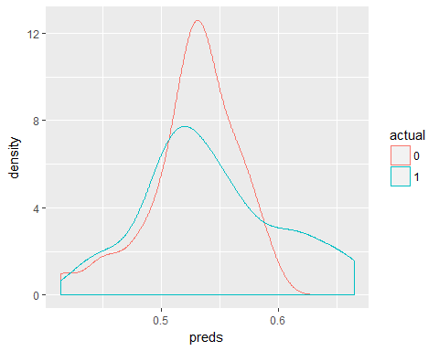
## MODEL 1 PERFORMANCE ASSESSMENT
## ROCR package is used to assess performance.
## We create two performance objects:
## one for the true positive/false positive rates, and
## one for the AUC score.
prediction <- prediction(preds, ytest)
perf <- performance(prediction, measure = "tpr", x.measure = "fpr")
auc <- performance(prediction, measure = "auc")
auc <- as.numeric(auc@y.values)
summary(auc)
## Min. 1st Qu. Median Mean 3rd Qu. Max.
## 0.5454 0.5454 0.5454 0.5454 0.5454 0.5454
roc.data <- data.frame(fpr=unlist(perf@x.values),
tpr=unlist(perf@y.values))
ggplot(roc.data, aes(x=fpr, ymin=0, ymax=tpr)) +
geom_ribbon(alpha=0.2) +
geom_line(aes(y=tpr)) +
geom_abline(slope=1, intercept=0, linetype='dashed') +
ggtitle("ROC Curve") +
ylab('True Positive Rate') +
xlab('False Positive Rate')
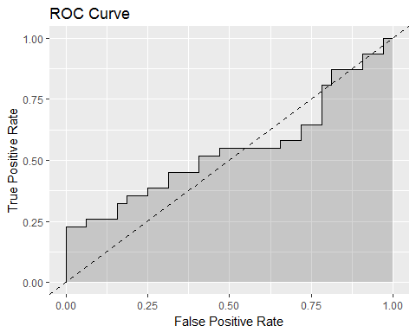
## ==================================
## MODEL 2
## Model 2 also uses individul words, just like model 1,
## but takes the tokenizer approach to delienate the individual words.
## Also, We will only use unigrams that appear in at least 20 of the documents.
## We won't use unigrams that appear in more than 120 of the documents.
unigramTokenizer <- function(x) NGramTokenizer(x, Weka_control(min = 1, max = 1))
control <- list(tokenize=unigramTokenizer, bounds = list(global = c(20, 120)))
dtm <- Corpus(VectorSource(headlines$all)) %>%
tm_map(removeNumbers) %>%
tm_map(stripWhitespace) %>%
tm_map(content_transformer(tolower)) %>%
DocumentTermMatrix(control=control)
split_index <- headlines$date <= '2016-09-30'
ytrain <- as.factor(headlines$label[split_index])
xtrain <- Matrix(as.matrix(dtm)[split_index, ], sparse=TRUE)
ytest <- as.factor(headlines$label[!split_index])
xtest <- Matrix(as.matrix(dtm)[!split_index, ], sparse=TRUE)
# Train the model
glmnet.fit <- cv.glmnet(x=xtrain, y=ytrain, family='binomial', alpha=0)
# Generate predictions
preds <- predict(glmnet.fit, newx=xtest, type='response', s="lambda.min")
# Put results into dataframe for plotting.
results <- data.frame(pred=preds, actual=ytest)
# Dual density plot. The predictions are not identical, there is separation.
ggplot(results, aes(x=preds, color=actual)) + geom_density()
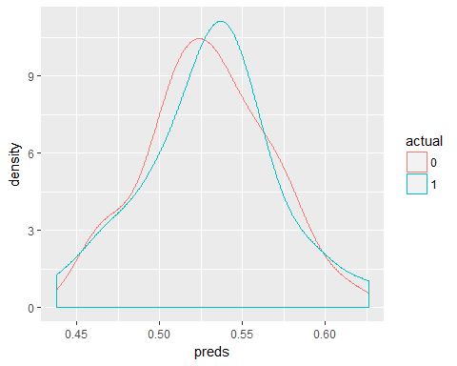
## MODEL 2 PERFORMANCE ASSESSMENT
## ROCR package is used to assess performance.
## We create two performance objects:
## one for the true positive/false positive rates, and
## one for the AUC score.
prediction <- prediction(preds, ytest)
perf <- performance(prediction, measure = "tpr", x.measure = "fpr")
auc <- performance(prediction, measure = "auc")
auc <- as.numeric(auc@y.values)
summary(auc)
## Min. 1st Qu. Median Mean 3rd Qu. Max.
## 0.5141 0.5141 0.5141 0.5141 0.5141 0.5141
roc.data <- data.frame(fpr=unlist(perf@x.values),
tpr=unlist(perf@y.values))
ggplot(roc.data, aes(x=fpr, ymin=0, ymax=tpr)) +
geom_ribbon(alpha=0.2) +
geom_line(aes(y=tpr)) +
geom_abline(slope=1, intercept=0, linetype='dashed') +
ggtitle("ROC Curve") +
ylab('True Positive Rate') +
xlab('False Positive Rate')
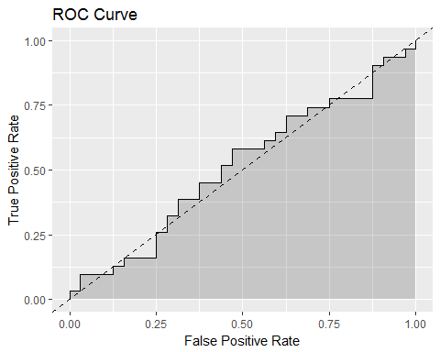
## ================================================
## MODEL 3
## Model 3 uses bigrams instead of individul words. NGramTokenizer
## from RWeka package is used to build a tokenizer.
## Also, We will only use bigrams that appear in at least 30 of the documents.
## We won't use biigrams that appear in more than 75 of the documents.
bigramTokenizer <- function(x) NGramTokenizer(x, Weka_control(min = 2, max = 2))
control <- list(tokenize=bigramTokenizer, bounds = list(global = c(30, 75)))
dtm <- Corpus(VectorSource(headlines$all)) %>%
tm_map(removeNumbers) %>%
tm_map(stripWhitespace) %>%
tm_map(content_transformer(tolower)) %>%
DocumentTermMatrix(control=control)
split_index <- headlines$date <= '2016-09-30'
ytrain <- as.factor(headlines$label[split_index])
xtrain <- Matrix(as.matrix(dtm)[split_index, ], sparse=TRUE)
ytest <- as.factor(headlines$label[!split_index])
xtest <- Matrix(as.matrix(dtm)[!split_index, ], sparse=TRUE)
# Train the model
glmnet.fit <- cv.glmnet(x=xtrain, y=ytrain, family='binomial', alpha=0)
# Generate predictions
preds <- predict(glmnet.fit, newx=xtest, type='response', s="lambda.min")
# Put results into dataframe for plotting.
results <- data.frame(pred=preds, actual=ytest)
ggplot(results, aes(x=preds, color=actual)) + geom_density()
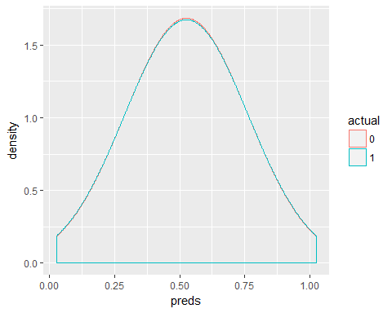
## MODEL 3 PERFORMANCE ASSESSMENT
prediction <- prediction(preds, ytest)
perf <- performance(prediction, measure = "tpr", x.measure = "fpr")
auc <- performance(prediction, measure = "auc")
auc <- as.numeric(auc@y.values)
summary(auc)
## Min. 1st Qu. Median Mean 3rd Qu. Max.
## 0.5 0.5 0.5 0.5 0.5 0.5
roc.data <- data.frame(fpr=unlist(perf@x.values),
tpr=unlist(perf@y.values))
ggplot(roc.data, aes(x=fpr, ymin=0, ymax=tpr)) +
geom_ribbon(alpha=0.2) +
geom_line(aes(y=tpr)) +
geom_abline(slope=1, intercept=0, linetype='dashed') +
ggtitle("ROC Curve") +
ylab('True Positive Rate') +
xlab('False Positive Rate')
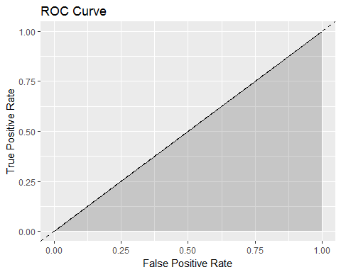
## ==============================================
## MODEL 4
trigramTokenizer <- function(x) NGramTokenizer(x, Weka_control(min = 3, max = 3))
control <- list(tokenize=trigramTokenizer, bounds = list(global = c(20, 275)))
dtm <- Corpus(VectorSource(headlines$all)) %>%
tm_map(removeNumbers) %>%
tm_map(stripWhitespace) %>%
tm_map(content_transformer(tolower)) %>%
DocumentTermMatrix(control=control)
split_index <- headlines$date <= '2016-09-30'
ytrain <- as.factor(headlines$label[split_index])
xtrain <- Matrix(as.matrix(dtm)[split_index, ], sparse=TRUE)
ytest <- as.factor(headlines$label[!split_index])
xtest <- Matrix(as.matrix(dtm)[!split_index, ], sparse=TRUE)
# Train the model
glmnet.fit <- cv.glmnet(x=xtrain, y=ytrain, family='binomial', alpha=0)
# Generate predictions
preds <- predict(glmnet.fit, newx=xtest, type='response', s="lambda.min")
# Put results into dataframe for plotting.
results <- data.frame(pred=preds, actual=ytest)
ggplot(results, aes(x=preds, color=actual)) + geom_density()
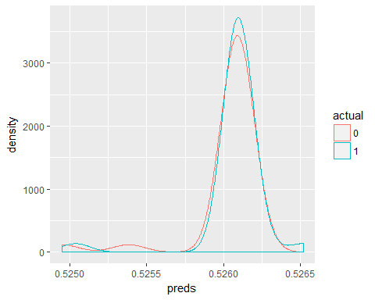
## MODEL 4 PERFORMANCE ASSESSMENT
prediction <- prediction(preds, ytest)
perf <- performance(prediction, measure = "tpr", x.measure = "fpr")
auc <- performance(prediction, measure = "auc")
auc <- as.numeric(auc@y.values)
summary(auc)
## Min. 1st Qu. Median Mean 3rd Qu. Max.
## 0.562 0.562 0.562 0.562 0.562 0.562
roc.data <- data.frame(fpr=unlist(perf@x.values),
tpr=unlist(perf@y.values))
ggplot(roc.data, aes(x=fpr, ymin=0, ymax=tpr)) +
geom_ribbon(alpha=0.2) +
geom_line(aes(y=tpr)) +
geom_abline(slope=1, intercept=0, linetype='dashed') +
ggtitle("ROC Curve") +
ylab('True Positive Rate') +
xlab('False Positive Rate')
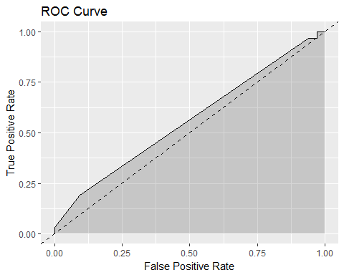
##=======================================
## MODEL 5
FourgramTokenizer <- function(x) NGramTokenizer(x, Weka_control(min = 4, max = 4))
control <- list(tokenize=trigramTokenizer, bounds = list(global = c(10, 50)))
dtm <- Corpus(VectorSource(headlines$all)) %>%
tm_map(removeNumbers) %>%
tm_map(stripWhitespace) %>%
tm_map(content_transformer(tolower)) %>%
DocumentTermMatrix(control=control)
split_index <- headlines$date <= '2016-09-30'
ytrain <- as.factor(headlines$label[split_index])
xtrain <- Matrix(as.matrix(dtm)[split_index, ], sparse=TRUE)
ytest <- as.factor(headlines$label[!split_index])
xtest <- Matrix(as.matrix(dtm)[!split_index, ], sparse=TRUE)
# Train the model
glmnet.fit <- cv.glmnet(x=xtrain, y=ytrain, family='binomial', alpha=0)
# Generate predictions
preds <- predict(glmnet.fit, newx=xtest, type='response', s="lambda.min")
# Put results into dataframe for plotting.
results <- data.frame(pred=preds, actual=ytest)
# Dual density plot
ggplot(results, aes(x=preds, color=actual)) + geom_density()
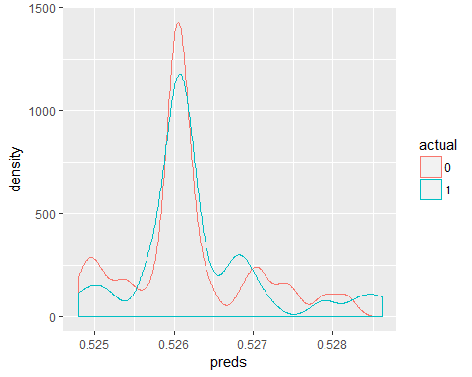
## MODEL 5 PERFORMANCE ASSESSMENT
prediction <- prediction(preds, ytest)
perf <- performance(prediction, measure = "tpr", x.measure = "fpr")
auc <- performance(prediction, measure = "auc")
auc <- as.numeric(auc@y.values)
summary(auc)
## Min. 1st Qu. Median Mean 3rd Qu. Max.
## 0.5459 0.5459 0.5459 0.5459 0.5459 0.5459
roc.data <- data.frame(fpr=unlist(perf@x.values),
tpr=unlist(perf@y.values))
ggplot(roc.data, aes(x=fpr, ymin=0, ymax=tpr)) +
geom_ribbon(alpha=0.2) +
geom_line(aes(y=tpr)) +
geom_abline(slope=1, intercept=0, linetype='dashed') +
ggtitle("ROC Curve") +
ylab('True Positive Rate') +
xlab('False Positive Rate')
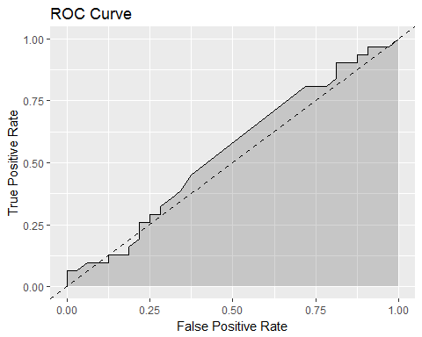
##=========================================================
## LIMITATIONS OF THIS STUDY
## This study has several limitations. The dataset is small, only 275 observations,
## 3 variables used in the analysis, and 20+ unused variables. Although 5 models were tested
## in this study, repetitive methodology was used. Although the predictions were separated,
## there was no major separation. One might argue that the separation was by chance.
## +++++++++++++++++++++++
## Model# AUC Score
## +++++++++++++++++++++++
## Model 1 0.5454
## Model 2 0.5141
## Model 3 0.5000
## Model 4 0.5620
## Model 5 0.5459
## +++++++++++++++++++++++
##====================================================================
## FURTHER RESEARCH DIRECTIONS
## The topic of stock prediction is of great interest. Other methods including
## Naive Baeys classification and Support Vector Machine may offer better solution possibilities.
## It is interesting and worth investigating these possibilities.
##=====================================================================
## REFERENCES:
## 1. https://www.r-bloggers.com/illustrated-guide-to-roc-and-auc/
## 2. https://www.kaggle.com/aaron7sun/stocknews
## 3. http://stats.stackexchange.com/questions/132777/what-does-auc-stand-for-and-what-is-it
## 4. https://www.r-bloggers.com/illustrated-guide-to-roc-and-auc/
## 5. https://cran.r-project.org/web/packages/RWeka/RWeka.pdf
##====================================================================

