Initial Project Run

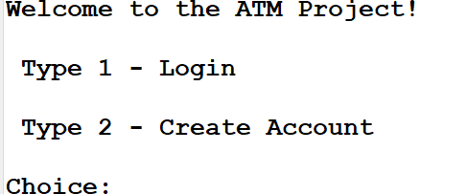

Case 1: Login with Wrong Account Number

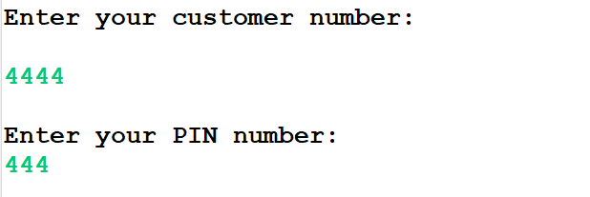

Case 2: Entering a Wrong Character

Case 3: Entering first customer credentials

Case 4: First customer checking account

Case5: First customer account balance

Case6: 1st Customer account Balance

Case7: 1st Customer with draw funds

Case13: 1st Customer with draw funds

Case14: 1st Customer with draw funds

Customer 2: