**Use case:** **Gen AI enabled Integrated Platform Environment**

**PoC Scope**:

Leverage Generative AI (Gen AI) within Salesforce to:

Automate Case Classification & Auto-Response Generation

Create Knowledge Articles from Resolved Cases

Build an AI-Powered Chatbot for FAQ and Case Creation

This solution is implemented in **Salesforce Environment**:

Configurations used

* Remote site setting:

Remote Site Settings allow your Apex code, API calls, and Visualforce pages to access external websites or services. By default, Salesforce blocks external HTTP requests for security reasons. To enable outbound calls, you must explicitly whitelist external domains via Remote Site Settings.

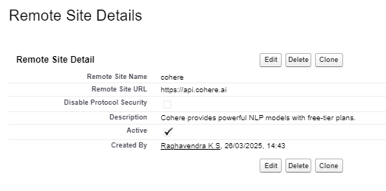

* Metadata

Custom Metadata Types allow you to store and manage metadata (configuration data) in Salesforce, similar to Custom Objects but with advantages like easier deployment and no SOQL limits. They are primarily used for configuration settings, feature toggles, and reusable data across orgs.

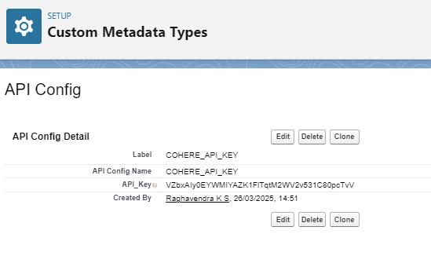

**Configure OpenAI API for AI-Driven Tasks**

**Get OpenAI API Key**

Using **cohere NLP** API model to generate the response

* Case classifications and AI Response generation

Based on the case classification and description, the AI model generates a suggested response.

This response is stored in a custom field (AI_Suggested_Response__c) on the Case object.

The generated response includes:

* **Troubleshooting Steps**
* **Recommended Solutions**
* **Links to Knowledge Articles (if applicable)**

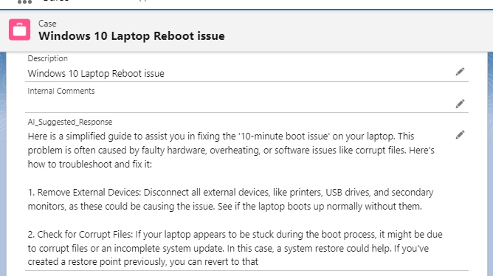

Also, providing an ability to generate additional response/help for any questions

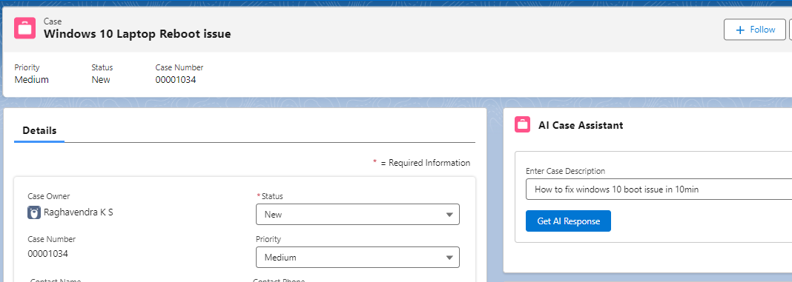

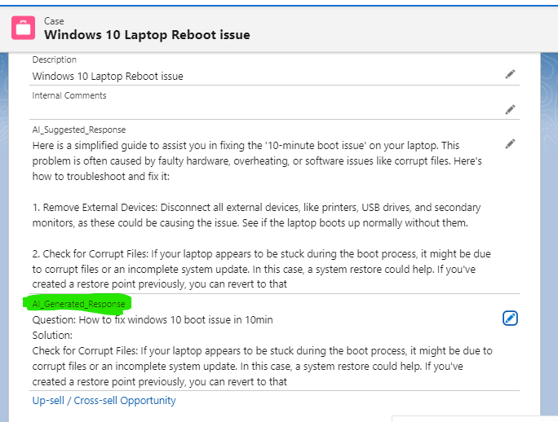

Future enhancement:

* Email classification
* Chat bot to support engineers