# Change request log

# Team

Team:6

Raghupathi Vasantavada(Raghu)

Devika Chakraborty

# Change Request

FEMR-138: don't let a user submit on Pharmacy unless they check the disclaimer

As a user, I should not be able to submit in Pharmacy unless the disclaimer is checked, so that patients always get counseled.

# Concept Location

|  |  |  |
| --- | --- | --- |
| Step # | Description | Rationale |
| 1 | We ran the system | To Reproduce the issue and to get a general idea of the place/module |
| 2 | We interacted with the system: after logging in we clicked on the pharmacy menu item | The indication from the change request description that the problem area is Pharmacy screen |
| 3 | We searched with a random patient id and realized it does not work and we ended up searching the Patients table to get a patient id | Did a trial and error approach to guess a patient id, eventually picked a patient ID from patients table. |
| 4 | Entered the patient ID on the pharmay screen after obtaining patient id from patients table. | Assumed that patient’s is somehow tied to pharmacy |
| 5 | When the system did not like PatientId given, we queried the Patients table in Descending order of ID column | The assumption is that data for older records could have been purged periodically by some DB job |
| 6 | As none of the IDs worked, decided to come from medication screen and ended up with same results as previous steps | Assumption here is that the screen just before this could give us some indication |
| 7 | Eventually, went to Triage screen, created a patient. | With the common sense assumption that a patient first should get registered, and doctors prescribe the medication next and finally pharmacy dispenses the medication |
| 8 | Tried to enter dummy data in each tab/ field and submit. | Received the error as mentioned in eLearning and applied the fix by looking into medications and chose Tylenol with the assumption that we will choose ‘headache’ in the ‘Diagnosis’ field. Correspondingly populated the  medication_inventories table |
| 9 | Created another patient encounter, medication | As the fix from eLearning mentioned that Trip had to be assigned to the logged in User, we gained understanding that patient – city was mapped to a trip and the original patient we created belonged to a different city. |
| 10 | Navigated to pharmacy screen, entered in the newly created patient ID and was able reproduce the issue on the screen | The screen was letting user submit without checking the disclaimer |
| 11 | Using IDE searched for the text next to label (Edit->file->find in path) and narrowed it down to edit.scala.html | Since the edit.scala.html under views/pharmacy, it can be concluded that this file represents the correct view |
| 12 | Viewed the source of the page from Browser and narrowed it 2 javascript files (PharmacyClientValidations.js and Pharmacy.js) | To identify the if there is javascript event on form submit button and to figure out where the event is getting fired from |
| 13 | PharmacyClientValidations.j is the file where we need to make code changes | Pharmacy.js does not contain any form submit event and hence can be ignored |

**Time spent (in minutes):** 65

# Impact Analysis

|  |  |  |
| --- | --- | --- |
| Step # | Description | Rationale |
| 1 | We made a list of methods called by PharmacyController . | To track the classes that could be impacted by the change. |
| 2 | As there is only one entry point(submit button) on this screen, the server side classes are not impacted | As the change is restricted to a validation on the GUI and the change is restricted to javascript, there is no impact on server side. |

**Time spent (in minutes):** 12

# Actualization

Using the table below, describe each step you followed when changing the code. Include as many details as possible, including why classes/methods were modified, added, removed, renamed, etc.

|  |  |  |
| --- | --- | --- |
| Step # | Description | Rationale |
| 1 | Changed the form submit event code in PharmacyClientValidations.js | We realized that the code has 2 fields with the same name ‘disclaimer’ (a checkbox and a hidden text field) and hence jquery needs to account for field type check before checking the filed name. |
| 2 | We tested manually | To make sure everything works. |

**Time spent (in minutes):** 15

# Validation

Using the table below, describe any validation activity (e.g., testing, code inspections, etc.) you performed for this change request. Include the description of each test case, the result (pass/fail) and its rationale.

|  |  |  |
| --- | --- | --- |
| Step # | Description | Rationale |
| 1 | Test case defined:  Inputs: 1.Navigate to Pahrmacy screen  2. enter patient id and hit search  3. In the next screen, do not check the checkbox that states ‘The patient was counseled on the risks and side effects of the medications dispensed.’ And hit Submit  Expected output:.Alert message should popup asking user to check the checkbox above, and should not submit form | This is the regular expected behavior.  The test passed. |
| 2 | Test case defined:  Inputs: 1.Navigate to Pahrmacy screen  2. enter patient id and hit search  3. In the next screen, check the checkbox that states ‘The patient was counseled on the risks and side effects of the medications dispensed.’ And hit Submit  Expected output:. Screen should refresh and show the message that the patient information was submitted successfully | This is the regular expected behavior.  The test passed. |

**Time spent (in minutes):** 4

# Timing

Summarize the time spent on each phase.

|  |  |
| --- | --- |
| Phase Name | Time (in minutes) |
| Concept location | 65 |
| Impact Analysis | 12 |
| Prefactoring | 0 |
| Actualization | 15 |
| Postfactoring | 0 |
| Verification | 4 |
| Total | 96 |

# Reverse engineering

# 

# Pharmacy SSD

# 

**Pharmacy Class Diagram**

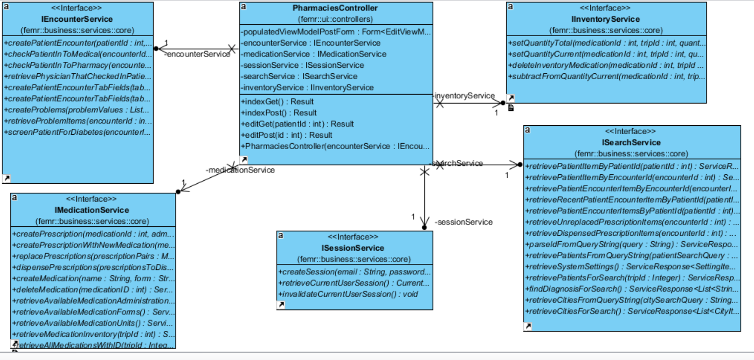

# Conclusions

We started the application and navigated to the screen on browser. We have identified the concept location easily because it is an easy guess that the concept location is local to that page and the search through the application for the text ‘disclaimer’ confirmed it. We did Impact Analysis and Actualization quickly and verified using manual test cases.

File changed:

js/pharmacy/pharmacyClientValidation.js