**REGISTRATION FORM**

**Exp No: 2**

**Date: 19.2.25**

**AIM:**

To write a JavaScript to validate the following fields of a registration page

1. First Name ( Name should contain alphabets and the length should not be less than 6 characters
2. Password (Password should not be less than 6 characters length)
3. Email id ( should not contain any invlaid and must follow the standard pattern [name@domain.com](mailto:name@domain.com))
4. Mobile Number(phone number should contain 10 digits only )
5. Last Name and Address ( should not be Empty)

PROGRAM:

<html>

<head>

<title>Registration Form</title>

<script>

function validateForm() {

let name = document.forms["regForm"]["name"].value;

let password = document.forms["regForm"]["password"].value; let email = document.forms["regForm"]["email"].value;

let mobile = document.forms["regForm"]["mobile"].value;

if (!/^[A-Za-z]+$/.test(name)) { alert("Name must be alphabetic only"); return false;

}

if (password.length < 6) {

alert("Password must be at least 6 characters"); return false;

}

if (!email.includes("@")) { alert("Invalid email format"); return false;

}

if (!/^\d{10}$/.test(mobile)) { alert("Mobile number must be 10 digits"); return false;

}

alert("Form successfully submitted!");

return true; // allows form to submit (to same page or backend if added)

}

</script>

</head>

<body>

<center>

<h2>Registration Form</h2>

<form name="regForm" onsubmit="return validateForm()" action="#">

<label for="name">Name:</label><br>

<input type="text" name="name" id="name" required><br><br>

<label for="password">Password:</label><br>

<input type="password" name="password" id="password" required><br><br>

<label for="email">Email:</label><br>

<input type="text" name="email" id="email" required><br><br>

<label for="mobile">Mobile:</label><br>

<input type="text" name="mobile" id="mobile" required><br><br>

<input type="submit" value="Register">

</form>

</center>

</body>

</html>

**OUTPUT:**

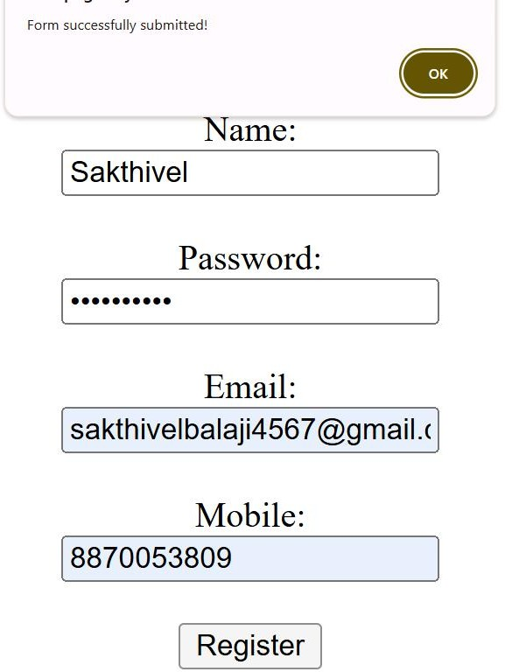

**RESULT :**

Thus the experiment to create a web page that embeds a map with hotspots, frames, and links using embedded, external, and inline CSS has been successfully implemented and verified .