**Multistep-Form:**

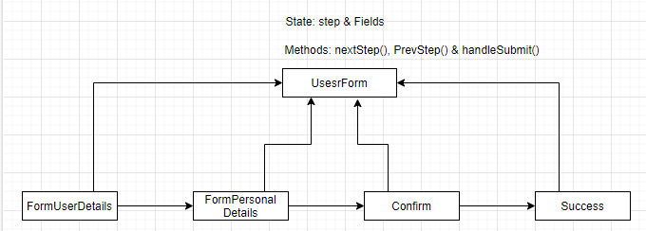

* All the blocks are react components, **UserForm** is like the parent component
* **UserForm** holds the **state** which has the (**step**: this is a number) and also the fields(name, contact etc.)
* **Methods: nextStep()-** incerments one step**, PrevStep()-** decrements one step, **handleChange()-** makes change to field in the state upon new data.

**#UserForm.js**