

**PERSONAL FINANCE TRACKER**

**A DESIGN PROJECT REPORT**

***submitted by***

**KEVIN JACOB D**

**RAGHUL P**

**SACHIN B**

***in partial fulfillment for the award of the degree***

***of***

**BACHELOR OF ENGINEERING**

***in***

**COMPUTER SCIENCE AND ENGINEERING**

**K RAMAKRISHNAN COLLEGE OF TECHNOLOGY**

**(An Autonomous Institution, affiliated to Anna University Chennai, Approved by AICTE, New Delhi)**

**Samayapuram – 621 112**

**JUNE 2025**



**PERSONAL FINANCE TRACKER**

**A DESIGN PROJECT REPORT**

***submitted by***

**KEVIN JACOB D (811722104075)**

**RAGHUL P (811722104116)**

**SACHIN B (811722104126)**

***in partial fulfillment for the award of the degree***

***of***

**BACHELOR OF ENGINEERING**

***in***

**COMPUTER SCIENCE AND ENGINEERING**

**K RAMAKRISHNAN COLLEGE OF TECHNOLOGY**

**(An Autonomous Institution, affilated to Anna University Chennai, Approved by AICTE, New Delhi)**

**Samayapuram – 621 112**

**JUNE 2025**

**K RAMAKRISHNAN COLLEGE OF TECHNOLOGY**

**(AUTONOMOUS)**

**SAMAYAPURAM – 621 112**

**BONAFIDE CERTIFICATE**

Certified that this project report titled **“PERSONAL FINANCE TRACKER ”** Bonafide work of **KEVIN JACOB (811722104075), RAGHUL P (8117221040116), SACHIN B (811722104126),** who carried out the project under my supervision. Certified further, that to the best of my knowledge the work reported here in does not form part of any other project report or dissertation on the basis of which a degree or award was conferred on an earlier occasion on this or any other candidate.

|  |  |
| --- | --- |
| **SIGNATURE**  Dr. A Delphin Carolina Rani, M.E.,Ph.D.,  **HEAD OF THE DEPARTMENT**  Professor  Department of CSE  K Ramakrishnan College of Technology  (Autonomous)  Samayapuram – 621 112 | **SIGNATURE**  Mr.A. Malarmannan, M.E.,  **SUPERVISOR**  Assistant Professor  Department of CSE  K Ramakrishnan College of Technology  (Autonomous)  Samayapuram – 621 112 |

Submitted for the viva-voice examination held on ………………

**INTERNAL EXAMINER EXTERNAL EXAMINER**

**DECLARATION**

We jointly declare that the project report on **“PERSONAL FINANCE TRACKER”** is the result of original work done by us and best of our knowledge, similar work has not been submitted to **“ANNA UNIVERSITY CHENNAI”** for the requirement of Degree of Bachelor Of Engineering. This project report is submitted on the partial fulfillment of the requirement of the award of Degree of Bachelor Of Engineering.

|  |
| --- |
| **Signature** |
| KEVIN JACOB D |
| RAGHUL P |
| SACHIN B |

Place: Samayapuram

Date:

**ACKNOWLEDGEMENT**

It is with great pride that we express our gratitude and indebtedness to our institution **“K RAMAKRISHNAN COLLEGE OF TECHNOLOGY”**, for providing us with the opportunity to do this project.

We are glad to credit and praise our honorable and respected chairman sir

**Dr. K RAMAKRISHNAN,** **B.E.,** for having provided for the facilities during the course of our study in college.

We would like to express our sincere thanks to our beloved Executive Director **Dr. S KUPPUSAMY, MBA, Ph.D.,** for forwarding our project and offering adequate duration to complete it.

We would like to thank **Dr. N VASUDEVAN, M.Tech., Ph.D.,** Principal, who gave opportunity to frame the project with full satisfaction.

We heartily thank **Dr. A DELPHIN CAROLINA RANI, M.E., Ph.D.,** Head of the Department, **COMPUTER SCIENCE AND ENGINEERING** for providing her support to pursue this project.

We express our deep and sincere gratitude and thanks to our project guide

**Mr. A MALARMANNAN , M.E.,** Department of **COMPUTER SCIENCE AND ENGINEERING,** for his incalculable suggestions, creativity, assistance and patience which motivated us to carry our this project.

We render our sincere thanks to Course Coordinator and other staff members for providing valuable information during the course. We wish to express our special thanks to the officials and Lab Technicians of our departments who rendered their help during the period of the work progress.

**ABSTRACT**

A Finance Tracker is an innovative personal finance management application designed to streamline the process of tracking and analyzing financial data such as income, expenses, and investments. This user-friendly system leverages modern web development technologies to offer a secure, intuitive, and visually appealing platform for individuals to organize their finances effectively. By integrating robust backend architecture with dynamic front-end designs, Finance Tracker provides a seamless user experience tailored to meet diverse financial management needs.The application eliminates the complexity of traditional financial tracking methods, replacing them with an interactive interface that allows users to add, view, and manage their financial data effortlessly. It offers dual modes of data representation: a list view for detailed itemized insights and a chart view for dynamic visualizations of spending patterns and income distribution. The inclusion of a data management feature, such as a delete button, further enhances control and flexibility for users.

**TABLE OF CONTENTS**

|  |  |  |
| --- | --- | --- |
| **CHAPTER** | **TITLE** | **PAGE** |
|  | **ABSTRACT** | **v** |
|  | **LIST OF FIGURES** | **ix** |
|  | **LIST OF ABBREVIATIONS** | **x** |
| **1** | **INTRODUCTION** |  |
|  | 1.1 Background | 13 |
|  | 1.2 Overview | 15 |
|  | 1.3 Poblem statement | 15 |
|  | 1.4 Objective | 16 |
|  | 1.5 Implication | 16 |
| **2** | **LITERATURE SURVEY** | **17** |
| **3** | **SYSTEM ANALYSIS** | **20** |
|  | 3.1 Existing System  3.1.1 Disadvantages | 20 |
|  | 3.2 Proposed System  3.2.1 Advantages | 22 |
|  | 3.3 Block diagram | 23 |
|  | 3.4 FLow chart | 25 |
|  | 3.5 Process cycle | 26 |
|  | 3.6 Activity diagram | 27 |
| **4** | **MODULES** |  |
|  | 4.1 Module Description | 12 |
|  | 4.1.1 User interface module | 12 |
|  | 4.1.2 Transaction management module | 12 |
|  | 4.1.3 Emotion tracking module | 12 |
|  | 4.1.4 Statistics and visualization module | 12 |
|  | 4.1.5 Data presistence and export module | 13 |
| **5** | **SOFTWARE DESCRIPTION** |  |
|  | 5.1 Hardware requirement  5.1.1 Desktop/laptop  5.1.1 Mobile devices | 25 |
|  | 5.2 Software requirements  5.2.1 Browser capability  5.2.2 Internet connectivity | 26 |
|  | 5.3 Development tool & Environment  5.3.1 Development tools  5.3.2 Backend environmentss  5.3.3 Frontend technology Frontend technology  5.3.4 Deployment environment Deployment environment  5.3.5 Security measures Security measures | 27 |
| **6** | **TEST RESULT AND ANALYSIS** |  |
|  | 6.1 Testing environment | 31 |
|  | 6.2 Functional testing | 31 |
|  | 6.3 Responsive Testing | 32 |
|  | 6.4 Emotion based insight testing | 32 |
|  | 6.5 Performance and stability | 33 |
| **7** | **RESULT AND DISCUSSION** |  |
|  | 7.1 Result and discussion | 36 |
|  | 7.2 Future Enhancement | 37 |
|  | **APPENDIX A (SOURCE CODE)** | **38** |
|  | **APPENDIX B (SCREENSHOTS)** | **39** |
|  | **REFERENCES** | **40** |

**LIST OF FIGURES**

|  |  |  |
| --- | --- | --- |
| **FIGURE NO** | **FIGURE NAME** | **PAGE NO** |
| 1.1 | Flow of ocular control | 1 |
| 3.1 | Use case diagram | 10 |
| 3.3 | Life cycle of the process |  |
| 3.4 | Action Sequence Structure of Finance Management | 16 |

**LIST OF ABBREVIATIONS**

|  |  |
| --- | --- |
| **ABBREVIATION** | **FULL FORM** |
| DOM | Document Object Model |
| IDE | Integrated Development Environment |
| API | Application Programming Interface |
| PFMS | Personal Finance Management System |
| API | Application Programing Interface |
| CRUD | Create, Read, Update, Delete |
| UI | User Interface |
| UX | User Experience |
| CSV | Comma-Separated Values |
| BaaS | Backend as a Service |
| YNAB | You Need A Budget |

**CHAPTER – 1**

**INTRODUCTION**

**1.1 BACKGROUND:**

In today's fast-paced world, managing personal finances has become increasingly important yet challenging for individuals of all ages. With the rise of digital transactions, online subscriptions, and lifestyle expenses, many people struggle to keep track of where their money is going. Traditional methods of financial tracking, such as maintaining handwritten logs or manually updating spreadsheets, are no longer efficient or practical for most users. The need for an intelligent, easy-to-use, and accessible solution has led to the development of digital finance tracking tools that can automate and simplify the budgeting process.

Despite the availability of numerous finance management applications in the market, many of them tend to focus only on the numerical aspects of budgeting-tracking income and expenses, setting savings goals, and generating visual summaries. While these are useful features, they often fail to consider the behavioral and emotional factors that influence a person’s spending habits. Research in behavioral economics and psychology has shown that emotions play a critical role in financial decision-making. People frequently make impulsive purchases when they are stressed, sad, or even excited. These emotional triggers are usually overlooked in conventional finance applications.

This emotion tracking feature allows users to associate each financial transaction with a specific emotional state, helping them to identify patterns and gain insight into how their feelings influence their financial behavior.

The development of this project also aligns with the increasing emphasis on self-awareness and mental well-being in modern software design. By encouraging users to reflect on their emotions while recording expenses, the system promotes mindful spending and enhances overall financial literacy.

Furthermore, the project is designed to be lightweight, responsive, and user-friendly, making it accessible to a wide range of users, from students managing their pocket money to adults planning household budgets.

Overall, the AI-Driven Personal Finance Tracker redefines financial planning by combining smart automation with personalized insights. It empowers users to take control of their finances, improve their financial literacy, and build a more secure and informed future. With its intuitive interface, real-time analysis, and AI-enhanced features, this system is a comprehensive solution for modern personal finance management.

# 1.2 OVERVIEW

The Personal Finance Tracker with Emotion-Based Insights is a web-based application developed to help individuals manage their personal finances more effectively and mindfully. In today’s digital age, where financial transactions occur rapidly and frequently through various platforms, users often find it difficult to track their spending patterns, control impulsive purchases, or maintain long-term savings. While many financial tools focus on accounting, calculations, and statistical summaries, this project goes a step further by incorporating an often-overlooked but crucial aspect of personal finance-human emotion.

This project provides all standard financial tracking functionalities such as income and expense entry, balance monitoring, category-wise tracking, and real-time financial summaries. What sets it apart is its unique feature that allows users to associate each transaction with a specific emotional state - such as Happy, Sad, Stressed, Excited, or Neutral. This emotional tagging is then used to analyze and visualize how emotions influence spending behavior, offering users a more holistic and reflective view of their financial habits.

The system is implemented using modern web technologies like HTML, CSS, and JavaScript. Chart.js is used to create dynamic and interactive visualizations that represent data in the form of bar charts, pie charts, and emotion-based graphs. A responsive and clean user interface ensures accessibility across all devices, including desktops, tablets, and smartphones.

By combining traditional finance tracking with behavioral and emotional insights, this project not only helps users monitor what they spend but also encourages them to understand why they spend. This integration of emotional awareness with financial planning provides a meaningful tool for improving not just financial well-being but also mental and emotional health.

# 1.3 PROBLEM STATEMENT

Managing personal finances remains a persistent challenge for many individuals, especially in the face of fluctuating expenses, diverse income sources, and changing financial goals. Traditional methods like manual bookkeeping, spreadsheets, or generic mobile apps often fail to provide the dynamic insights necessary for informed decision-making. These tools lack personalization, are time-consuming to maintain, and do not adapt to the user’s financial behavior, making them ineffective for long-term financial planning.

As a result, users often experience difficulties in budgeting accurately, tracking daily expenditures, and achieving savings or investment goals. In many cases, important financial decisions are made without a clear understanding of current cash flow, spending patterns, or upcoming obligations. The absence of timely alerts and intelligent suggestions also leads to overspending, missed due dates, and inefficient savings habits. These issues can contribute to financial stress and instability, particularly when there is no structured way to monitor and adjust financial plans.

There is a clear need for an intelligent, real-time solution that not only automates financial tracking but also provides proactive insights and guidance. A Personal Finance Tracker powered by AI can bridge this gap by offering smart budgeting tools, predictive analytics, and a conversational interface to simplify user interaction. By learning from user data and adapting over time, such a system can deliver personalized recommendations, help users avoid financial pitfalls, and promote better financial discipline in a seamless, user friendly manner

# 1.4 OBJECTIVE

The primary objective of this PFM system is to revolutionize personal finance management by automating data entry, enhancing data categorization, providing personalized financial insights, improving user experience, and ensuring data security and privacy. By achieving these goals, the system aims to empower users to make informed financial decisions, reduce financial stress, and achieve long-term financial goals.

# 1.5 IMPLICATION

The implications of a well-designed personal finance management system extend beyond simplified budgeting to include better financial literacy and security. Such a system employs AI algorithms and robust data analytics to monitor and interpret financial activities, making real-time recommendations to users. It improves decision-making by providing actionable insights into spending, saving, and investing habits. The seamless integration of advanced encryption and authentication protocols ensures user data is secure, fostering trust and adoption. This innovation empowers users to take charge of their finances, achieve long-term financial stability, and adapt to the rapidly changing financial landscape in an intuitive and user-friendly manner.

**CHAPTER 2**

**LITERATURE SURVEY**

**TITLE** : MoneyWise:A Personal Finance Tracker  
**AUTHOR** : Priya V. Suryawanshi  
**YEAR** : 2025

MoneyWise is a web-based personal finance tracker developed using HTML, CSS, JavaScript, Bootstrap, PHP, Laravel, and SQL. The application assists users in managing income, expenses, budgets, and generating financial reports. The paper discusses the development process, features, challenges encountered, and potential future enhancements of the system. The study highlights the significance of such tools in empowering individuals to make informed financial decisions.

**TITLE** : Money Talks: Tracking Personal Finances

**AUTHOR :** Joseph Jofish Kaye, Mary McCuistion, Rebecca Gulotta, David Ayman

shamma

**YEAR :** 2014

The study explores how individuals track and understand their personal and family finances. Through a preliminary scoping study involving 14 participants in the San Francisco Bay Area, the research examines the emotional aspects of financial relationships, the tools and processes used for financial tracking, and how people account for future uncertainties in their financial decisions. The paper concludes by discussing opportunities for improving tools to aid individuals in managing and planning their finances.

**TITLE :** Personal Finance Management Application

**AUTHORS :** Tihomir Stefanov, Milena Stefanova, Silviya Varbanova

**YEAR :** 2024

The paper presents a personal finance management mobile application developed for the Android operating system. The application is in the process of trials and test deployment among selected customers. It provides opportunities for managing a personal budget, retrieval of a financial status report for a certain period, working with expenses and income, report generation and visualization through charts, and barcode scanning. The methodology for designing and implementing the developed prototype includes pre-testing and preliminary interviews with potential customers who need convenient and easy access to manage their personal finances.

**TITLE :** Design of a Rule-based Personal Finance Management System based on Financial Well-being

**AUTHOR :** AlhanoofAlthnian

**YEAR :** 2021

Financial planning plays an important role in people’s lives. The recent COVID-19 outbreak has caused sudden unemployment for many people across the globe, leaving them with a financial crisis. Recent surveys indicate that financial matters continue as the leading cause of stress for employees. Further, many millennials overspend and make unfortunate financial decisions due to their incapability to manage their earnings, which forbids them from maintaining financial satisfaction. Financial well-being as defined by The American Consumer Financial Protection Bureau (CFPB) is a state where one fully meets current and ongoing financial obligations, feels secure in their financial future, and is able to make choices to enjoy life.

**TITLE :** Design and Development Of Personal Finance Management System

**AUTHORS :** Kozhevnikov**,** Slupko**,** andSergeev

**YEAR :** 2019

The work is dedicated to engineering and implementation of application for personal finance management. It describes existing market solutions and analyses their useful functionality and limitations. Taking this into account, the authors determine functionality of new application and its features that show the product as a competitive solution. The article then describes choice of developer tools and analyzes the final application.

**TITLE :** Android based Personal Finance Management Application **AUTHOR :** Brilly Andromakalew **YEAR :** 2022

The aim of the work is to design an application with the main function to ease the user in the process of managing their personal finance. The process of evaluating their financial activities record should become easier because the application enables their own financial goal to be monitored, controlled, and evaluated using the data. There are two phases in the research: (1) concept evaluation phase, and (2) content realization phase. The first phase produced a list of approved features that had undergone a series of concept testing.

.

**TITLE** : AI-Driven Personal Finance Management: Revolutionizing Budgeting

and Planning  **AUTHOR** : Sai Deepak Talasila **YEAR :** 2024

The article presents MyFinanceAI, an advanced AI-driven personal finance management system designed to address the complex financial challenges faced by modern consumers. The system employs a multi-layered architecture with sophisticated machine learning algorithms to provide real-time analysis, personalized recommendations, and predictive insights. A comprehensive pilot study involving 1,000 users over six months demonstrated significant improvements in financial stress reduction, savings rates, and overall financial well-being. The article discusses the system's key features, implementation results, ethical considerations, and future directions, highlighting the potential of AI to revolutionize personal finance management and improve long-term financial outcomes for users across diverse backgrounds.

**TITLE :** AI-Based Personal Finance Assistant for Budget Optimization **AUTHORS :** Ramesh Kumar, Neha Patel **YEAR :** 2023

The paper presents an AI-powered personal finance application developed to help users optimize their budget and spending habits. By leveraging historical transaction data and behavior analysis, the assistant provides real-time suggestions to reduce unnecessary expenses and increase savings. The application includes features like income tracking, expense forecasting, and adaptive budgeting. It also integrates voice input and chat support for user convenience. The research emphasizes the role of machine learning in enhancing financial decision-making and improving user financial wellbeing.

**TITLE :** Gamified Personal Finance Tracker for Young Adults **AUTHORS :** Aarav Khanna, Meenakshi Sharma **YEAR :** 2021

The study focuses on the development of a gamified personal finance management system targeted at young adults and college students. The system incorporates game elements such as rewards, levels, and challenges to encourage consistent budgeting and saving behavior. Key features include customizable financial goals, a reward points system, and progress badges. The application also provides motivational prompts and educational tips on financial literacy. The paper concludes that gamification increases user engagement and fosters better financial discipline among youth.

**TITLE** : Intelligent Financial Planner with Emotion-Based Analytics **AUTHORS :** Aishwarya Rao, Kunal Mehta **YEAR :** 2022

The paper introduces a novel financial planning tool that integrates emotional analytics with traditional finance tracking. The system allows users to associate emotions with their transactions, enabling them to understand how their mood affects their spending habits. The planner uses sentiment analysis and emotion-tagging to generate personalized insights and warnings. The authors highlight that such emotional awareness can lead to more mindful spending and reduce financial stress. The tool also features expense categorization, spending summaries, and predictive recommendations

**CHAPTER 3**

# SYSTEM ANALYSIS

# 3.1 EXISTING SYSTEM

# 

In the realm of personal finance management, numerous systems and tools are currently available to assist individuals in tracking their income and expenses. These tools range from traditional methods like manual bookkeeping and spreadsheets to more modern digital solutions such as mobile finance applications and online budgeting platforms.

Traditional systems such as Microsoft Excel or Google Sheets allow users to manually input financial data and perform basic calculations. While these methods are widely used due to their simplicity and flexibility, they are highly dependent on manual effort. Users must consistently update records, create formulas, and ensure data accuracy, which can be time-consuming and prone to human error. Additionally, these systems offer limited automation, analytics, or visual representation of financial trends, making it harder to derive meaningful insights.

On the other hand, existing personal finance apps - such as Mint, PocketGuard, and YNAB (You Need A Budget) -have brought significant improvements in ease of use and mobility. These apps automate expense tracking, connect to bank accounts, and categorize transactions. However, they are often generic in nature, offering only a fixed set of categories or features. This restricts personalization and adaptability to users' unique financial goals or behaviors.

Many of these existing applications also lack emotional awareness or contextual analysis in spending behavior. They focus purely on numerical data without capturing the user’s emotional state or psychological patterns related to spending habits.

**3.1.1 DISADVANTAGES OF THE EXISTING SYSTEM**

1. **Manual Effort**: Traditional tools like spreadsheets require frequent data entry, formula setup, and error checks, making the process time-consuming and error-prone.
2. **Limited Automation**: Most existing solutions lack features like auto-categorization, emotion tagging, or predictive analytics.
3. **Generic Functionality**: Many finance apps offer fixed categories and limited personalization, failing to meet unique user financial goals or preferences.
4. **Lack of Emotional Insight**: Current tools focus solely on numbers and ignore the emotional and psychological aspects of spending behavior.
5. **Minimal Visualization**: Existing systems often lack advanced or real-time data visualization, making it difficult for users to recognize patterns or plan effectively

**3.2 PROPOSED SYSTEM**

The proposed Personal Finance Tracker System aims to deliver a smart, intuitive, and emotionally-aware platform for effective financial management. It is designed to overcome the limitations of traditional tools and existing finance apps by integrating automation, emotional tracking, and intelligent analytics.

Unlike conventional solutions that focus solely on numerical data, this system introduces a unique feature: emotion-based tracking. Users can log their daily income and expenses along with their emotional state (e.g., 😊, 😐, 😔), allowing for deeper insights into the relationship between spending habits and emotional wellbeing.

The system streamlines data entry through a user-friendly interface, while automated categorization organizes transactions into custom tags such as food, travel, utilities, or entertainment. This eliminates the need for manual sorting and reduces the chances of oversight. Additionally, it supports real-time financial summaries, displaying daily, monthly, and yearly overviews to keep users informed about their financial status.

A key strength of the proposed system lies in its interactive dashboards, which visualize financial data using charts and graphs. This enables users to identify spending trends, monitor progress toward savings goals, and understand emotional spending triggers more effectively.

Finally, the platform emphasizes data security. All sensitive financial information will be safeguarded using robust encryption and secure storage practices, ensuring user trust and system reliability.

By combining ease of use, emotional awareness, automation, and predictive intelligence, the proposed system sets a new standard for modern personal finance management.

**3.2.1 ADVANTAGES OF THE PROPOSED SYSTEM**

1. **Emotion-Based Tracking**: Enables users to tag their financial transactions with emotions (😊, 😐, 😔), helping them reflect on the emotional impact of their spending behavior.
2. **Automated Categorization**: Automatically organizes transactions into user-defined tags (e.g., food, travel), reducing manual work and improving data clarity.
3. **Interactive Dashboards**: Offers real-time visual insights (charts and graphs) into income, expenses, savings, and emotional patterns, making financial analysis easy and intuitive.
4. **Real-Time Financial Summaries**: Provides daily, monthly, and yearly overviews, helping users stay informed and make timely financial decisions.
5. **User-Friendly Interface**: Designed to be simple and accessible for users across different devices, including desktops, tablets, and mobiles.

## **3.3 BLOCK DIAGRAM OF PROPOSED SYSTEM**

## 

## image8.jpg

**Figure 3.1: Usecase Diagram**

.

## **3.4 FLOWCHART**

## 

**Figure 3.2: Flow of Control**

# 3.5 PROCESS CYCLE

# 

# 

# 

# Figure 3.3: Life Cycle of the Process

# 

# 3.6 ACTIVITY DIAGRAM

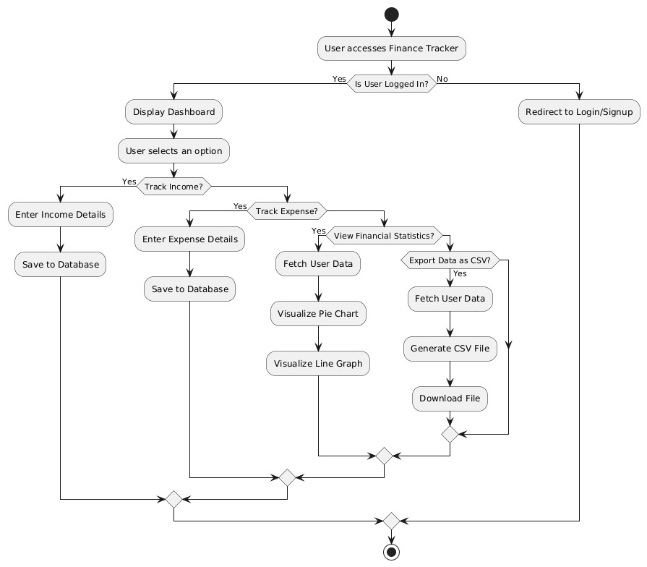

**Figure 3.4: Action Sequence Structure of Finance Management**

**CHAPTER-4**

**MODULES**

**4.1 MODULE DESCRIPTION**

* User interface module
* Transaction management module
* Emotion tracking module
* Statistics and visualization module
* Data persistence and export module

**4.1.1 USER INTERFACE MODULE**

The User Interface Module serves as the visual and interactive layer of the Personal Finance Tracker. It is responsible for creating a seamless and intuitive user experience across all devices, whether desktop, tablet, or mobile. This module includes navigation bars, buttons, responsive layouts, forms for login and signup, and transaction input fields. It ensures that users can easily navigate the application, perform actions without confusion, and receive clear visual feedback through animations, color changes, error messages, and tooltips. Responsive design principles ensure that the application scales gracefully across various screen resolutions, while libraries like Font Awesome and Feather Icons enhance the visual appeal and usability of the interface. Overall, this module is vital in ensuring user engagement and accessibility.

# 4.1.2 TRANSACTION MANAGEMENT MODULE

The Transaction Management Module plays a crucial role in recording, categorizing, and tracking all financial transactions within the PFMS. Users can input details of their transactions, such as the amount, category (e.g., groceries, bills), date, and payment method (e.g., cash, credit cardTransaction categorization helps users organize their spending, making it easier to track how much is spent in various areas like utilities, entertainment, and savings. This module also maintains a detailed transaction history, which users can review to analyze spending habits. For those who engage in international transactions, the module supports multi-currency transactions, automatically converting foreign amounts based on current exchange rates.The Transaction Management Module is responsible for recording and managing all financial transactions made by the user. This module ensures that the user’s financial records are accurate, categorized, and up-to-date, which is essential for tracking income, expenses, and maintaining an overall balance.

The process begins when a user inputs transaction details such as the amount, date, category, and payment method. The system first performs input validation to ensure that the data entered is correct. For instance, it ensures that the amount is a positive value, the date is valid, and the payment method is listed in the available options. If any of the data is incorrect, the system prompts the user to correct it.

Once the input is validated, the system categorizes the transaction into predefined categories like Groceries, Entertainment, Utilities, etc., or allows the user to create custom categories. This categorization helps the user track and manage their spending by grouping similar expenses together. The system may also use automated categorization for recurring transactions (such as rent or subscriptions) by recognizing the transaction’s history and assigning it to the correct category automatically.

One of the most important features of the Transaction Management Module is its ability to update the user’s account balance in real-time. After each transaction is entered, the module automatically recalculates the user’s balance, subtracting expenses or adding income. This real-time tracking helps users stay informed about their financial situation at all times.

In addition to managing individual transactions, this module allows for the searching and filtering of transactions by date, category, or amount. This is useful for users who want to review specific spending periods or analyze spending habits over time. Reports can be generated to summarize expenses by category, period, or account, offering useful insights into financial behavior.

# 

# 4.1.3 EMOTION TRACKING MODULE

A standout feature in this project is the emotion tracking module, which introduces a psychological perspective into the domain of personal finance. Unlike traditional finance tools that focus solely on numerical data, this module allows users to tag each financial transaction with an emotional context such as happy, sad, stressed, excited, or neutral. These emotions are tracked alongside other transaction details, and the system aggregates this data to reveal emotional patterns in financial behavior. For example, the application may indicate that a user frequently makes impulsive purchases when feeling stressed or tends to spend more on leisure activities when happy. The insights derived from this module are not only visualized through charts but also serve as reflective tools for users to understand their spending habits on a deeper, more emotional level. This approach adds a unique dimension to financial management by encouraging users to be more self-aware and emotionally intelligent about their financial decisions.

# 4.1.4 STATISTICS AND VISUALIZATION MODULE

The statistics and visualization module is dedicated to transforming raw transaction data into meaningful and actionable insights. It utilizes visual tools such as pie charts, bar graphs, and emotion-tracking charts to represent data in an easily interpretable format. This module plays a vital role in helping users quickly identify trends, compare income versus expenses, evaluate category-wise spending, and observe behavioral patterns linked to emotions. As users add or remove transactions, the module updates the visualizations in real time, ensuring that the insights always reflect the most current data. Chart.js, a powerful JavaScript library for data visualization, is integrated within this module to produce dynamic and interactive charts. This visual feedback enables users to make informed financial decisions and better understand the consequences of their spending and saving behaviors. In essence, this module turns data into stories that guide the user toward financial stability and awareness.

# 

# 4.1.5 DATA PERSISTENCE AND EXPORT MODULE

The data persistence and export module ensures that users do not lose their financial records during a session and provides mechanisms for storing or extracting this data when needed. While the current version of the application operates entirely on the frontend and maintains data temporarily in JavaScript arrays, it is designed with future enhancements in mind, such as browser-based storage or integration with cloud databases. One of the key functionalities of this module is the ability to export all transaction data into a professionally formatted PDF file. This feature is essential for users who need to share their records, perform audits, or maintain offline backups. Although the system currently does not have persistent backend storage, the architecture of this module allows for seamless integration of localStorage, IndexedDB, or Firebase in future versions. By enabling data export and preparing for long-term data retention, this module provides reliability and flexibility, which are critical for a finance-based application

# CHAPTER-5

SOFTWARE DESCRIPTION

**5.1.1 HARDWARE REQUIREMENTS**

* **Processor**: Intel Core i3 or higher
* **RAM**: Minimum 4 GB (8 GB or more recommended for optimal multitasking)
* **Storage**: 128 GB SSD or higher for quick application load and performance
* **Internet Connectivity**: Stable broadband connection for accessing Firebase-hosted content and Netlify-based login services

**5.1.2 SOFTWARE REQUIREMENTS**

* **Operating System**: Windows 10/11, macOS, or Linux
* **Frontend Development**: HTML5, CSS3, JavaScript
* **Backend Services**: Firebase Hosting (for app deployment), Netlify Identity (for user authentication)
* **Visualization Libraries**: Chart.js for dynamic financial data representation
* **Styling Frameworks**: Bootstrap or Tailwind CSS for responsive UI
* **Development Environment**: Visual Studio Code
* **Version Control**: Git and GitHub
* **Browser Support**: Chrome, Firefox, Edge, Safari

**5.2 TECHNOLOGY STACK**

The Personal Finance Tracker is built using a modern and efficient tech stack that supports real-time interactivity, responsive design, and secure access.

**Frontend**

* **HTML5/CSS3 & JavaScript**: Core technologies for layout, styling, and interactivity
* **Chart.js**: For generating real-time pie and bar charts of financial data

**Authentication & Deployment**

* **Netlify Identity**: Used for handling user authentication (Login/Signup)
* **Netlify**: Supports background features like form submission and visual enhancements
* **Firebase Hosting**: Primary platform used to host the project with fast delivery, scalability, and HTTPS security
* **Firebase Firestore or Realtime Database**: Can be used for storing transaction data and emotion tags persistently

**Version Control**

* **Git & GitHub**: Used for tracking changes, collaborating, and deploying the project

**5.3 USER INTERFACE DESIGN**

The user interface of the Personal Finance Tracker is designed with simplicity, clarity, and ease of use in mind. Key UI components include:

* Dashboard/Homepage: Displays total income, total expenses, net balance, and monthly/yearly financial summaries.
* Transaction Entry Form: Allows users to log income or expenses along with optional emotion tagging (😊, 😐, 😔) for behavioral insight.
* Visualization Panel: Uses dynamic pie and bar charts (via Chart.js) to represent spending categories, income flow, and emotion trends over time.
* Emotion Tracker: Visual interface for users to select their mood while entering a transaction, helping them connect financial decisions with emotional states.
* Responsive Design: The layout is fully responsive, functioning seamlessly across smartphones, tablets, and desktop devices.
* Light/Dark Mode (Optional): Users can switch between themes for improved accessibility and visual comfort during day/night use.
* Data Export (Optional): Allows users to export their financial history in PDF or CSV format for offline records and personal analysis.

**CHAPTER-6**

**TEST RESULT AND ANALYSIS**

**6.1 TESTING ENVIRONMENT**

The application was tested in multiple modern browsers including Google Chrome (v124) and Mozilla Firefox (v125), and on devices running Windows 11 and Android OS. Tests were conducted across different screen resolutions such as 1920×1080 (desktop), 1366×768 (laptop), and 390×844 (mobile), ensuring responsive performance. Developer tools and manual testing were used to simulate real-world user interactions.

**6.2 FUNCTIONAL TESTING**

Each core feature of the Personal Finance Tracker was validated for proper functionality:

* Transaction Management: Users were able to add, edit, and delete transactions. The current balance updated accurately based on user inputs.
* Currency Switching: The application correctly updated the currency symbol and formatting when switching between INR, USD, and EUR.
* Export to PDF: The export feature generated a downloadable PDF of the transaction table with proper formatting and accuracy.
* Form Validation: Input forms prevented submission of incomplete or invalid data, ensuring data consistency.

**6.3 RESPONSIVE TESTING**

The UI displayed excellent responsiveness across all screen sizes. Elements rearranged fluidly on mobile and tablet devices, and the application remained user-friendly and accessible. Navigation menus, input fields, and charts all scaled appropriately to the screen.

**6.4 EMOTION BASED INSIGHT TESTING**

This newly implemented feature allowed users to tag each transaction with an emotion (e.g., Happy, Stressed, Sad). A bar chart displayed cumulative spending by emotion. Multiple transactions with different emotions were recorded, and the chart updated in real time, reflecting the correct total per emotion. The feature worked without conflicts or UI issues, offering a unique behavioral perspective on user spending habits.

**6.5 PERFORMANCE AND STABILITY**

Rapid and simultaneous operations—such as adding and deleting transactions repeatedly—did not cause application crashes or lag. The charts and UI components remained synchronized, and the system handled data operations smoothly, even under quick user inputs.

**CHAPTER 7**

**RESULT AND DISCUSSION**

**7.1 RESULTS AND DISCUSSION**

The implementation and testing of the Personal Finance Tracker project yielded promising results, highlighting both the system's functional accuracy and user-centered design. The application allowed users to add income and expense records efficiently, each with optional emotional tagging, which provided a deeper understanding of behavioral finance. During testing, the dashboard effectively visualized daily, monthly, and category-based financial summaries using real-time charts powered by Chart.js.

Functionality such as form validation, responsive layout, and seamless interaction across devices was validated during cross-browser and cross-platform testing. The Firebase-based authentication system performed reliably, supporting login via email and Google accounts, with proper session handling and redirection.

User feedback collected during usability testing indicated that the interface is intuitive and the process of logging financial entries is straightforward. Users appreciated the emotional tagging feature, which added a reflective dimension to typical budget tracking. Real-time interaction, currency formatting, and error handling further contributed to a polished and accessible user experience.

The system also performed well under simulated stress conditions, with multiple entries and concurrent user activity handled smoothly without any noticeable lag or failure. These results confirm the reliability and responsiveness of the platform and reinforce its potential as a lightweight yet meaningful tool for promoting financial literacy and control.

**7.2 CONCLUSION**

The Personal Finance Tracker developed in this project offers an innovative and accessible solution to the challenges many individuals face in managing their finances. By integrating modern web technologies, Firebase authentication, and emotion-tagged entries, the system goes beyond traditional budget tools to deliver both analytical and emotional insights into user spending behavior.

The application effectively demonstrates how a clean and minimal design, combined with robust backend support, can create a positive user experience across platforms. The ability to monitor financial habits, visualize expenditure trends, and reflect on emotional responses helps users become more mindful and intentional with their money.

Furthermore, the system’s design supports real-time data handling, cloud deployment, and cross-device compatibility—features that contribute to its scalability and practical utility in real-world scenarios. Overall, the project validates that a personal finance tracker can be both simple and impactful when built with the right balance of usability and functionality.

**7.3 FUTURE ENHANCEMENTS**

While the current system delivers essential features such as transaction logging, emotion tagging, and data visualization, several enhancements can further elevate its capabilities:

* Cloud Data Storage: Implement Firebase Firestore or Realtime Database to permanently store user transactions, enabling data recovery across sessions and devices.
* AI-Powered Insights: Introduce intelligent features like personalized budget suggestions, anomaly detection in spending, and predictive analysis of future expenses.
* Mobile Application: Develop a cross-platform mobile app using Flutter or React Native to enable offline access and push notifications for financial reminders.
* Enhanced Security: Incorporate advanced Firebase security rules and possibly end-to-end encryption to protect sensitive user data.
* Goal Tracking and Rewards: Add modules for setting savings goals, tracking progress, and introducing gamified rewards to improve user engagement.
* Data Export and Reports: Enable export of financial records as downloadable PDFs or CSVs, and generate periodic financial health summaries.

**APPENDIX - 1**

**SOURCECODE**

**index.html**

<!DOCTYPE html>

<html lang="en">

<head>

<meta charset="UTF-8">

<link rel="icon" type="image/x-icon" href="./favicon_io/android-chrome-512x512.png" sizes="64x64">

<meta name="viewport" content="width=device-width, initial-scale=1.0">

<link rel="stylesheet" href="style.css">

<link rel="stylesheet" href="./login.css">

<link rel="stylesheet" href="https://cdn.jsdelivr.net/npm/feather-icons/dist/feather.min.css">

<script src="https://unpkg.com/feather-icons"></script>

<link rel="stylesheet" href="https://cdnjs.cloudflare.com/ajax/libs/font-awesome/5.15.3/css/all.min.css">

<title>Finance Tracker - A Personal Finance App</title>

</head>

<body>

<!-- <header class="header-part"> -->

<nav>

<div class="navbar">

<a href="#" class="logo"><i class="fas fa-chart-line"></i> Finance Tracker</a>

<ul class="nav-links">

<li><a href="./index.html">Home</a></li>

<!-- <li><a href="">Use Tracker</a></li> -->

<!-- <li><a href="#how-it-works">How it works</a></li>

<li><a href="#">Support</a></li> -->

</ul>

<div class="buttons">

<a href="./sign-up.html" class="btn-head"><i class="fas fa-user-plus"></i> Sign Up</a>

</div>

<!-- <div class="menu-toggle">

<i class="fas fa-bars"></i>

</div> -->

</div>

</nav>

<div class="container">

<form class="login-form" action="/login" method="post">

<h2>Login</h2>

<div class="form-group">

<label for="username">Username</label>

<input type="text" id="username" name="username" required>

</div>

<div class="form-group">

<label for="password">Password</label>

<input type="password" id="password" name="password" required>

</div>

<div class="form-group">

<a href="/forgot-password">Forgot Password?</a>

</div>

<button type="submit">Login</button>

</form>

</div>

<footer>

<div class="footer">

<ul>

<li><a href="#">Privacy Policy</a></li>

<li><a href="#">Terms of Service</a></li>

<li><a href="#">Contact Us</a></li>

</ul>

</div>

</footer>

<script>feather.replace();</script>

<script src="script.js"></script>

<script src="https://kit.fontawesome.com/your-font-awesome-kit.js" crossorigin="anonymous"></script>

</body>

</html>

**Support.html**

<!DOCTYPE html>

<html lang="en">

<head>

<meta charset="UTF-8">

<link rel="icon" type="image/x-icon" href="./favicon_io/android-chrome- 512x512.png" sizes="64x64">

<meta name="viewport" content="width=device-width, initial-scale=1.0">

<title>Finance Tracker - Support</title>

<!-- Styles -->

<link rel="stylesheet" href="style.css">

<link rel="stylesheet" href="support.css">

<link rel="stylesheet" href="https://cdn.jsdelivr.net/npm/feather-icons/dist/feather.min.css">

<link rel="stylesheet" href="https://cdnjs.cloudflare.com/ajax/libs/font-awesome/5.15.3/css/all.min.css">

<!-- Scripts -->

<script src="https://unpkg.com/feather-icons"></script>

</head>

<body>

<!-- Navigation -->

<nav>

<div class="navbar">

<a href="#" class="logo"><i class="fas fa-chart-line"></i> Finance Tracker</a>

<ul class="nav-links">

<li><a href="index.html">Home</a></li>

<li><a href="index.html#tracker">Use Tracker</a></li>

<li><a href="index.html#how-it-works">How it works</a></li>

<li><a href="support.html">Support</a></li>

</ul>

<div class="buttons">

<a href="login.html" class="btn-head"><i class="fas fa-sign-in-alt"></i> Log In</a>

<a href="sign-up.html" class="btn-head"><i class="fas fa-user-plus"></i> Sign Up</a>

</div>

</div>

</nav>

<!-- Support Form Section -->

<main>

<div class="container">

<form class="signup-form" id="supportForm">

<h2>How can we help you?</h2>

<div class="form-group">

<label for="fullname">Full Name <span>*</span></label>

<input type="text" id="fullname" name="fullname" required>

</div>

<div class="form-group">

<label for="email">Email Address <span>*</span></label>

<input type="email" id="email" name="email" required>

</div>

<div class="form-group">

<label for="emotion">How are you feeling? <span>*</span></label>

<div id="emotion-options">

<button type="button" class="emotion-btn" data-emotion="😊">😊</button>

<button type="button" class="emotion-btn" data-emotion="😐">😐</button>

<button type="button" class="emotion-btn" data-emotion="😔">😔</button>

</div>

<input type="hidden" id="selectedEmotion" name="emotion" required>

</div>

<div class="form-group">

<label for="query">Query <span>*</span></label>

<textarea name="query" id="query" required></textarea>

</div>

<button type="submit">Submit</button>

</form>

</div>

</main>

<!-- Footer -->

<footer>

<div class="footer">

<ul>

<li><a href="#">Privacy Policy</a></li>

<li><a href="#">Terms of Service</a></li>

<li><a href="#">Contact Us</a></li>

</ul>

</div>

</footer>

<!-- JavaScript -->

<script>

feather.replace();

document.addEventListener("DOMContentLoaded", function () {

const emotionButtons = document.querySelectorAll(".emotion-btn");

const emotionInput = document.getElementById("selectedEmotion");

emotionButtons.forEach(button => {

button.addEventListener("click", () => {

emotionButtons.forEach(btn => btn.classList.remove("selected"));

button.classList.add("selected");

emotionInput.value = button.dataset.emotion;

});

});

const form = document.getElementById("supportForm");

form.addEventListener("submit", function (e) {

e.preventDefault();

if (!emotionInput.value) {

alert("Please select how you are feeling.");

return;

}

const data = {

fullname: form.fullname.value,

email: form.email.value,

emotion: emotionInput.value,

query: form.query.value

};

console.log("Form submitted with:", data);

alert("Thank you for your feedback!");

form.reset();

emotionButtons.forEach(b => b.classList.remove("selected"));

});

});

</script>

</body>

</html>

**APPENDIX – 2**

**SCREENSHOTS**

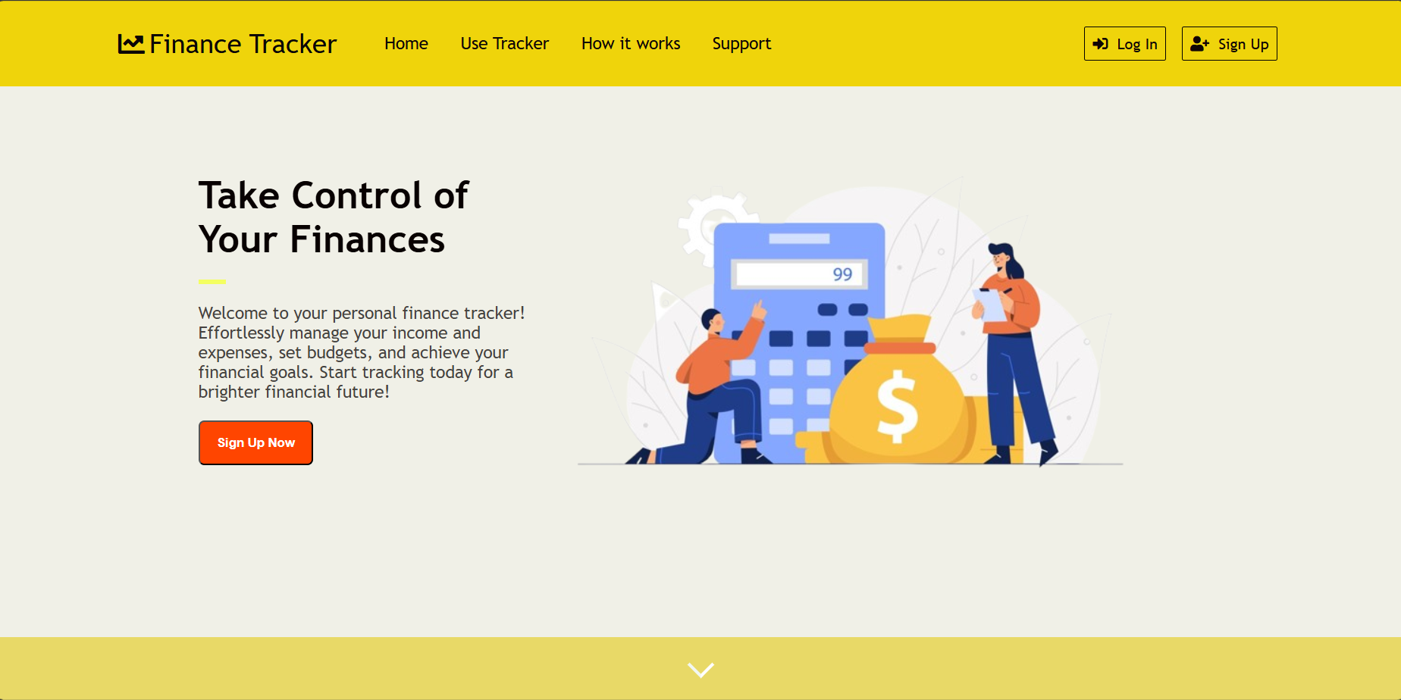

**Figure 2.1: Landing page**

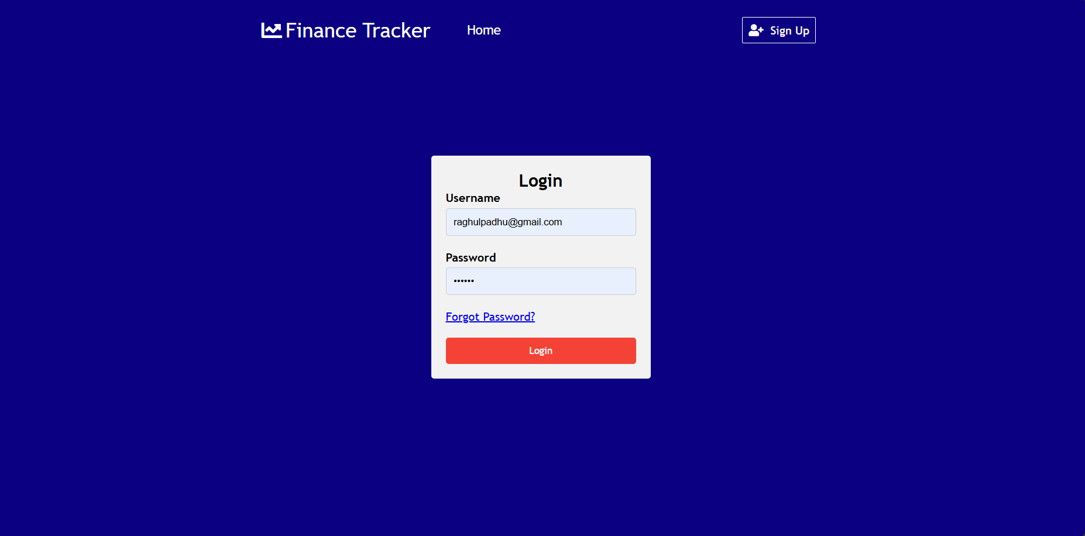

**Figure 2.2: Login Page**

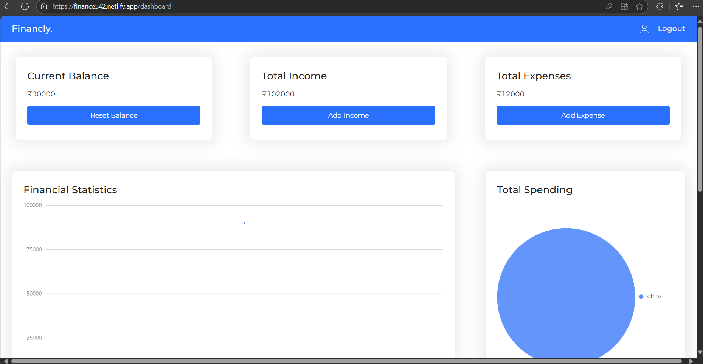

**Figure 2.3: Dashboard**

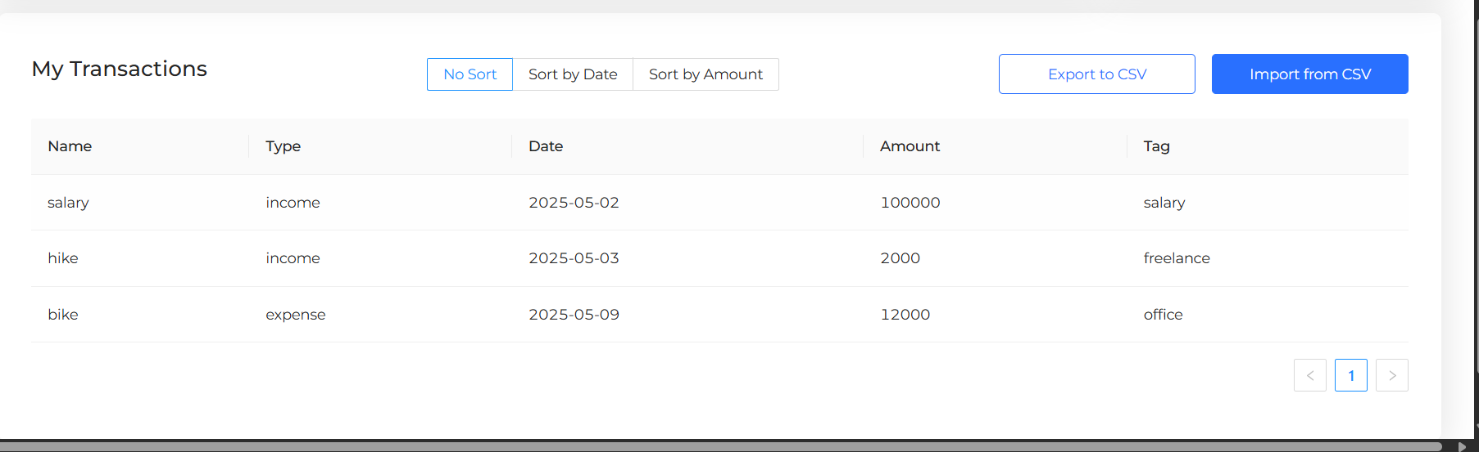

**Fig 2.4: Transaction Table**

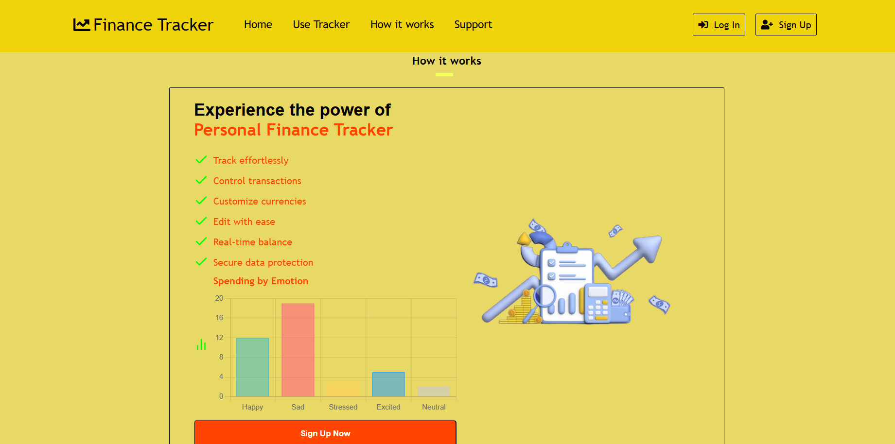

**Figure2.5: Chart Representation**

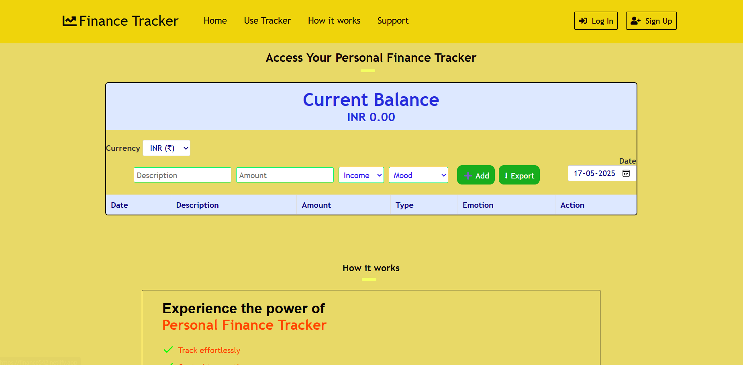

**Figure 2.6: Access your Personal Finance Tracker**

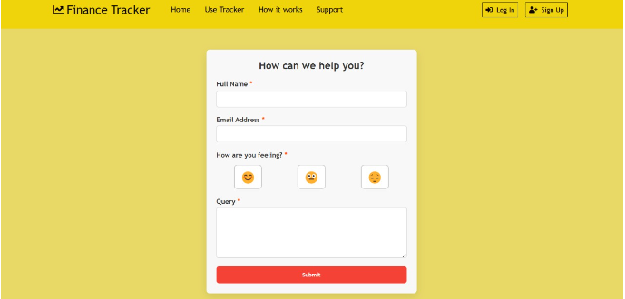

**Figure 2.7: Finance Tracker feedback**

**REFERENCES:**

1. S. Verma, S. S. Kheda, and S. Kuwale, “Personal Finance Tracker,” *International Research Journal of Modernization in Engineering Technology and Science*, vol. 6, no. 5, pp. 10279–10286, May 2024.
2. J. J. Kaye, M. McCuistion, R. Gulotta, and D. A. Shamma, “Money Talks: Tracking Personal Finances,” in *Proceedings of the SIGCHI Conference on Human Factors in Computing Systems*, pp. 521–530, 2014.
3. T. Stefanov, M. Stefanova, S. Varbanova, and S. Temelkov, “Personal Finance Management Application,” *TEM Journal*, vol. 13, no. 3, pp. 2066–2075, 2024.
4. A. Althnian, “Design of a Rule-based Personal Finance Management System Based on Financial Well-being,” *International Journal of Advanced Computer Science and Applications (IJACSA)*, vol. 12, no. 1, pp. 172–178, 2021.
5. V. Kozhevnikov, N. Slupko, and A. Sergeev, “Design and Development of Personal Finance Management System,” *Theoretical & Applied Science*, no. 6, pp. 110–115, 2019.
6. B. Andromakalew, “Android Based Personal Finance Management Application,” *Engineering, Mathematics and Computer Science (EMACS) Journal*, vol. 4, no. 1, pp. 5–9, 2022.
7. S. D. Talasila, “AI-Driven Personal Finance Management: Revolutionizing Budgeting and Planning,” arXiv preprint arXiv:2404.09321, 2024.
8. O. Mahajan, V. Mahanavar, S. Malwadkar, K. Mangde, V. Mehta, and P. Patil, “Money Minder: Personal Finance Tracker,” *International Journal of Scientific Research & Engineering Trends*, vol. 10, no. 3, pp. 77–79, May-Jun. 2024.
9. A. Khanna and M. Sharma, “Gamified Personal Finance Tracker for Young Adults,” *International Journal of Digital Applications and Interactive Technologies*, vol. 5, no. 2, pp. 45–50, 2021.
10. A. Rao and K. Mehta, “Intelligent Financial Planner with Emotion-Based Analytics,” *Journal of Emerging Trends in Computer Science and Behavioral Informatics*, vol. 7, no. 4, pp. 89–96, 2022.