### **Task 1: Create an instance in US-East-1 with Linux OS**

1.Open the AWS Management console:

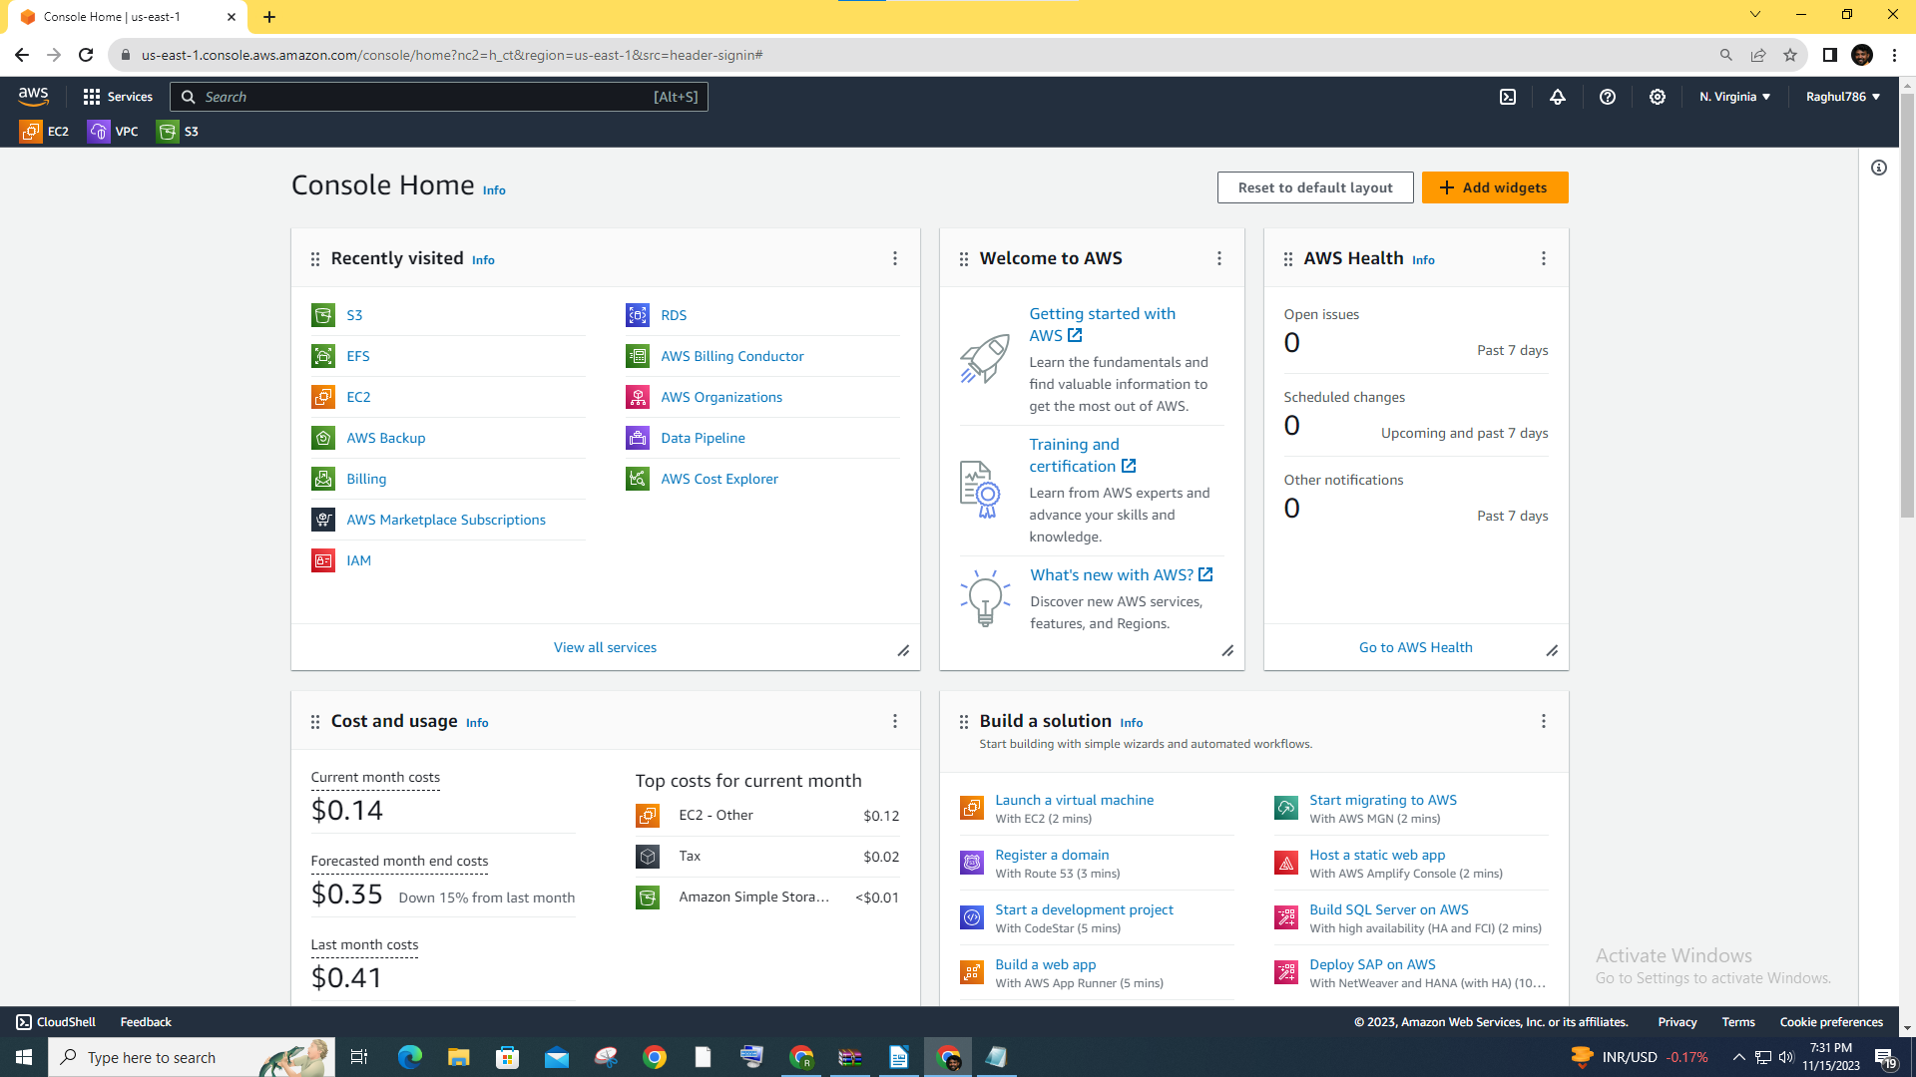2.Go to the EC2 service select region US-East-1

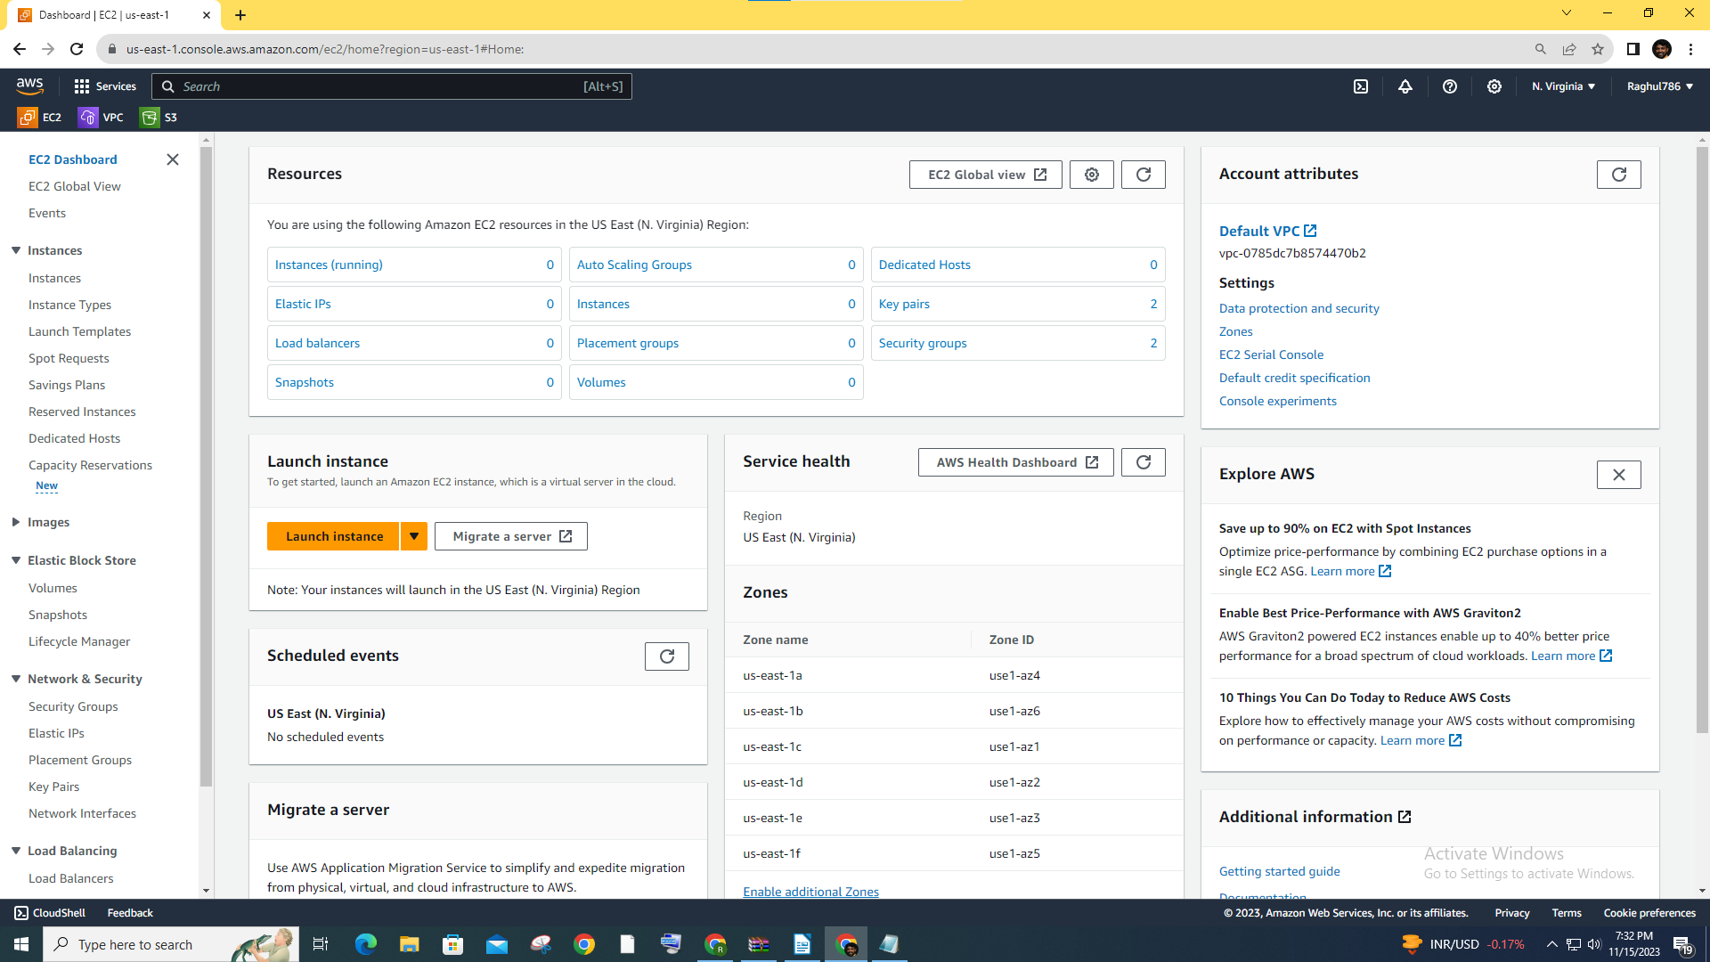

3.Click on "Launch Instance" and follow the wizard.

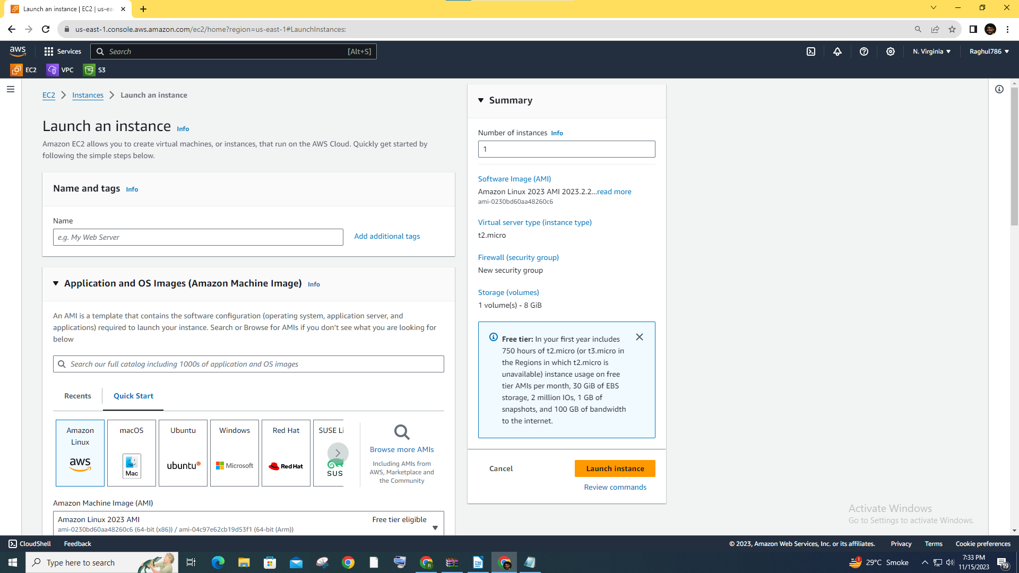4.Configure instance details, add storage, and configure security groups to allow web traffic (HTTP/HTTPS).

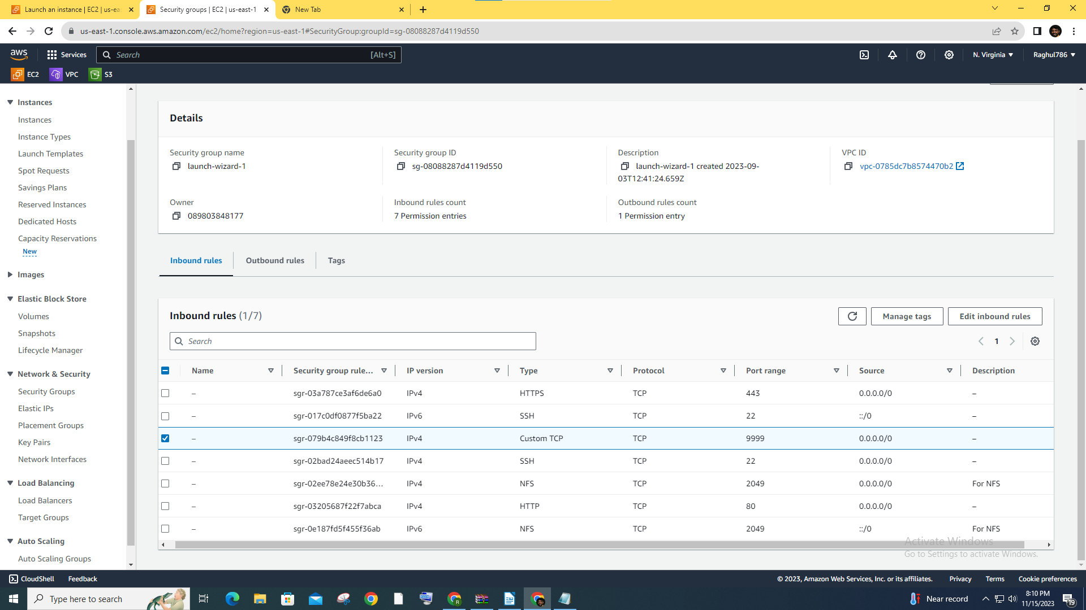

5.Additionally Configure user-data to run script and display webserver

**Script:**

**#!/bin/bash**

**yum update -y**

**yum install httpd -y**

**systemctl start httpd**

**systemctl enable httpd**

**echo "<h1>Hello World from $(hostname -f)</h1>" > /var/www/html/index.html**

Launched Instance and found webserver is accessible over internet

### 

**Task 2: Replicate the instance in US-West-2**

1.Create an AMI of the Instance

* In the EC2 dashboard, select your instance.
* Click on "Actions" > "Create Image."
* Follow the wizard to create an Amazon Machine Image (AMI).

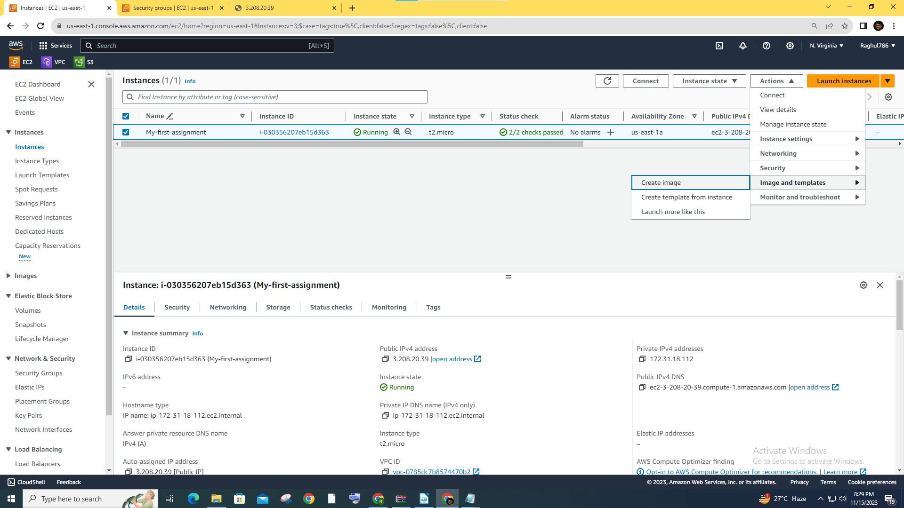

2. Copy the AMI to Different region US-West-2 Oregon

* In the EC2 dashboard, Click on AMIs
* Select the AMI and on Actions tab click on copy AMI

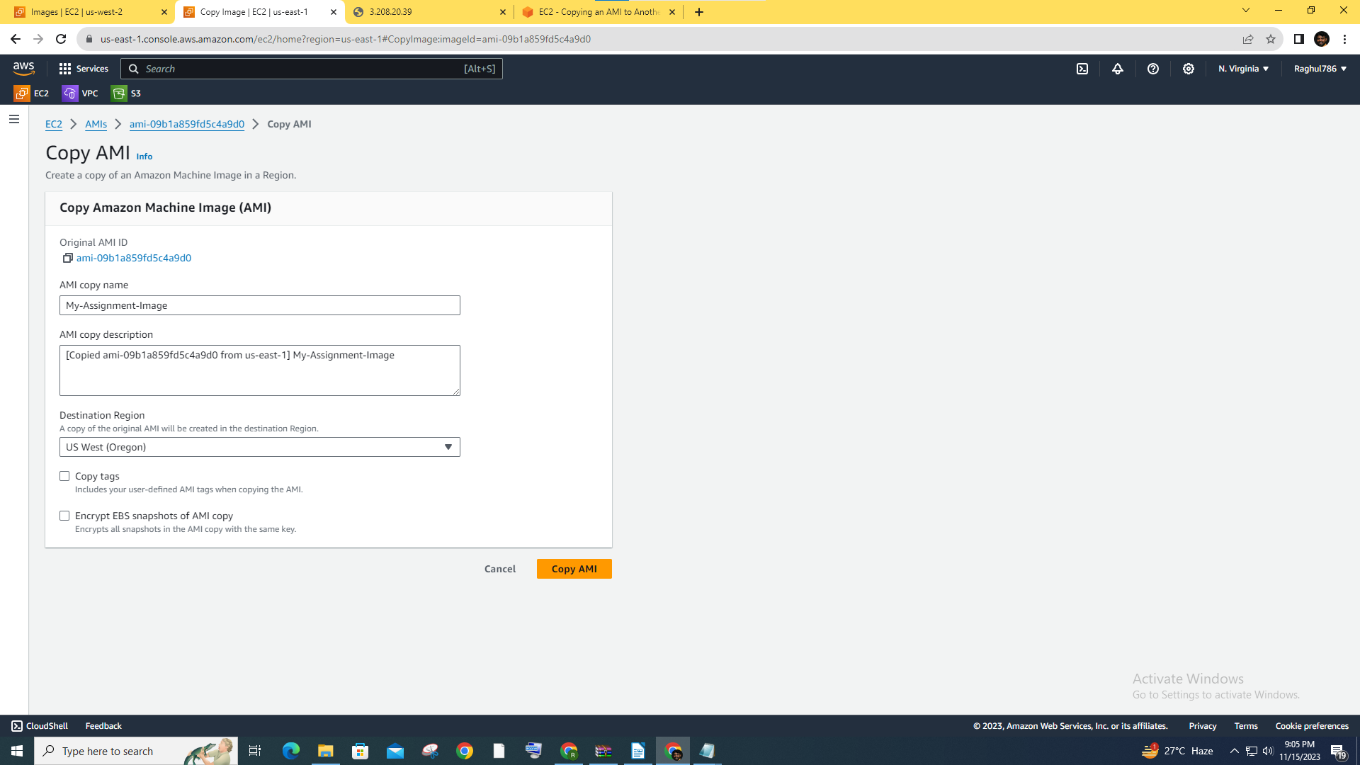

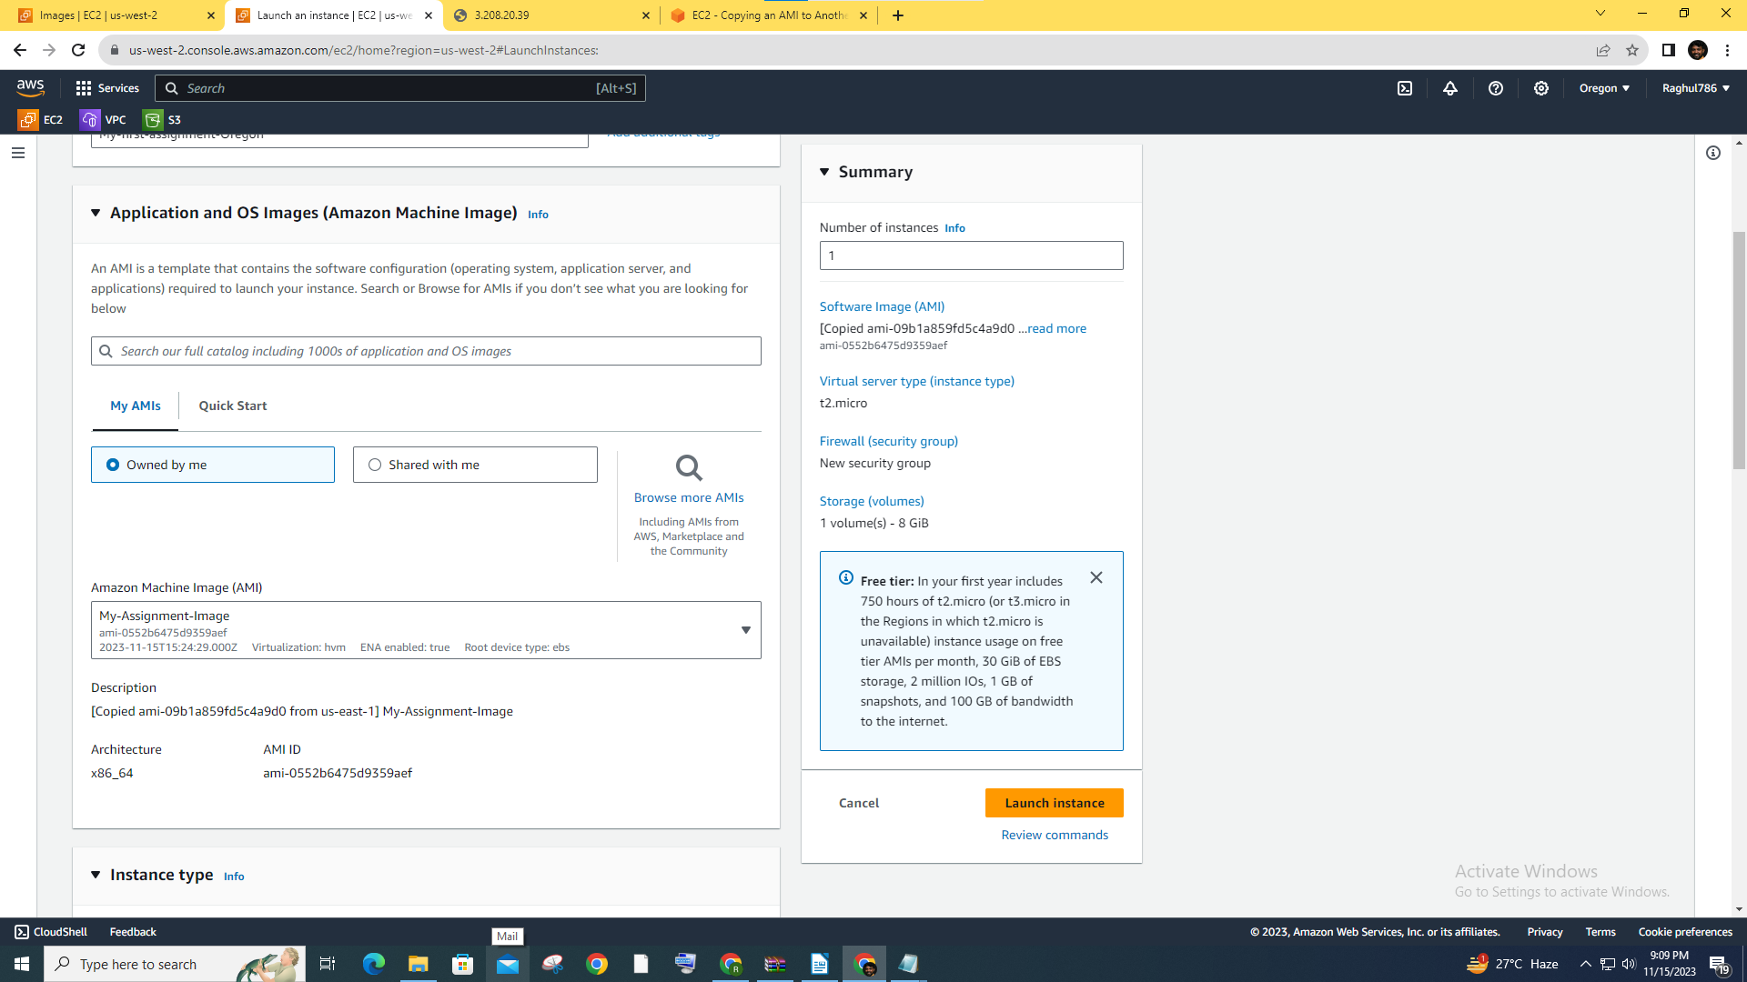3. Launch Instance using copied AMI in US-West-2 Oregon

### **Task 3: Build two EBS volumes in US-East-1**

**Create EBS Volumes**

* **In the EC2 dashboard (US-East-1), go to "Volumes" in the left menu.**
* **Click "Create Volume" and configure the size and type.**
* 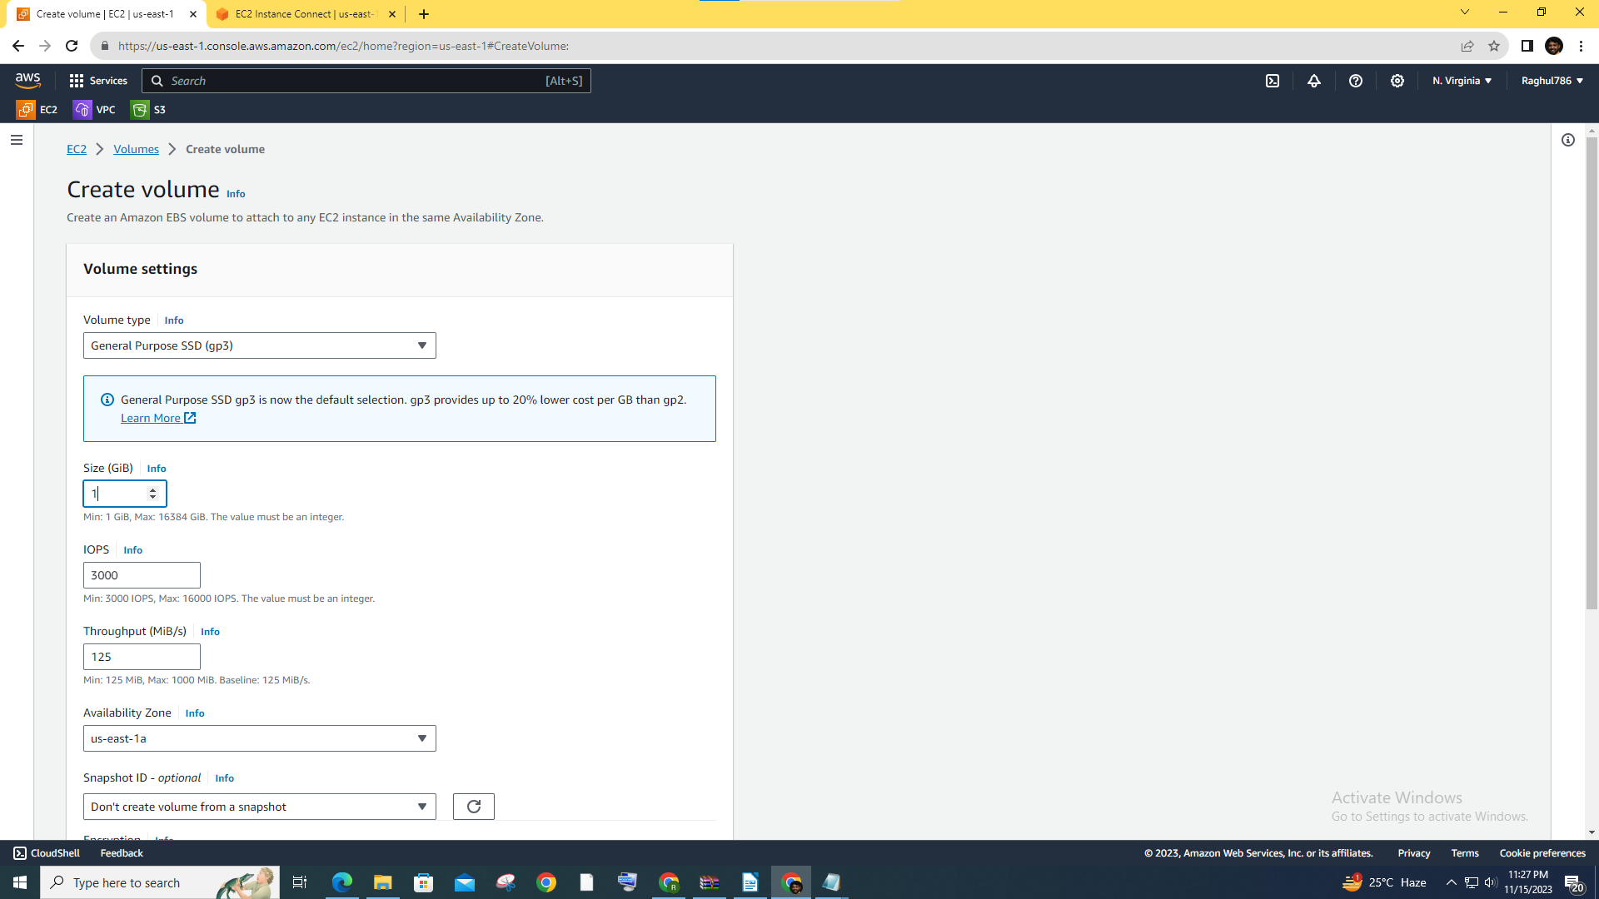**Repeat the process to create a second volume.**

**Attach the volumes to the instance:**

* **Attach the created volumes to the instance you launched in Task 1.**
* **In the EC2 dashboard, select the instance, go to the "Volumes" tab, and attach the volumes. Task 4: Detach and Extend EBS volume in US-East-1**

### 

### ****Task 4: Detach and Extend EBS volume in US-East-1****

**Detach one volume:**

* **In the EC2 dashboard, go to the "Volumes" section.**
* **Select the volume you want to detach, click "Actions" > "Detach Volume."**
* **After detaching, you can delete the volume if no longer needed.**
* **Click "Actions" > "Modify Volume" and increase the size.**

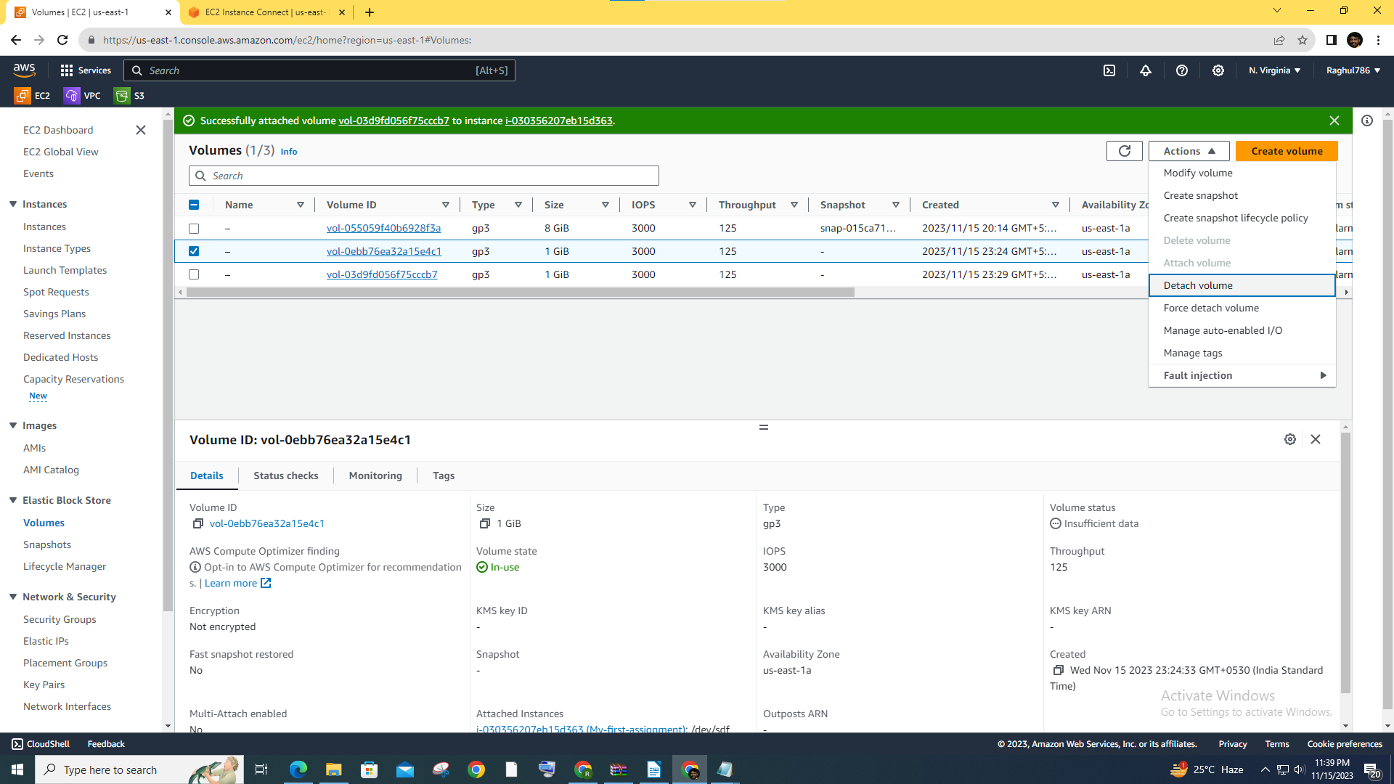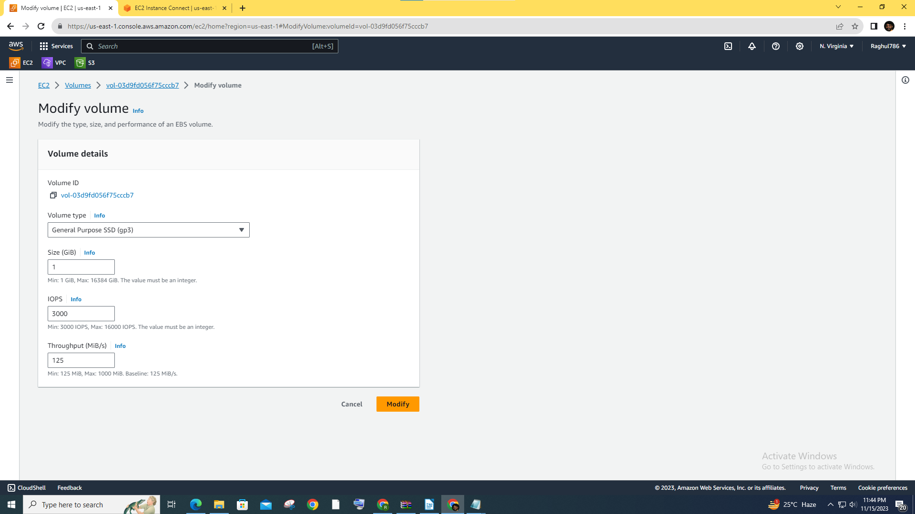

### ****Task 5: Take backup of EBS volume****

**Create a snapshot:**

* **In the EC2 dashboard, go to the "Volumes" section.**
* **Select the volume you want to back up, click "Actions" > "Create Snapshot."**
* **Enter a meaningful description for the snapshot.**

