CKAD --> Udemy

Teacher --> Mumshad Mannambeth

Need to go through this document:

Certified Kubernetes Application Developer: https://www.cncf.io/certification/ckad/
Candidate Handbook: https://www.cncf.io/certification/candidate-handbook

Exam Tips: https://docs.linuxfoundation.org/tc-docs/certification/tips-cka-and-ckad

Section 2:
Core Concepts.

Kubernetes Architecture:

Node is virtual or physical machine, on which kubernetes componentes installed.
Cluster is a set of nodes grouped together, which each have role to run cluster.

Master node watched over the nodes and is a responsible for actual orchestration of containers on worker node.

Overview explaination:

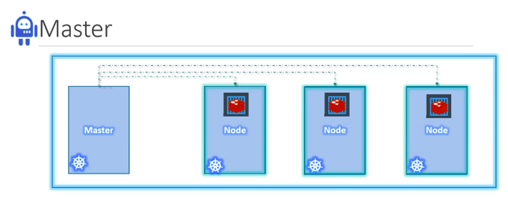

When you install kubernetes on server,your actually installing the following components on each node.

API Server: is front end of kubernetes cluster, command line interfaces will interact with API server to get the details of aplication,cluster info,deploying the application,updating application

ectd: is distributed,reliable key value store, it stores the cluster information,persistant details. Ex: you have multiple master node and worker node, etcd is storing the all node details as key value, is resposible for locking to avoid the conclits.

Kubelet: is agent which is running in all nodes. Which is resposible to make sure the all containers are running as expected in node and report to master.

Container runtime: is underlying software to run the containers. In our case we are using docker as container run time. We have other container run time that are rkt,CRI-O(CRT-O is latest container runtime).

Control manager: is responsible for managing the nodes,containers in nodes. If any node go down,try to up node or handle the request to working nodes.

Scheduler: responsible for distributing the work across the muitiple node based on available resource.

Kubeproxy: will handle the network related configurations into deployed application.

Cloud control manager if need to interact with cloud provided services.

Kubectl : is a command line inteface,used to infact with cluster to deploy,update,get the details of application and cluster.

Docker VS Containerd:

In the beggining of container era, there is just docker , other tools are also present rkt(rocket) but better user experience to work with containers, docker become popular. Then kubernetes is came to orchestrate the docker,so docker and kubernetes are were tightly coupled earlier.

*Later,as kubernetes grow up, users come and asked to work with other container runtimes.

*Kubernetes introduces interface calles container runtime interface(CRI). Kubernetes allow any vendor to work as container runtime as long as they follows the OCI(open container initiative) standards

*OCI is consists of image spec and runtime spec.
Image spec means how an the image should build
runtime spec means how the container runtime shoul be developed

*CRI and OCI is idea about supporting the other container runtimes in kubernetes.

*Docker wasn’t build to support the CRI standards because docker was developed before CRI is introduced and kubernet has to continue to support docker because of most people use docker.

*To support docker as container runtime,kubenetes have dockershim that is solution to support the docker as container runtime in kubenetes.

*Most other container runtime work through the CRI but docker will work through the dockershim

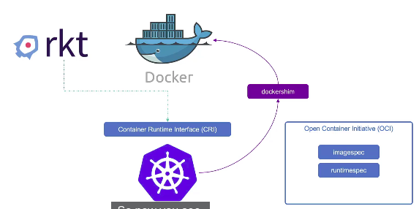

Docker is not just a container runtime, which include the multiple tools like build tool for building image,there is support for security, auth,volume also support container runtime called containerd.

Containerd is CRI compatible,can use the containerd as container runtime with kubernetes directly as other container runtime.

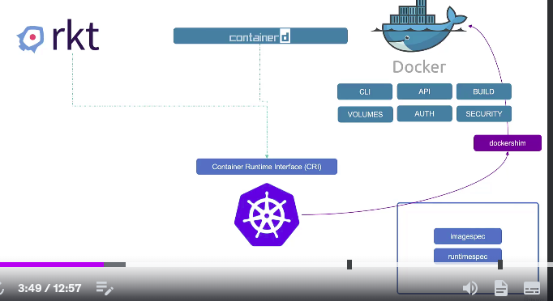
In kubernetes v1.24 and onword removed the dockershim to support the docker as continer runtime.
