\*In crude application we created three files

app.js

product.js --->This is a model connected to controller

controller.js -->controller take request from client communicate with database through model

\*Here app.js is simple client, it is writing some text to http:localhost3000 api

\*we include the controller to client with different api http:localhost3000/api/product

\*when we call http:localhost3000/api/product api,

it call controller to get,post,put,delete data from database(now we are using array) using express router methods

//initially we are getting empty we are not storing in array

//post is used adding data to database but here we used array as database now

//put method is used to update the already exsiting data

//delete method is used to delete data

\* Now click on reqbin chrome extention, it show option send request

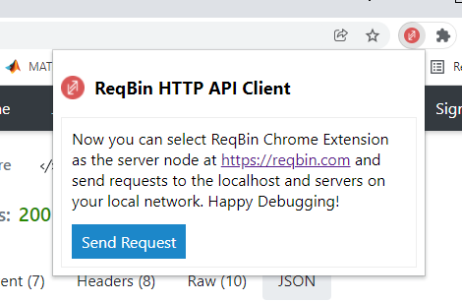

\*click on send request

\*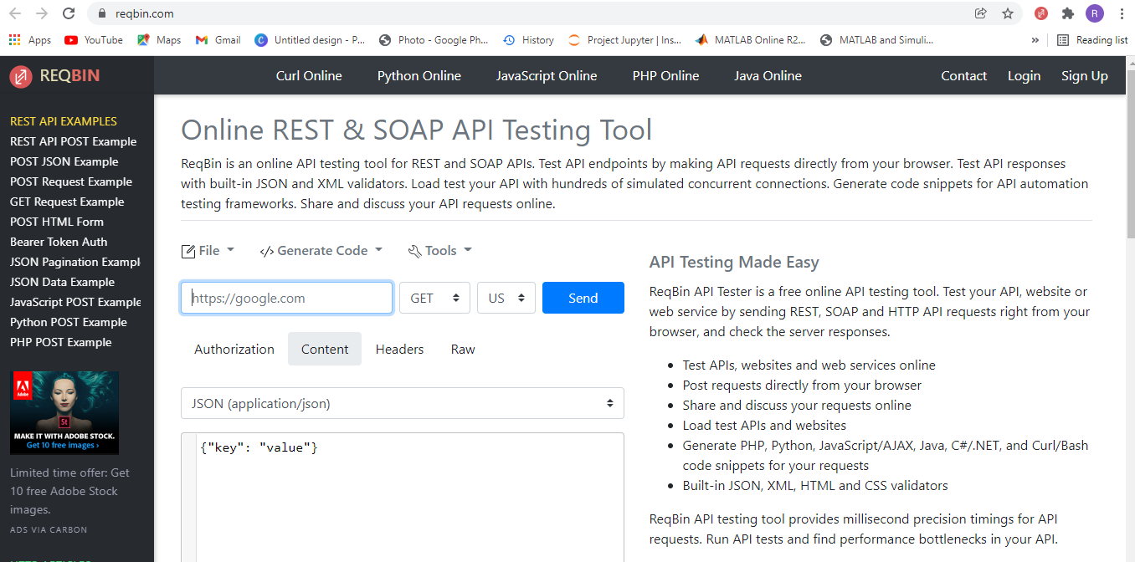

\*in the above image, paste url in url box , select method, select content, select json,

Write 🡪 {“name”:”Raghu”,”price”:”87”} in text box

Now select post method to post data to api(means url), refresh url to see posted data

\*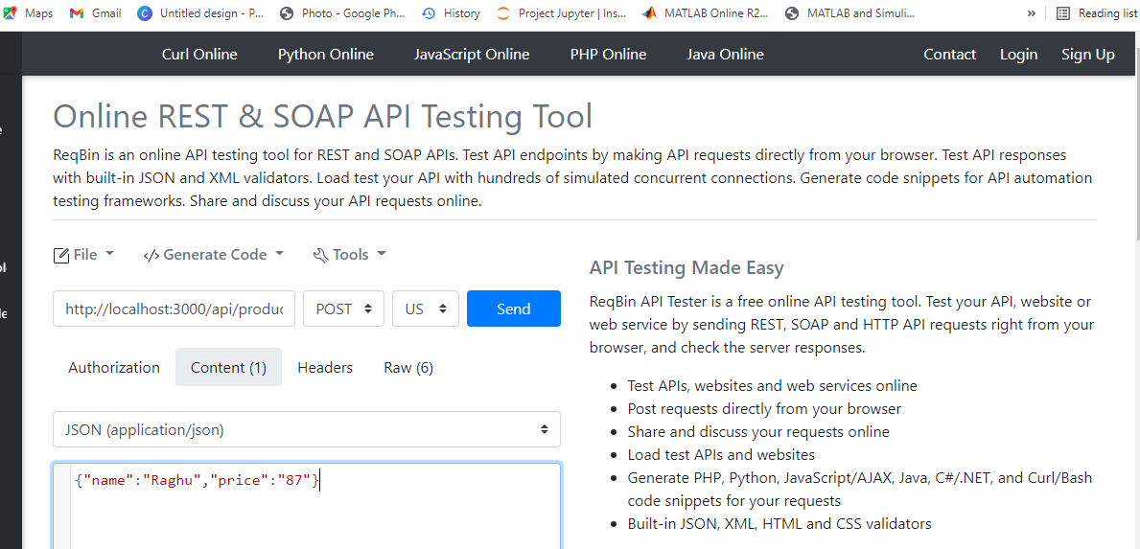

\*click on send button to post data to api

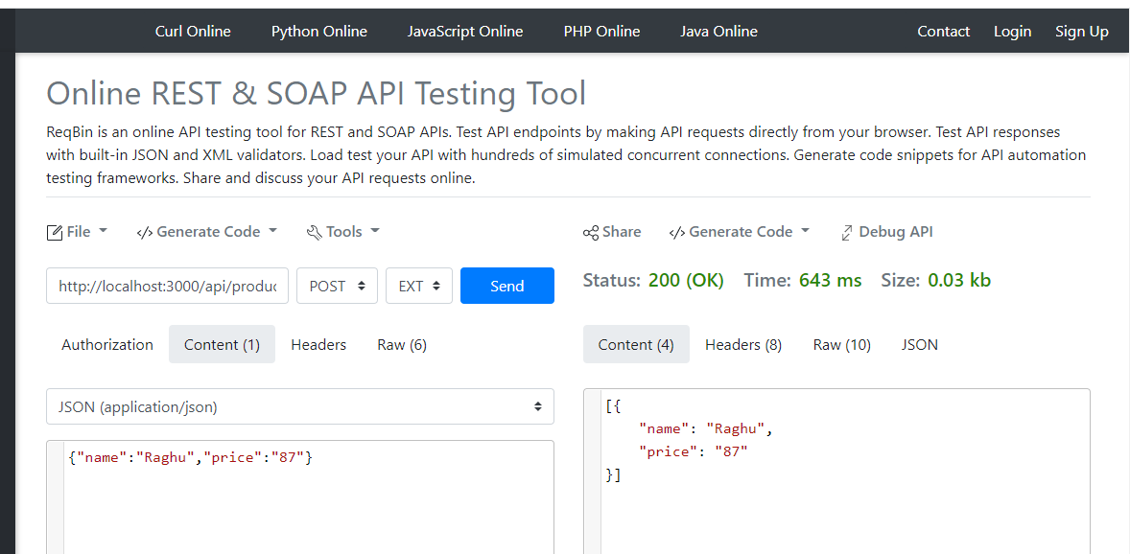

\*go and refresh api pag, it show as bellow

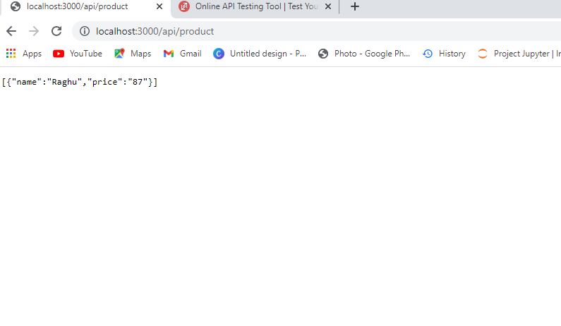

If you want post another data, just edit name and price click on send as bellow

{“name”:”Ravi”,”price”:”100”}

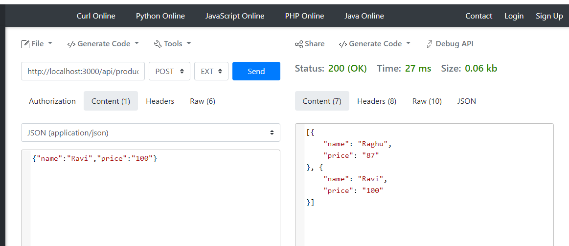

\*get method is used to check which data is stored in our api when we open newly

\* put method is used to update the already exsiting data

Example changing price of Raghu

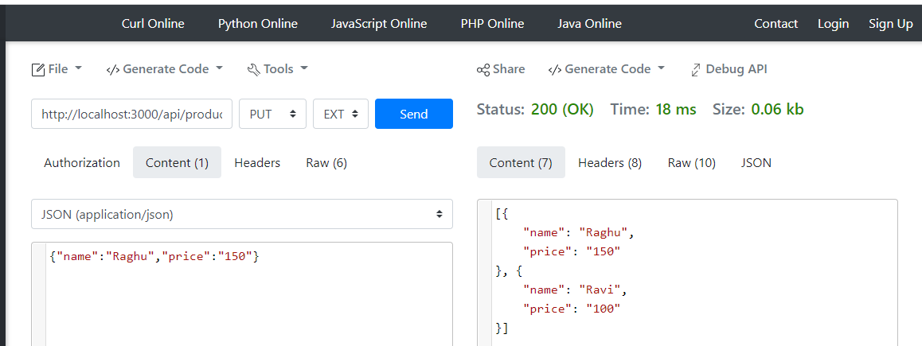

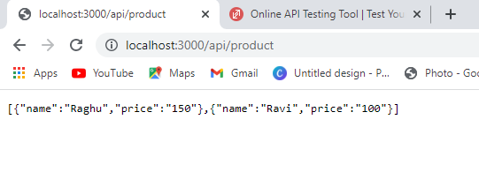

\*delete method is used to delete data

Now delete the Ravi data

