Udemy docker course

Section 8: Running mongo db container

Running mongo db container
*MongoDB is an open-source document-oriented NoSQL database management program that uses collections and documents instead of tables and rows to store and retrieve data.
*it uses the nginx and js,It is used for any micro service like front-end and back-end

$ docker pull mongo
$ docker run mongo

it always listen on 27017 port for connection

Starting the additional process in running container

* Using docker exec,we can create the additional process for running container

$ docker exec -it container_id_or_name bash
$ docker exec -it container_id_or_name sh

from above command,we created two additional process,run $ ps -e inside container--> i will show the running processes

$ ps -e
PID TTY TIME CMD
1 ? 00:00:08 mongod
56 pts/0 00:00:00 bash
65 pts/1 00:00:00 sh
71 pts/1 00:00:00 ps

Entrypoint and docker-entrypoint.sh location in mongodb

what is Entrypoint? --> once the container is created,it execute the command or executable file mentioned in entrypoint block,you can’t overwrite the entrypoint.Best practice to use the CMD in your docker file

$ docker inspect container_id_name --> give information about the container

[
{
"Id": "2e19ee00ad0004e2b5b779358ec8411b950ece60867dfa546b6dd725a2f8da77",
"Created": "2023-10-27T03:44:56.366140806Z",
"Path": "docker-entrypoint.sh",
"Args": [
"mongod"
],
it is located in /usr/bin/ --> mongodb container will execute the docker-entrypoint.sh file once the container created

Creating the database using mongo shell

$ docker exec -it conatiner_id_or_name mongosh --> it open the mongo shell and connect to mongo db

$ docker exec -it 2e mongosh

output:
Current Mongosh Log ID: 653b3a123a2731f6baa7cd91
Connecting to: mongodb://127.0.0.1:27017/?directConnection=true&serverSelectionTimeoutMS=2000&appName=mongosh+2.0.1
Using MongoDB: 7.0.2
Using Mongosh: 2.0.1

For mongosh info see: https://docs.mongodb.com/mongodb-shell/

------
The server generated these startup warnings when booting
2023-10-27T03:45:06.576+00:00: Using the XFS filesystem is strongly recommended with the WiredTiger storage engine. See http://dochub.mongodb.org/core/prodnotes-filesystem
2023-10-27T03:45:07.168+00:00: Access control is not enabled for the database. Read and write access to data and configuration is unrestricted
2023-10-27T03:45:07.168+00:00: vm.max_map_count is too low
------
test>

Now inside container,you can use the db commands

db.version()
show dbs
use test --> created the test database and using test database
db --> show the which db is using now
db.animals.insert({“animal”:”cat”})
db.animals.insert({“animal”:”dog”})
db.animals.find()

Creating the mongodb container with persistance data:

$ docker run -d -v $PWD/db:/data/db mongo

Section 8: Communication between the containers and Environment variables

Creating the wordpress container:
what is wordpress?
WordPress is an open-source,blogging tool and content management system (CMS) based on PHP and MySQL, which runs on a web hosting service. It’s a popular tool for individuals without any coding experience who want to build websites and blogs.

$ docker run -d -p 8090:80 wordpress

Important Note:
In docker,have the principle as single responsibility. In every conatiner have responsible for only one process or service

Default Bridge Network and communication between containers:

Create two busybox containers and ping the ip in each container.

$ docker run -it –name box1 busybox

$ docker run -it –name box2 busybox

check for ip using $ hostname -i

ping that in each containers --> ping ip --> it able to ping in both containers,have communication between box1 and box2 two containers.
ping command is used to check the connectivity is avaible or not from system to other system or url

$ docker inspect box1
$ docker inspect box2

Important Note:
From the container,you can able to connect to any ip or hostname and internet
ping google.com

Summary: Containers in default network could communicate with each other uisng ip address
but not able to communicate using hostname or container name

Environmental varibales:

Environmental variables are used set the values which are required for application.Every container have it’s own environmental variables.we can create and pass the environment variables file using
--env-file flag or we can pass using -e flag one environmental varibale at a time

Example:
created the my_env.env file with below content

MY_CUSTOM_VAR=my_custom_value
ANOTHER_VAR=another_value

$ docker run -it --env-file path_to_env_file/ my_env.env ngixn bash --> in terminal you can type
env you will get the all env varible alone with you defined variable

$ docker run -it -e MY_CUSTOM_VAR=Raghu nginx bash

Starting the mysql container:
$ docker run --name=mysql_test_container -e MYSQL_ROOT_PASSWORD=Raghu -d mysql

$ docker logs mysql_test_container

2023-11-06T18:47:32.853787Z 0 [System] [MY-010931] [Server] /usr/sbin/mysqld: ready for connections. Version: '8.2.0' socket: '/var/run/mysqld/mysqld.sock' port: 3306 MySQL Community Server - GPL.

$ docker exec mysql_test_container env -->checking the environmental variables in mysql

PATH=/usr/local/sbin:/usr/local/bin:/usr/sbin:/usr/bin:/sbin:/bin
HOSTNAME=ade3ae2a7794
MYSQL_ROOT_PASSWORD=Raghu
GOSU_VERSION=1.16
MYSQL_MAJOR=innovation
MYSQL_VERSION=8.2.0-1.el8
MYSQL_SHELL_VERSION=8.0.35-1.el8
HOME=/root

Starting phpmyadmin container and connecting to mysql container:

Get the ip of my sql container --> docker inspect mysql_test_container

$ docker run --name myadmin -d -e PMA_HOST=172.16.0.2 -p 8080:80 phpmyadmin

open http://localhost:8080 and enter user name as root and password as you passed while creating mysql container

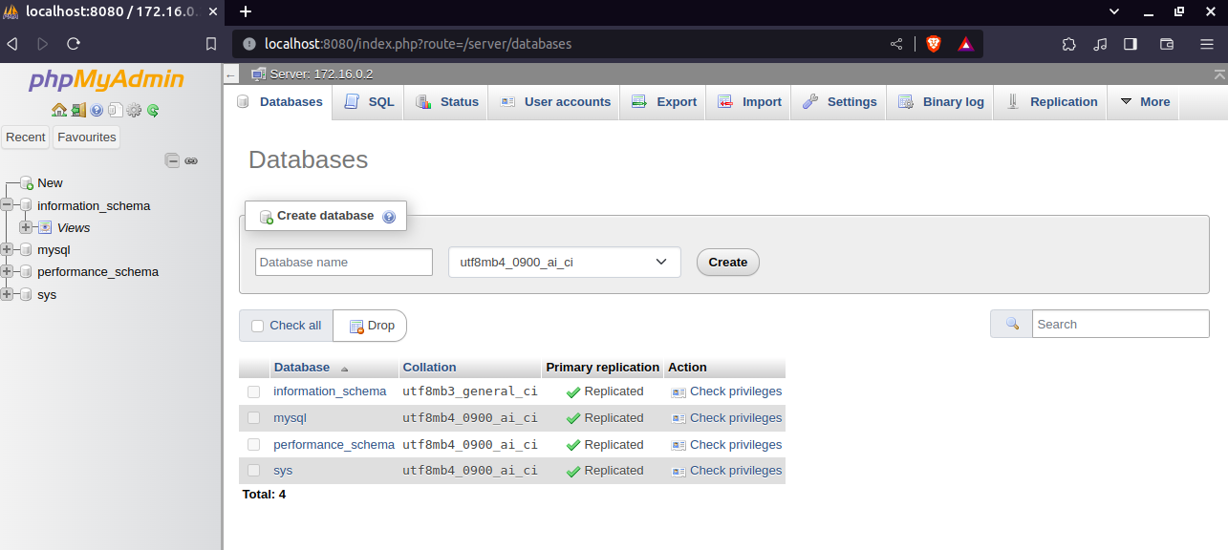

Note: ip of mysql will change for every new container,check on creating the mysql container by passing --hostname mysql_container and try to use in phpmyadmin but not worked.

Section 10:

Defaulf bridge network in docker:

Hostname is internal hostname of container and Name is external docker name for container.set hostname using -h or --hostname and set name using --name

$ docker run -it --name busybox-one -h busybox1 busybox

$ docker run -it --name busybox-two -h busybox2 busybox

ping the hostname and container names in both terminals you will get the bad address error

ping busybox2
ping: bad address 'busybox2'

Summary: containers not able to communicate between each other using hostname or conatiner name in defaulf bridge network.

Custom(user defined) bridge network in docker:

$ docker network create my_busybox_nettwork
$ docker run -it --network my_busybox_network --name busybox-one -h busybox1 busybox
$ docker run -it --network my_busybox_network --name busybox-two -h busybox2 busybox

go to busybox1 container and ping the hostname and name of busybox2 container,Now they are able to communicate using hostname and container name.

ping busybox-two
PING busybox-two (172.16.32.3): 56 data bytes
64 bytes from 172.16.32.3: seq=0 ttl=64 time=0.073 ms
64 bytes from 172.16.32.3: seq=1 ttl=64 time=0.140 ms

ping busybox2
PING busybox2 (172.16.32.3): 56 data bytes
64 bytes from 172.16.32.3: seq=0 ttl=64 time=0.193 ms
64 bytes from 172.16.32.3: seq=1 ttl=64 time=0.152 ms

Summary: In custom (user defined) bridge network,containers in custom network are able to communicate usig their hostname and container name.

docker network –help --> get commands in docker network

Usage: docker network COMMAND

Manage networks

Commands:
connect Connect a container to a network
create Create a network
disconnect Disconnect a container from a network
inspect Display detailed information on one or more networks
ls List networks
prune Remove all unused networks
rm Remove one or more networks

$ docker network ls --> list all avaiable network
$ docker network inspect name_of_network --> get the info about your network

creating the network , running mysql and phpadmin container,they communicate with mysql container using its name:

$ docker network create mysql_network

$ docker run --network mysql_network -e MYSQL_ROOT_PASSWORD=Raghu -d --name mysql_container mysql

$ docker run --network mysql_network -e PMA_HOST=mysql_container -d -p 8080:80 --name phpadmin_container phpmyadmin

user--> root and password Raghu
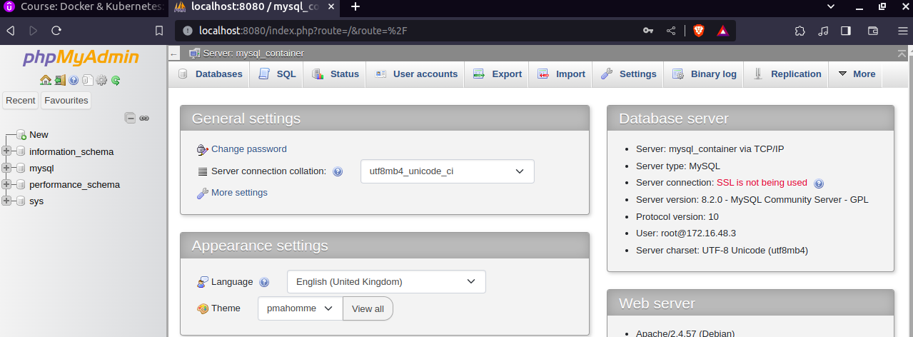
In the above image,you can observ phpadmin container is connected to msql_container.

Challenge:
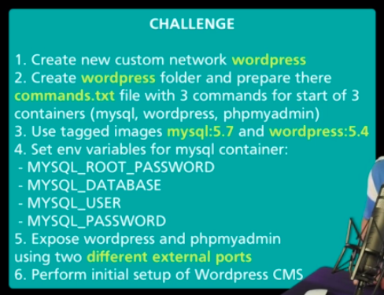

$ docker network create wordpress_network
$ docker run -d --network wordpress_network \
-e MYSQL_ROOT_PASSWORD=Raghu \
-e MYSQL_DATABASE=wordpress_database \
-e MYSQL_USER=wordpress \
-e MYSQL_PASSWORD=wordpress@19 \
--name wordpress_mysql \
-h wordpress_mysql \
mysql:5.7
$ docker run -d --network wordpress_network \
-p 8090:80 --name wordpress_container wordpress:5.4
$ docker run -d --network wordpress_network \
-p 8050:80 \
-e PMA_HOST=wordpress_mysql \
--name phpadmin_wordpress_container \
phpmyadmin

username --> root and password Raghu for phpmyadmin container

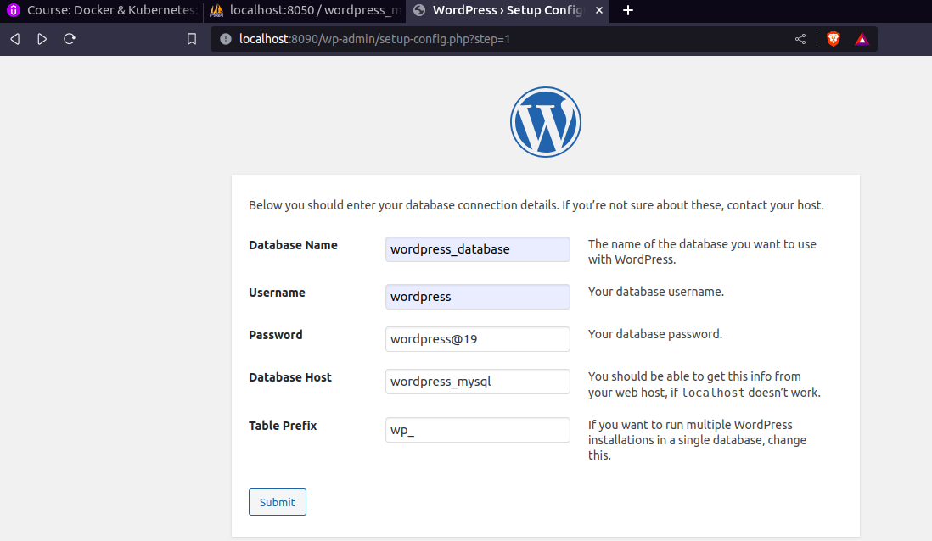
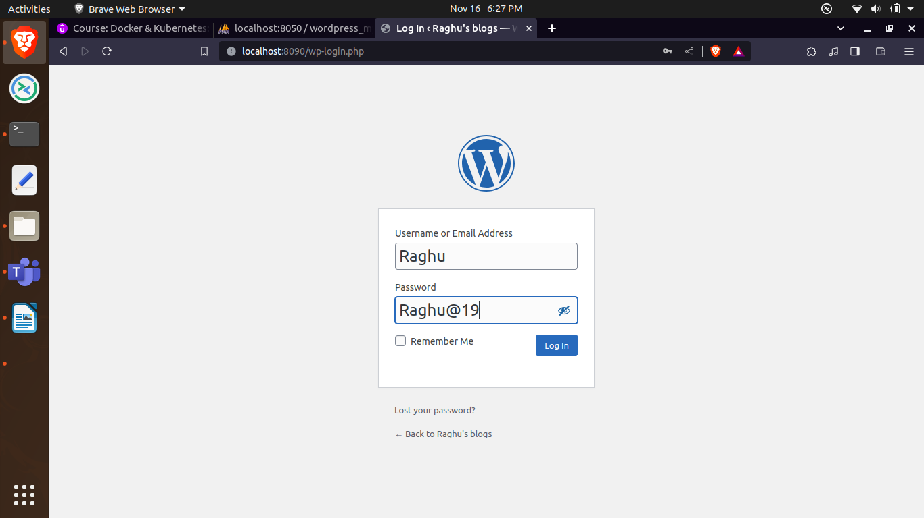
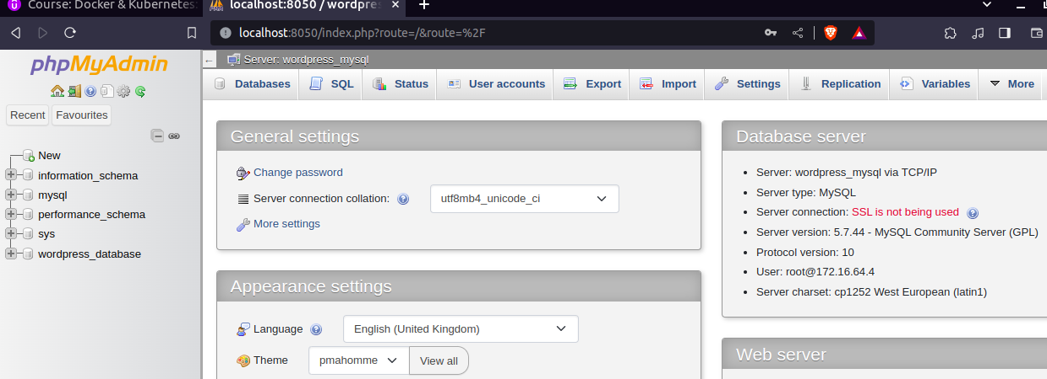

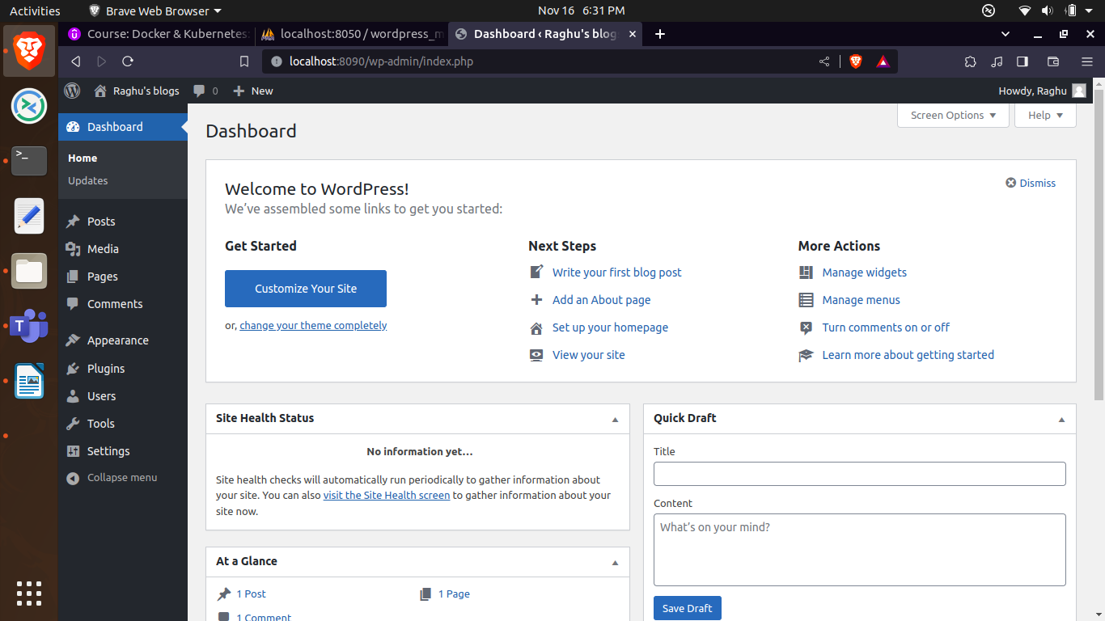

Section 11:
Challenge on Elastic search engine container creation.
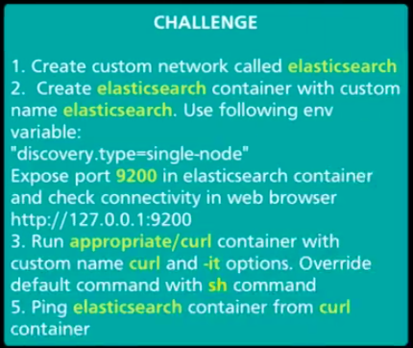

In above they mention to use the appropriate/curl for get the curl command in alphine image but i am using curlimages/curl image , just need curl command to check elastic container

What is Elastic Search Engine?
Elasticsearch is a distributed, open-source search and analytics engine built on Apache Lucene and developed in Java.
Elasticsearch allows you to store, search, and analyze huge volumes of data quickly and in near real-time and give back answers in milliseconds.
It’s able to achieve fast search responses because instead of searching the text directly, it searches an index.
It uses a structure based on documents instead of tables and schemas and comes with extensive REST APIs for storing and searching the data

$ docker network create elasticsearch
$ docker run -d --network elasticsearch -p 9200:9200 -p 9300:9300 -e "discovery.type=single-node" --name elasticsearch elasticsearch:7.17.15
$ docker run -it --network elasticsearch --name curl curlimages/curl sh

skiping the redis and httpd(apache) container example.

Section 13: what is Docker and Docker components

Virtual Machine:
Virtual machine is different operating system machine,which is created on top of host machine or pyshical server or virtual server.
Hypervisor are required to create the VM.hypervisor is software,which help us to create VM.
there many hypervisor providers for different os. Below are list of hypervisor softwares.

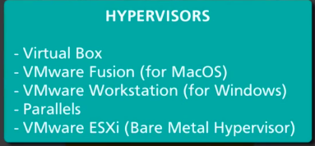

Virtual Machine
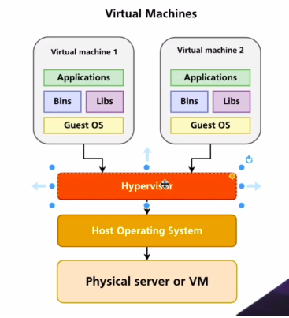

Docker containers: the main difference between the containers and VM are Guest OS are not present in containers and Docker Engine is responsible for making communication between the container and undelying host operating system
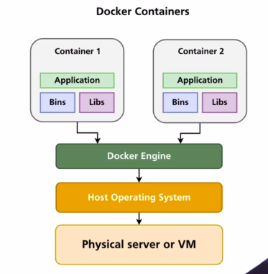

Docker on different operating system.

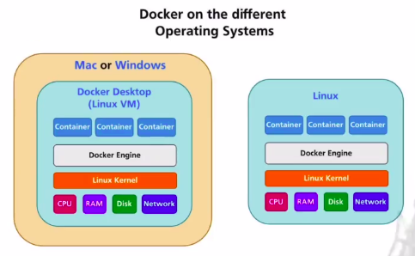

On Mac or Windows -->
*As you are seeing in above figure. Docker desktop will create the Linux VM on top of MAC or Windows OS and Docker Engin in Linux VM will handle the containers because of that Docker Desktop sofware size very big when we compre to docker software which will install on Linux.
*On MAC and Windows system,we can set the limit to usage of system resources(CPU,Memory,Disk) by containers(The max of resource allocated to Docker).

On Linux -->
*On linux os,we will install only the Docker Engine,Docker Engine will handle the containers in linux
*On linux system,single process in container have ability to utilize the 100% of your linux system resource,by initially we are not setting the resource limit to docker (in docker containers only utilize).
We can achieve the resource limit by using cgroups,it is possible to limit the resources per process or processes.

Container Processes and Resources:

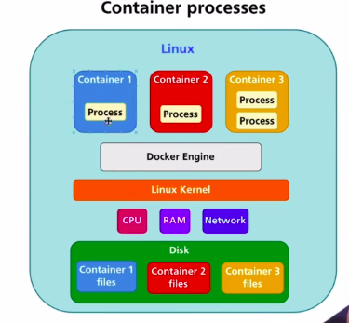

Container will always run on linux system,even on Mac or windows, Docker Desktop software will create Linux VM on top of Mac or windows system.

Container will communicate to linux kernel through docker engine(containerd and runc will handle conatiner related jobs) to utilize the resources and every conatiner have isolated disk space, processes and other resources as shown in above image.

Namespaces in linux allow isolation of computer resources between processes,
we can able to create seperate user,seperate process using namespace feature of linux.

During development and in production,you should always use the single-purpose container,means only single process running in the container because if that proccess go down,container will be stopped and you will get to know process is stopped in container

Docker components:

what is docker ?
Docker is tool,used to developing, shipping and running the applications.
Docker allows you to seperate your application from infrastructure.
Docker provides ability to run your application in lossely isolated environment called container.

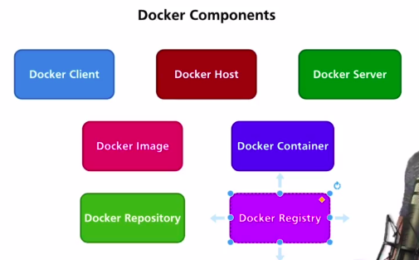
Docker client: Docker Client is docker commands and used for execution of docker commands on docker server and getting the output from docker server.
Docker client will communicatre to docker server though API.
Docker clinet is lauched when we run the docker commands.

Docker client is simply seperate binary file in every computer,we will stop docker service and able to lauch the docker client

$ systemctl stop docker

$ docker version

docker version
Client: Docker Engine - Community
Version: 24.0.6
API version: 1.43
Go version: go1.20.7
Git commit: ed223bc
Built: Mon Sep 4 12:32:12 2023
OS/Arch: linux/amd64
Context: default

Can’t connect to docker daemon

Binary file location
$ ls /usr/bin/ | grep -i docker
docker
dockerd
dockerd-rootless-setuptool.sh
dockerd-rootless.sh
docker-proxy
rootlesskit-docker-proxy

Docker server: is a Set of different process,responsible for creation,management and execution of containers,
ex: on of process is docker daemon --> docker client will connect to daemon and pass the command to do some functinality on container.

$ docker version
Client: Docker Engine - Community
Version: 24.0.6
API version: 1.43
Go version: go1.20.7
Git commit: ed223bc
Built: Mon Sep 4 12:32:12 2023
OS/Arch: linux/amd64
Context: default

Server: Docker Engine - Community
Engine:
Version: 24.0.6
API version: 1.43 (minimum version 1.12)
Go version: go1.20.7
Git commit: 1a79695
Built: Mon Sep 4 12:32:12 2023
OS/Arch: linux/amd64
Experimental: false
containerd:
Version: 1.6.24
GitCommit: 61f9fd88f79f081d64d6fa3bb1a0dc71ec870523
runc:
Version: 1.1.9
GitCommit: v1.1.9-0-gccaecfc
docker-init:
Version: 0.19.0
GitCommit: de40ad0

Docker daemon: it is not listed in docker server part but is very importance.
In general linux world,daemon is a long running process and always lisening.
In docker also,docker daemon is a long running process and it always lisening/waiting for docker client.when docker client pass any command thoughapi, communicate with containerd(containerd will communicate with runc for any resouces related allocation) and provide output to docker client
API: -->through API,docker client and docker server will communicate
Go version: Both docker client and docker server are written in go language. Actually docker is written in go language.
OS/Arch : linux/amd64, --> docker server always run linux system,on mac or windows,small linux vm will be created and installed docker server on it by docker desktop software. On window or mac,check os/Arch on docker client and docker server will be different.
docker-ini: --> docker-init is reposible for start of docker server(means set of processes)
containerd: is responsible for creation of container in high level and in low level,containerd will communicate with runc for resouces.
Need to read more about containerd and runc
runc(run container): runc will closely work with linux kernel and responsble for allocation of resource into containers.

Docker host: *The creation and manage of containers on system is Docker host.
*if your runnig docker on Mac or windows,docker will create the linux VM and linux VM will be the docker host. Indise of linux VM,docker daemon,containerd,runc and all containers will be created.

*If your running on linux system,your linux system only the docker host.

*There is new network interface for docker that called as docker0,the ip address in the docker0 interface is the default gateway for all container which are created under default bridge network and container will communicate to internet through this gateway.To prove that,create a container and check for ip,the ip will be from same network (172.16.0.2) according to below gateway ip

$ ifconfig

docker0: flags=4099<UP,BROADCAST,MULTICAST> mtu 1500
inet 172.16.0.1 netmask 255.255.240.0 broadcast 172.16.15.255
ether 02:42:ea:b8:d9:66 txqueuelen 0 (Ethernet)
RX packets 0 bytes 0 (0.0 B)
RX errors 0 dropped 0 overruns 0 frame 0
TX packets 0 bytes 0 (0.0 B)
TX errors 0 dropped 0 overruns 0 carrier 0 collisions 0

*If you check on Mac or windows machine cmd using ifconfig,it will not give the docker0 network interface because Mac or windows are not docker host,small linux VM was created in Mac or windows,all processes of docker,containers are running inside small linux VM.

To check/access the small linux VM on Mac,use the below docker image.for windows use different image.

$ docker run -it --rm --privileged –pid=host justincormack/nsenter1

Docker image: docker image is ready only set of files.which consists of multiple fs layers and docker image is used to create the containers.We can create our custom docker image.we can create N number of containers from same docker image.

Docker container: will be created using docker image and running process inside it.
Running single process inside every container is best practice.
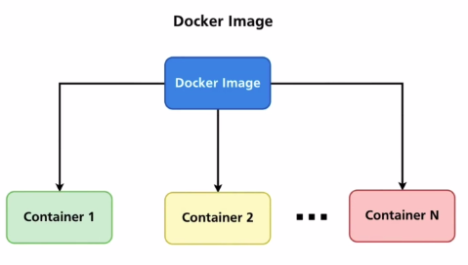

$ docker run -d busybox
$ docker run -d busybox

$ docker ps --> above both containers are created from same busybox docker image

Dokcer repository: is set of docker images with different versions.
You can create the different versions of images using tags.
Every image have atleast one tag,that is called as latest
Ex: redhat docker image with different versions -->one repository

Docker registry: The place where we will store the docker repository(set of docker images) is docker registry. Largest registy in world is docker hub.
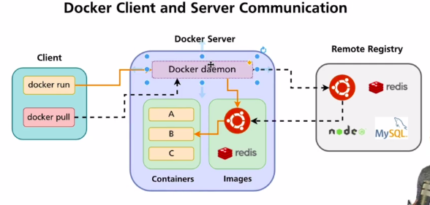

Based on what i leant from docker component section,i am writing the workflow of docker using above figure.

Section 14: Introduction to docker images and docker containers.

Docker commands vs management commands

In docker,there are three types of commands,
1) common commands
2) commands
3)management commands

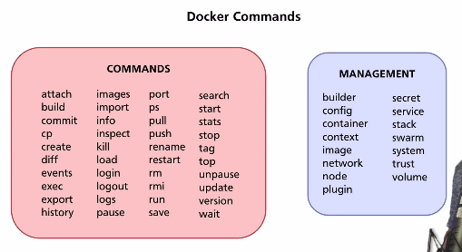
For management commands,always required the subcommands(common commands) and options
For commands,availble the options

$ docker --help --> will give all available commands,
read the docker document if you need the info on particular command

$ docker ps --help --> give options available for that command,there is short and long versions of every option are available,i always go with short version option

$ docker container --help --> give which and all sub commands are available for mangement commands

$ docker container wait --help --> give options

Alternative docker commands:

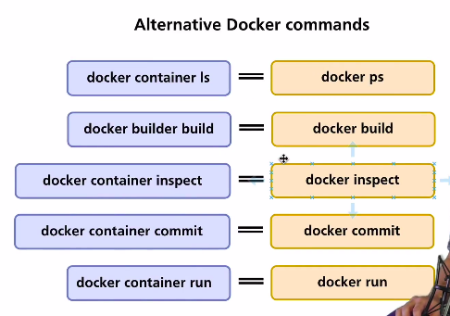

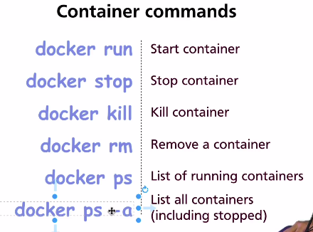

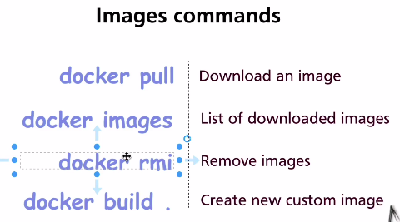

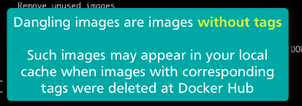

what is Docker image?

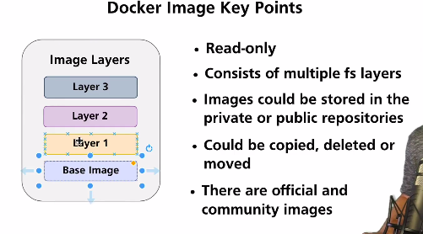

docker image is ready only set of files.which consists of multiple fs layers and docker image is used to create the containers.We can create our custom docker image.we can create N number of containers from same docker image.

Important:
*In any dockerfile,if we use base image,the base image contains the file system of mentioned os.
Example: From redhat/ubi:8.9 --> we mention like this,the redhat base image contains the file system of redhad os.
*At the end of the day,all required files for redhat are available in base image and container use files with host machine linux kernel.

What is CMD in Docker image?
CMD in docker image is instruction to start the process when the container created from that image.

CMD instruction is used to mention the command to run when the container create.we can overwrite the command mentioned in CMD instruction by passing the command while creating the image.

docker run -it centos /bin/bash -->once conrtainer created,run the bash executable means open bash terminal

The main difference between the CMD and Entrypoint is,
CMD --> overwrite the command mentioned in CMD instruction.
Entrypoint --> we can’t overwrite the command mentioned in Entrypoint instruction.it will be executed followed by container created.

docker inspect image_name --> give the info about the image

What is Docker container?

Docker container is stanalone unit of software,that packages up code and it’s dependencies to run the application.

How container will be created internally:
When we create docker container,docker will create the thin writable layer into fs layers of docker image,using that writable layer we can read and write files,then docker check the commands mentioned in Entrypoint and CMD instruction to run the application.

Key point-->fs layers of image will not copied into container,docker will create writable layer into fs layer of image and reuse fs layers of image into all containers created from specific image.

If you create two containers from same image,docker will creates two seperate writable layers into same image fs layers by reusing fs layers of image. As show in below

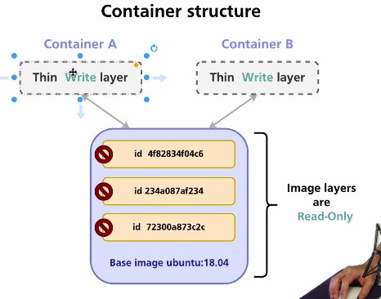

Practical Example:
$ docker pull hello-world --> hellow-world docker image pulled into your systemdocker,it contains multile fs layers. As show in below

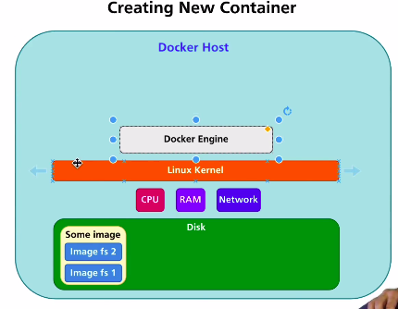

$ docker run hello-world --> docker will create the thin writable layer into multiple fs layers of image,then docker will check Entrypoint and CMD to run the specified command create a process and if no process running inside conatiner,container will be stopped by docker but writetable layer exists untill you remove the stopped container. As show in below figures.

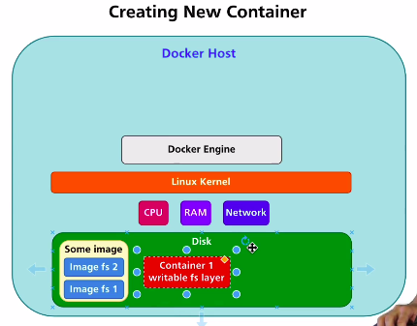

*When any process running inside container,the internally work-flow look like below
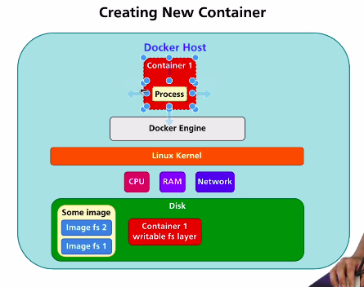

*When no proccess running inside container,docker will stop the container and writable layer exists untill you remove the stopped container.As show in below image
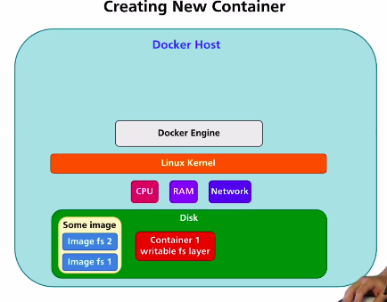

*If you create another container from same image,docker will create seperate writable layer into multiple fs layers of image.As shown in below

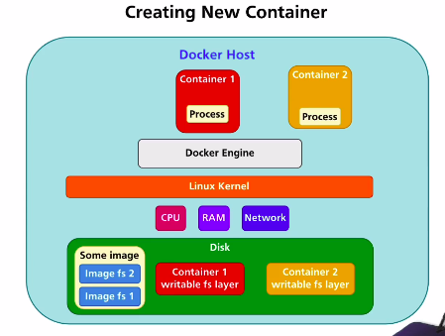

* when we remove the stopped conatiner,the thin writable layer of that particular container will be removed but the fs layers of image exists untill you remove the docker image.As show in image.
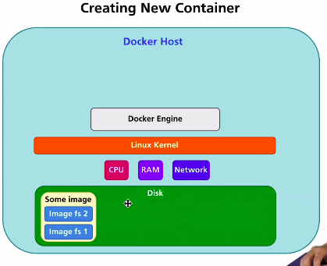

* when you remove the docker image,the system look like below.

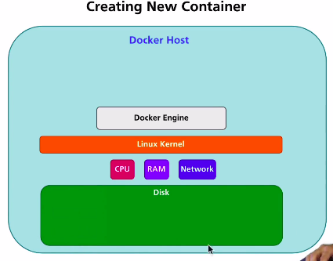

New Section--> Introduction to Linux and understanding the basic of linux.

What is terminal,shelland command?
Terminal is command line interface,allow user to enter the commands to perform different types of tasks.we can connect to different types of interpreter using commond line interface.
Open terminal and enter $ sh -->now you connected to shell interpreter using terminal(command line interface)

Shell is interpreter into linux command,usd to peform tasks and have different types of interpreters in linux.
Different interpreter will interprets same command differently.
When enter any command,it will connect to that command process and give result on interpreter and end the process.

All commands are process only,some are short term process and some are long term process.

$ ls --> ls command also short term process,list the files of directory and end the process

commands -->
$ uname -a --> display all infomation about the system.

Here are some common options used with uname:
- -a or --all: Display all available information.
- -s or --kernel-name: Display the kernel name.
- -n or --nodename: Display the network node hostname.
- -r or --kernel-release: Display the kernel release.
- -v or --kernel-version: Display the kernel version.
- -m or --machine: Display the machine hardware name.
- -p or --processor: Display the processor type.
- -i or --hardware-platform: Display the hardware platform.
- -o or --operating-system: Display the operating system.
$ uptime --> give info about powered on details.
$ uptime -p --> give in human readable format.
$ w --> to check how any user are logged in,if user logged as root user,it will show that user.root user will not be considered.

How shell or bash understands that you have entered command?
When enter the command,linux/interpreter will search for executable file of that command in directories listed in PATH env variable and give respective output if found executable in directories listed in PATH env variable.

ls --> command executable file present in /bin

$ echo $PATH
/usr/local/sbin:/usr/local/bin:/usr/sbin:/usr/bin:/sbin:/bin:/usr/games:/usr/local/games:/snap/bin

$ ls /bin | grep ls --> you will found ls executable

Getting the help for linux commands using man command or online man website.
$ apt-get update
$ apt-get install man-db --> installing man page for getting help of commands

man ls --> give the information about the ls command and usage options

website --> https://linux.die.net/man/ --> go to section 1 for daily use commands,explore on other sections,and search for command which you are looking for help

https://linux.die.net/man/1/ls -->ls command details

Command options:
$ uname --help --> all commands will not have --help options,that time use man page

Usage: uname [OPTION]...
Print certain system information. With no OPTION, same as -s.

-a, --all print all information, in the following order,
except omit -p and -i if unknown:
-s, --kernel-name print the kernel name
-n, --nodename print the network node hostname
-r, --kernel-release print the kernel release
-v, --kernel-version print the kernel version
-m, --machine print the machine hardware name
-p, --processor print the processor type (non-portable)
-i, --hardware-platform print the hardware platform (non-portable)
-o, --operating-system print the operating system
--help display this help and exit
--version output version information and exit

GNU coreutils online help: <https://www.gnu.org/software/coreutils/>
Full documentation at: <https://www.gnu.org/software/coreutils/uname>
or available locally via: info '(coreutils) uname invocation'

we can use the combination of multiple options without considering the order of options,i always use the short version of options.
All commands options and aruguments are case-sensitive.

$ uname -sp or uname -ps--> give info about kernel name and processor

$ uname -psr

Command Arguments:
command arguments are custom input to command from the user,some command will not executed without arguments. We can ignore passing the Options for command but argument are mandory for some commands.

Within square bracket are optional and without([]) are mondetory

Ex: $ mkdir --help
Usage: mkdir [OPTION]... DIRECTORY...

the directory name argument is mandory for mkdir to create directory,without name how directory will be getting created.

$ rm –help

Usage of Arguments for options:
we can use the argument for options of command.
Ex: date command -->

$ date --help

Usage: date [OPTION]... [+FORMAT]
or: date [-u|--utc|--universal] [MMDDhhmm[[CC]YY][.ss]]
Display the current time in the given FORMAT, or set the system date.

Mandatory arguments to long options are mandatory for short options too.
-d, --date=STRING display time described by STRING, not 'now'
--debug annotate the parsed date,
and warn about questionable usage to stderr
-f, --file=DATEFILE like --date; once for each line of DATEFILE
-I[FMT], --iso-8601[=FMT] output date/time in ISO 8601 format.
FMT='date' for date only (the default),
'hours', 'minutes', 'seconds', or 'ns'
for date and time to the indicated precision.
Example: 2006-08-14T02:34:56-06:00
-R, --rfc-email output date and time in RFC 5322 format.
Example: Mon, 14 Aug 2006 02:34:56 -0600
--rfc-3339=FMT output date/time in RFC 3339 format.
FMT='date', 'seconds', or 'ns'
for date and time to the indicated precision.
Example: 2006-08-14 02:34:56-06:00
-r, --reference=FILE display the last modification time of FILE
-s, --set=STRING set time described by STRING
-u, --utc, --universal print or set Coordinated Universal Time (UTC)
--help display this help and exit
--version output version information and exit

Convert seconds since the epoch (1970-01-01 UTC) to a date
$ date --date='@2147483647' or date -d '@2147483647'

In above example,string is mandetory for -d option.

As date command,we have other command where will use the argument with options.
To understand any command,read the man page of command --> https://linux.die.net/man/

