Kubernetes Notes from Abhishek veeramalla

Why we are moving into kubernetes from docker or
what are advantages of kubernetes compare to docker?

Problems in Docker:
1)Single Host
Container are Ephemeral in nature mean container are short life,they can die and retrieve at any time

lets assume we are running 20 containers in my host system.
For some reason first 15 containers using all resources of my host system, 16th container and other containers will die due to resource unavailability. Linux have it’s own algrithm based priority it will delete other processes.

Container are scope to single host
2) Don’t have auto healing in docker
if some killed the container, the application ruuning inside of that container not accessable,some one have to create and keep on monitoring the containers to have the application up and running

3) Don’t have auto scaling in docker.

Let assume your application running in 100 containers and serving some users,
Due to some season your app will get the more requests,you have to serve the application to all users, to acchieve this,some one have to increase the application containers and need to taken care about the load balancing. Docker don’t auto scaling feature.

4) Docker don’t provide the enterprise level supports.
Some of enterprise level standard are
* Load balancing
* Firewall
* API Gateway etc

Kubernetes will solve all of above problems:
K8s have the following

*Multi server deployment --> Kubernetes is a cluster,it have one master and many wokers nodes, put the pod into other worker node to serve the allication if pod is getting affected from the resource.

*Auto scaling --> there is replication contoller in k8s,when we increase the replicas in yaml specification and deploy,it spin up the that much pods this is mannual may.
Kubernetes will also support auto scaling by Horizantel pod auto scaller.

*Auto healing --> whenever the pod down,kubenetes will spin up the new pod.
Kubernetes will always try to maintain the desired number of pod which are specified in yaml configuration

*Enterprise level support --> kubernetes will suppport the enterprise level support.
To run application on plateform which is not enterprise platform. Docker never used in production, it may used with docker swam
Example: i need to block some ip which will not able access the application.this is not supported from docker
Kubernetes will provide the custer resource definition to define our resource.

Take same examples and explain in interview.

Yaml configuration in k8s:

*No need to remember the yaml file syntax,that is waste of time.
Refer the kubernetes document which k8s object you want to deploy.

*search kubernetes deployment examples github--> you will get the doc https://kubernetes.io/docs/concepts/workloads/controllers/deployment

*interviwer ask about what particular atrribute will do for deployment(role of labels,replicas, etc)

How to write the yaml specification using kubernetes document:

*I have created the document about how to write yaml specification into k8s object,it is very easily understandable,read that document.

Below is the link of docker notes,it contains the how to write yaml specification at end
https://github.com/Raghumnstudent/Docker/blob/main/docker_udemy/Docker_Notes.odt

* Search kubernetes resource_name examples github --> give respective resource example
Ex: kebernetes deployement examples github

Kubernetes Artitecture:

In docker,to create and manage containers,require the container runtime like to run java application java software is required.
Docker will use the dockershim as container runtime,but when i checked in local system i got info as docker using containerd

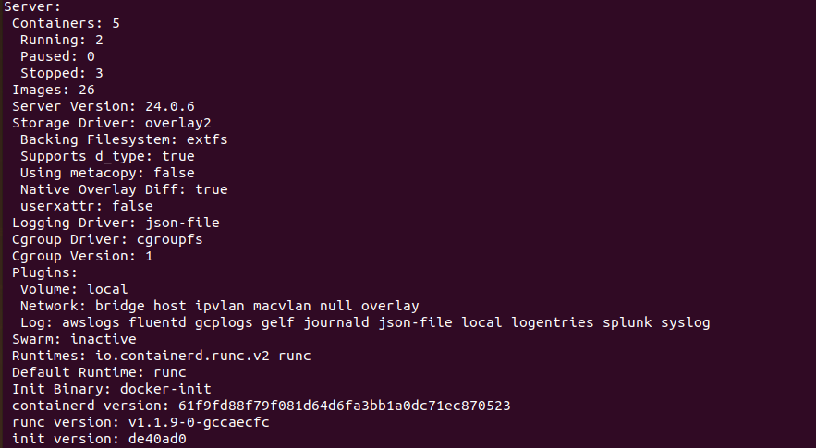

Kubernetes have master and worker artitecture.

Components in worker node:

Container runtimes: In k8s,we can use any container runtime,which will support k8s infra.we can setup the k8s without docker by using other container runtime,container runtime required to create and manage the containers.

Container runtimes are
*containerd
*cri-o

kubelet: kubelet in worker node is responisble keep on watching pod running or not. If pod not running inform to master node

kubeproxy: kubeproxy is responsible for providing networking,handling load balancing.kubeproxy uses the ip tables in worker node to assgin the ip .As in docker we have docker0 network interface and brige network like that

why we need if worker node doing the all above tasks:

Any enterprise tool have the standards,clutering also one of standard,To manage cluster need core component.that is api server in k8s. In furure if we want implement advanced sso(single sign on user),identity provider configuratin etc
Master node will decide
*where we need to deploy the application,which worker node have resource,
*action will be taken from master when kubelet info pod not running

Components in master node:

API server: API server responsible for taking the request from user, informing to master node and give the respective output to user about the request

Scheduler: Scheduler is resposible for scheduling the pod on which worker node or which worker node need to use to schedule pod based resource available in worker node or labels in worker node

etcd: etcd is basically key vaule store component,entire cluster information stored in etcd as key vaule pair.if want restore the cluster,etcd is very important.

Control manager: is responsible to ensure that all controllers are runnning or not. Let assume you deploy application,i have to increase the pods,you will change the replicas into 5,there is conttoller called resplica set controller will create and ensure 5 pods up and running.

Controllers are:
Replica set controller

if you are running k8s on on-premise,cloud control manager not required.

Cloud Control manager: k8s can run on cloud platforms. That are EKS(Elastic Kubernetes service),AKS.
If there is request from user to create storage or load balancer etc ,k8s have to understand underlying cloud platform and convert request into api request which cloude platform can understand and do the task.
This are all done from cloud control manager.

Cloud control manager is open source,if any new cloud provider come,write the logic to support k8s on new cloud and raise request.

Ex:
if we create the service with service type as Load Balancer,k8s need to make communication to get the external ip from cloud provider.
This is all taken care from Cloud Contol Manger

what is Distributions in kubernetes?what is advantage of using distribution?

*Linux is open source free software,on top of linux code,developed more code to enhance the user experience and released the own linux,newly release linux is called distribution.

Linux --> distributions
* Amazon linux
*Redhat
*centos
etc

*Kubernetes is also open source free container archestration engine.
To enhance user experience and efficiency,provider have written the code(wrapper,plugin,command lins etc) on top of kubernetes.

Kubernetes --> distributions
*EKS --> Elastic kubernetes service from amazon
*openshift --> from redhat
*Tanzu --> from vm ware
etc

The advantage of using distribution is they will provide the support if we are facing issue in their distribution because we are paying that distribution,give the security patch update etc

what will you use the container archestration tool in production?

*Kubernetes -->if end up with any production issue, it also have support,but they will have their priory works then they will look into your production issue
*openshift
*Rancher
*Tanzu
*EKS
*AKS
*GKE
*DKE --> docker kubernetes engine

How devops engineer install and manage k8s cluster in production using kops? --> kubernetes operations
Create an EC2 instance or use your personal laptop.

Installing the dependencies:
Python3
AWS CLI
kubectl

$ curl -s https://packages.cloud.google.com/apt/doc/apt-key.gpg | sudo apt-key add -

$ echo "deb https://apt.kubernetes.io/ kubernetes-xenial main" | sudo tee -a /etc/apt/sources.list.d/kubernetes.list

$ sudo apt-get update
$ sudo apt-get install -y python3-pip apt-transport-https kubectl

$ pip3 install awscli --upgrade

$ export PATH="$PATH:/home/your_username/.local/bin/"

Provide the below permissions to your IAM user. If you are using the admin user, the below permissions are available by default
- AmazonEC2FullAccess
- AmazonS3FullAccess
- IAMFullAccess
- AmazonVPCFullAccess

Set up AWS CLI configuration on your EC2 Instance or Laptop:

Login into your aws account from your local system
$ aws configure
--> it will ask for access and secret key,top right side of your usename--> security credential--> create access key

Before creating the access key,you have create the IAM user into you account,From that IAM user create the access and secret key.
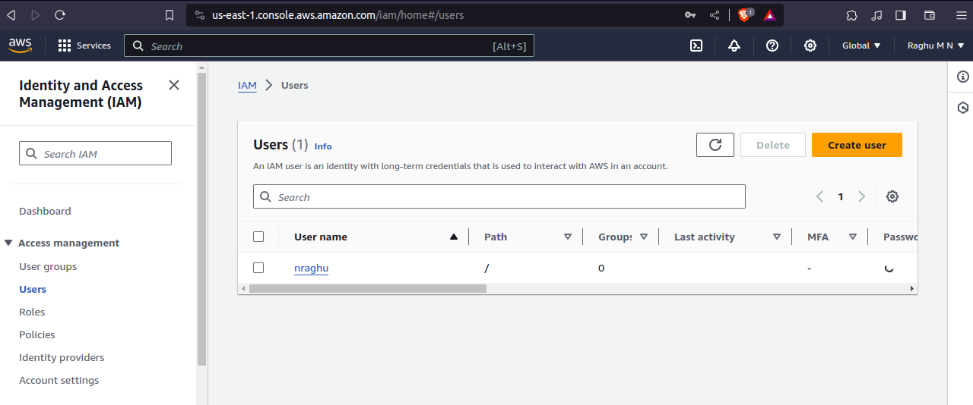
I created the IAM user as nraghu,click that user and create access key,it will give secret key also. Keep the secret key some where.
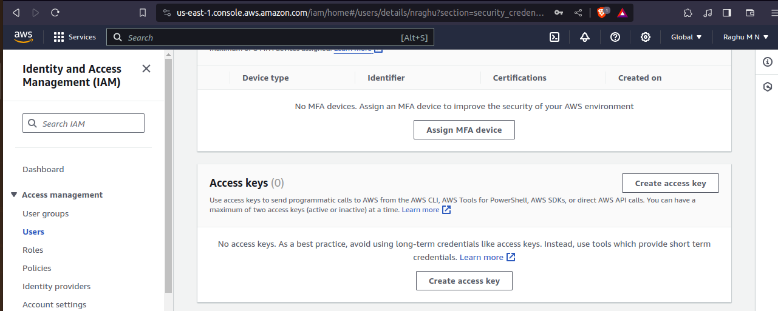

Create S3 bucket for storing the KOPS objects:
$ aws s3api create-bucket --bucket kops-abhi-storage --region us-east-1

Create the cluster:
kops create cluster --name=demok8scluster.k8s.local --state=s3://kops-abhi-storage --zones=us-east-1a --node-count=1 --node-size=t2.micro --master-size=t2.micro --master-volume-size=8 --node-volume-size=8

where name is cluster name and we are using .local as dsn for local usage. \
if we are creating for production,we need buy domin from one of provider like godaddy,letsencrypt and configure in route 53 and use it in cluster name
node-count --> how many woker nodes required

command to configure dsn in route 53:
$ aws route53 create-hosted-zone --name dev.example.com --caller-referece 1

Important: Edit the configuration as there are multiple resources created which won't fall into the free tier.
$ kops edit cluster myfirstcluster.k8s.local

Build the cluster:
$ kops update cluster demok8scluster.k8s.local --yes --state=s3://kops-abhi-storage
Validate the cluster:
$ kops validate cluster demok8scluster.k8s.local

this cluster create the bill in your amazon account,edit the configuration of cluster using kops edit and make configuration to use free resources.

Kubernetes Pods:

Pods is smallest deployment object in k8s,is single or collection of containers deployment.
Pod deployment will not provide the auto-scaling and auto-healing feature.
In k8s,not a tall recommends to deployment the application with pod object.

Important:
If we deploy pod with multiple containers, k8s allow you
*shared networking
*shared storage
*communicate each other using localhost,
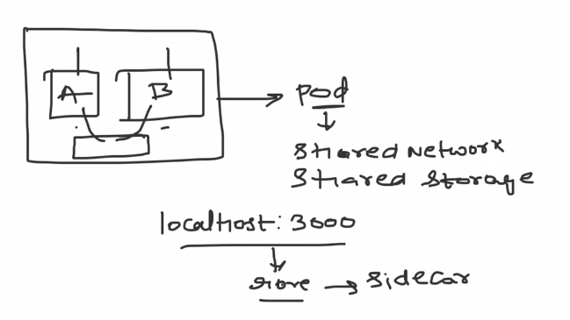

this is very rarecase,deploying the mutiple containers in pod.

K8s create the ip into pod,not to the containers.pod act as a host for containers running in side of that pod.

Kubectl is command line tool for k8s,we can directly iteract with k8s cluster using it’s config file from kubectl.

Install kubectl --> https://kubernetes.io/docs/tasks/tools/

we have multiple options of single node cluster
*minikube
*k3s
*kind
*microk8s

kind is advanced single node cluster,i will create the k8s cluster using docker,once you learn k8s/flexible with k8s,go and do more practice on kind

As of now going with minikube.
Install minikube --> https://minikube.sigs.k8s.io/docs/start/

minikube start --> creating cluster
minikube ssh --> login into cluster
minikube ip --> get the node ip
minikube dashboard --> open the cluster UI in browser
minikube status -->checking cluster status
minikube stop --> removing cluster
minikube pause --> don’t use resouces by minikube cluster, running object can use resource

In general kubectl commands:

$ kubectl apply -f path_to_spec_yaml_file

$ kubectl get name_of_object --> name_of_object is pod,deployment,svc,ingreess,pv etc

$ kubectl delete name_of_object

$ kubectl delete -f path_to_spec_yaml_file --> delete the specified yaml object if it present in k8s

kubectl command details.
https://kubernetes.io/docs/reference/generated/kubectl/kubectl-commands
https://kubernetes.io/docs/reference/kubectl/quick-reference/

Creating the pod: In real time,we will not deployment any application with pod because pod don’t have auto healing and auto scaling feature.
$ kubectl apply -f pod.yaml --> f stands for file and creating pod using specification mentioned in pod.yaml

$ kubectl get pods -o wide --> get all pods details with more info

$kubectl describe name_of_pod --> to debug and check all info about the pod.

$kubectl logs name_of_pod --> give the logs giving by pod
$ kubectl delete name_of _pod --> delete the object.

Difference between container, pod, and deployment

Container Pod Deployment

*Pass the all specification *Pod is a single or group of containers. *Have auto healing &
required run conatiner through k8s provide the facility to mention auto healing
the specification on yaml and run
CLI
*Don’t have auto healing and *Don’t have auto healing and auto scaling.
auto scaling

*deployment engineer have to *Understand the pod by reading the yaml *same as pod
inspect container to get info specification

