**Introduction to Indexing**

Indexes are data structures that store collection’s data set in a form that is easy to traverse.

**Indexes help to perform the following functions**:

● Execute queries and find documents that match the query criteria without a

collection scan

● Limit the number of documents a query examines

● Store field value in the order of the value

● Support equality matches that are range-based querie

**MongoDB supports the following index types for querying:**

● **Default _id**: Each MongoDB collection contains an index on the default _id field.

**● Single Field**: For single-field index and sort operations, MongoDB can traverse the indexes

either in the ascending or descending order.

● **Compound Index**: MongoDB supports user-defined indexes, such as compound indexes for multiple fields.

● **Multikey Index**: Multikey indexes are used for indexing array data.

● **Geospatial Index**: Geospatial indexes use 2D indexes and 2Dsphere indexes.

● **Text Indexes**: Text indexes search data string in a collection.

● **Hashed Indexes**: MongoDB supports hash-based sharding and provides hashed indexes.

**\*Creating the database indexing_practice**

**Inside the database creating details collection**

**Inserting the some documents for creating different types of indexing methods**

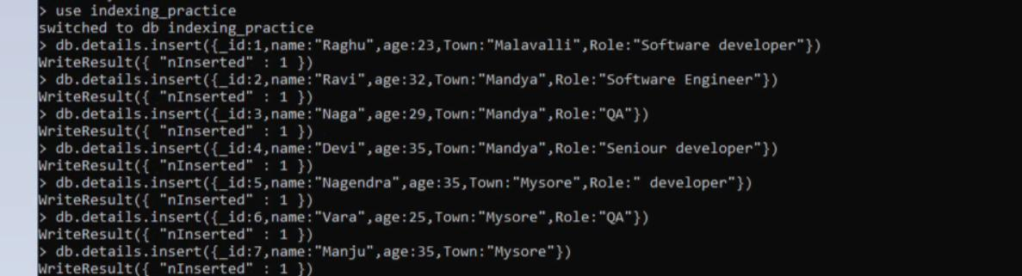

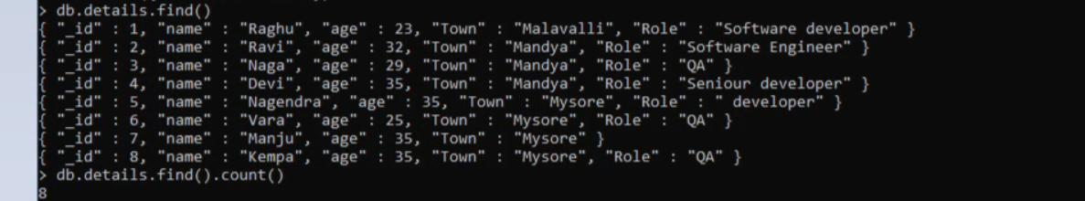

**\*Default _id Index 🡪** **Each MongoDB collection contains an index on the default _id field**



**\*Single field index 🡪creating the index on Town field**



**\*Compound index 🡪 A compound index in MongoDB contains multiple single field indexes separated by a comma. MongoDB limits the fields of a compound index to a maximum of 31.**



\***sparse Index** 🡪 **Sparse indexes manage documents with indexed fields and ignore documents which do not contain any index field.**

**To create a sparse index, use the db.collection.createIndex() method and set the sparse option to true.**



**Unique index** 🡪 **Unique indexes can be created by using the db.collection.createIndex() method and set the unique option to true. To create a unique index on the item field of the items collection, execute the operation given below.**

**db.items.createIndex( { “item": 1 }, { unique: true } )**

**If a unique index has no value, the index stores a null value for the document. Because of this unique constraint, MongoDB permits only one document**

**without the indexed field. For more than one document with a valueless or missing indexed field, the index build process fails.**

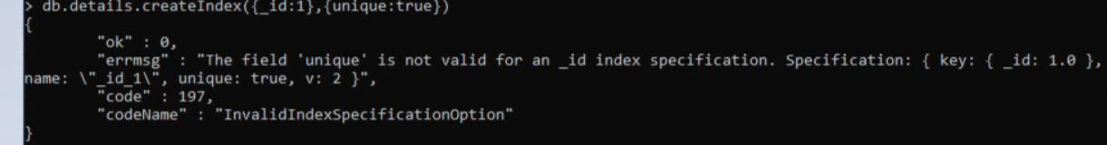

**Command for to check the how many indexes are created in the collection**

