We have docker to run our appliaction in container,why people are going with platform service
like ECS,EKS?

Ready Kubernetes day 1 notes to understand

*Auto scaling
*Auto healing
*Multi node deployment
*Enterprise level support.

AWS ECS:
Elastice container service

On The Evalution of container orchestraction environment:

Kubernetes giving above features to overcome problem, on top of kubernetes open source project , other companies are making customization and releasing their own distibution for container orchestration. Like Openshift,rancher,EKS.

AWS started with ECS.
Amazon Elastic Container Service (Amazon ECS) is a fully managed container orchestration service that helps you easily deploy, manage, and scale containerized applications.

AWS come up with service which don’t have dependency on kubernetes like
docker-swam,mesos none of them are not so successfull.
Aws told we will not use any concept called pod, deployment etc. We will have oun task definition service,cluster

The jounny of ECS:
ECS platform developed from aws is only restricted to aws,this will not be a open source platform.
We will restict this into customers of aws and services of aws.

Advanages of ECS
*AWS will manage the service and provide the ECS service, ECS cluster support fargate or ec2 instance, fargat is a serverless service like lambda function container runs n fargates no need to mange anything on it.
*Cost effective(less cost) compare to EKS

Major disadvantage of ECS:
*When your orgnization moves from aws into azure,we will not able to use the task definition service(resources) etc which created in ECS,you have to start from scrach.
*Features in ECS are less
Features are -->
Don’t have support on custom resource definition
we have use their own service for load balance

Advantage of using kubenetes over ECS:
*your org have kubernetes cluster and created many resouces,later decided to move to azure,we can re-use 80 to 90 of manifest to deploy in azure kubernetes service
*Kubernetes have more features,kubernetes have strong community support,lot of peoples are contributing enhance the kubernetes features because kubernete is open source project.

Features are
*Custom resouce definition,we can implement or install custom controller on kubernetes to extend functionality like istio, argo CD.
*we have multiple ingress contoller installed on kubernetes,more rules that are advanced web application firewall,advance secret management etc

Structure of ECS:

we can create task definition like pod.yaml to mention on how to run the container in ECS,once you apply the taskdefinition,task will be create and running containers,then you can create service for load balancing.

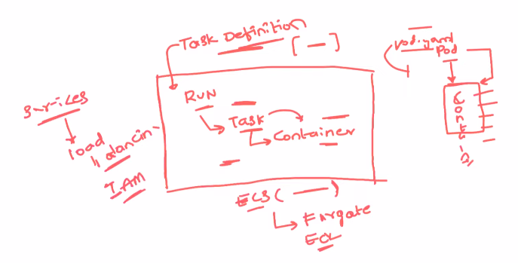

Creation of ECS:

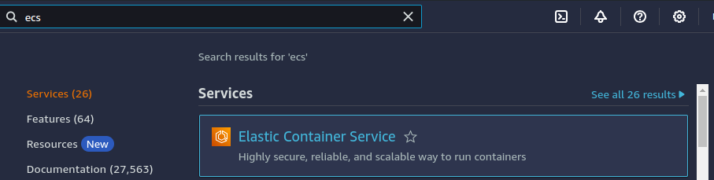

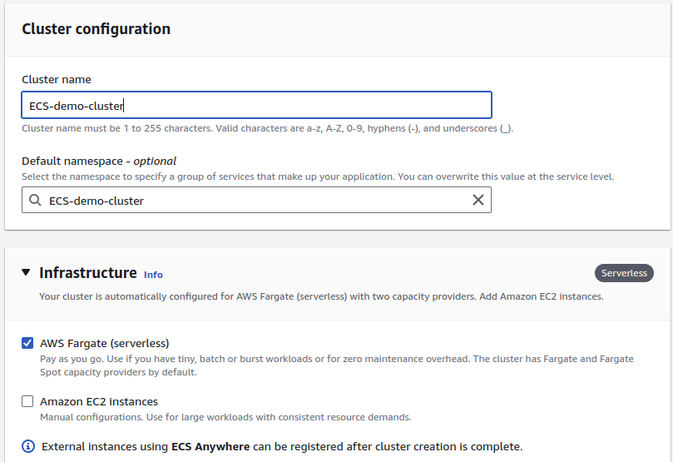
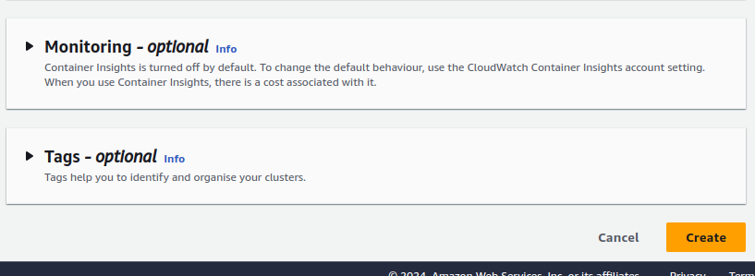
By default,cloud watch will monitor the ECS cluster.

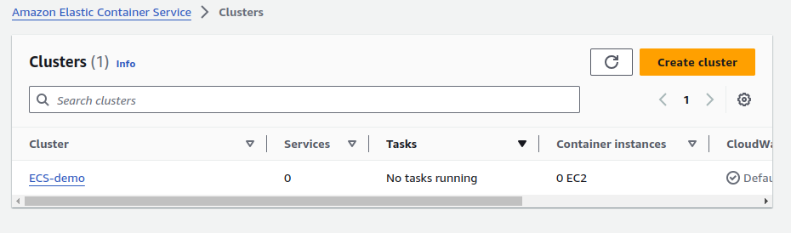

Create repository in ECR:

As exapained in previous vedio.

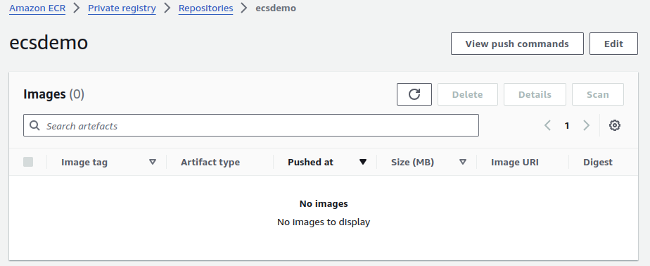

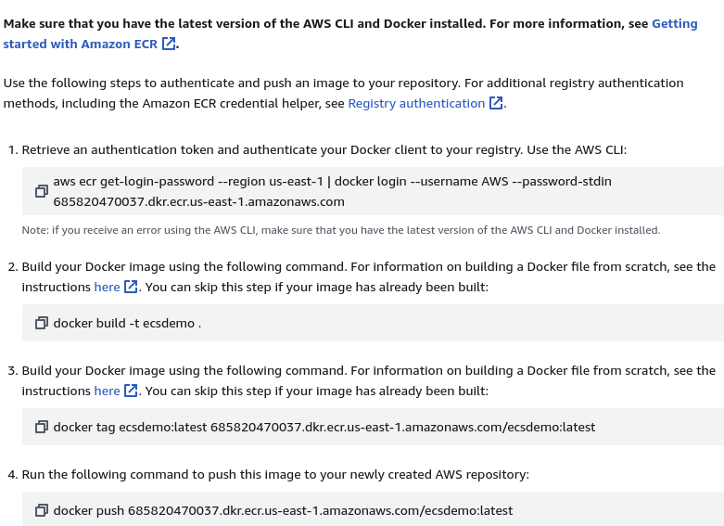

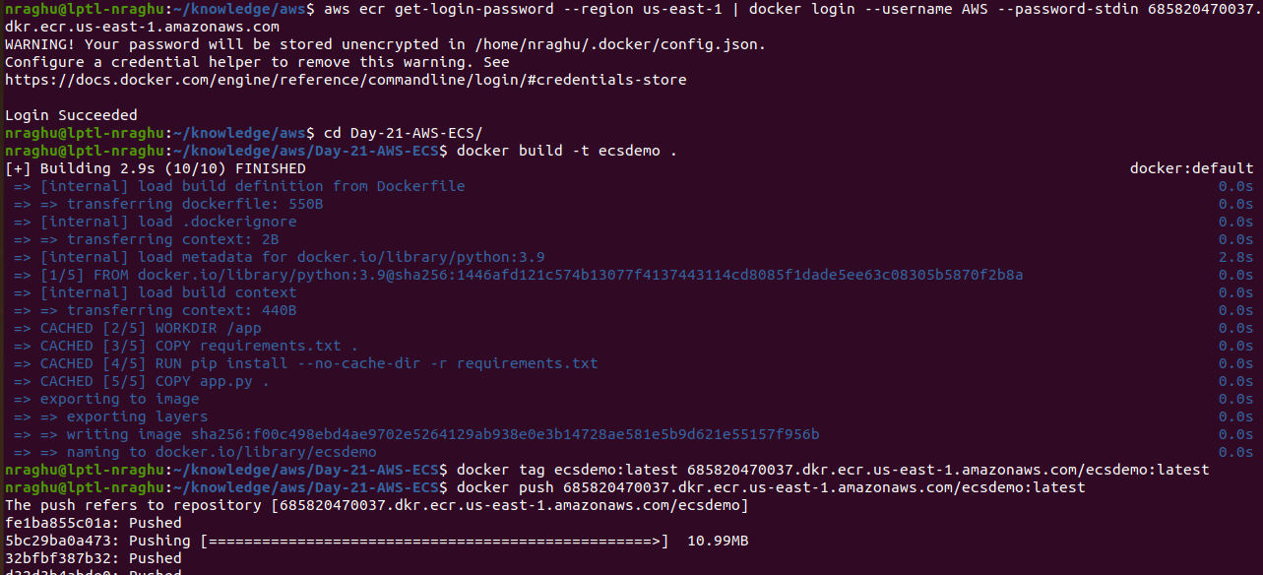

Creation of Task definition:

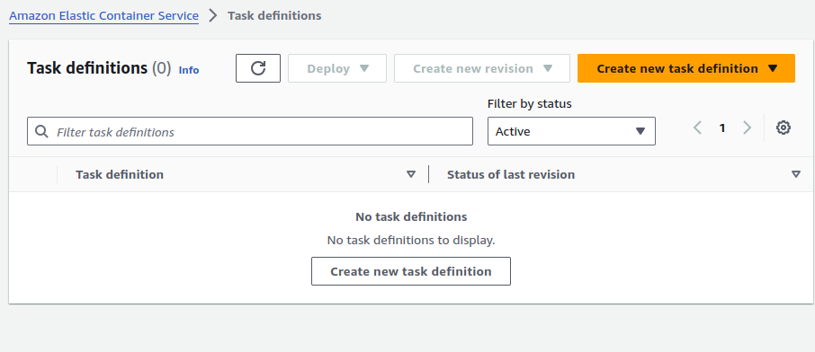

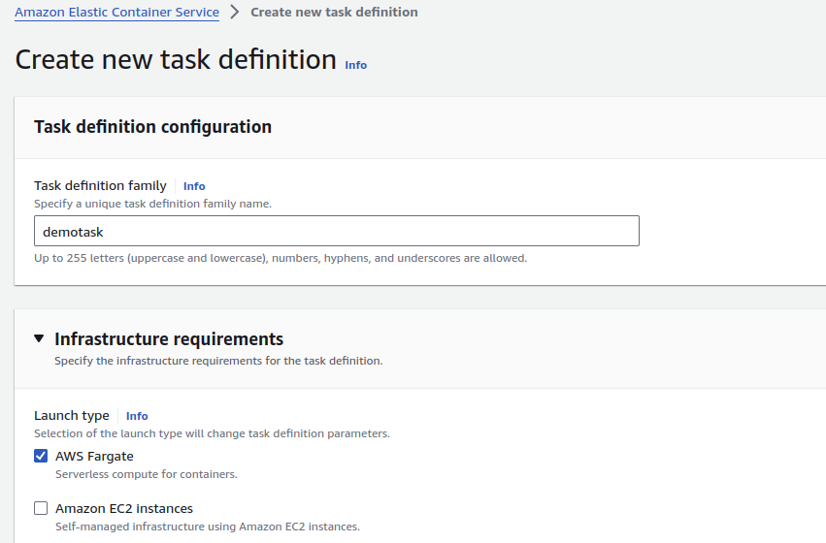
go with Fargate for nodes

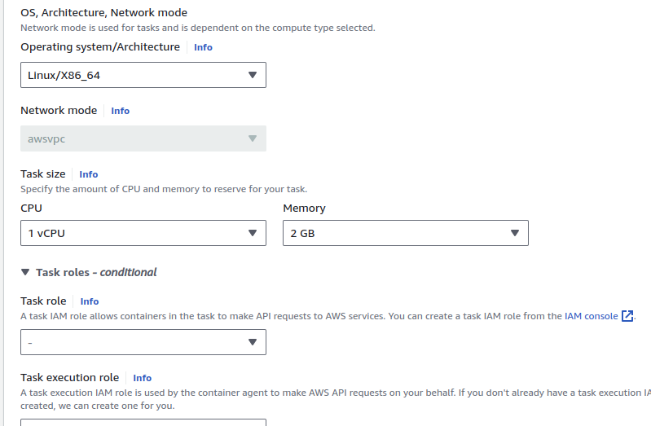

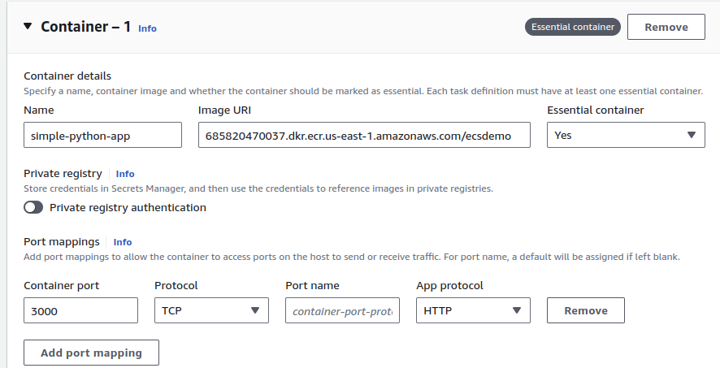
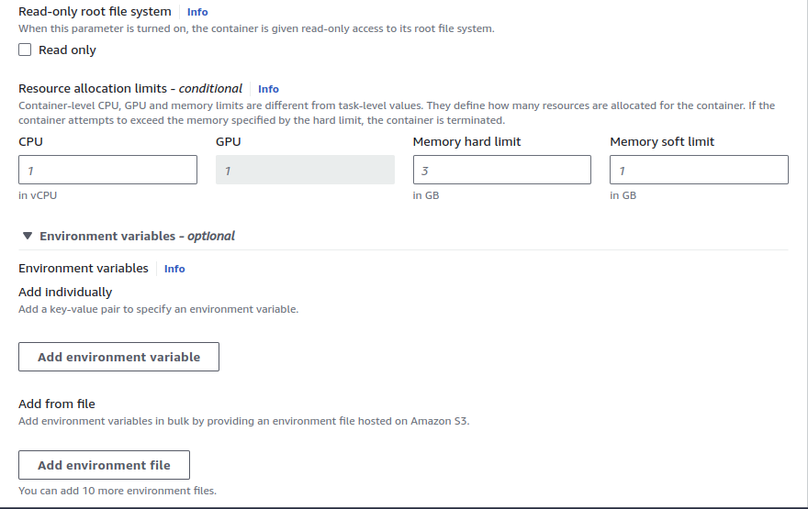
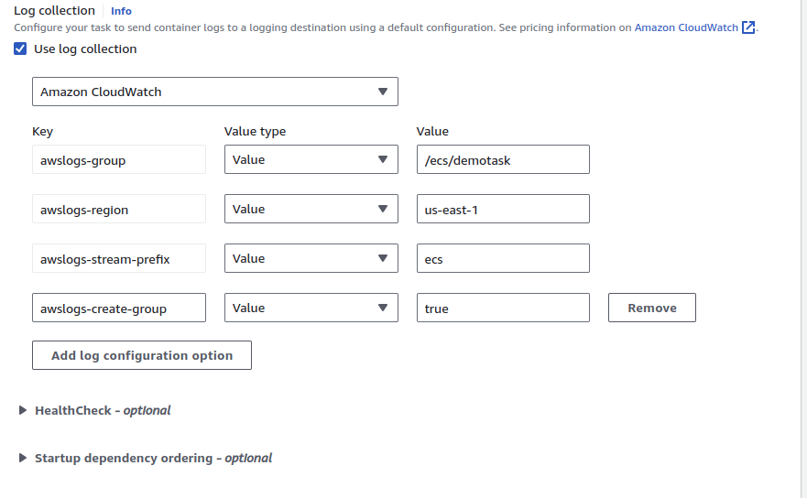

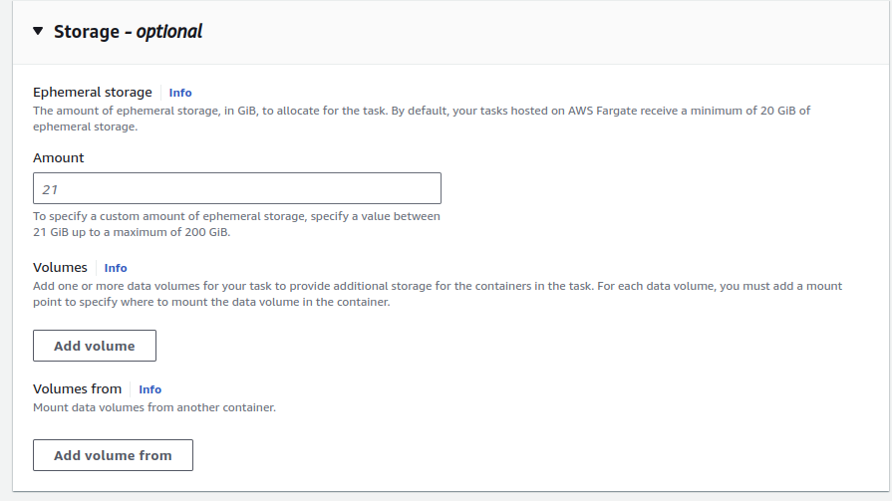
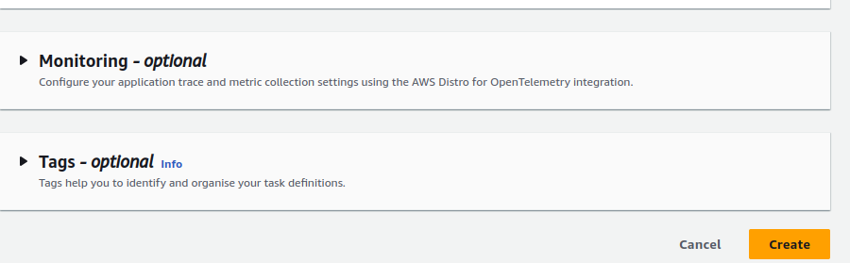

Create task from Task definition:

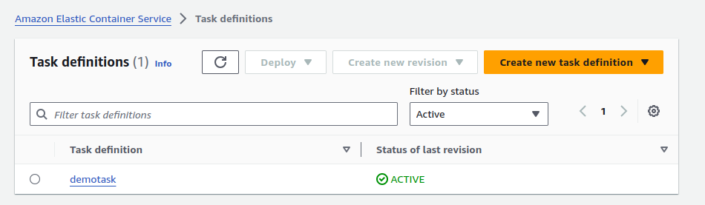
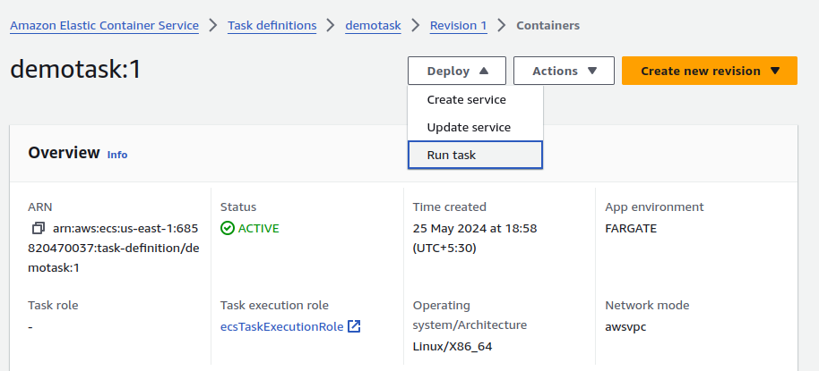

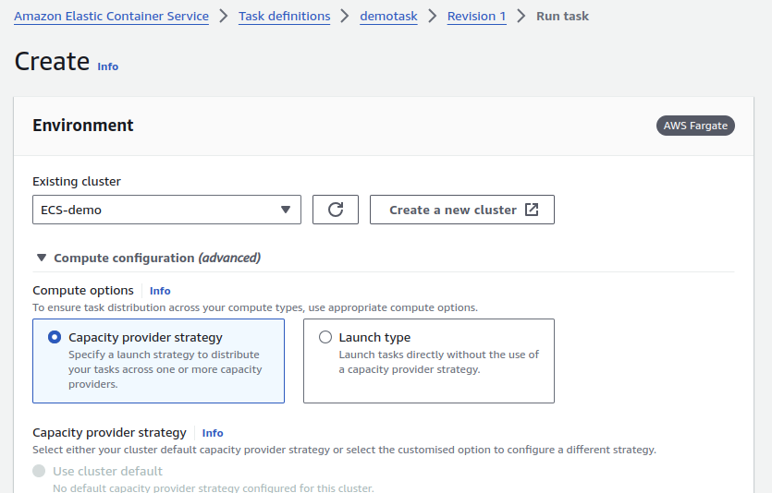

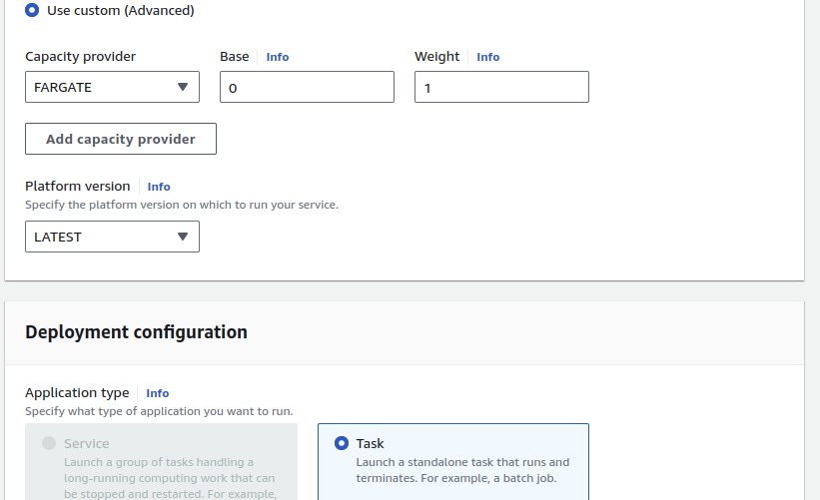

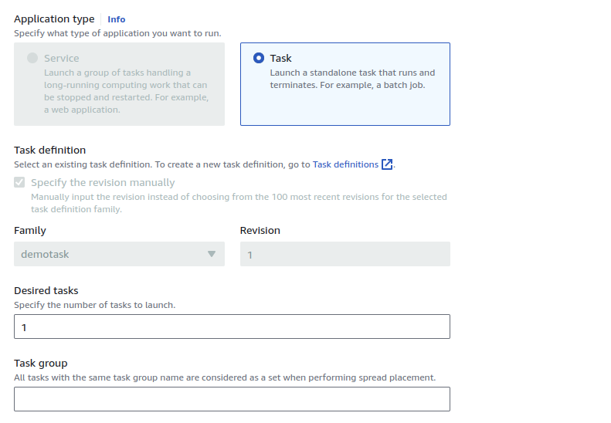

Scrol dowm and click on create task --> container will start running

