IAM in aws:

IAM --> identity and access management

*IAM is authentication and authorization service in aws.

*Authentication and Authorization:
Checking is the user is valid or not in platform,is called authentication.

Authentication, if user is valid in our platform what type of permission user have is called authorization.

Ex: In the bank,there are different places to places, customer place, employee place and sensitive data storage room etc.

When person enter into bank,checking the person is valid by taking details of him,like he have account or he is bank employee is called authentication

once authencation is done,what type of permission have in bank is called authorization.
Like if he is employed enter to work or manager check the sentive storage room is called athorization.

Developer come and ask to give read access to db and deploy access to eks,then devops engineer need to create user and attach policy which have access to whatever requested.

If your Devops engineer which user want to use or recommen to other devops engineer to use?

I would recommend to use IAM with almost full access because if all people will use root permission,we can’t track who did what action in aws account.

IAM server ,there are four things

Users
Policies
Groups
Role

Users --> For authentication purpose(entering into account),we will create user in IAM service,user don’t have access to any service untill policy attached to user.

Policies --> which have information about the permission into services.

Groups--> we can’t create all users in company,many people join or left, to manage users create groups and attach some policies into group,when new user come,check which group he belongs,add user into that group. No need create policu into new users.

Role--> Role will provide access to one aws account into another aws account or access the aws service from on premises and it is tempovary user.

Creating IAM user:
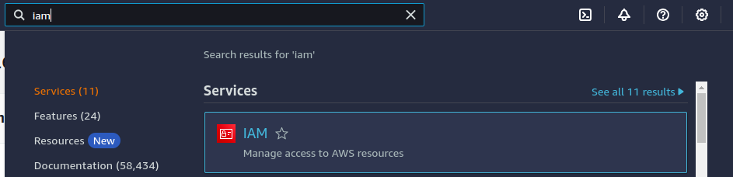
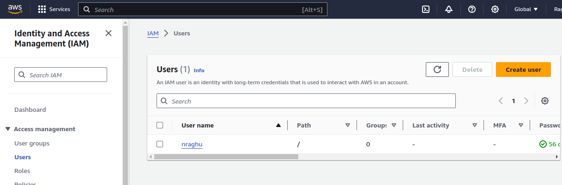

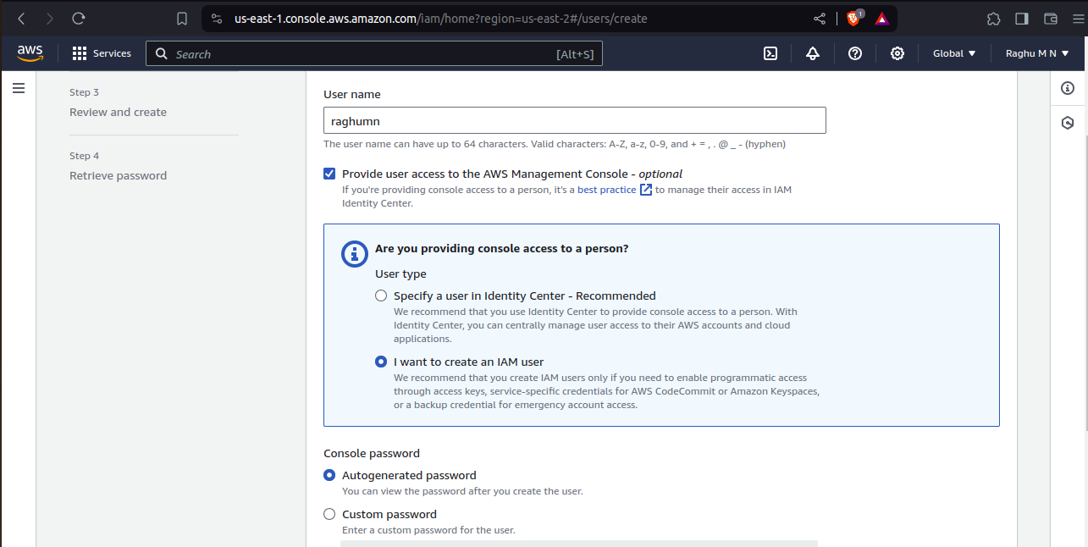

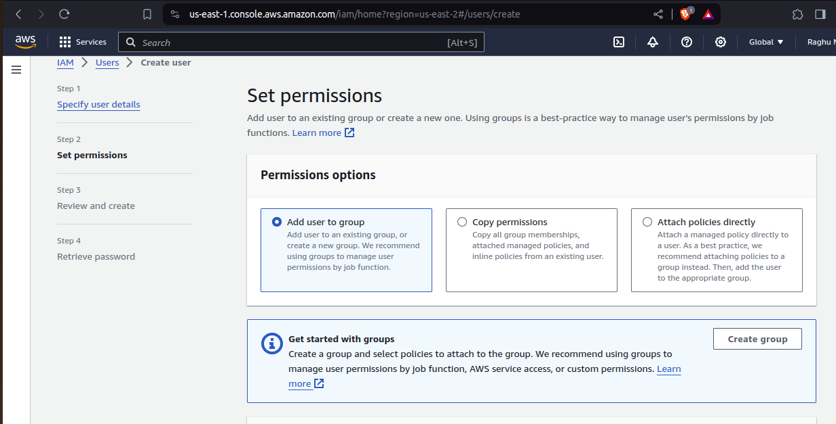

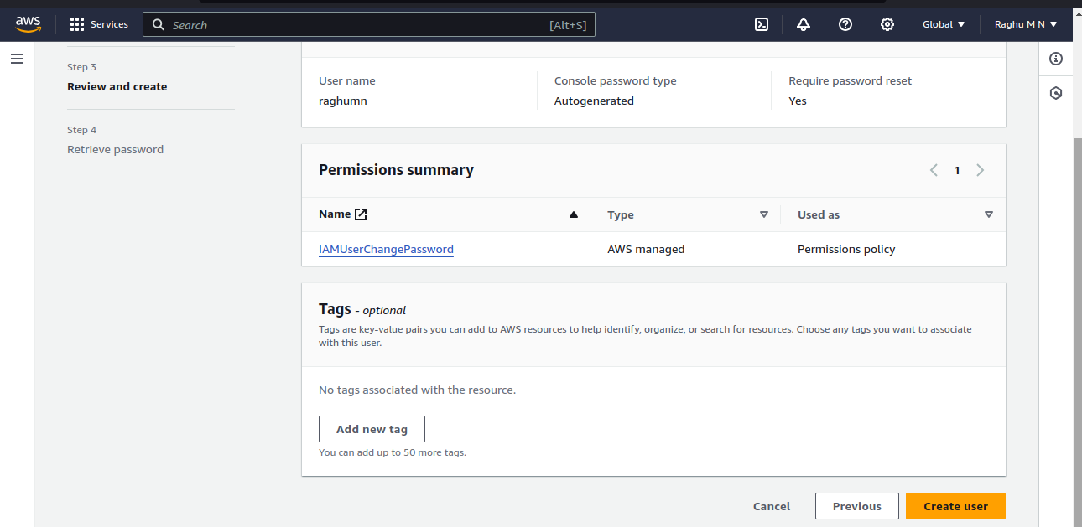
Once user created download the .csv file to share to user to login into aws aacount.
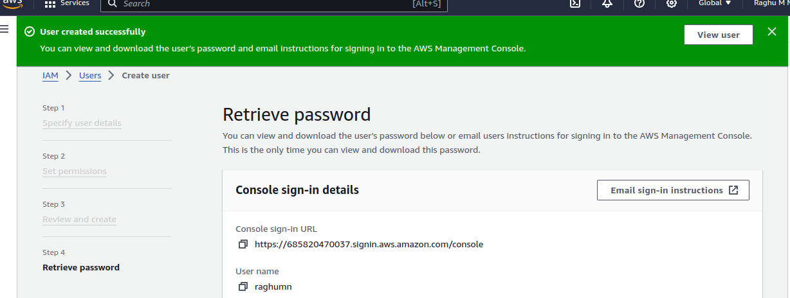

Attaching the policy to user
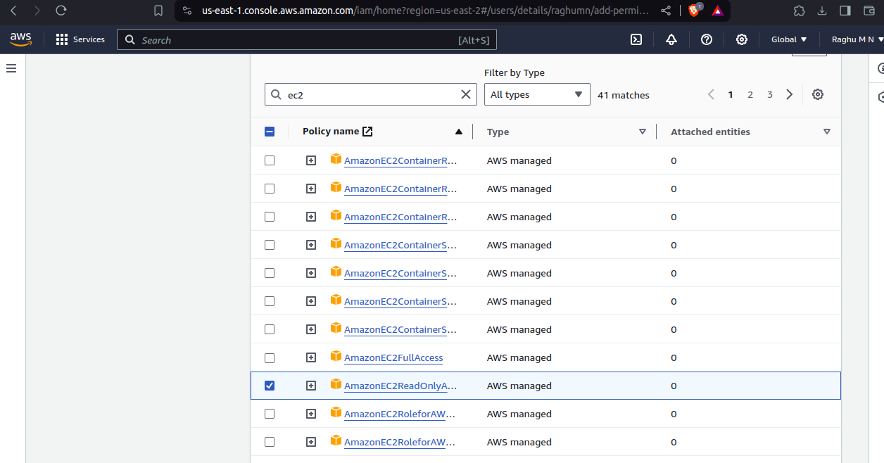

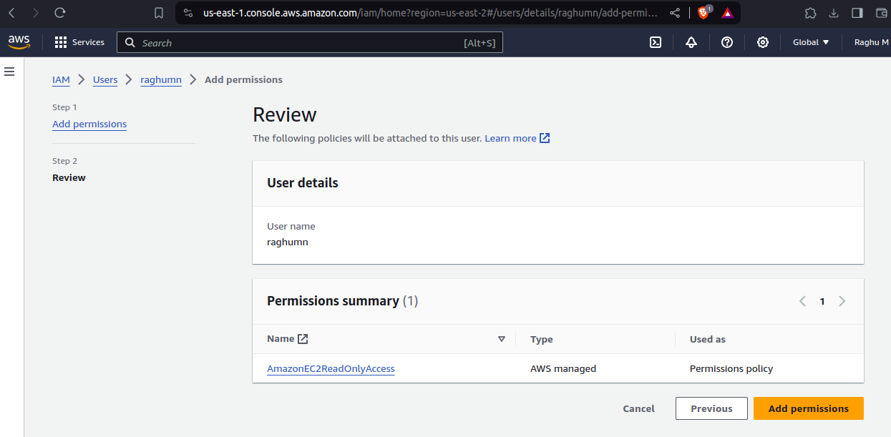
Creating custom policy:

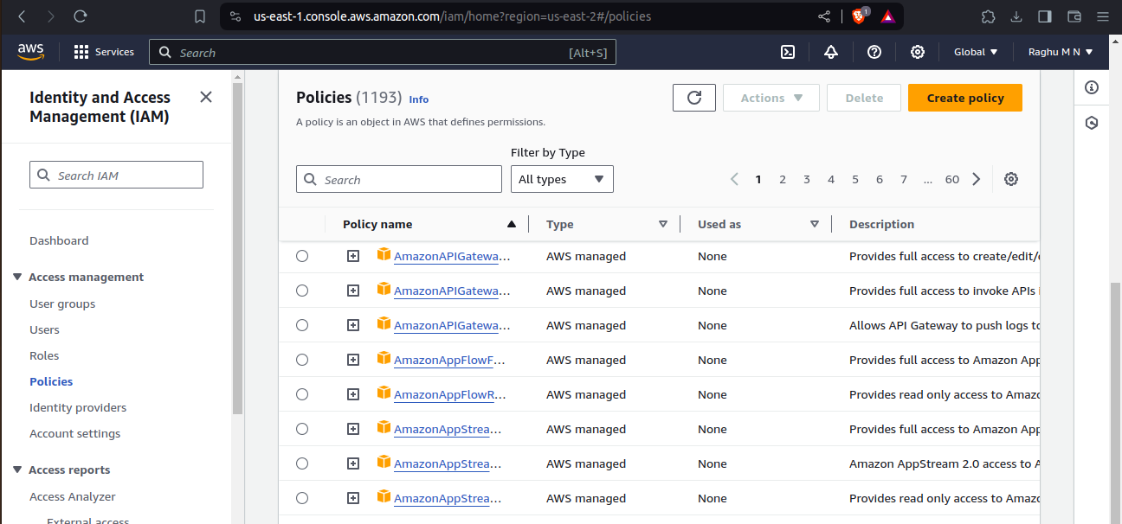

Creating group:
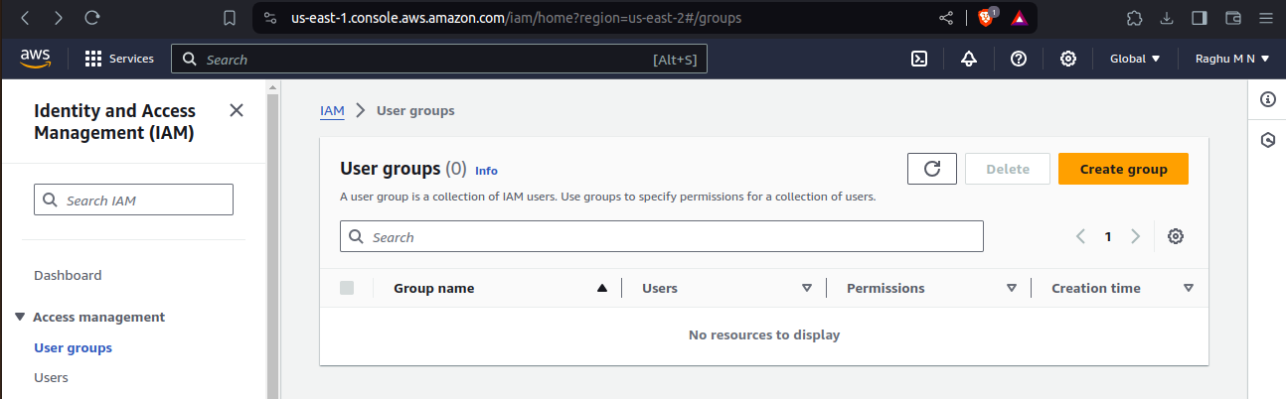

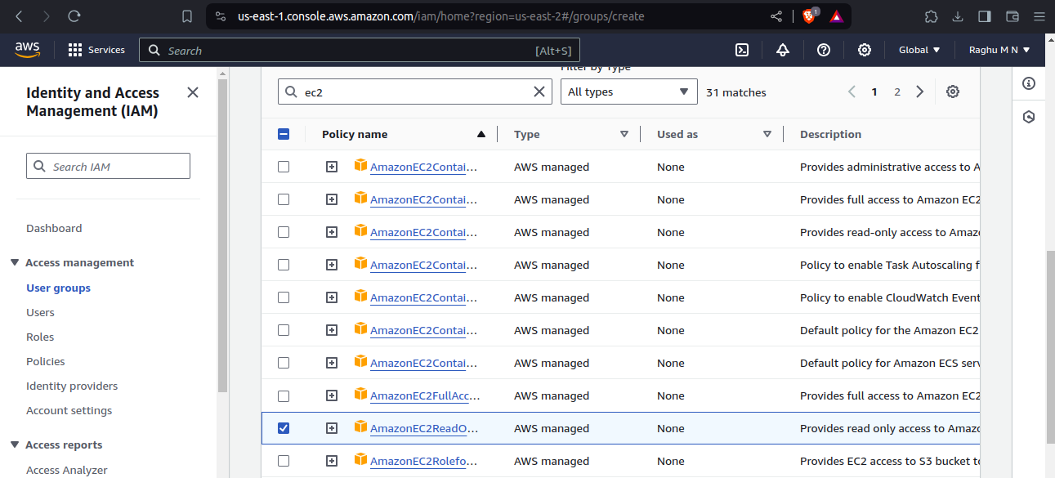
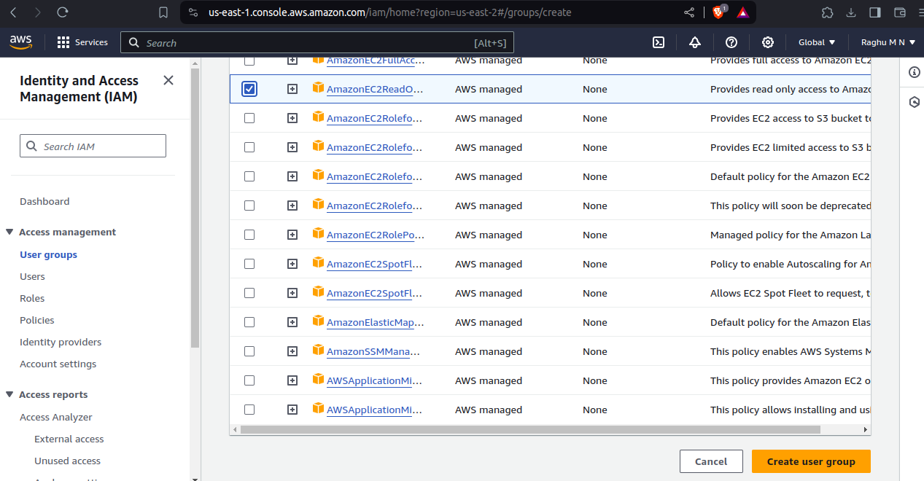
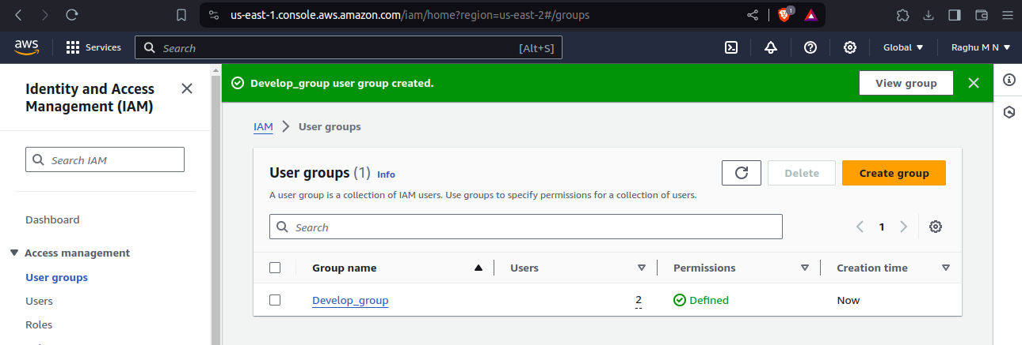

Creating Role:

