AWS security group and NACL:

Funactinal diagram of VPC:

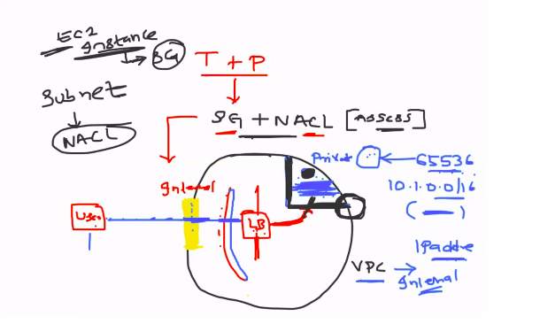

*When user sent the request to access application,application is deployed in one of server comes under VPC.
Request will be checked by internet gateway,then it go to public subnet of VPC,then go to load balancer,load balancer have route tables and redirect to application server.

VPC will be created from particular ip range and inside of vpc,divided into multiple subnets.

*Adding the security check at subnet level is called NACL

*Adding the security check at application server(ec2 instance) level is called aws security.

*AWS sayes security is shared responsibility,mean will do all possible security things by giving services like VPC,aws security group,NACL etc.
Devops engineer or aws engineer from your org need to add this by creating custom service
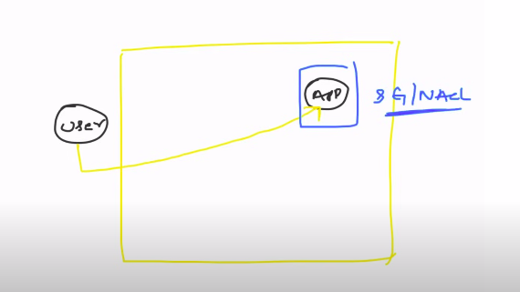

Security Group:
*inbound rule --> request coming from outside to access application is inbound rule or inbound trafic
*outbound rule --> request going from application server is outbound rule or outbound trafic.
*in security gorup ,there is no concept of deny,we can’t configure to do deny for some configuration.

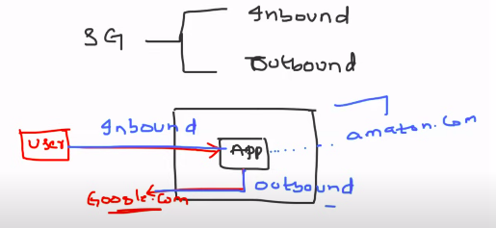
*By default, aws add default security group.
Defult security group will block all port access from outside(there is no inbound trafic by default) and allows all ports from outbount trafic except port 25,because 25 is mailing serve port there will be swam will happen.

NACL: Network access control list

*Adding the security configuraion at subnet level is called NACL
*In NACL,you can define which configuration need to be denied and allowed.
The secutity configuration created by NACL will apply to all EC2 instances in subnet.
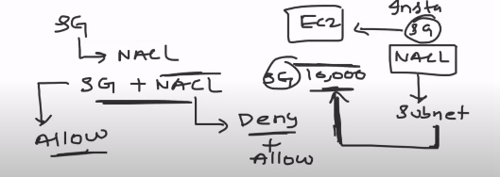
Practicals:

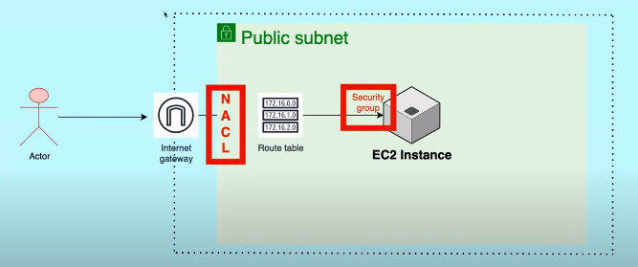

Creating the VPC:
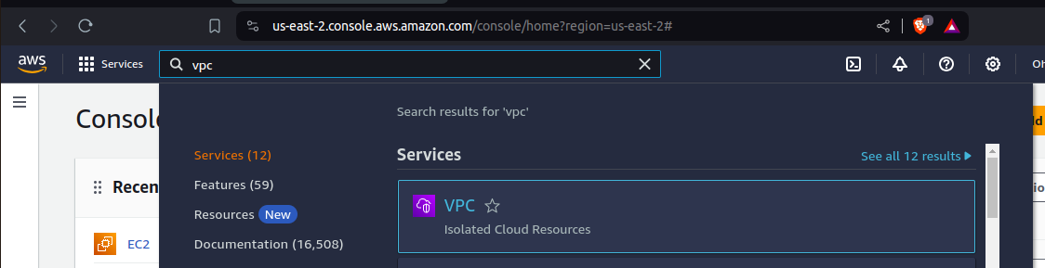

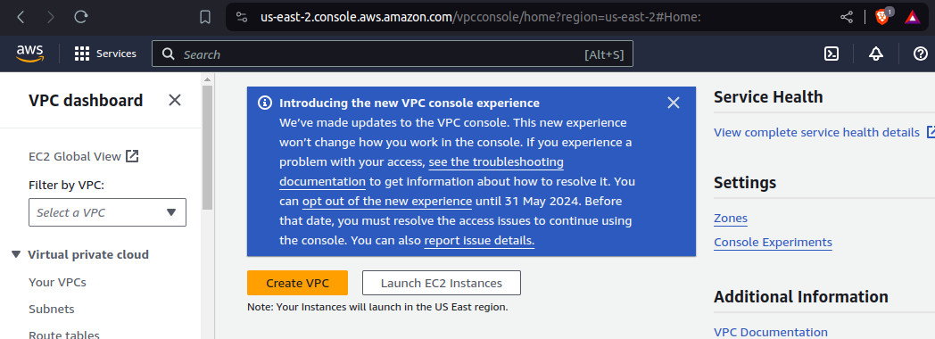
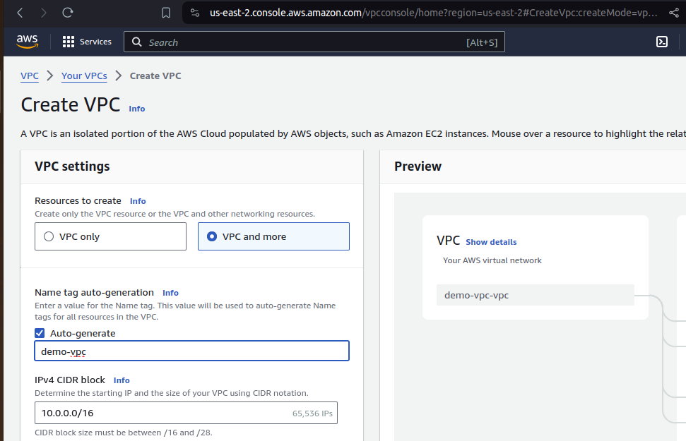

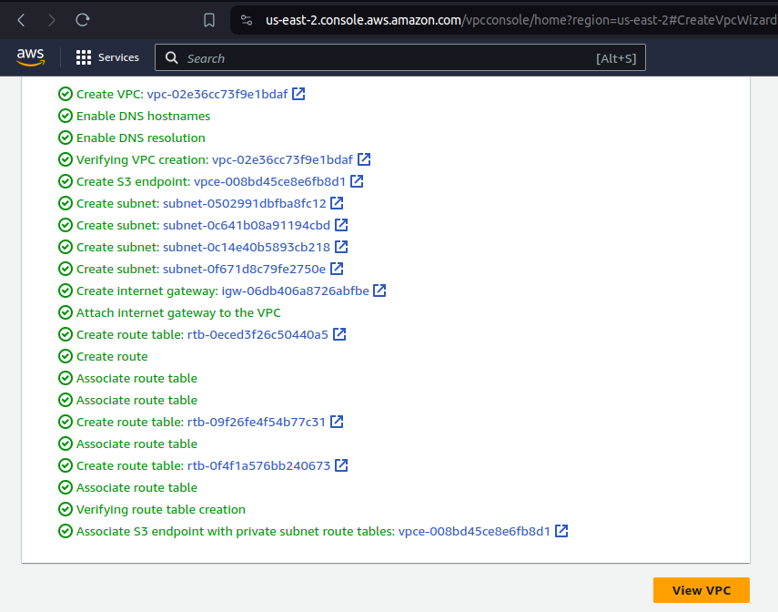
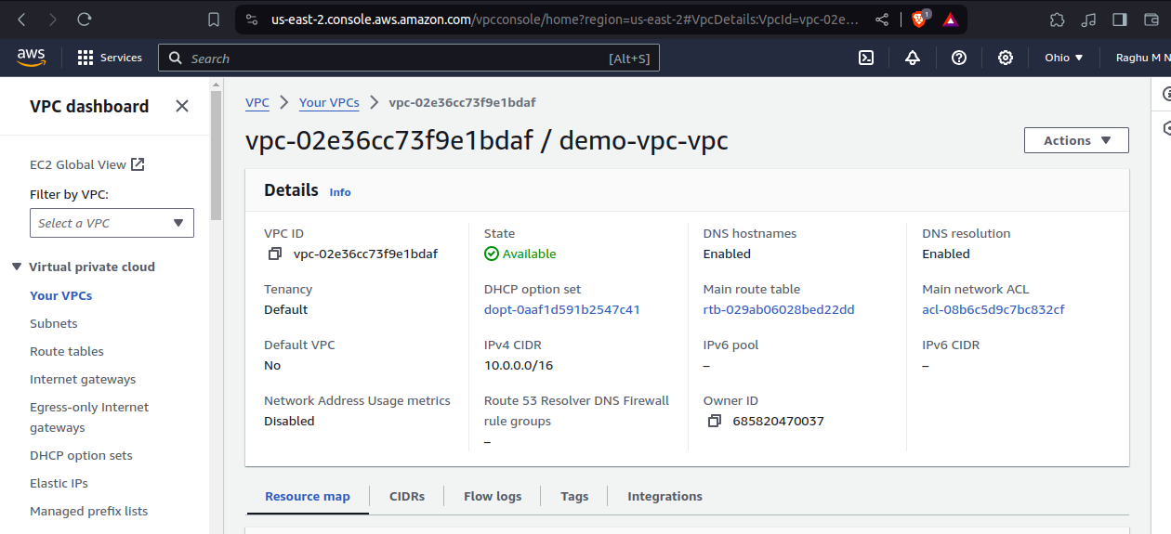

EC2: Creating EC2 instance and adding into our vpc.

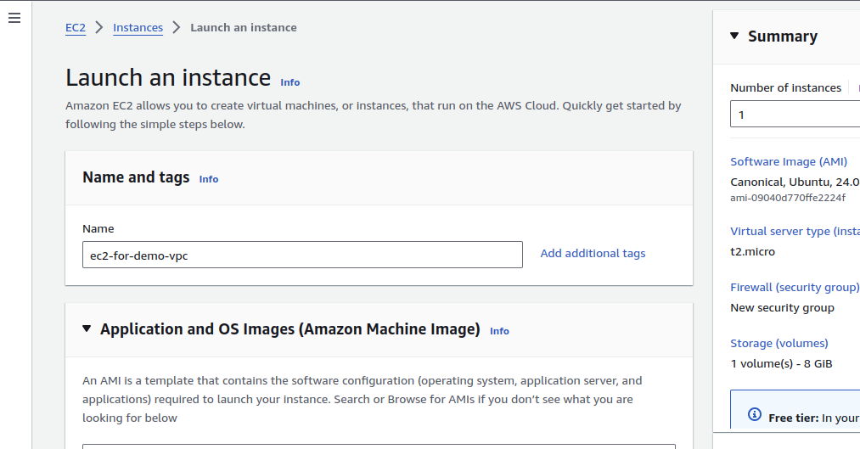

Selecting our demon-vpc in network security and select enable for auto sign public ip address to connect through ssh.
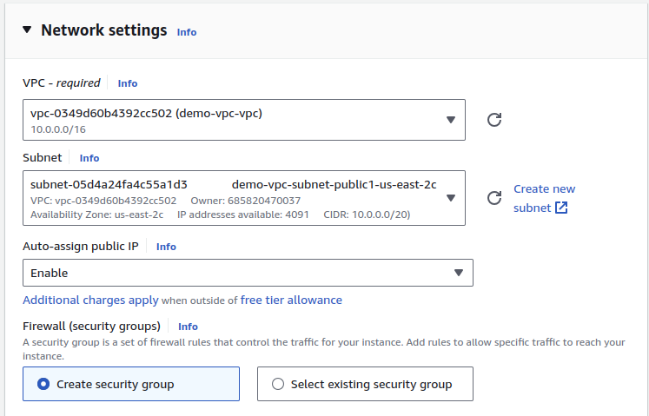

By default aws add security group to ec2 instance:
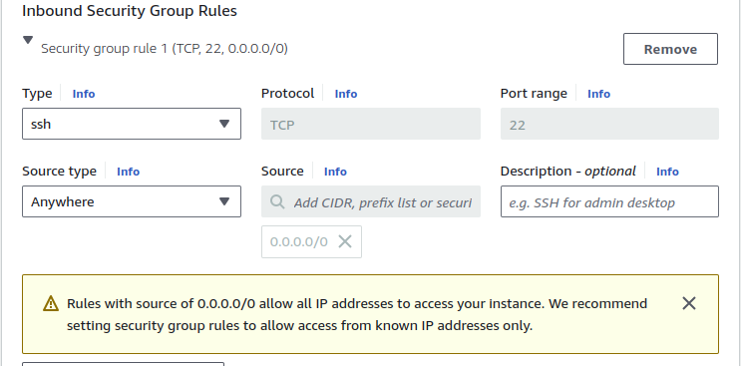
connecting to ec2 instance:
ssh -i .pem ubuntu@public_ip

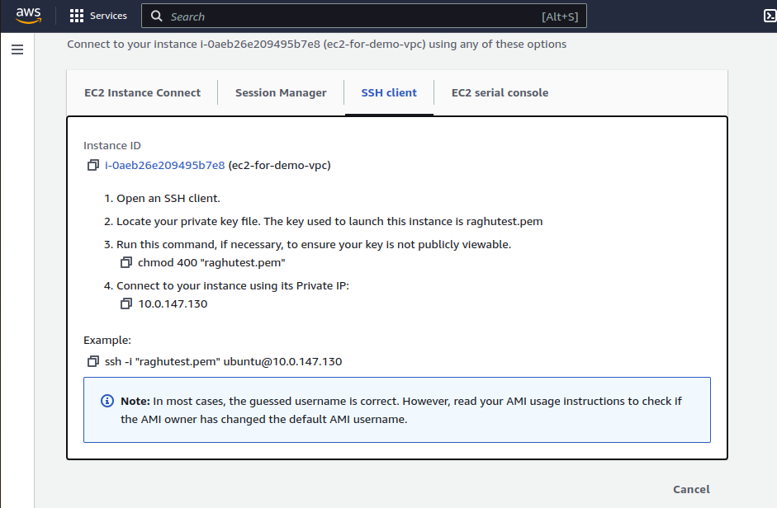

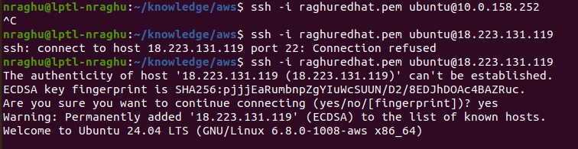
In above example show,ec2 instance is not completely ready when it shows runnig,i got port 22 as connection refused mean updating instance configuration is still pending from aws.

I am just serving simple web server using python3

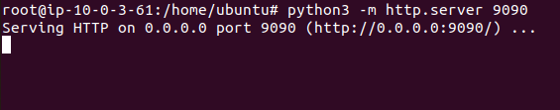

i go and access using public ip and 9090 port,it will not allow me to accees because by default aws applied security group to block all incomig requests

Enable inbound :

Go to security section in below of instance details
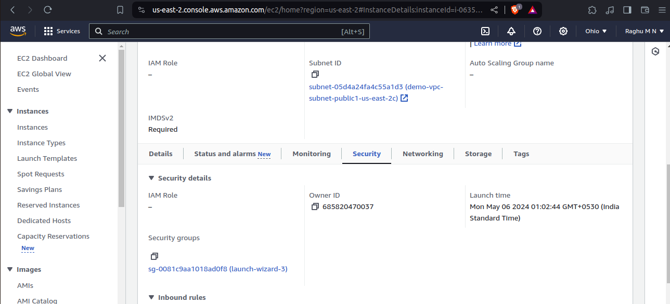
Click on security groups click as shown in above image

click on edit inbound rules:

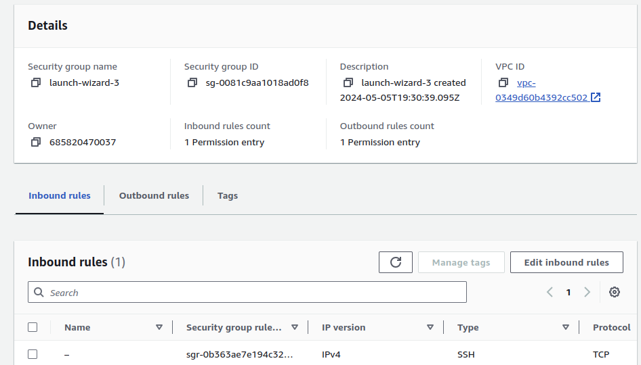
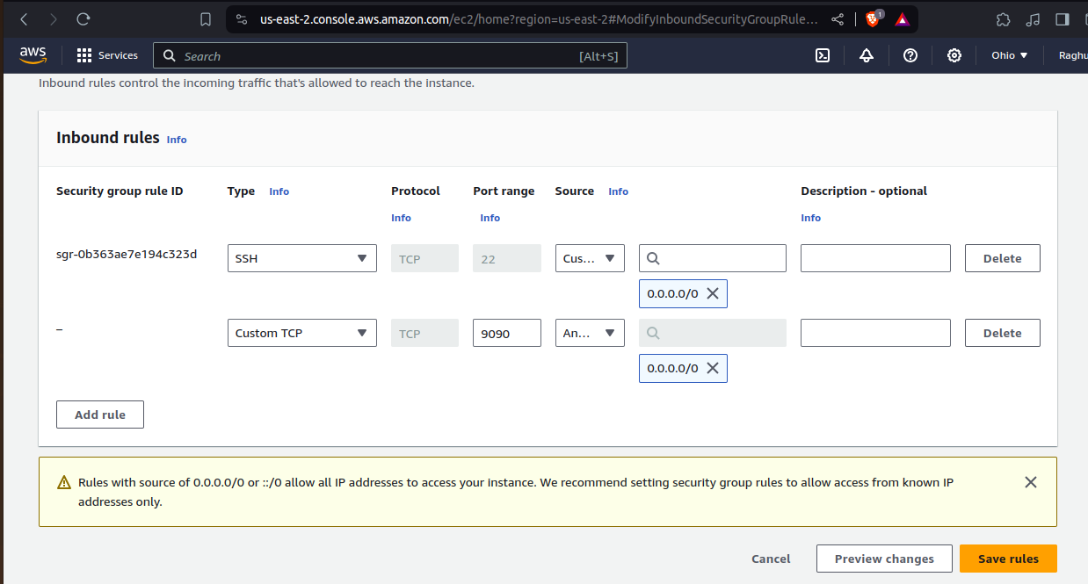

Now i can able to access application.
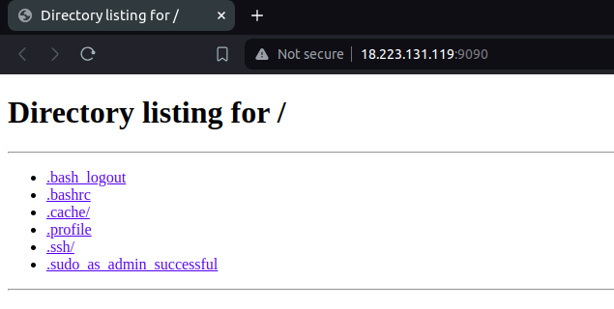
Deny the reqest to 9090 port of all instances in vpc, even if it allowed in ec2 instance security group level,NACL will block to access it:

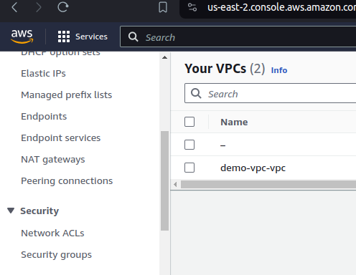

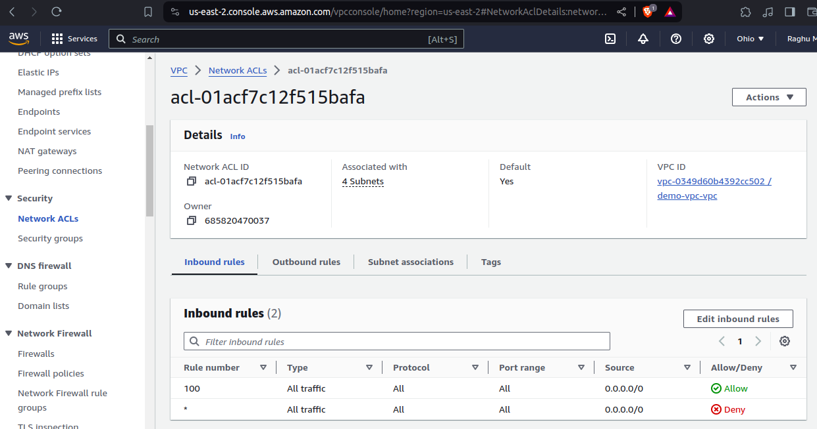
Rules will be check from rule number,first check 100 then go to 110.
if request is satisfied in 100 rule,will not go and check 110
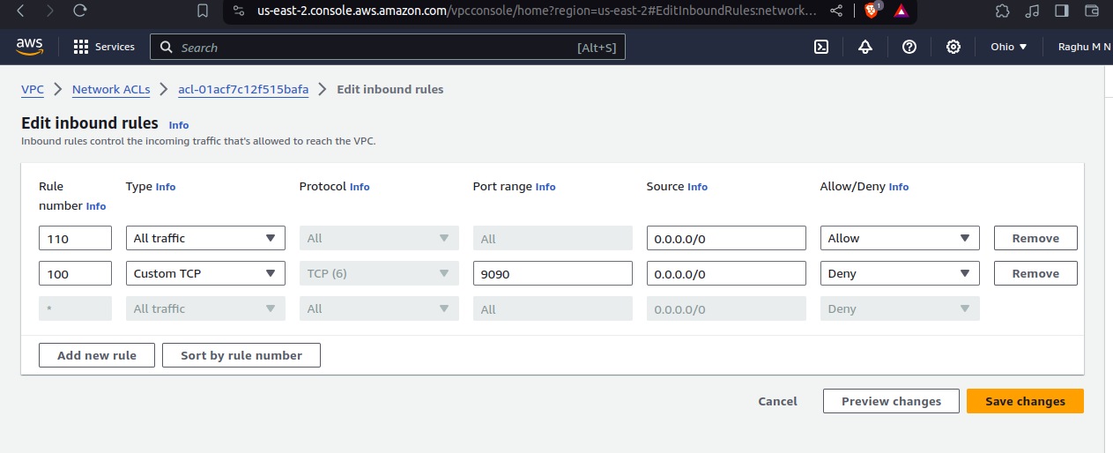
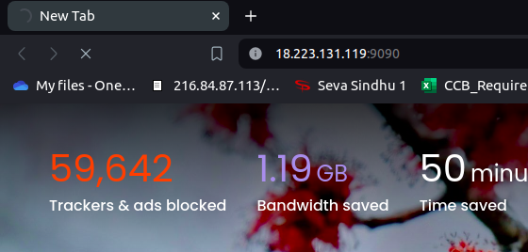
Now not able to access because it blocked from NACL level(subnet level of VPC)

