AWS Project on Production:

Official document from aws about the project:

https://docs.aws.amazon.com/vpc/latest/userguide/vpc-example-private-subnets-nat.html

Elastic IP address: is static ip address in aws,ip address will be changed.
If you attach ip address into ec2 instance,if ec2 instance goes down and come back,
the Elastice ip addess will be remains same.

The componets used in this project:

NAT Gateway --> When application need to download any package or data from internet,request will go to NAT Gateway,NAT Gateway will mask private ip address or use public ip address to down and give to private server.

Public subnet: Once the request come from internet gatway,public subnet will send to load balancer,then lb will redirect to application server using route table.

Auto Scalling group: used to create desired instance to us and also mention whenever the requests will be more into application servers,auto scale group will create another set of application servers. Scaling up application servers when requests are more.

Bastion-host : we can connect to private servers because they don’t have public ip address. Through bastion-host will able to connect to private servers and it will keep tract of login user(record the audit log).
Will do the ssh into bastion-host instance, then from bastion-host instance will do ssh into private servers.

Project: aws vpc with private subnet and public subnet to deploy application.
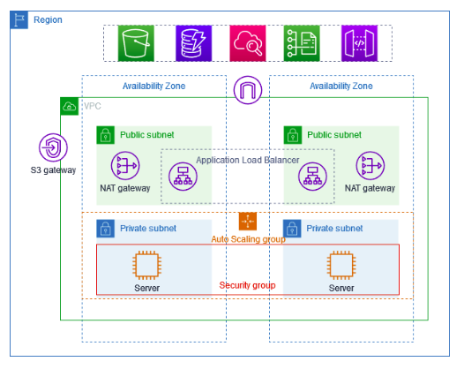

Proctically i need to do the project by creating VPC,auto scaling group,load load balancer,bastion-host and running application in private servers.
Creating VPC,which have two zones,two public and private subnet(one per zone) and one NAT gateway per zone:

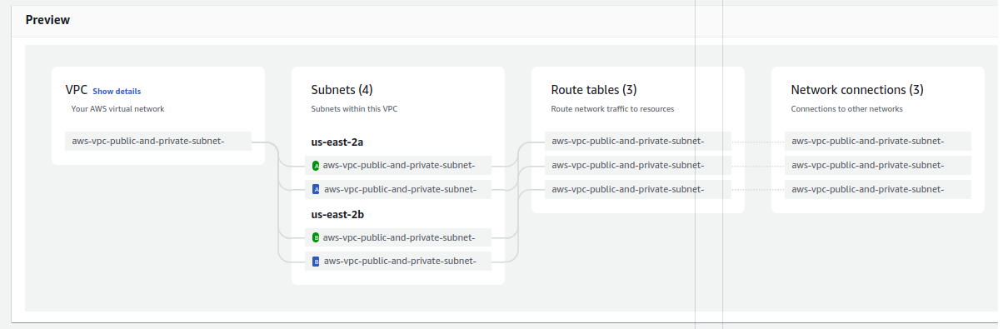
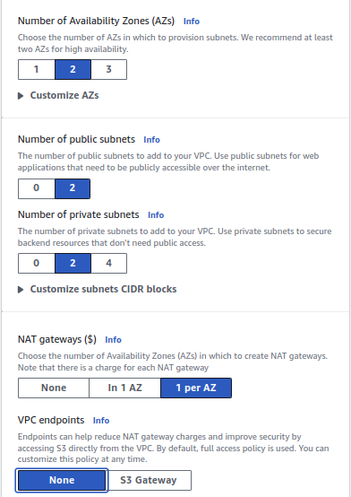

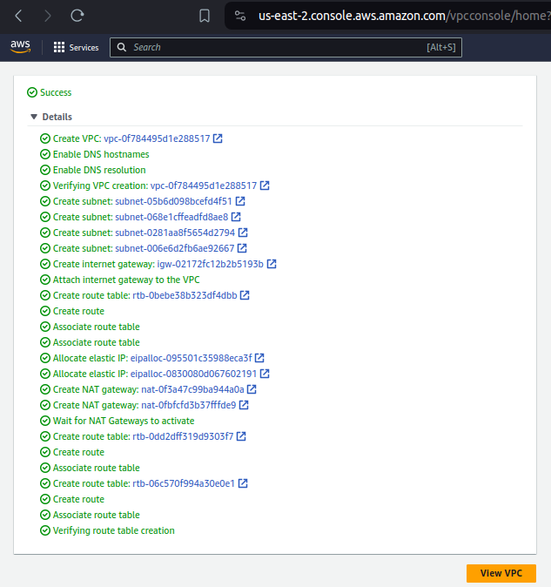

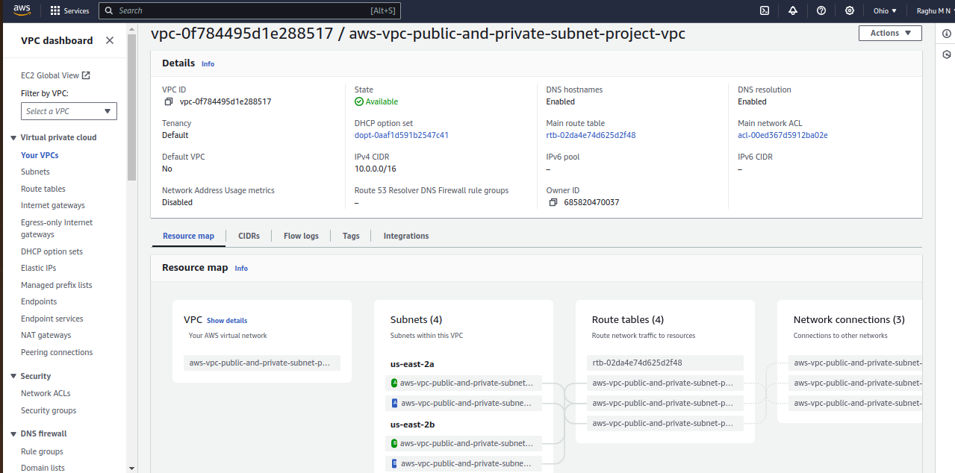

Creating Auto Scaling Group : it is creation of ec2 instance,required lauch template,launch template will have information about min and max instance and mentioning how many instances to be automatically created when the request to application is more.
And attaching the auto scaling group into our vpc

In EC2 instance view,at buttom,you will get the Auo scaling group.

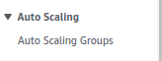

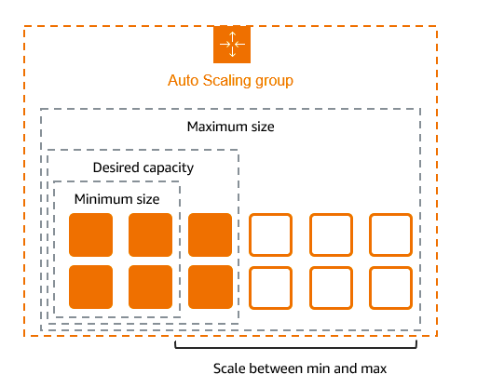

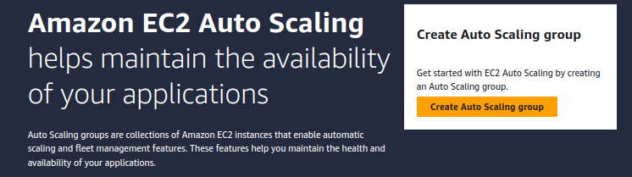

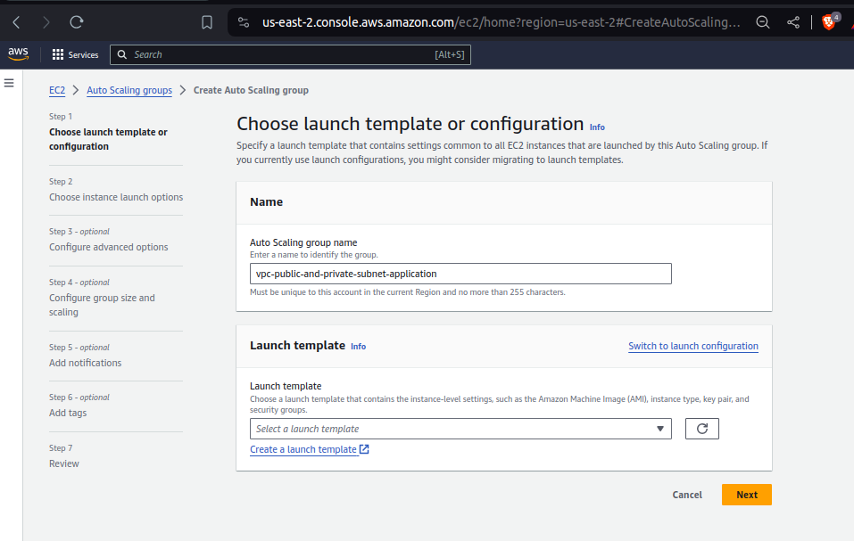

Creating template whic is required for auto scaling group.

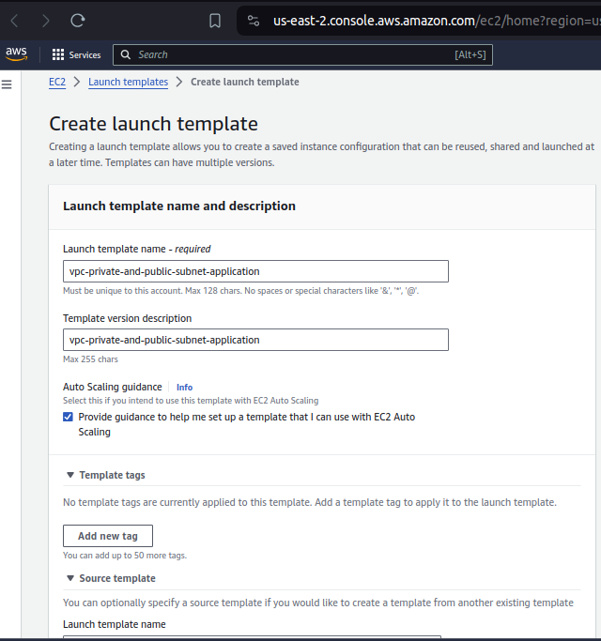

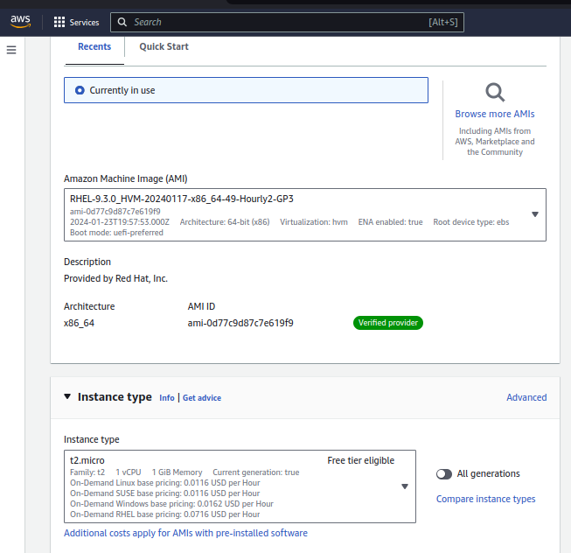

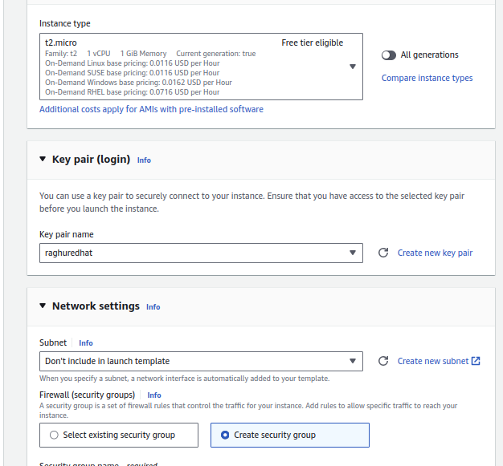
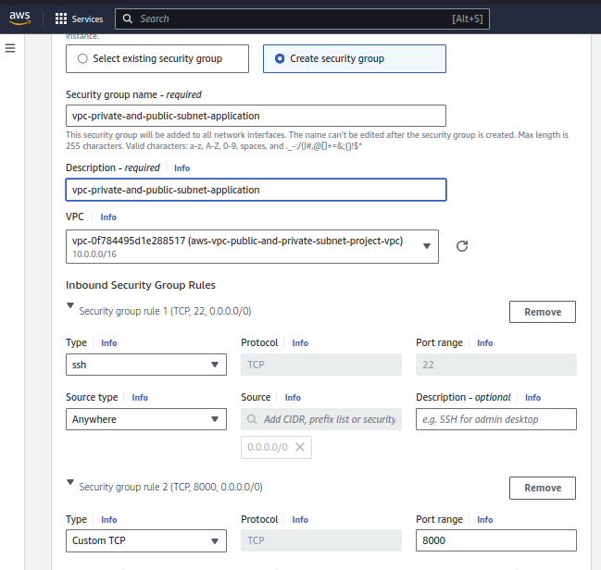

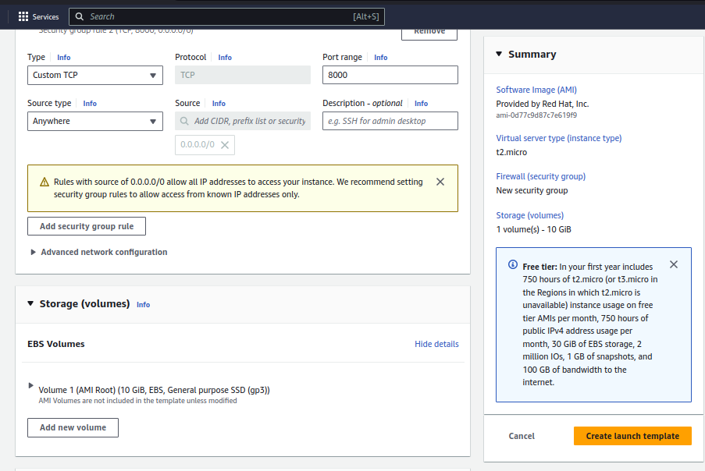

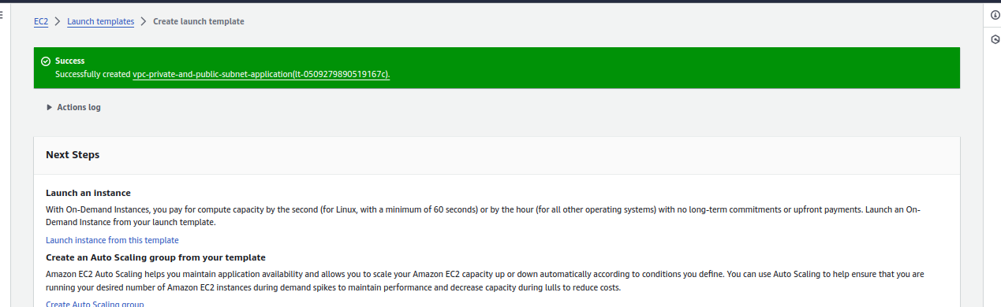

Go back to auto-scaling group url and reload page,in drop-down it will show the template

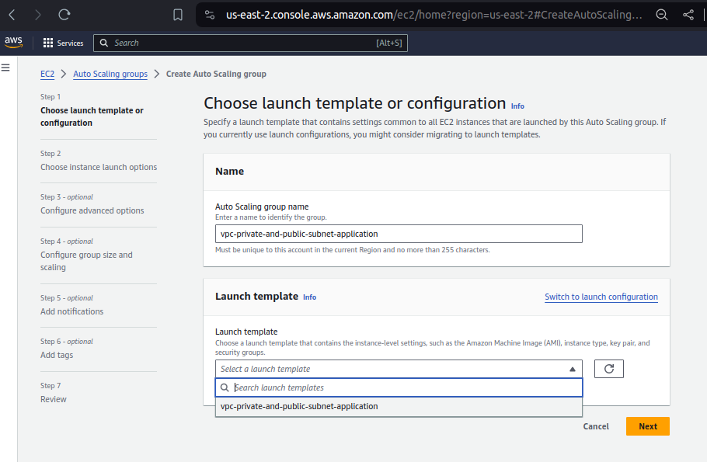
Select your VPC:

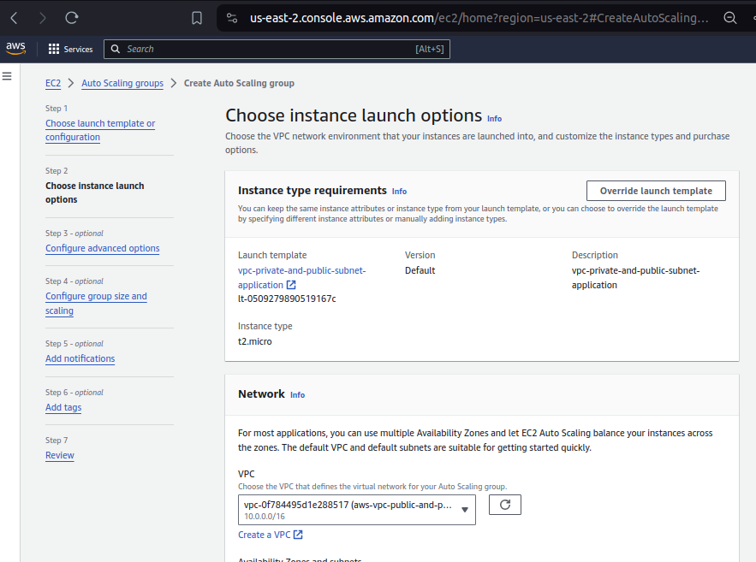

Select the two private zones and subnets as per the architecture. Need to select two defferent zones and aws will create instances in different zones.
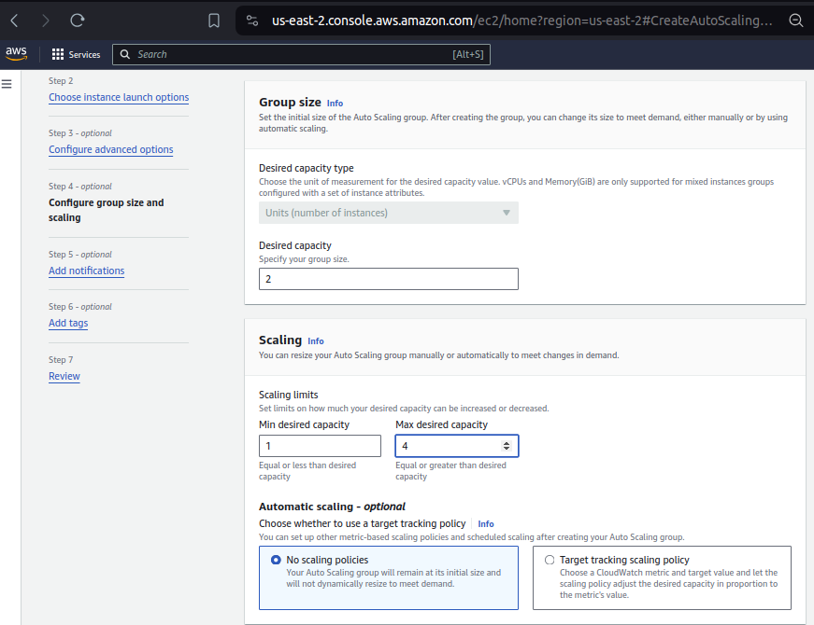
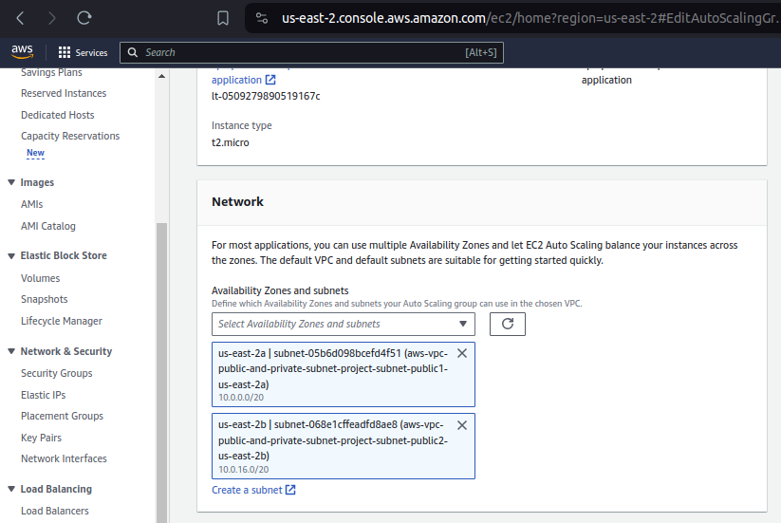

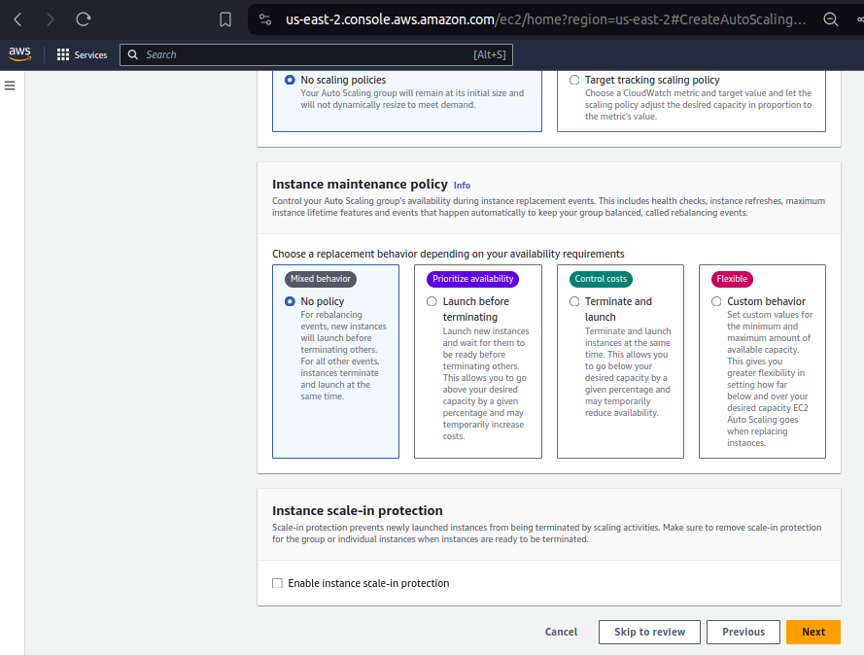

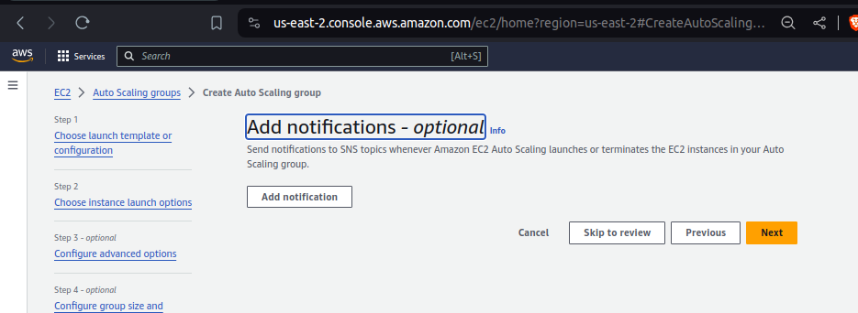

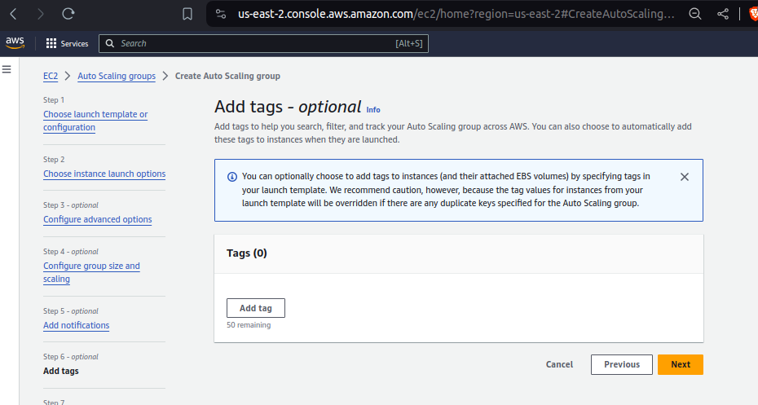
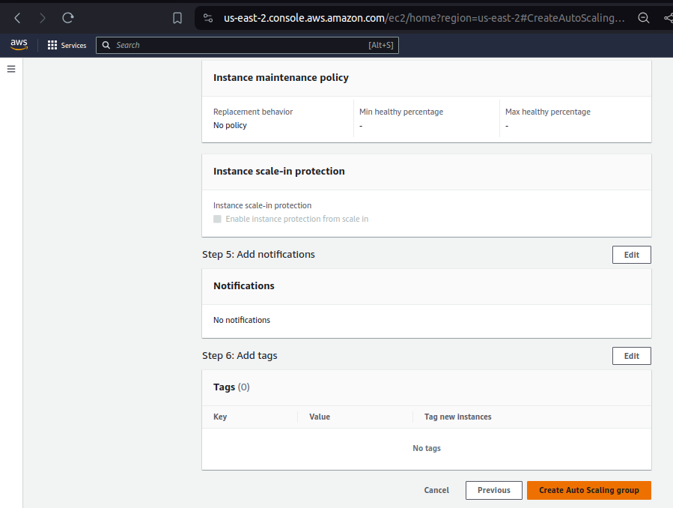

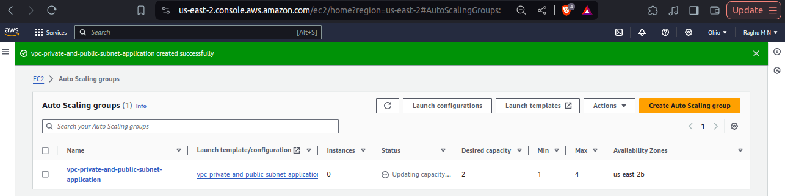

Creation of Bastion host(EC2 instance) to connect to EC2 instances in Private subnet.

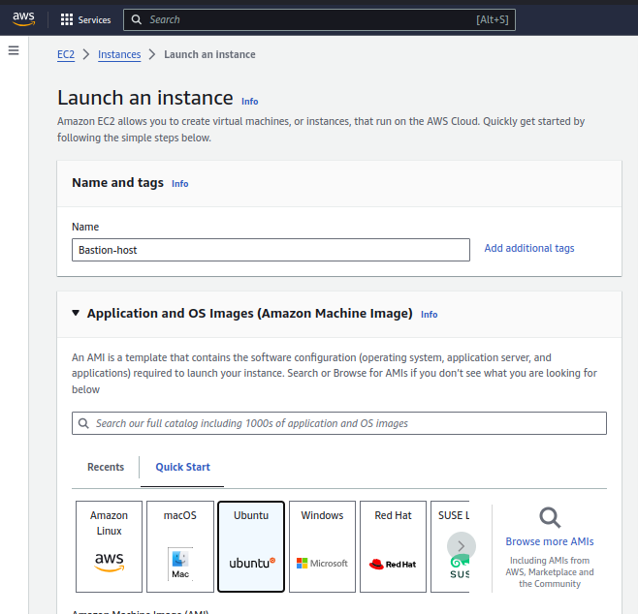

In the network setting,click on edit and select your VPC otherwise not abe to connect to private ec2 instaces and select enable option in assigin public ip otherwise not able to connect to bastion-host using ssh key.

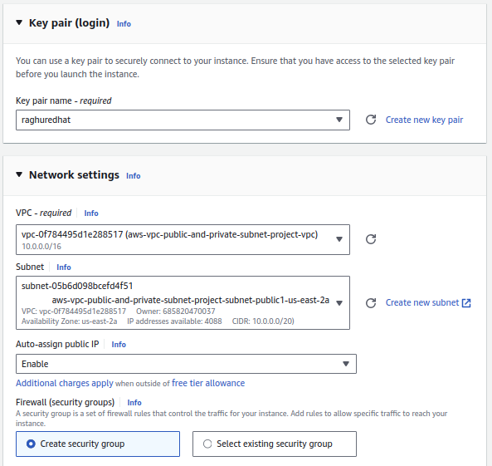

Click on lauch to create bastion host instance.

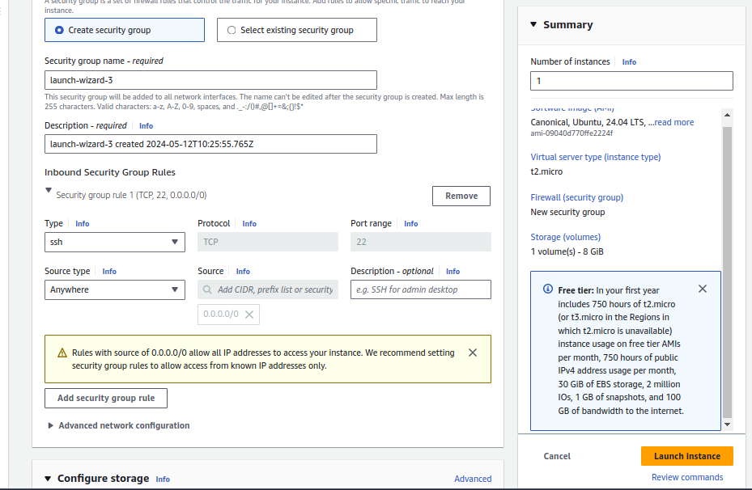

*Copy the ssh key (raghuredhat.pem) into bastion-host because you need to ssh key to connect to ec2 instances in private subnets

Login into Bastion-host:

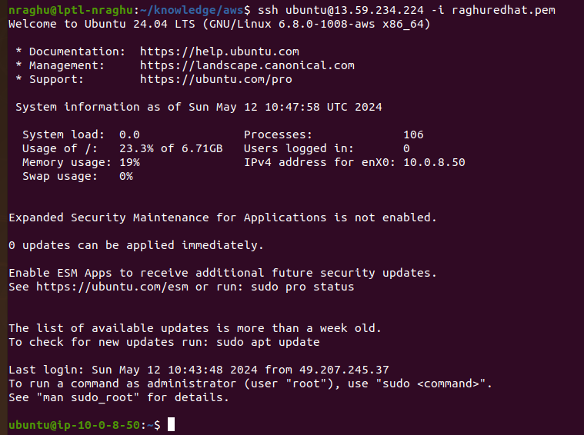
ssh -i raghuredhat.pem ubuntu@public_ip

From Bashtion-host,login into ec2 instance using private ip.

ssh -i raghuredhat.pem ubuntu@private_ip

