AWS CLI --> AWS Command line interface.

Why we need CLI?
Any automation can be done by running the commands,UI will not help us to do automation.
We can give automation to peform the large number of task with less time.

Ex: In your org,you are getting more request to create EC2 instance,IAM user and policy,daily we can’t spend time to create from UI.
If we have CLI,we can write script using CIL command and execute based on requirement. It will save our time.

AWS come with their own API(Application programing interface): Reaching application through program to do something is called API
The program can be shell script,python or command line tool.

Using command line tool,we can do automation of task.
AWS CLI,Terraform,cloud formation etc are command line tool

AWS CLI is command line tool for aws services. AWS CLI is written with python and is python utility(utility means command).
AWS CLI(any cli) will convert the input to cli into api and request to application.
Python
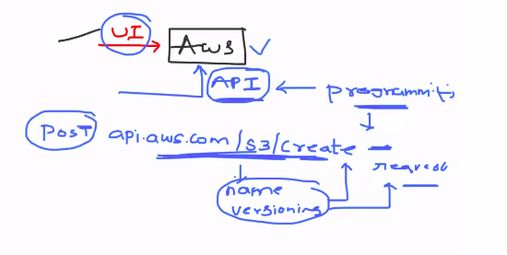

Definition for interview:
The AWS Command Line Interface (AWS CLI) is an open source command line tool that enables you to interact with AWS services using commands in your command-line shell. With minimal configuration, the AWS CLI enables you to start running commands that implement functionality equivalent to that provided by the browser-based AWS Management Console from the command prompt in your terminal program

Installation of aws cli on linux:

https://docs.aws.amazon.com/cli/latest/userguide/getting-started-install.html

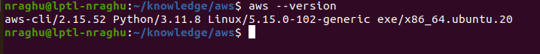

Configure your account:

$ aws configure

provide the access key,secret key and region and output format.

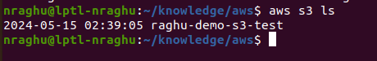

$ aws s3 ls --> list all s3 buckets

$ aws ec2 run-instances --image-id ami-xxxxxxxx --count 1 --instance-type t2.micro --key-name MyKeyPair --security-group-ids sg-903004f8 --subnet-id subnet-6e7f829e --> creating ec2 instance

$ aws iam create-group --group-name MyIamGroup --> creating the IAM group

Summary:
*if it is simple task like getting info of aws service,or creating one or two resources go with AWS CLI
*if you want to do infrastructure management,like creating more instances use CFT or Terrafrom

In organization,we IAM user and don’t use the root user
Interview you have to tell i will use the IAM user.

For your personal aws account, use the root user for practices.

