Understanding the CI/CD flow before we go to AWS pipeline:

*User coommit the code into github or gitlab
*Webhook is configured in jenkins to trigger when code commit happen to repository
*Jenkins will implement the Continuous integration (checkout,build,Unit test,code scan--. Docker image scaning and docker image pushing in general) means writing declarative pipeline script and invok the continuous delivery by upding manifest,helm chart.
Jenkins is a CI tool,it also invok the CD

CI --> checkout source code,build binary,push to binary repository is complete CI
CD --> Downloading Binary file,deploying on targete platform like ks8 clutser

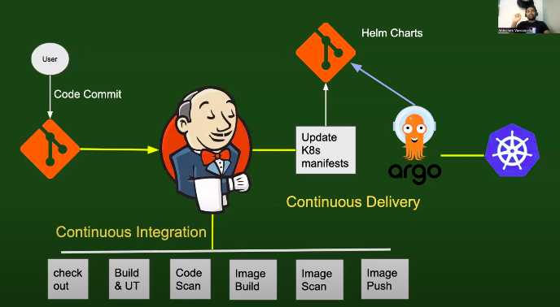

AWS pipeline:

AWS pipeline will invok CI and CD means once the code commit happen to Aws code commit,aws pipline invok the AWS build which will have responsible for all stages(checkout,build,code scan,image scan and image push).
And invok the AWS Deploy for CD.

In jenkins,it will implement CI and invok CD.

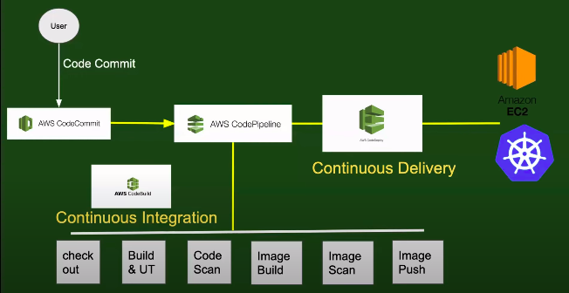

Why organizations will go for AWS pipeline even if open source jenkins is available? Or advantages of aws pipeline?

*Every thing will be managed by aws, like providing the service without downtime,scale up, if don’t have cost barrier.
*Don’t need seperate resource to manage the things.

What the adavantages of jenkins compare to aws pipeline?

*mainly is a free source
*it is not restricted to any platform,if our organization changes platform,we take backup of script and install jenkins and use the same script
*have intergration into more tools --> aws ,azure or GCP

