AWS Front

AWS Frontend is managed aws service that provides solution to CDN.
CDN solves the below problems:
latency --> CDN will create copy of content in edge server
cost --> no need to create storage class in all lolcation
security --> he is access through CDN,not from direct data source.

What is CDN?what problem it solve?
Content Delivery network(CDN) is like network of servers across various locations wideworld.
These servers stores a copy of website’s content. When user request the your website,the content will be delivered from closest server, making it fast. It’s like having local storage for your website everywhere in world.

Example:

Instagram app.

User in US uploaded the image,his friend in india need to see,we have one datacenter in us and request goes to multiple routes and latency will be inscreased and user experience will become worst.
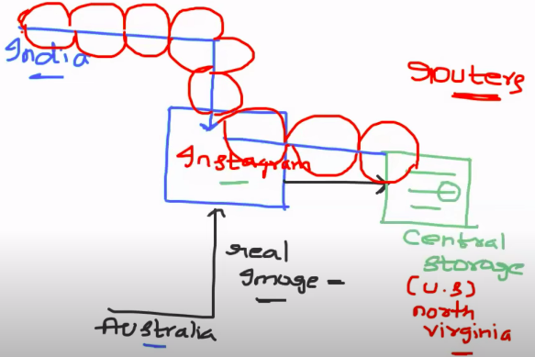

Content Delivey Network solve the problem:

Map the instagram dsn into CDN( based on CDN configuration),CDN will create local copies and store it in egde location(means closest servers)when first request come, for second request the content will be served from edge location,served immidiately.

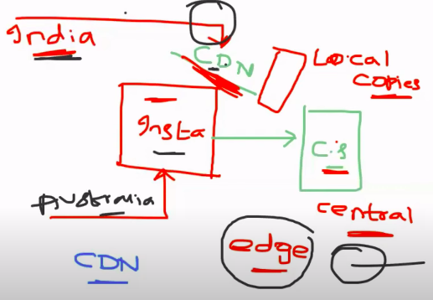

Create the s3 bucket to host the static file and create cloud frontend into your s3 bucket to provide access and reduce the latency problem.

Creattion of s3:
Bucket name must be match with your domain name.

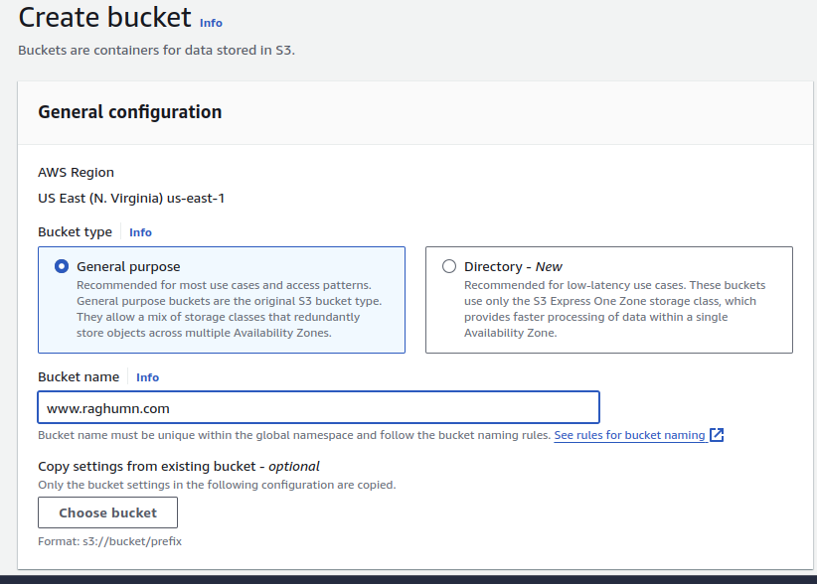
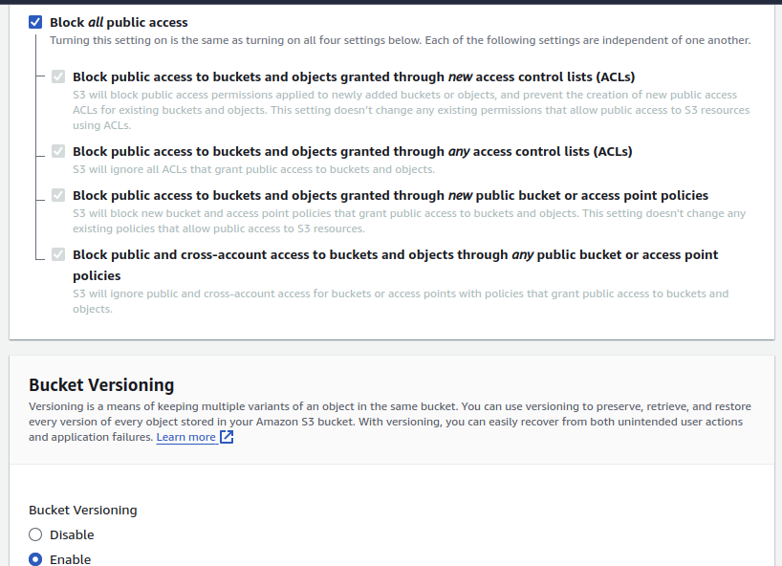
Block public access to s3 bucket and have track of object changes in s3

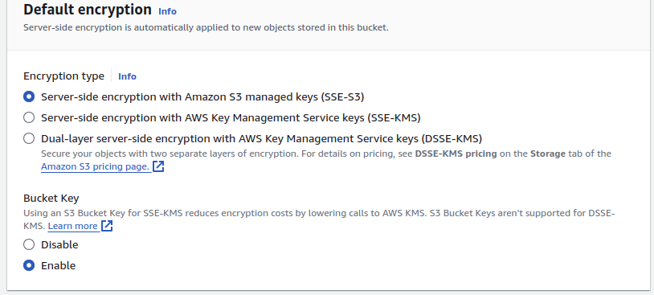
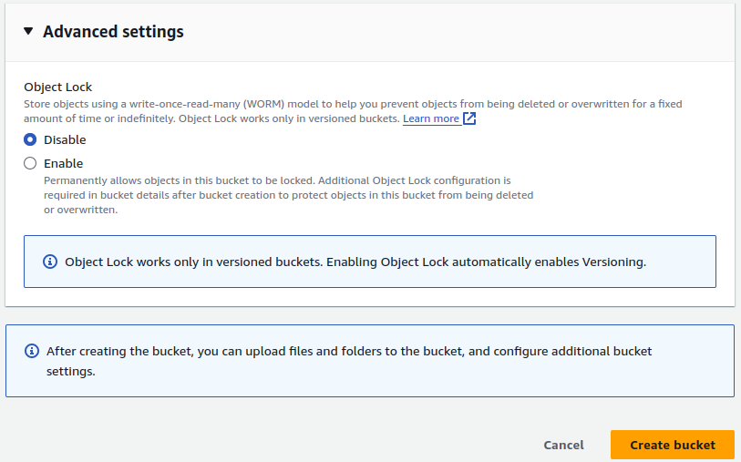

Enable static file hosting:

Click on s3 bucket and go to properties tag.

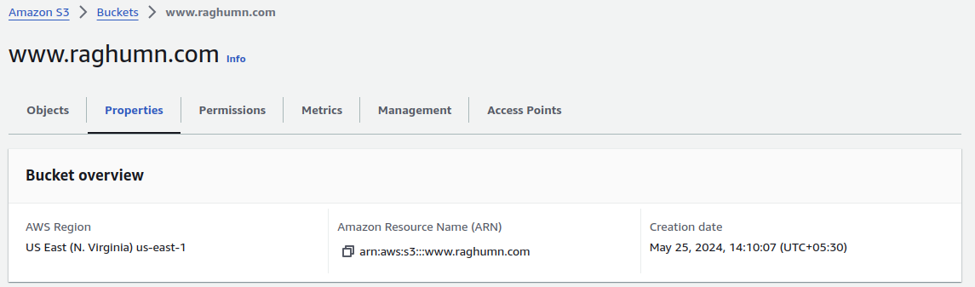
Click on edit and enable
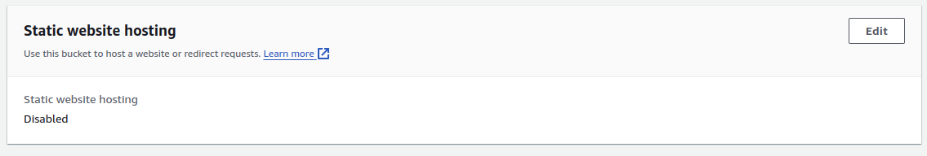

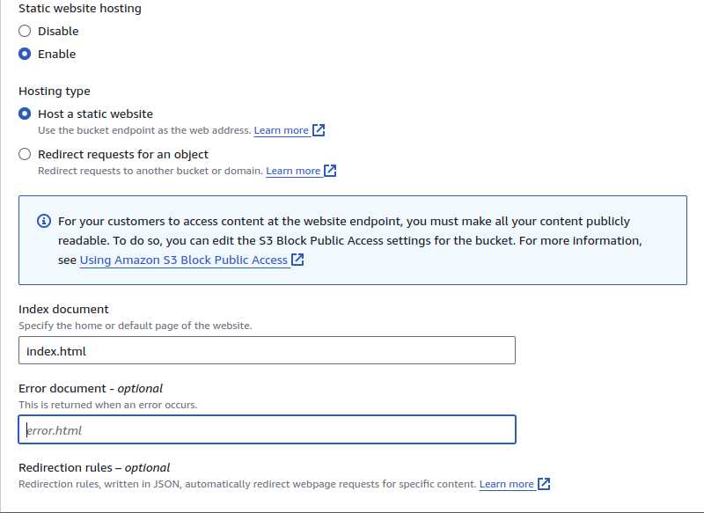
upload the index.html file
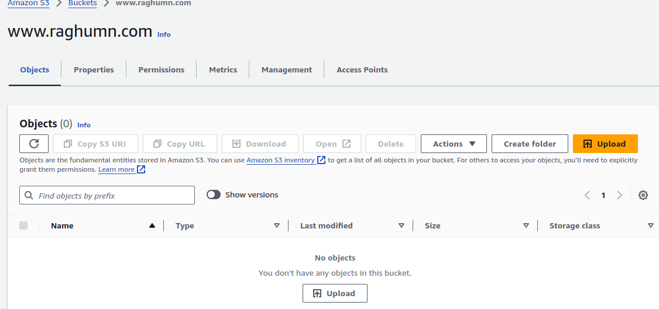
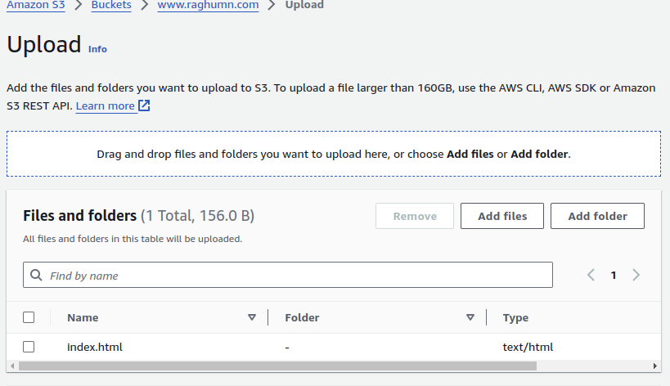
uploaded the index.html

Creation of Cloud front:

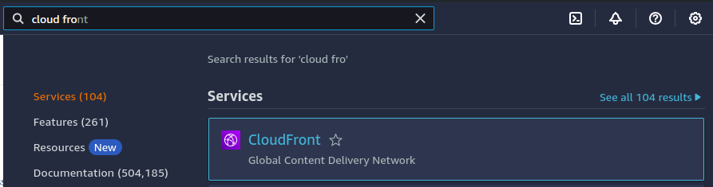
click on create cloudfront distribution
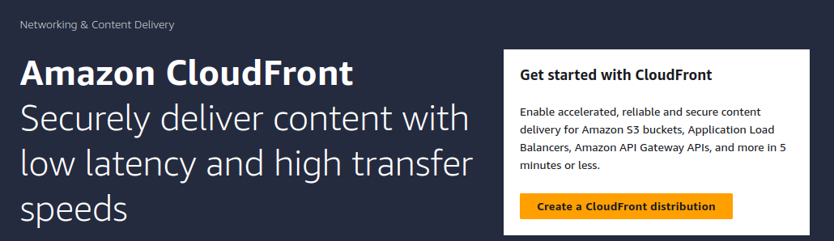
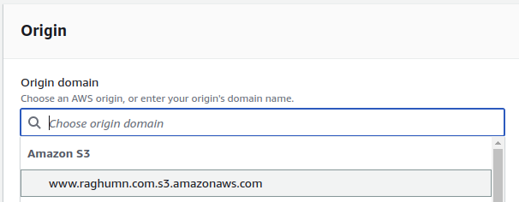
select your s3 bucket
click on create new OAI --> create virtual user for your this distibution to access your s3 bucket
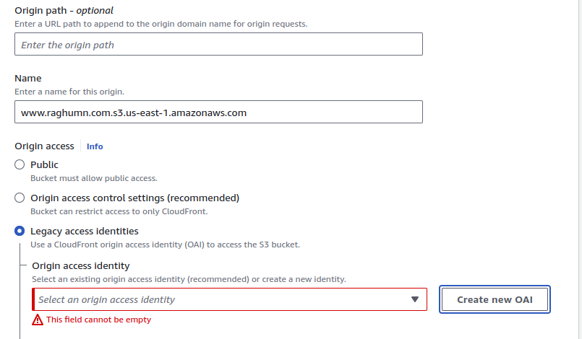
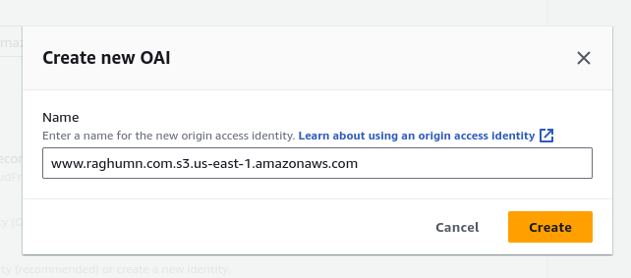
click on update policy, policy of s3 bucket will get updated like this OAI role able to access s3 bucket

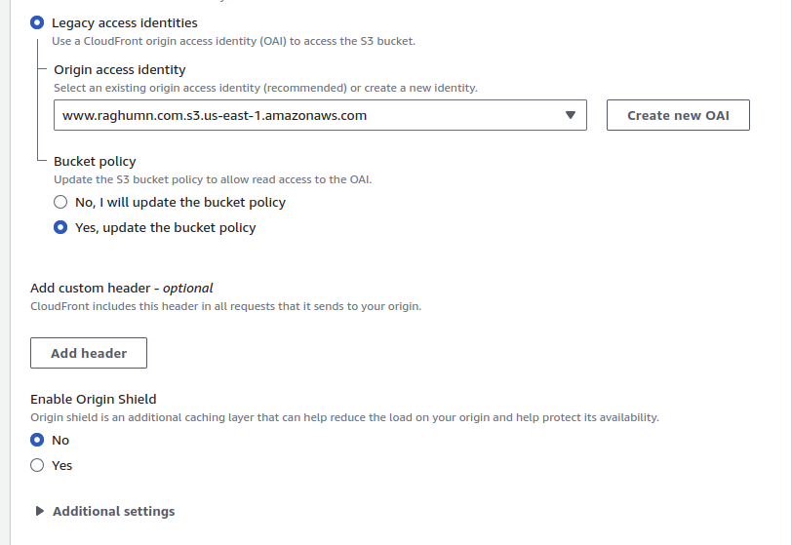
Keep all below options as default
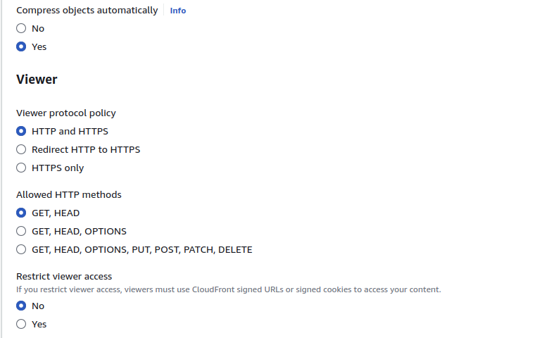
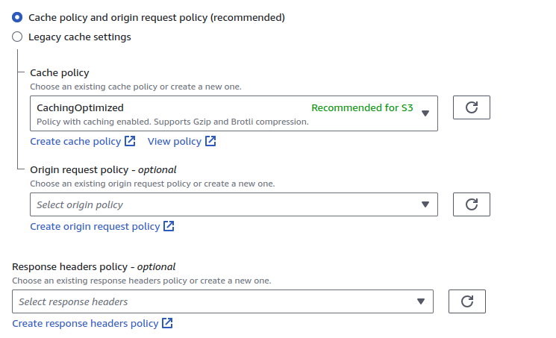

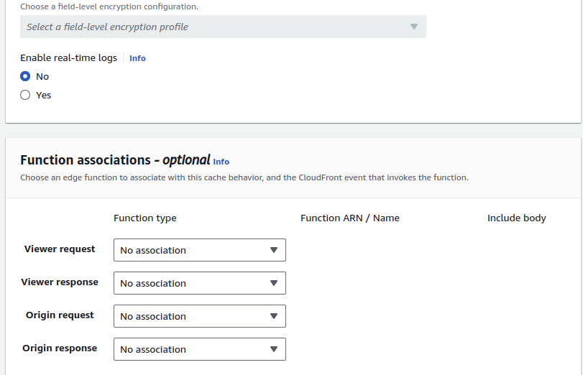
Update the defaut object,otherwise you will not be access to acccess content
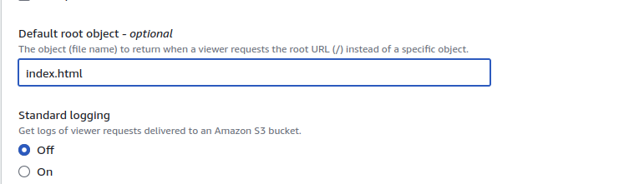

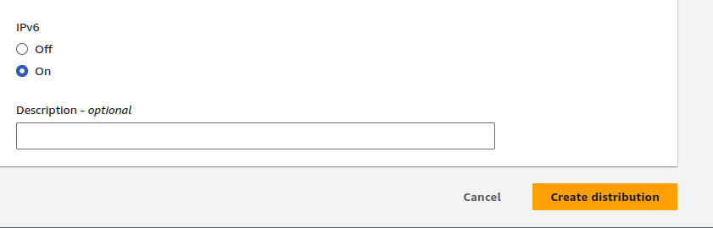

Policy got updated by automatically becasue of we clikced on yes update policy option
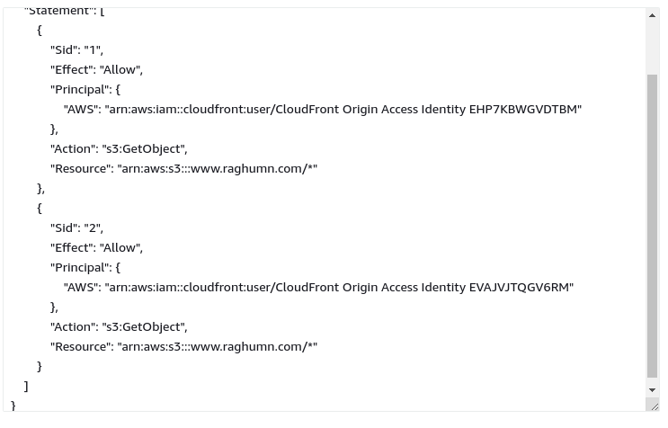

Copy the domian and paste it into browser

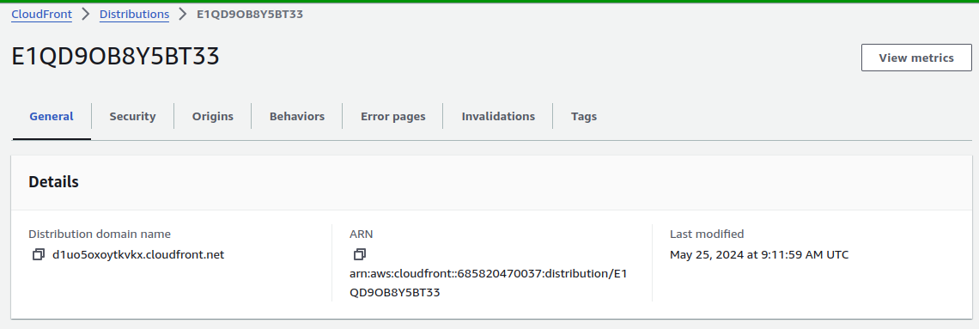
Able to accees website --> https://d1uo5oxoytkvkx.cloudfront.net/
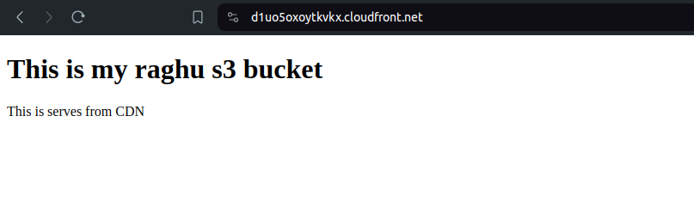

Delete the distribution,otherwise you end up billings
Delete s3 bucket

first click on disable then delet option will be enabled after 2min

