What is EC2?
EC2 --> Elastic Cloud Compute --> compute means creating virtual servers.

Amazon EC2 is a web service that provides scalable virtual servers in aws, we will create and use it for many purposes
Ex: for creating cluster,for development activity,running applications

*The prefix Elastic in any aws service respresents that service is scalable mean once it created we can scale up or scale down the resources.

Ex: Elastice cloud compute,Elastic kubernetes service, Elastice load balancer etc.

Why we need EC2? Advantages of EC2?
Management of servers : if your organization created servers,need to have dedicated people to do the following
*Security patch update
*Ensuring servers to be available at 24/7
*More regions: if your client is in usa,you create servers in USA region,this will reduce latency time
*Cost optimization: you have to pay how much resources you used on cloud

Types of EC2 instances:
* General purpose EC2 --> Cost effective for small workloads like hosting blogs / websites, development activity

* Compute optimized EC2(High CPU performance) --> Suitable for machine learning,batch processing,gaming servers

* Memory optimized EC2 --> Rich in memory and dedicated on memory based applications that requires lot of memory for faster data access.

* Storage optimized EC2 --> Rich in storage,used for application that requires high read/write speed on storage.

* Accelarated computing EC2(High GPU performance) --> suitable for Machine learning training and Deep learning,Graphic-intensive application,Big data and analytics

Check in aws document, is other type of ec2 instance is added?

Region in EC2: AWS have data center across the world and aks you from which region virtual server is required.

If you are client in usa,create servers in region as usa to reduce latency(taking time to process request and send the data) and keep data near to client

Inboun rule --> means defing the rule for coming request into your ec2 instance.

Outbound rule --> means defining the rule for out going request from ec2 instance.

Creating EC2 instance:

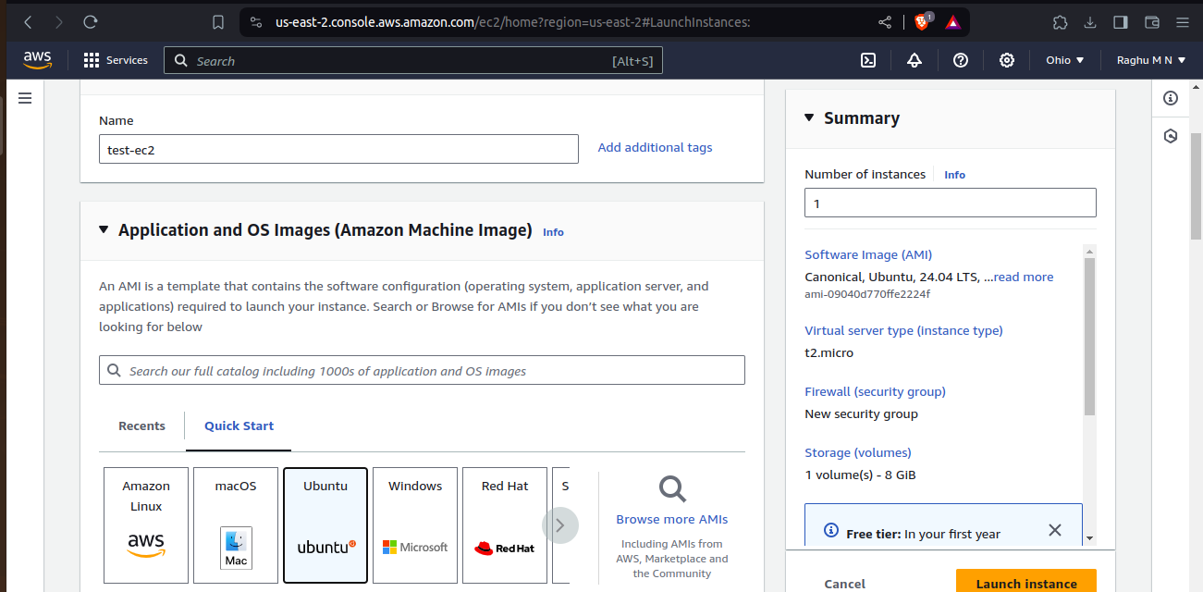

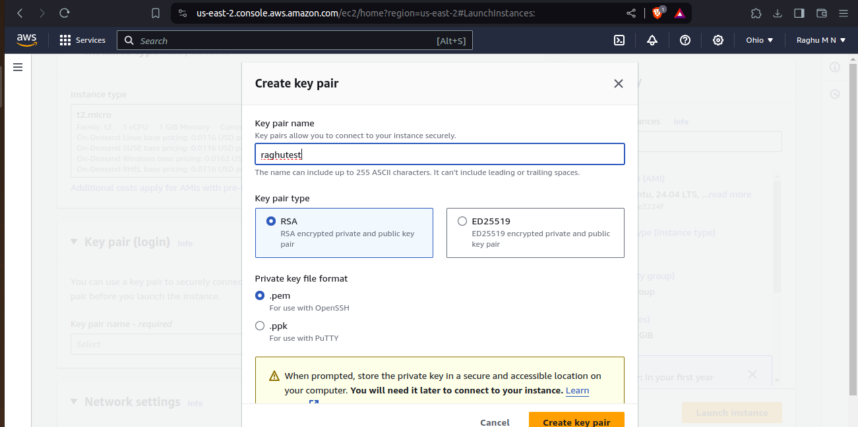

Download the .pem file to login instance

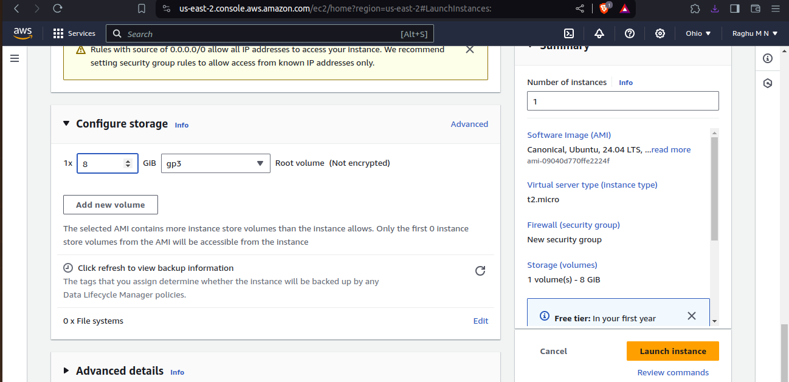

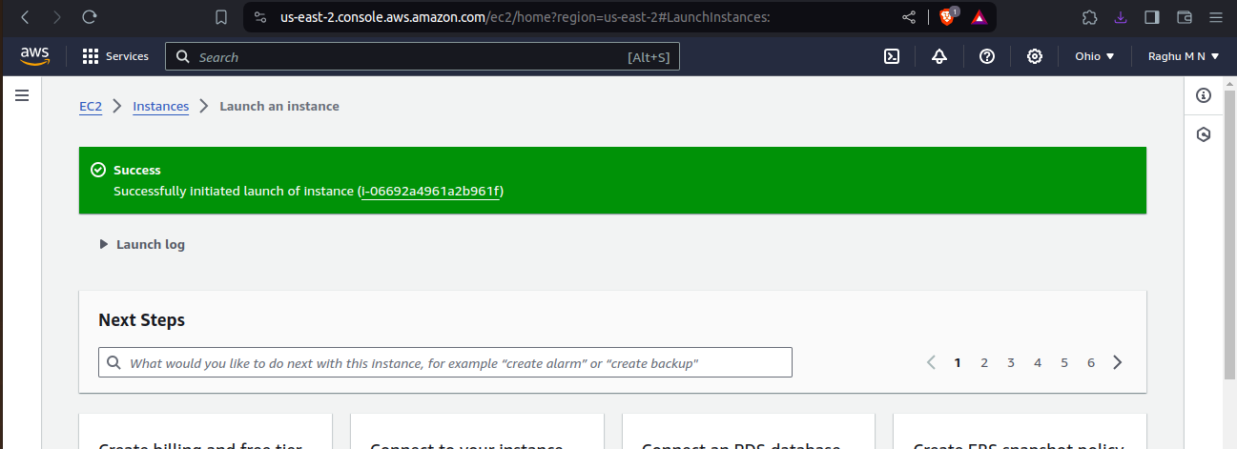

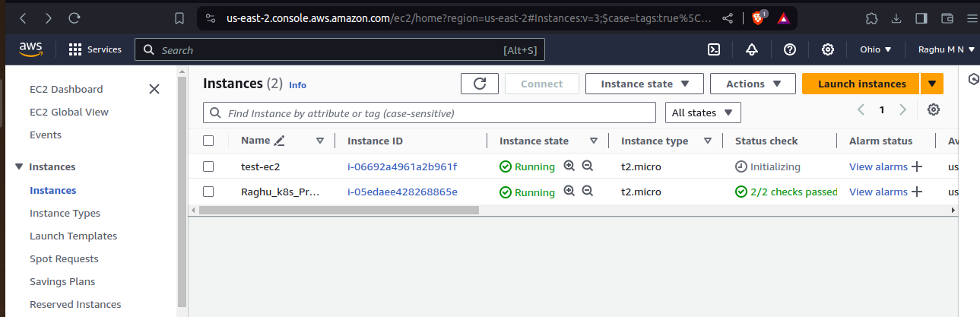

Login into EC2 instance:

we can login into ec2 intance using only through pem key. Change permission of pem file into 600

take public ip address and ubuntu user and pem key.

