VPC --> Virtual Private Cloud

Background on VPC or why VPC is required?:

Before VPC, when three companies are requested for virtual resources,AWS is creating the resources on region for all three companies. If hacker send the malware request into one of company application,if it got hacked,the servers in that region also got hacked.

Now there will be one default VPC is readily available.

What is VPC? and more details on VPC:
Virtual Private Cloud is private network in aws cloud that allow you to create and manage resources(EC2,S3 bucket etc) in a isolated ,customized environment. It provide control over your network setup, including subnets,ip ranges,routing and security,enabling you to define how resources communicate internally and externally.

Isolated means it operates as seperate and private network within aws,the resources you create in vpc can not be accessable by default from internet.
We can control how resources communicate internally and externally.

Key Concepts of a VPC (Simplified):
- Subnet:
  - A subdivision of your VPC. You can separate parts of your network into smaller chunks, like one for public-facing resources (e.g., web servers) and another for private ones (e.g., databases).
- Internet Gateway (IGW):
  - This connects your VPC to the internet. Think of it as a door that allows public traffic in and out.
- NAT Gateway:
  - Allows private resources (e.g., databases) to access the internet securely (e.g., download patches), but blocks incoming traffic.
- Security Groups:
  - Act as a firewall for your EC2 instances. You define rules to allow or block specific types of traffic (e.g., allow HTTP but block SSH).
- Route Tables:
  - Define how traffic is routed within the VPC and outside it (e.g., "Traffic from the public subnet should go to the internet gateway").

What is NAT?
A highly available, managed Network Address Translation (NAT) service. The instances in private subnets can use NAT to connect to services in other VPCs, on-premises networks, or the internet.

What if application need to download anything from internet?
NAT(Network Address Translation) --> NAT will help to download required thing by masking your application server ip or NAT will create LB to download and give it to you.

Functional diagram of VPC:
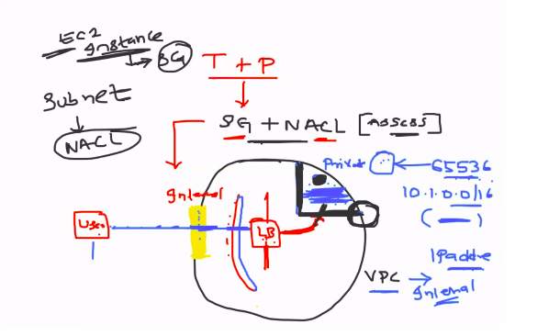
How request will flow inside of VPC when user requested access?
*When user sent the request to access application,application is deployed in one of server comes under VPC.
Request will be checked by internet gateway,then it go to public subnet of VPC,then go to load balancer,load balancer have route tables and redirect to application server.

VPC will be created from particular ip range and inside of vpc,divided into multiple subnets.

Summary:
To keep our application more secure, VPC is required

VPC creation screenshots are documented in next document

