Route53:

Route 53 is DNS(Domain name System) service provided from aws.

we can access any public application using dns.
DNS service reslove the dsn name into respective ip address.

Ex:
https://amazon.com --> will be reslove to Load balancer,Load balancer will redirect into one of application server. Why it reslove load balancer ip because we can serve application by deploying into multiple servers,load lalancer have info of servers list where application is running,based on load,lb will redirect to any one of application server.

Resloving into ip is done from DNS service.

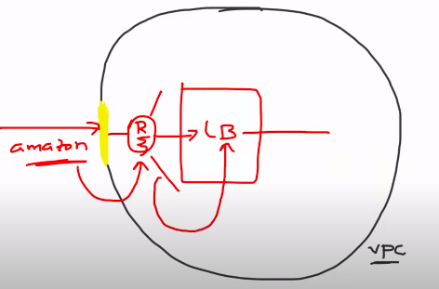

Why we can’t give ip address to access applicationo or why we need DNS?
1) security concern: we can’t share ip and port details to user,that will be misusable
2)Not easy to remember ip address to access application.
2)IP address will change in any time,ip address can static or dynamic.

DSN creation processs:

we have to buy the domain name from provider(godaddy) or aws also provide domain name,then configure in route53, route53 will go to hosted zone to reslove to ip to reslove to lb ip or application ip.
Hosted zope will tells route 53 how to respond to DNS queries for domain ex: example.com.

