S3 bucket:

What are S3 buckets?
S3(simple storage service) is scalable and secure cloud storage service provided from aws.. It allows you to store and retrieve any amount of data at any time from anywhere.

S3 buckets are containers for storing objects (files) in Amazon S3. Each bucket has a unique name globally across all of AWS.
Why use S3 buckets?
S3 buckets provide a reliable and highly scalable storage solution for various use cases. They are commonly used for backup and restore, data archiving, content storage for websites and as a data source for big data analytics.

Advantages or benifits of S3:

High Availabity ---> you can access data globally using http rule.once s3bucket created in any one region,aws will create replicas of data in multiple data centers,even if region will go down data will replaced from other data center.

99.999999999 --> Reliability
aws says that if you store 1 billion of objects for 100 year,there is change of getting deleted only one object. No one can give 100% service and assurence.

Scalabilty --> Store almost unlimited data in single bucket, but one object size must not be more than 5TB.
Tips:choose multiple parts to upload if object is very huge.

Version solution --> keep track of changes,we can able to get older data like git we upload object with new data but if we want see earlier data, we can able to retrieve

Cost Effective --> Based storage class,aws will charge for storing the data.
high speed writing it to s3 and reading from s3 depends on storage class(type of harddisk).
If you are ok with low speed writinng and reading,will get low cost s3 bucket.
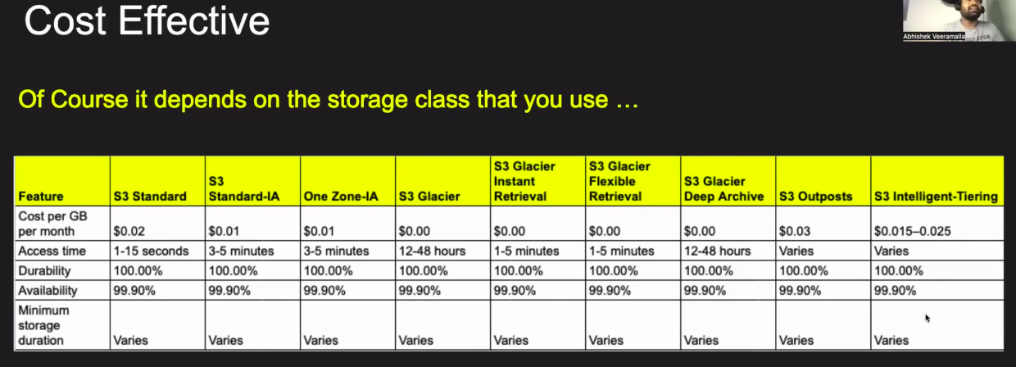

Security --> S3 provide the bucket policies,access control and encryption settings are appropriately configurable.
*Encrypt the data at rest using server side encryption option means that AWS handles the encryption and decryption of the data stored in S3 buckets. This ensures that the data is securely encrypted when stored and automatically decrypted when accessed by authorized users.
*Enable access logging to capture detailed records of requests made into s3 bucket.Manitor log and send alter message if found any suspicious activity.

Creation of S3 bucket:
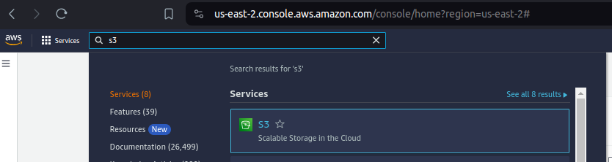
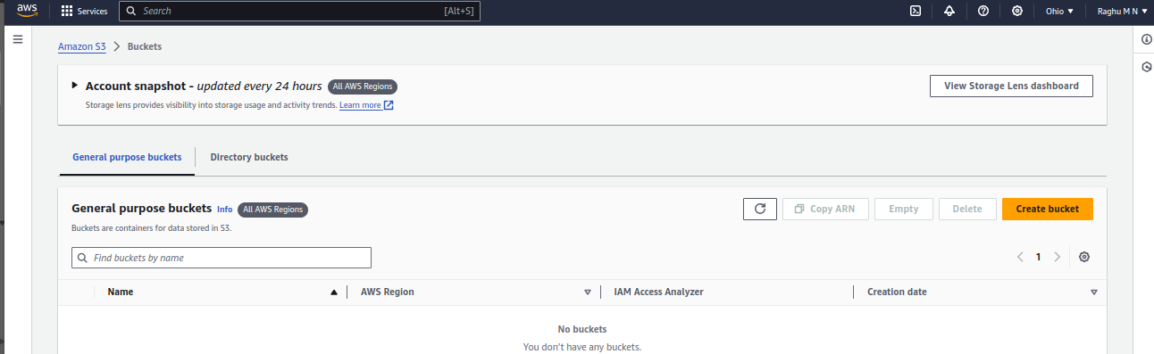

Give unique name to s3 bucket,it will check all s3 buckets names in aws and if it is unique then only allow to create
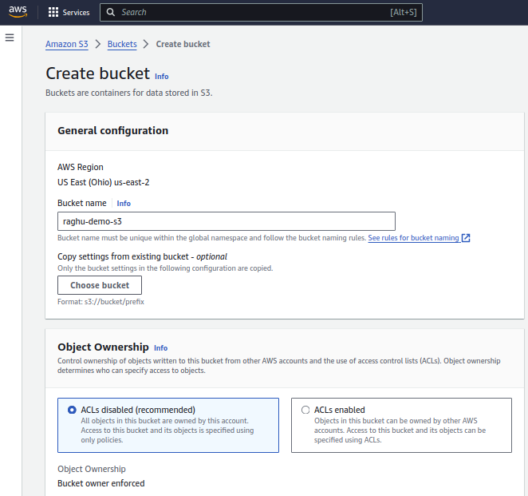
Obejct ownership mean,all access to this bucket will be owned by account used to create

As you now,s3 bucket objects can be accessable gobally.
If any one can able to s3 bucket publicly,you can uncheck the box and giving public access to s3 bucket.
Usaually it must be checked to retrick the access
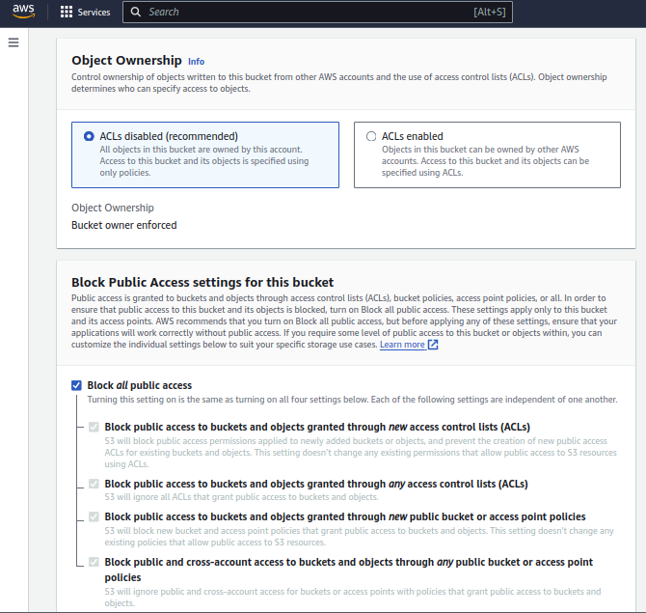
Version and object lock will cover later
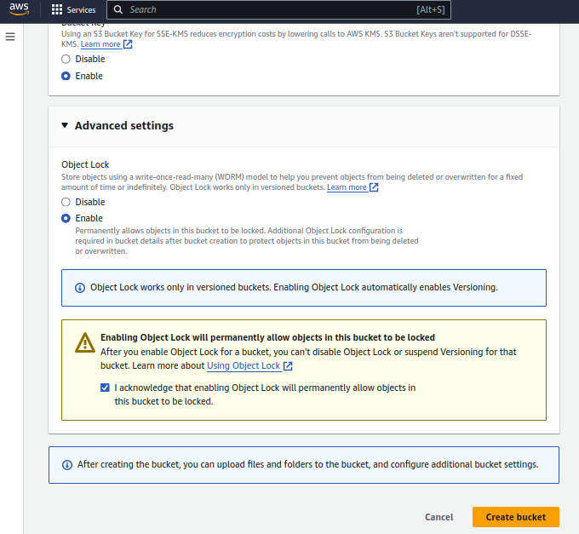

Uploading file to s3 bucket:

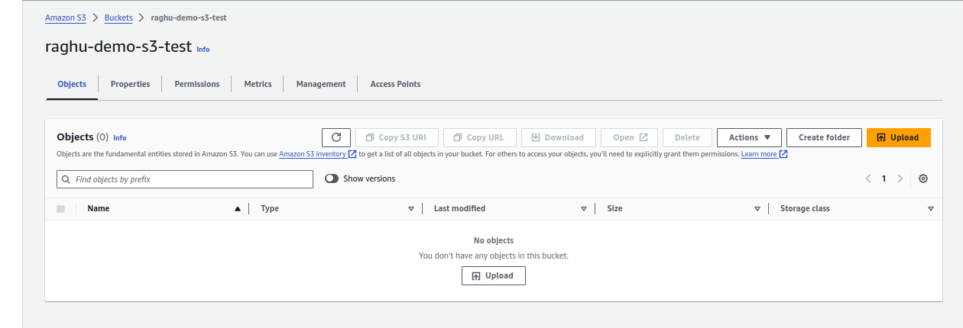

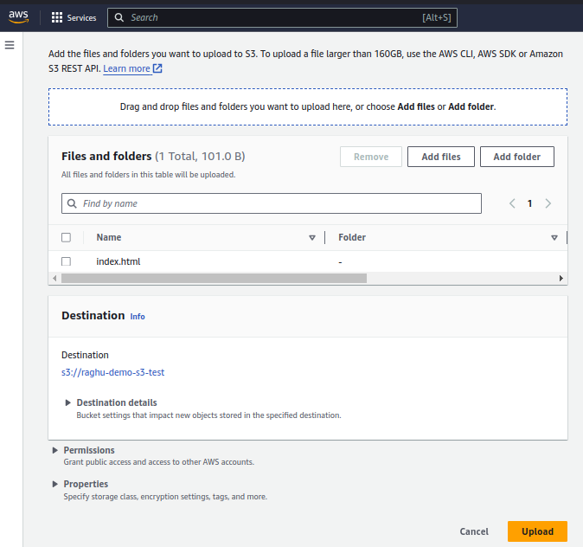

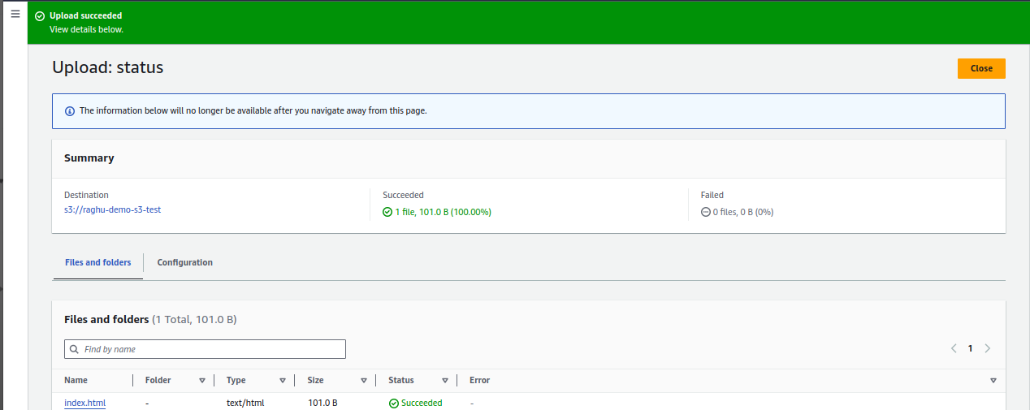

Properties of s3:

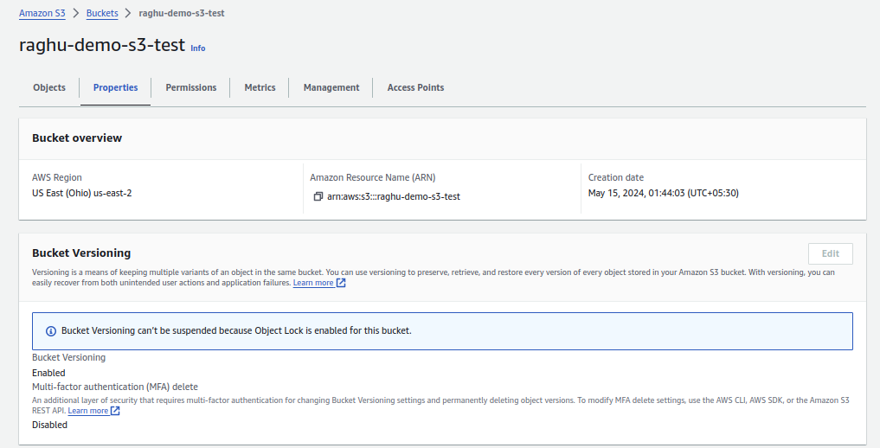

Bucket versioning: it you enable this option,we can able to get the eakier object even if we overwriten as like git

I uploaded same file by modifying the content,we can able to get the both version of file

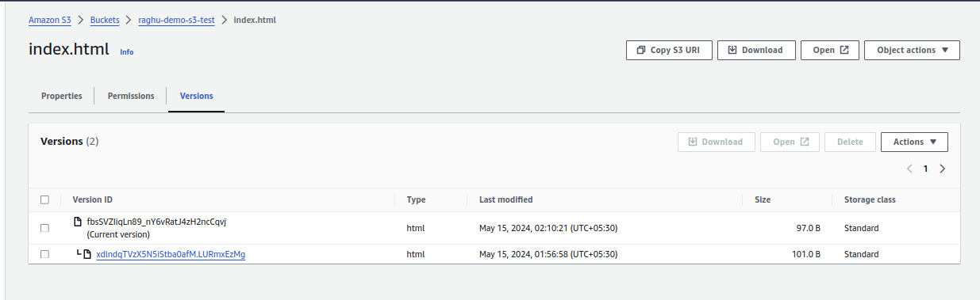

Tag: when you have more number of buckets,need to track based on projects,we can add project name as tag and get all buckets by tag name

aws will provide default encryption into object.

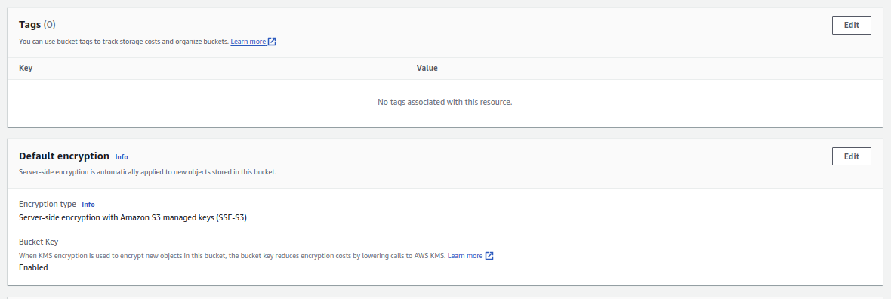

Server access logging: you can track access logs of s3 bucket and configure alert for any specific request.

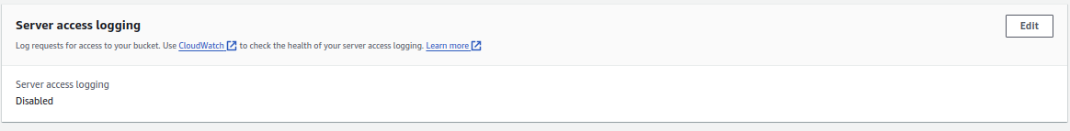

Object lock: Not allowing any one to owerwrite the object content present in this s3 bucket if object lock is enabled

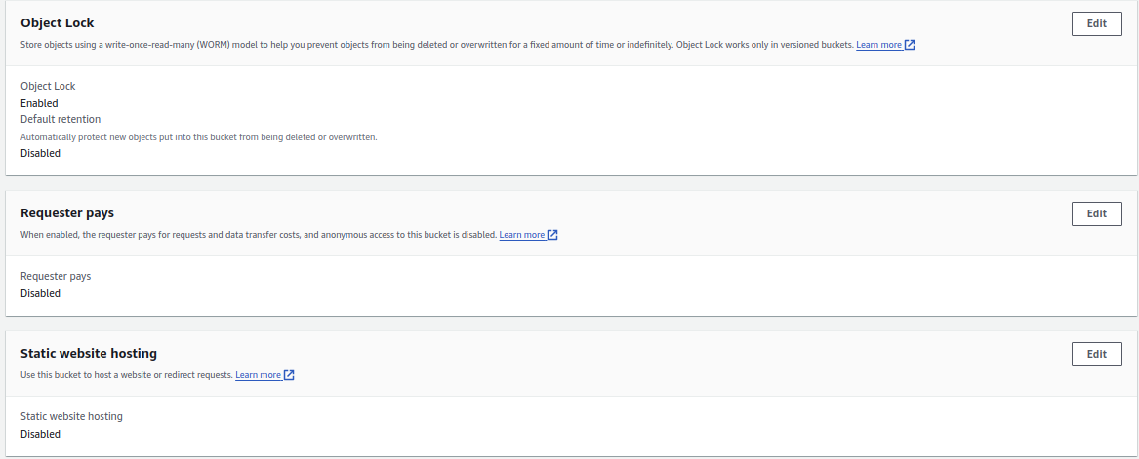

Static website hosting: s3 will provide option to host our website.
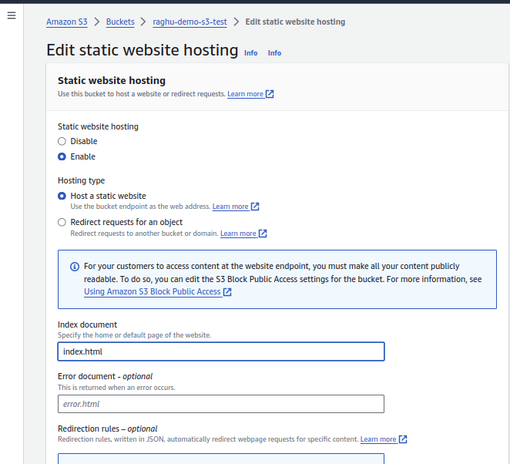

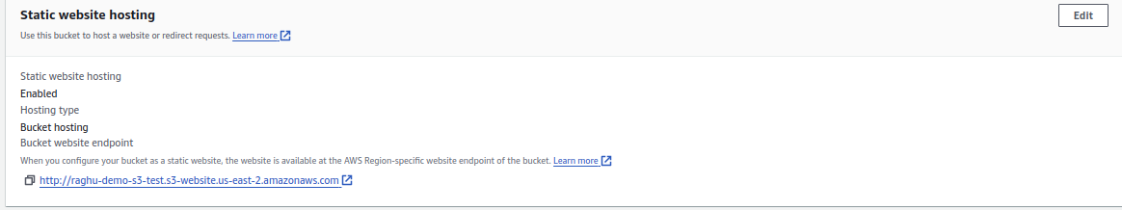

We hosted static web page,if s3 bucket have public access,any one can able to access using given url.

Bucket Policy: Very Very important.

As s3 bucket owner you can restrick the access to ypur s3 bucket even full permission of s3 is assgined to IAM user

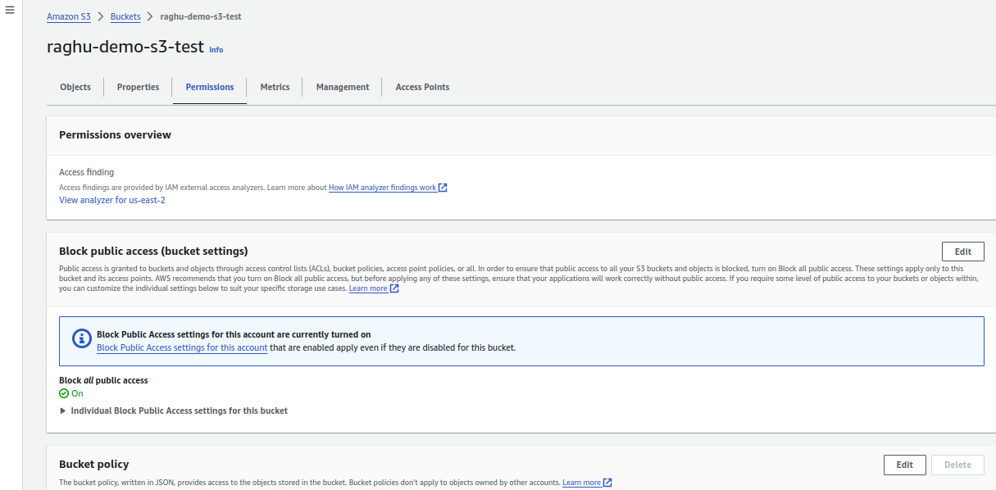

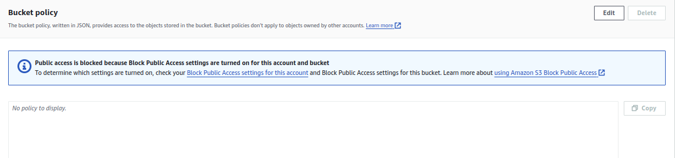
Configuring the s3 bucket policy: accoding to this policy,expect root user,no one can access this s3 bucket

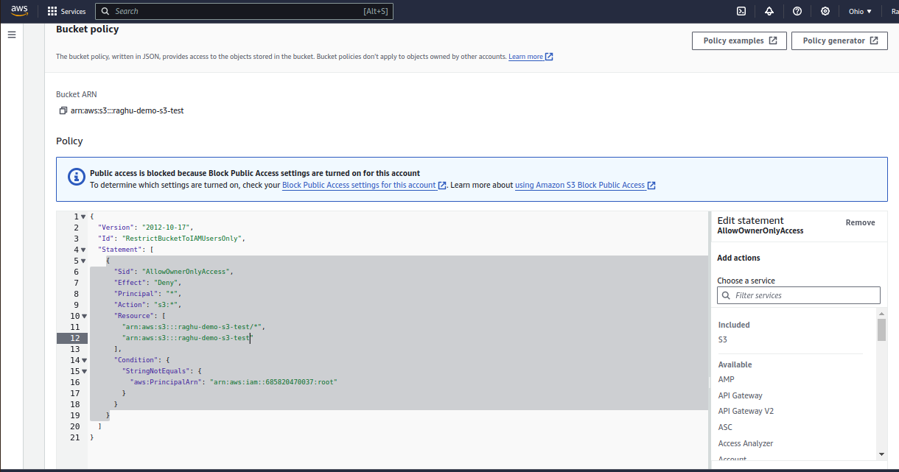
In the left side you can see, add action using that we can generate json file for bucket policy

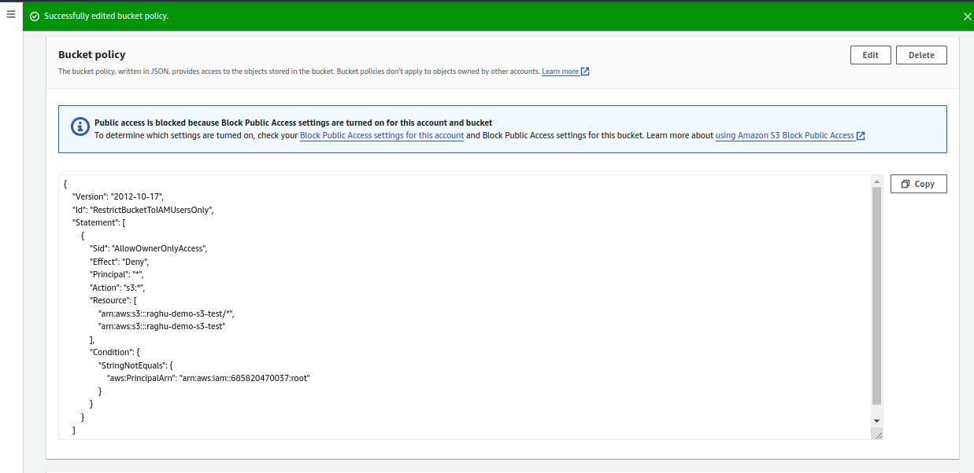

Configuring to allow all users:
To given access to all users,we have uncheck the block all public access and define the below policy

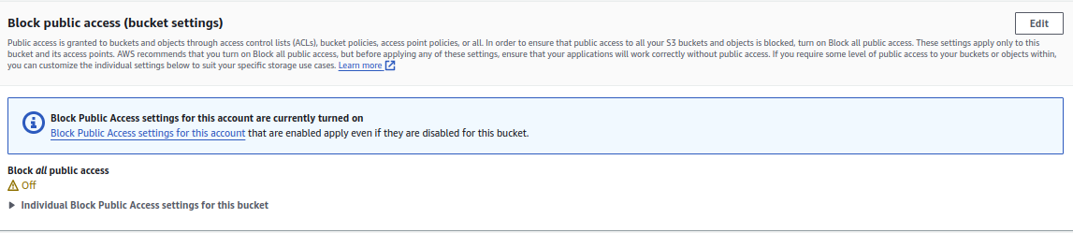

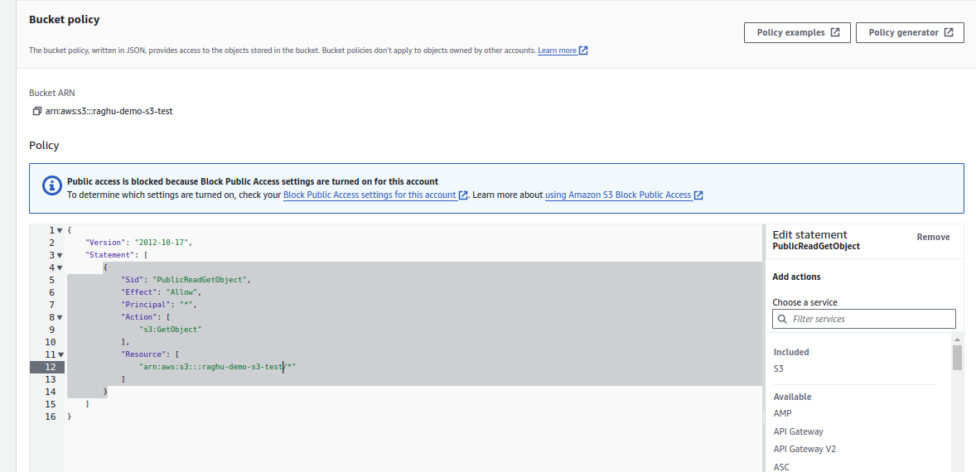
Able to access static web page publicly

