CFT : --> Cloud Formation Template

CFT is template which helps in aws cloud formation(aws cloud formation). cloud formation mean creating resouces,updating the resources in cloud.
CFT is IAC tool, support only the aws cloud provider,because is build from aws.

Why CFT,we have aws cli to create and manage the resource?or definition?
CFT is IAC tool support only aws because build from aws and implements the IAC(Infrastructure as code), instructure as code means write a code to create the infrastructure.

*CFT support Drift detection,drift detection means created resource ec2 and s3 with CFT template,some one did the changes into EC2 intance,CFT template will detect the changes and given option to revert it earlier stage. When we need to work with more resource creation and update more resources,using aws cli is not tidious work.

*CFT is IAC tool, IAC follows the principles,one of principle is IAC tool decarative in nature and versioned in nature. Accept the input from user in json or yaml,convert into cloud understandable and make api calls.

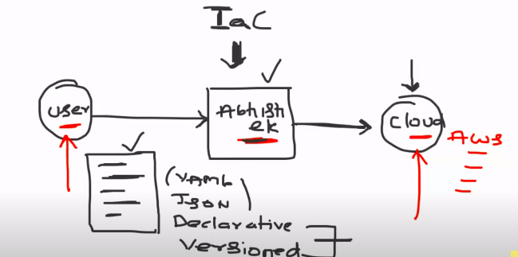

Principles of IAC:
* Declarative in nature mean what you see in template and what you have in platform,by looking at the template,we can able to unstand the what and all task that template will don
and versioned in nature mean have to track the changes,what was the earlier code and newly updated code.
* Act as mediator between user and cloud platform.
Difference between CFT and Terraform:
*CFT support only the aws cloud provider,because is build from aws.
*Terraform tool which support more cloud providers,that are terraform and crossplane etc.

In our organization,we are using only the aws cloud to our task from long back,we went with CFT.

As a devops engineer,when you to use AWC CLI and when you to use CFT?

AWS CLI --> any quick responsed needed(listing s3 resouces) and creation of one resource.

CFT --> when you want to mantain the declarative in nature(understandable to any one by seeing template ),versioning in nature (able to track changes) and work with more resouces.

CFT support both yaml and json. Use yaml because is easy readable,indendation based and able to add comment for code.

Using CFT:
You use the CFT from CLI or UI.
In CFT,there is stacks,click on create stack and upload the yaml or json from your local to create the insfrastructure.

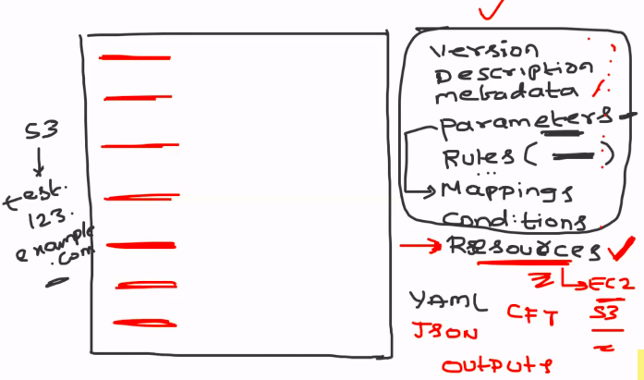
CFT structure:

Version:
description:
metadata:
paramters(just like jenkins parameters):
rules(used to evaluate the pamameter like par1 must be interger or environment name):
maping(mapping the vlaue of parameter into variable):
conditions:
resouces(s3 or ec2 etc):
outputs:

only resouces is mondatory field in CFT file,we can create using only resouces files in tempate.

CFT document:
https://docs.aws.amazon.com/AWSCloudFormation/latest/UserGuide/Welcome.html

AWSTemplateFormatVersion: 2010-09-09
Description: A sample template
Resources:
MyEC2Instance:
Type: 'AWS::EC2::Instance'
Properties:
ImageId: ami-0ff8a91507f77f867
InstanceType: t2.micro
KeyName: testkey
BlockDeviceMappings:
- DeviceName: /dev/sdm
Ebs:
VolumeType: io1
Iops: 200
DeleteOnTermination: false
VolumeSize: 20

To create the EC2 Instance with type is t2.micro and image id is ami-0ff8a91507f77f867

you can use the parameter to make configurable value into type and image id.
Set the rule to reject template of the type is not t2.micro or t2.medium.
Map the parameter into variable using mapping.
Conditions as other programing language conditions.
Resouces --> mention list of resources you want to create as objects

output --> specific output to your resouces.

All resouces template you will find here.
https://docs.aws.amazon.com/AWSCloudFormation/latest/UserGuide/aws-template-resource-type-ref.html

EC2 --> https://docs.aws.amazon.com/AWSCloudFormation/latest/UserGuide/aws-resource-ec2-instance.html

Creation of CFT:

using the CFT to create one or two resources will not efficient use of CFT. I am in begining, we went with one resource creation.

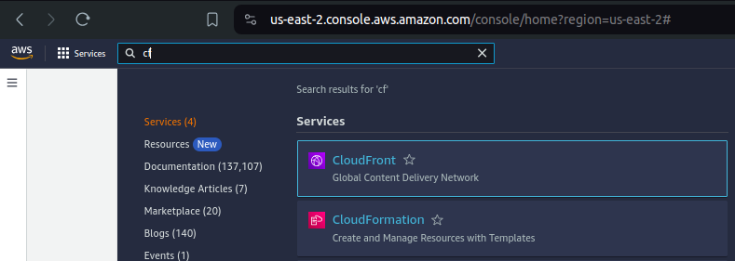
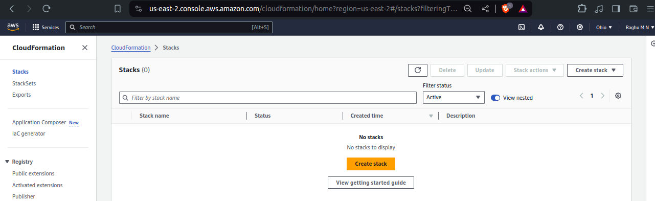

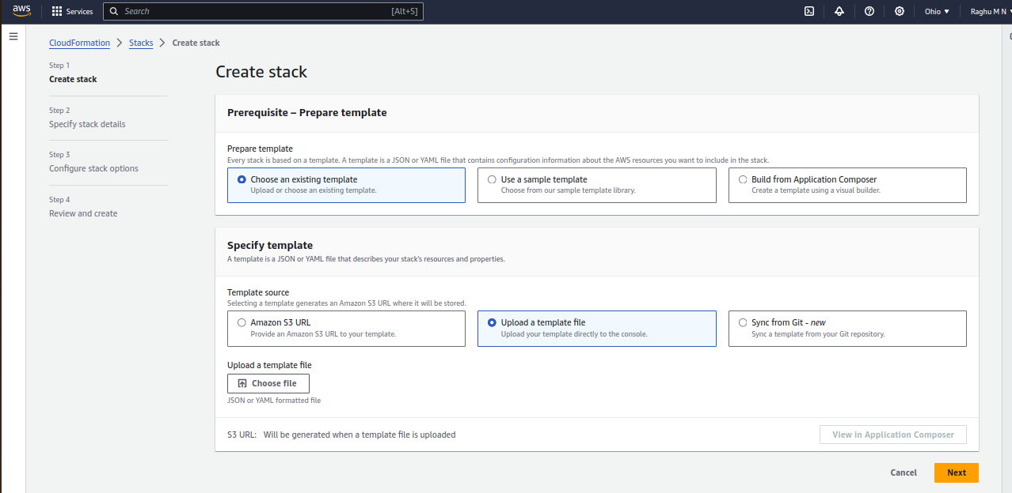
There are multple options to give template to stack,stack will create resource mentioned in template(yaml or json).

Build from composer --> give draw and drop option to create the template.

Amazon s3 --> stored in s3 and uploading

upload template file --> upload from your local system

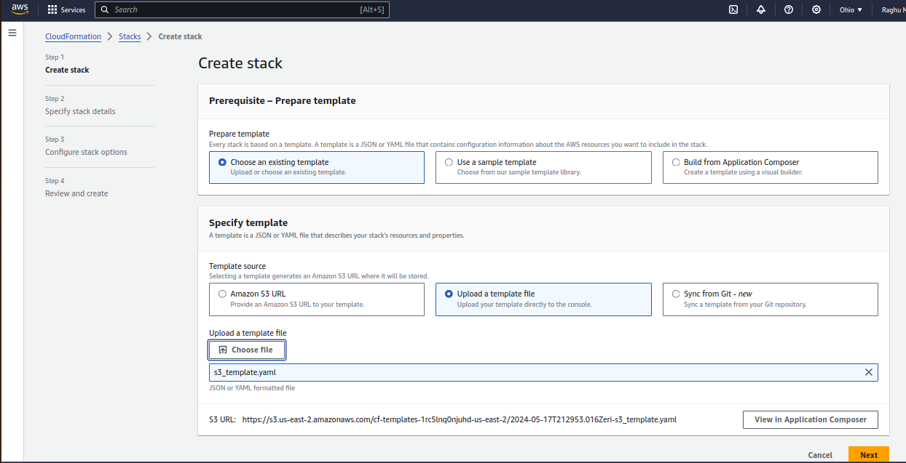

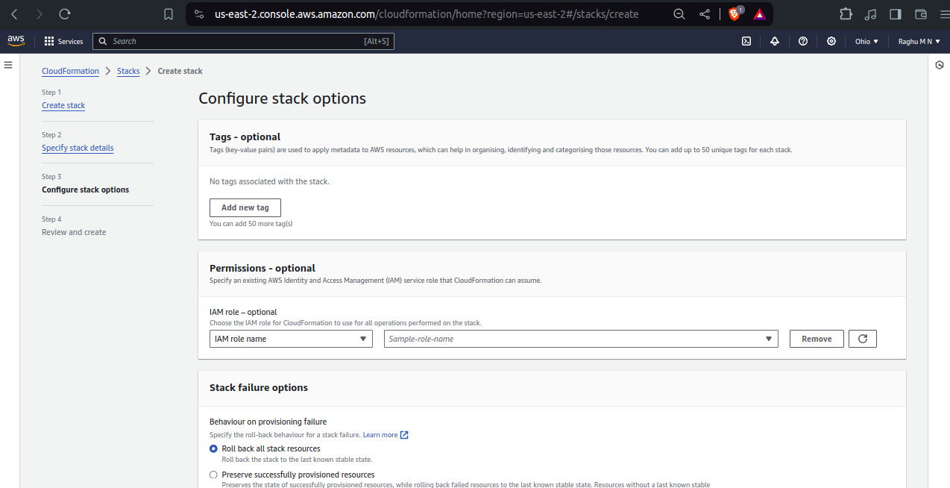
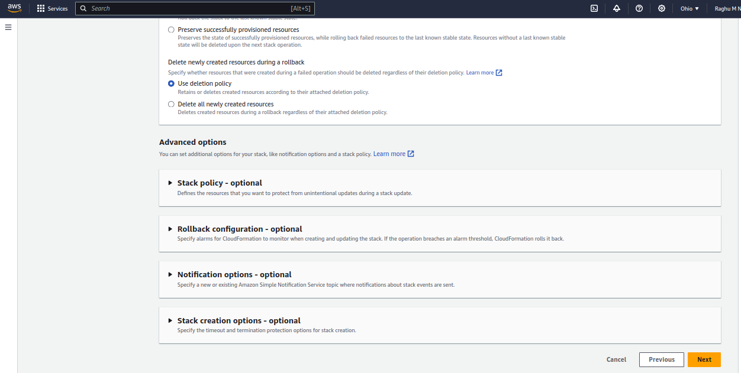
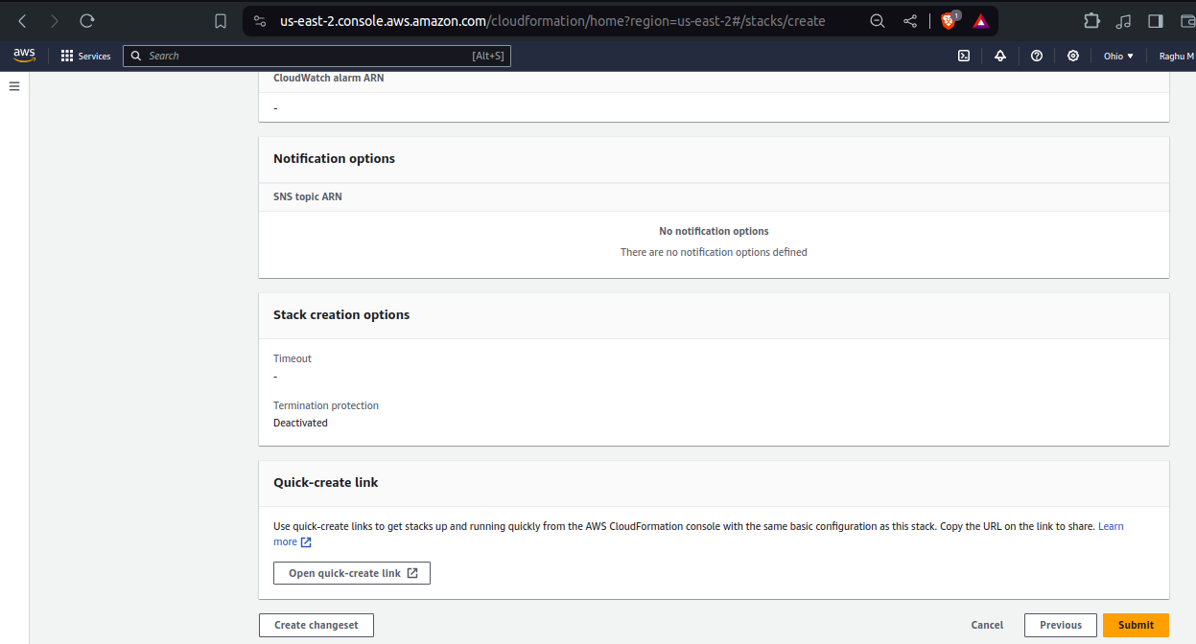
sroll down and submit

Creation is in progress
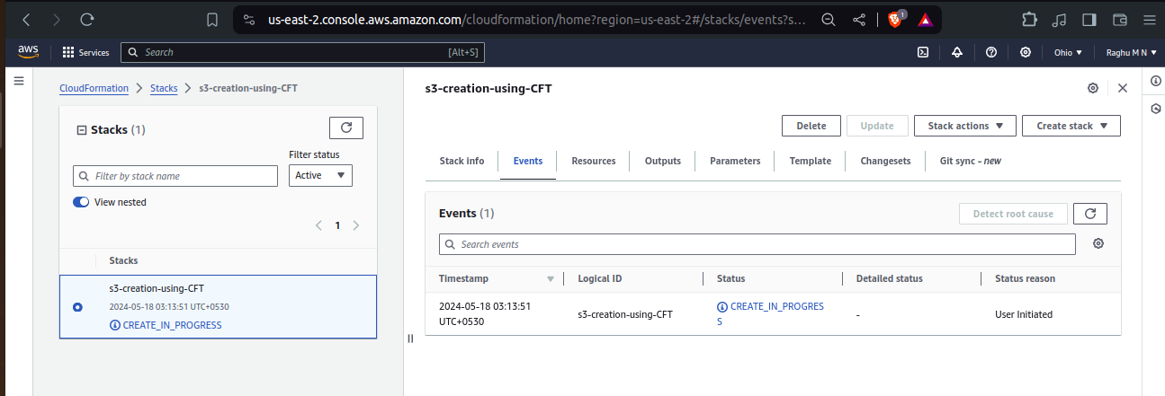
created
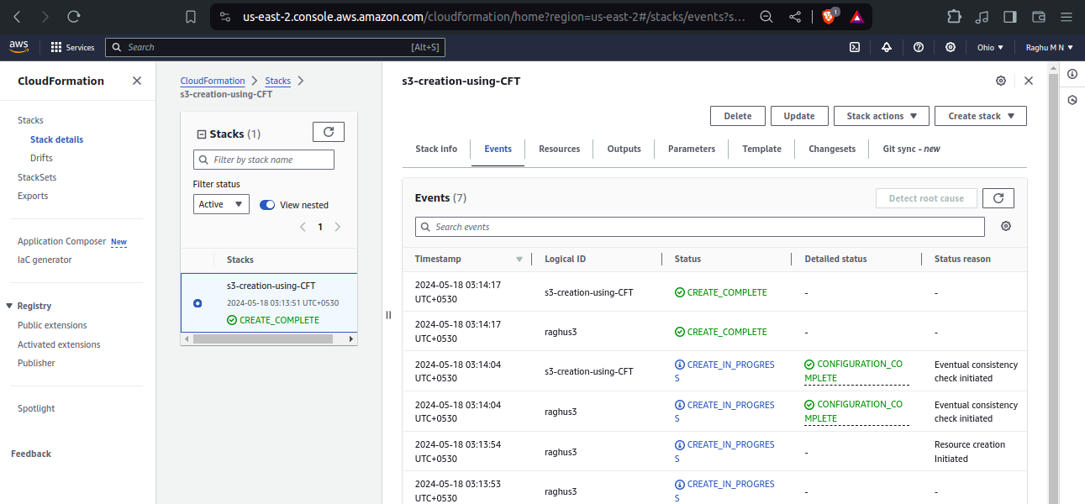

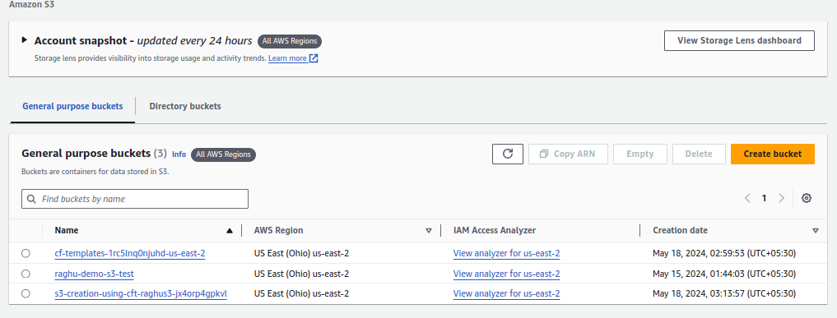

Checking on drift detection:

I will disable the versioning in s3 bucket and validate will drift detection happen or not

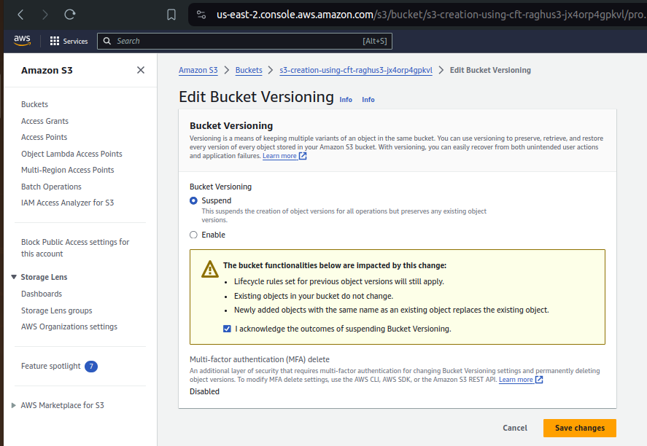

Go to CFT and click on stack,action and click drift view

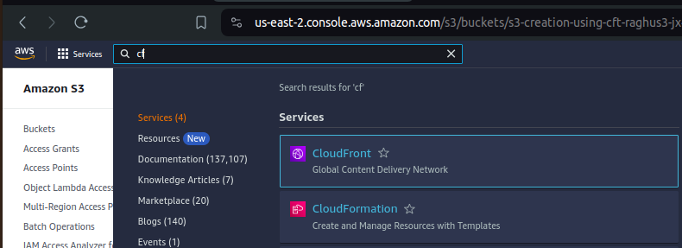
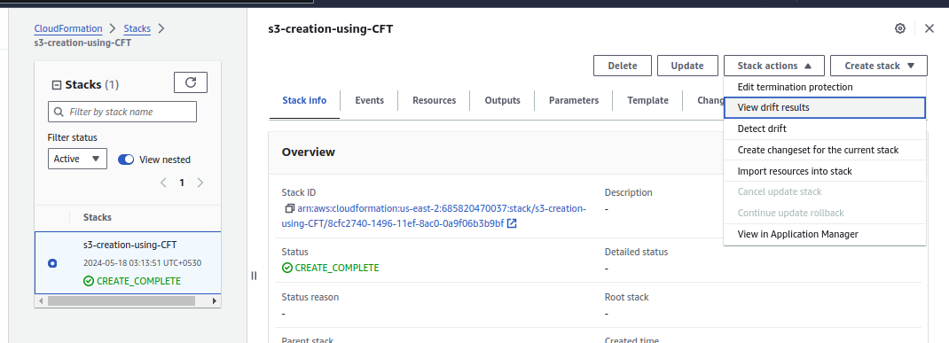
Drift detection initialted,wait for min,it will show the changes which are modified compare to template
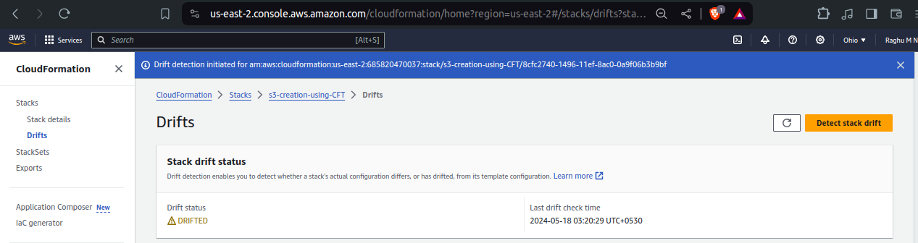
click on view drift
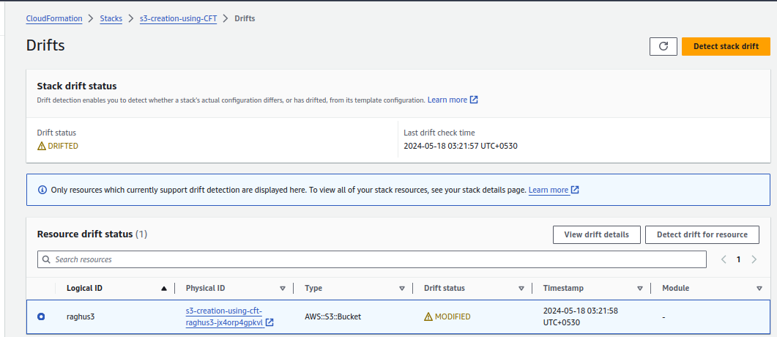
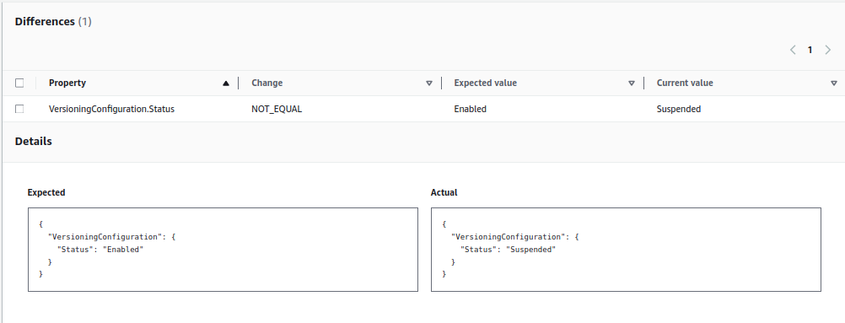

Simple tricks and tips to write CFT template: you have go through document,below plgings will help you to write it easilly.

Plugins which help me to write CFT templates easily:

YAML plugin into VS code.

AWS Toolki plugin into VS code.

