AWS CI/CD:

how we will implement the CI/CD?
Commit the code into git
use jenkins to create pipeline script
build the code using docker build(pip or poetry install) or maven build
deploy to k8s cluster using kubeconfig file

To complete CI/CD,we used four tools that are git,jenkins,docker or maven and deploy tool(kubectl or helm using kubeconfig file)

AWS provides the comprehensive set of services to implement the complete CI/CD.
That services are AWS code commit --> as git
AWS pipeline --> as jenkins
AWS build --> as maven or docker build
AWS Deploy --> as helm or kubectl

AWS code commit is version control system service provides from aws service.
Aws code commit is like git.

Why aws code commit instead of github or git lab? --> tell advantages of AWS code commit
*Managed git solution from aws,no need to warry about installing on servers,scaling up when require,all things will done from aws.
*Even some organization use github private repository or github enterprise or gitlab based their convience.Org use gitlab buy and install it their servers. No one will commit the code changes into public repo or use free github except open source code,personal project.

open source code mean code is available to use or modify it and used your custom changes

Advanges of AWS code Commit:
*Managed git solution --> Provide the git service and manage from them self
*Scalabilty --> no need warry about availabilty,as they number of repositories increase,they will scale up
*Reliability

AWS don’t recomment to use the root account because you can’t do the ssh into your repo(clonning),commit the code. It recommend to use the IAM user



Creation of Repo:

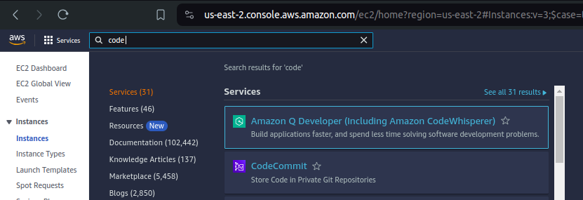

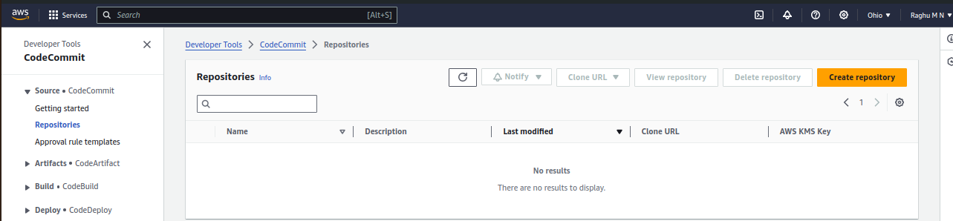
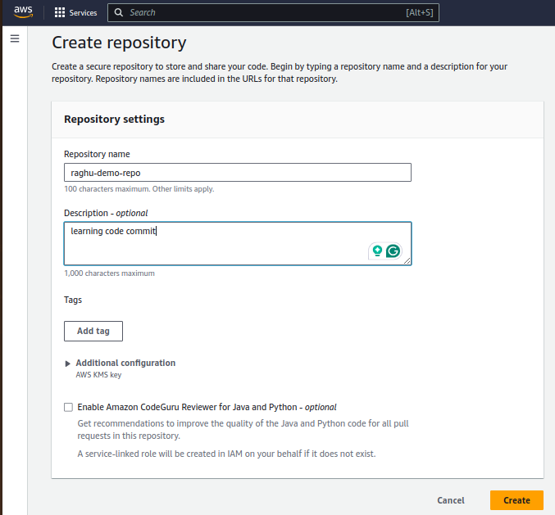

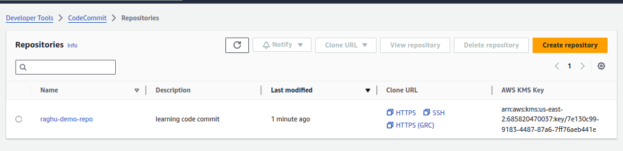

Creation of IAM user:

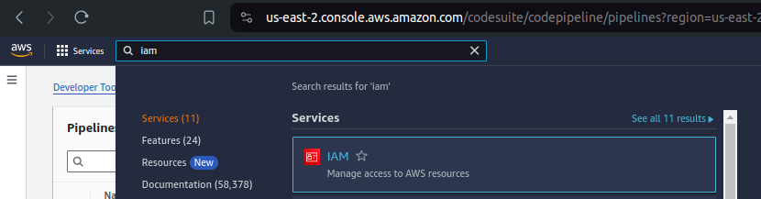
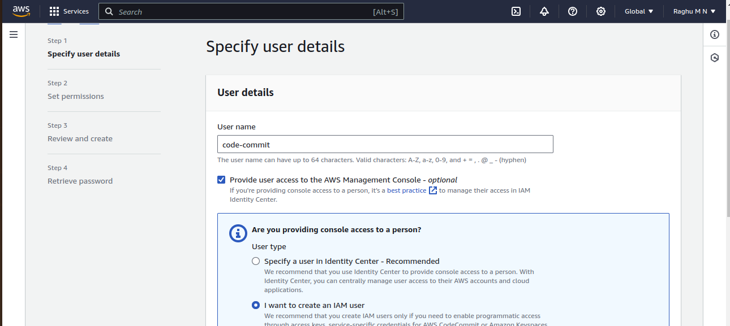
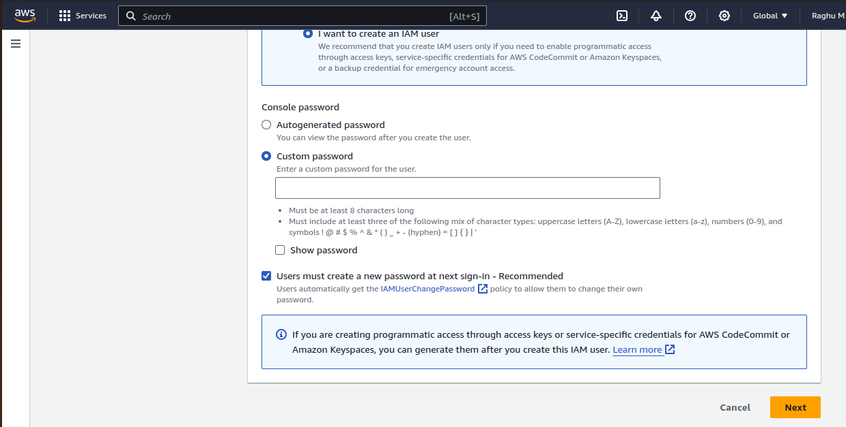

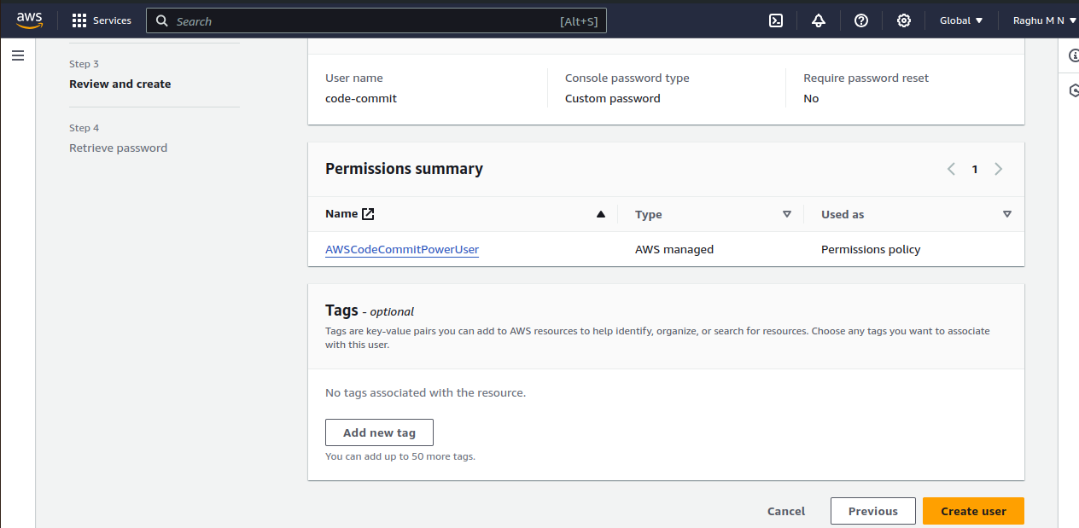

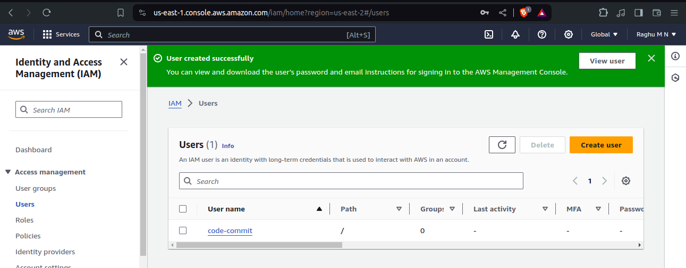

Login as IAM user:

you will get the account id from your top right side,account id is required to login as IAM user. I create the IAM user as code-commit.
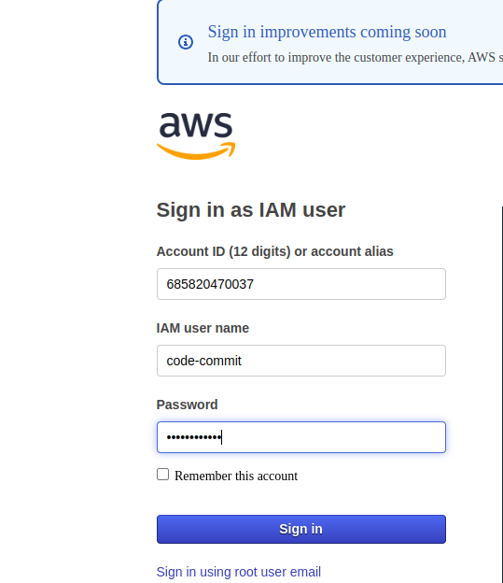

Change the Region,once you login,it will show different Region

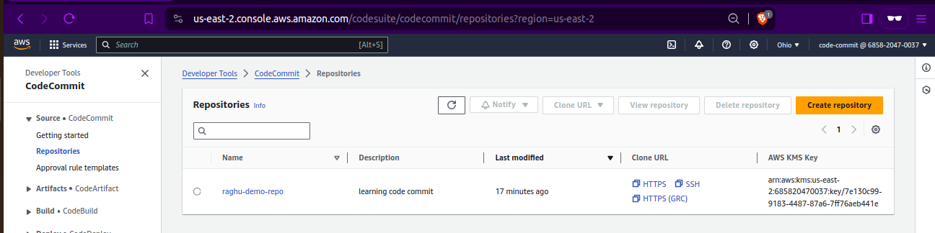
seeing the repo as code-commit user

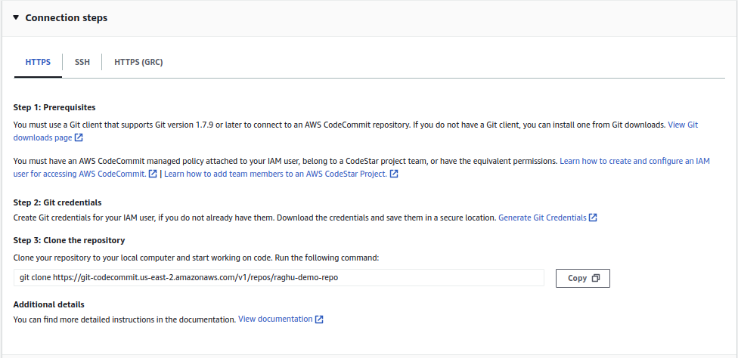

Install git on your system

set the user and email using git config user.name and email

creating HTTPS git credential for code cmmit

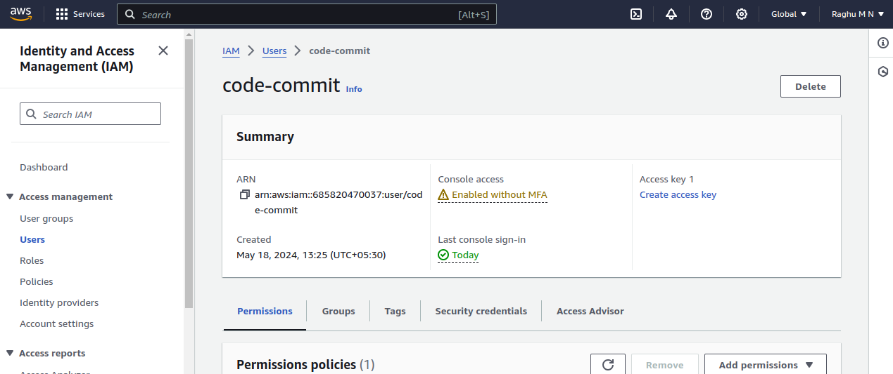
select security group

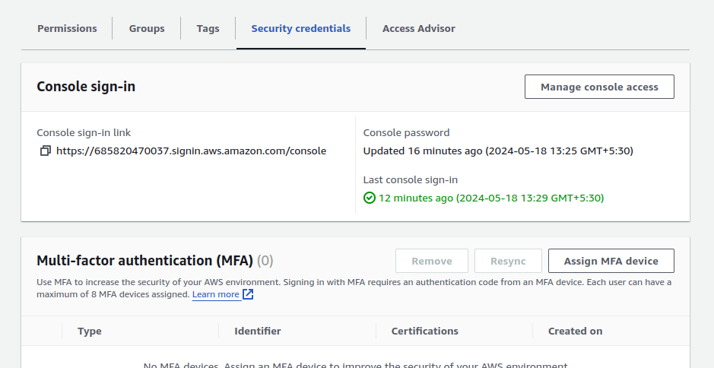
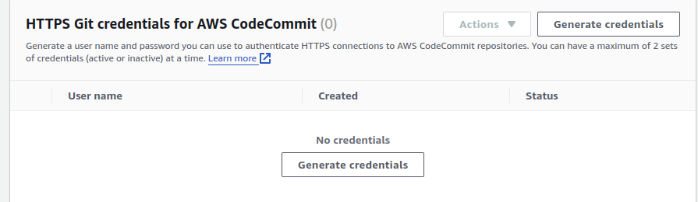

download copy username and password,save it some where. While cloning it will ask for username and password

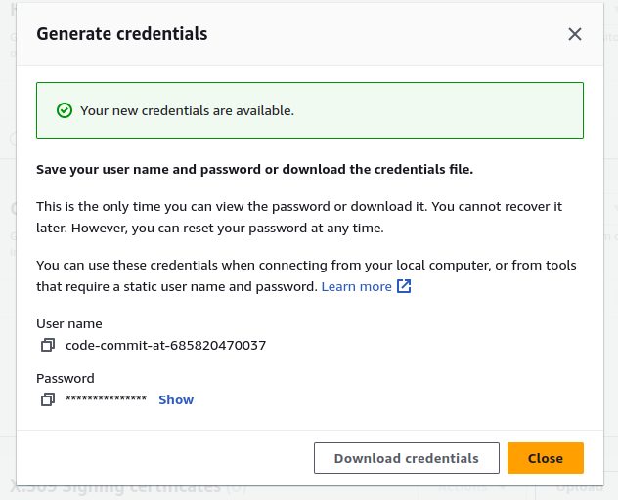

clone it --> git clone

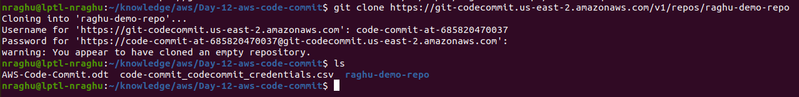

Do the code changes,commit,push

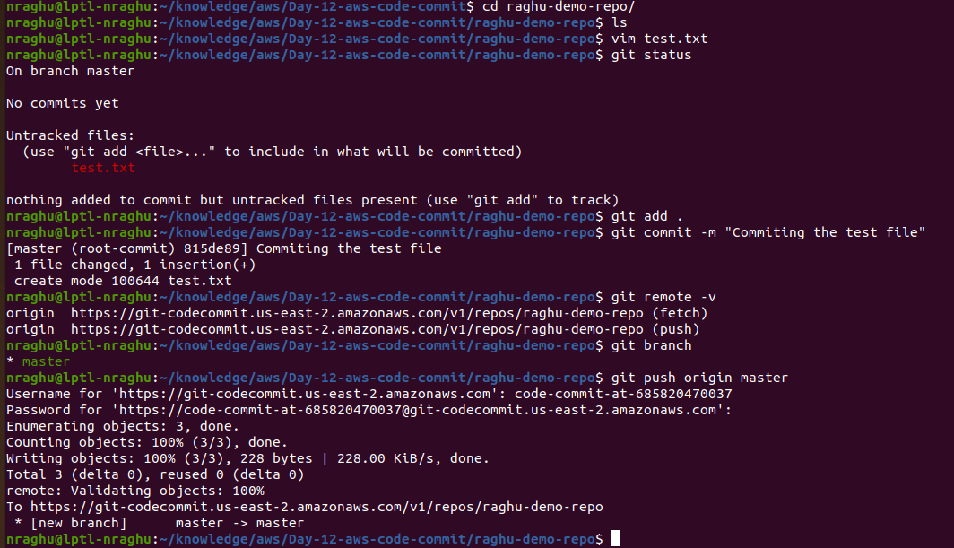

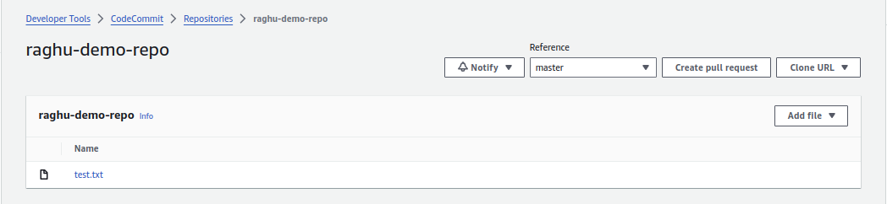

Disadvanates of AWS code commit:

*Less features --> gitlab or github have more feature like codepilet, auto devops, VS code ingetration
*AWS Restricted --> aws is resticted to use with other tool integration like VS code
*Less integration with services outside of aws

