AWS END TO END CI:

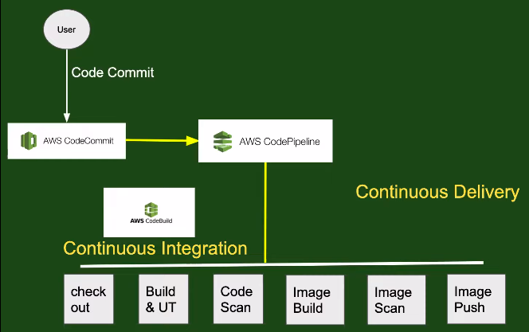

As we learn,AWS pipeline will invok the CI and CD mean call the AWS Build for CI
and AWS deploy for CD.

Creation of AWS build:

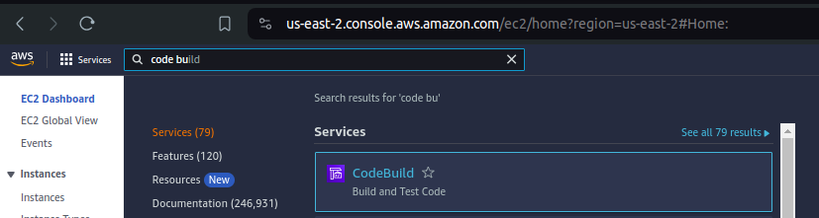

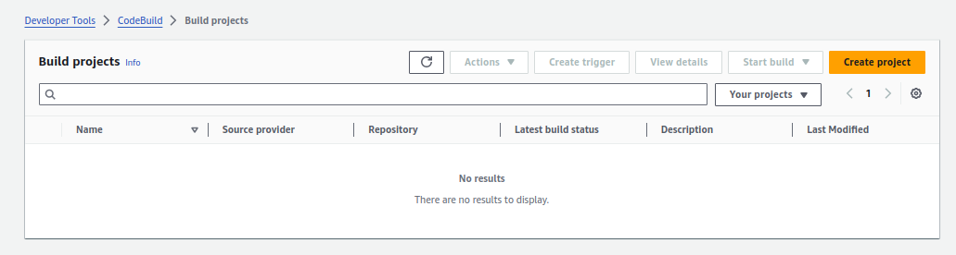
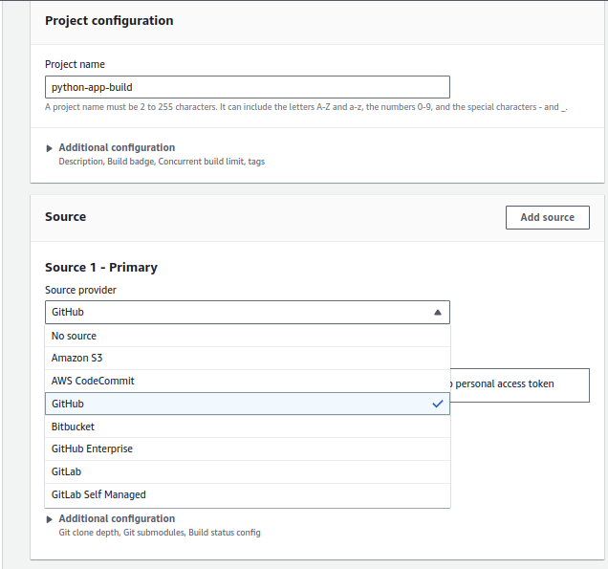
Select your source code tool

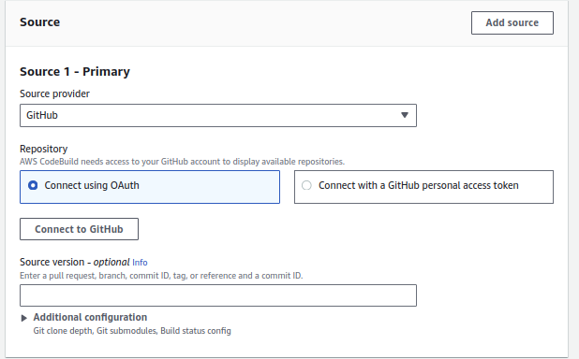
select connect using Oauth and click connect to github

click on autherize aws code-suit

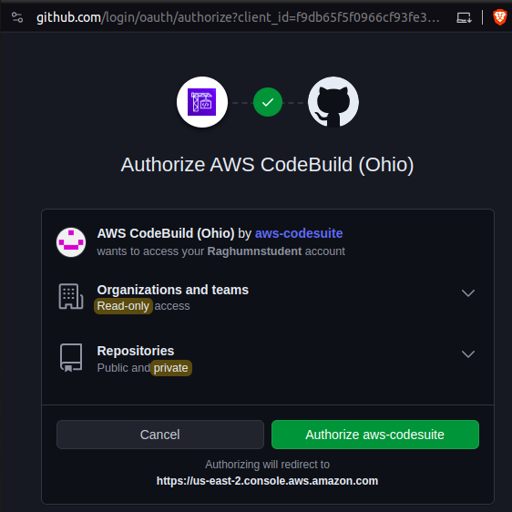

it will ask you for username and password

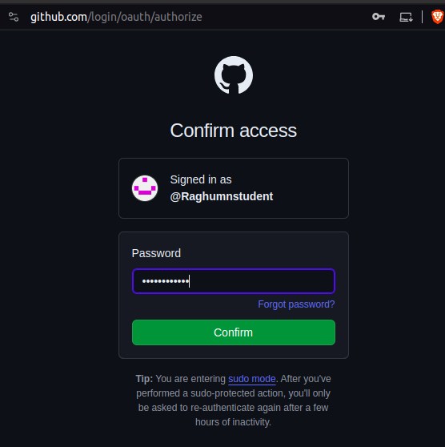

Once github is connected,show all repositories available in your github account

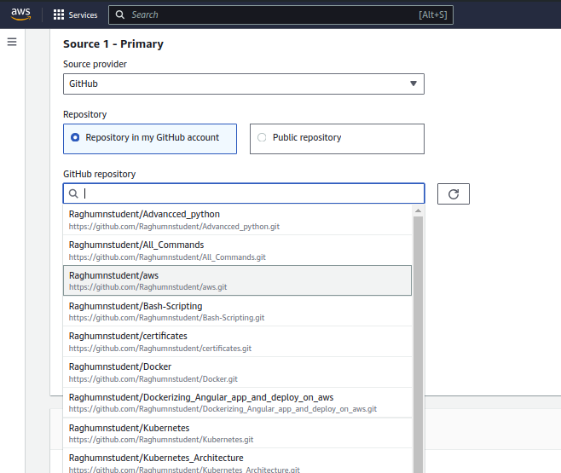

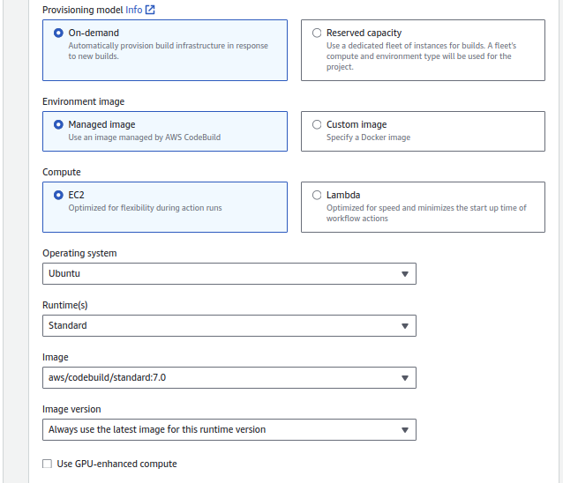
Selecting on which machine build script should run
New Service role will be created
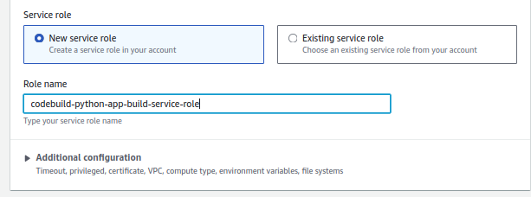
Why we are using service role ?
Aws build is a service which is performing some action.
Role are used to run services within aws or access to aws service from external tool

write build script to perform CI activity

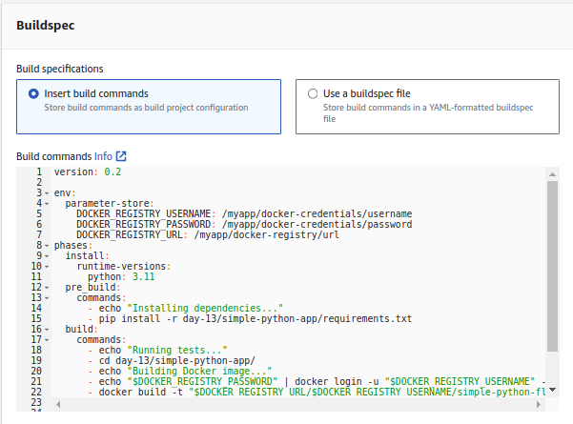

we can’t pass the username and password in plan text,user parameter store to store the sensitive infomation.

Creation of parameter store.

Click on aws systems manager

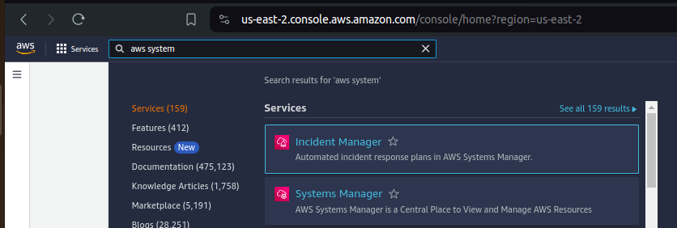

Left side there is paramer store option,click on it

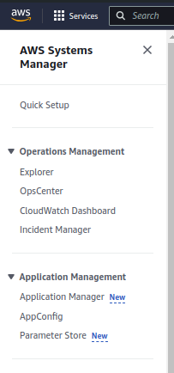

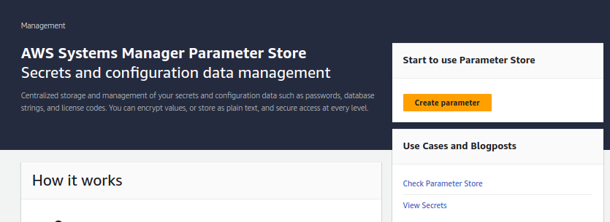
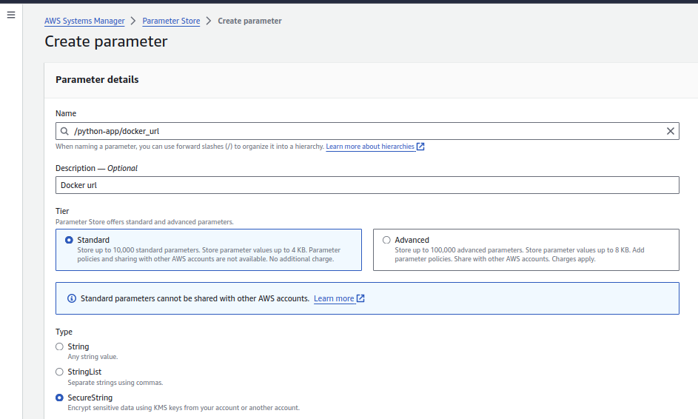
give name,description,select standard and securestring

give value to parameter

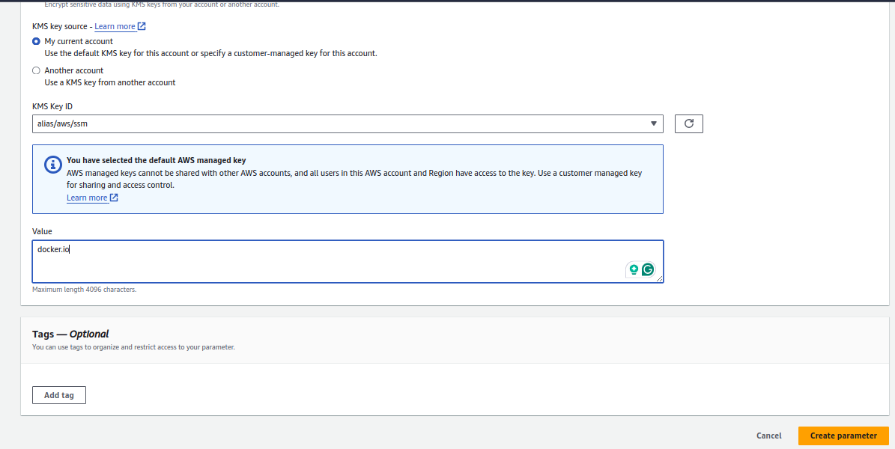

Created all three required parameter

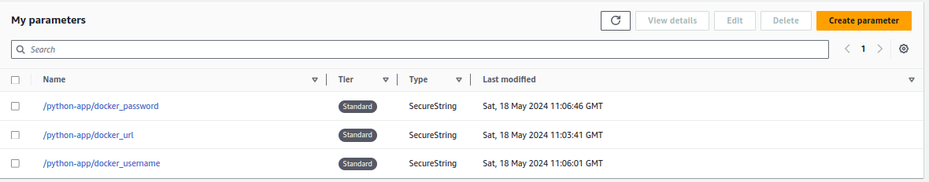

Updated parameter stores and file path in script

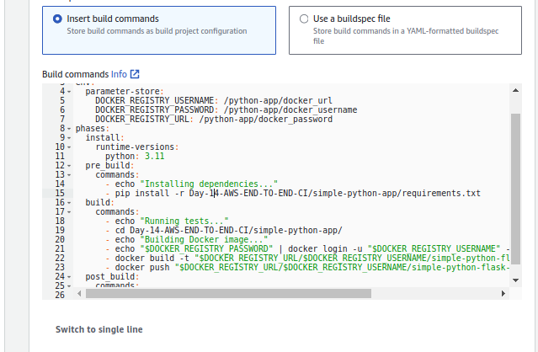

check the cloudwatch logs and Un-check on s3 logs,click on create build project.

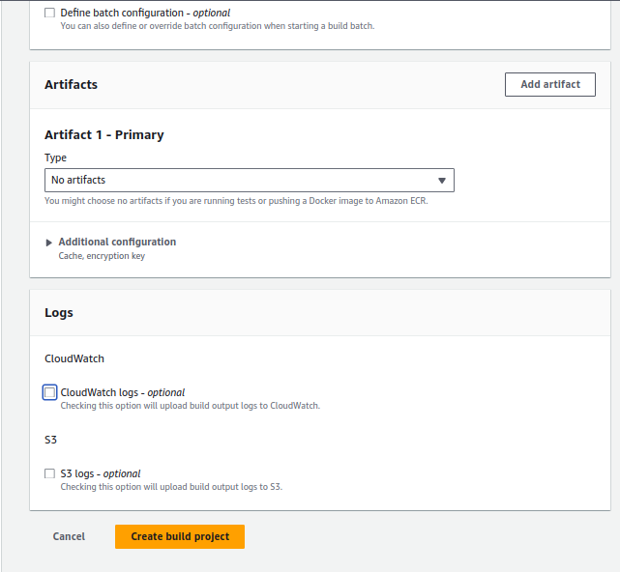
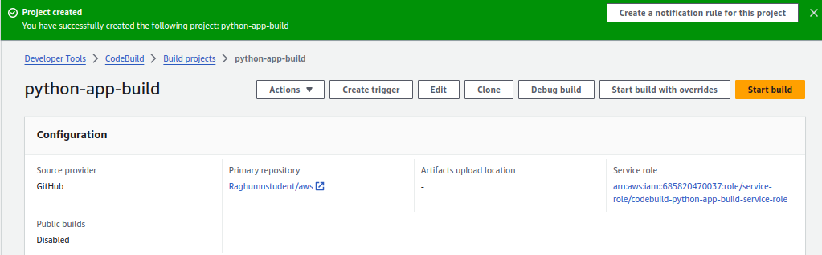

Build is failed becuase we not attached policy to ready parameter store from system manager.

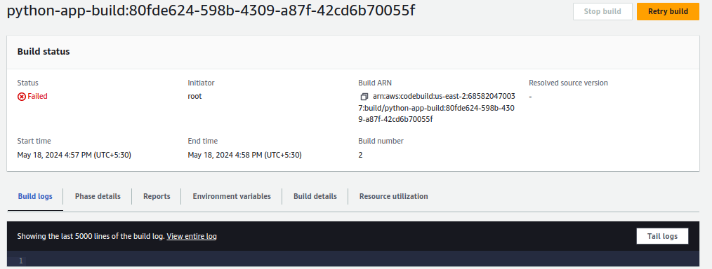
Click view entire log or taill logs to see the log messages

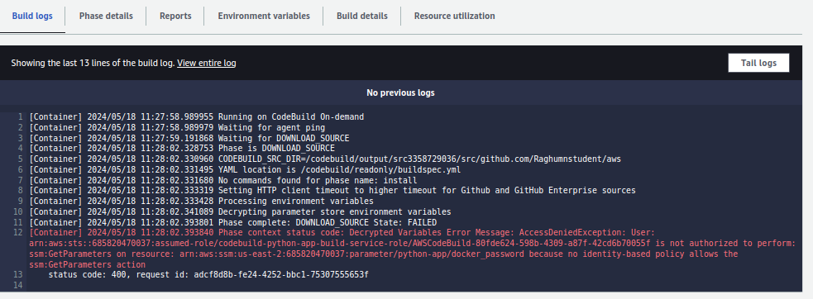
Go to IAM --> roles ->select role and click on attach policy,search for system manager,select system manager full access

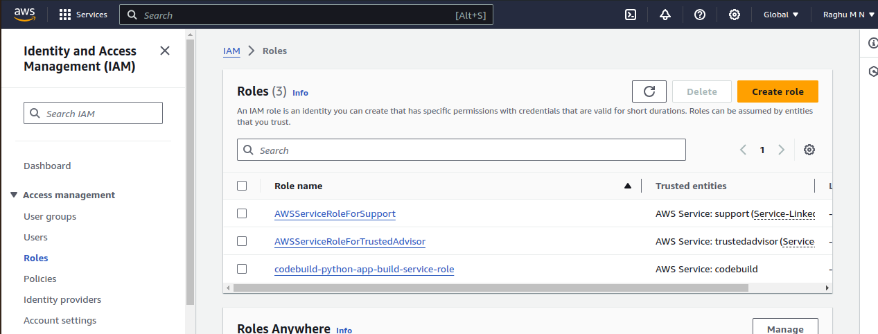
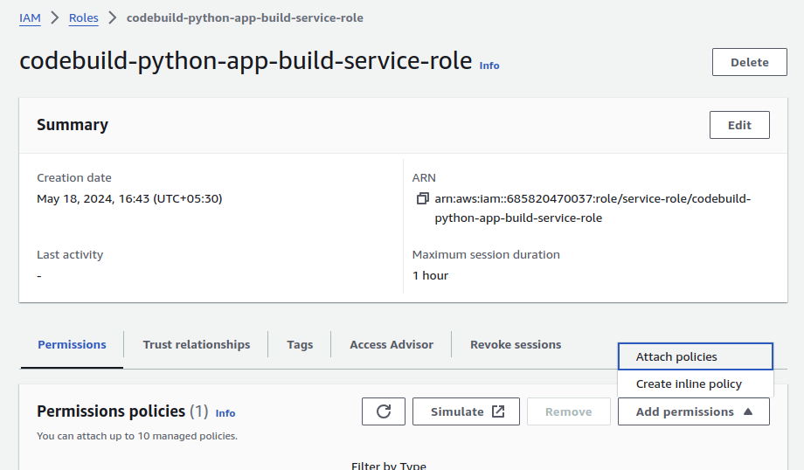
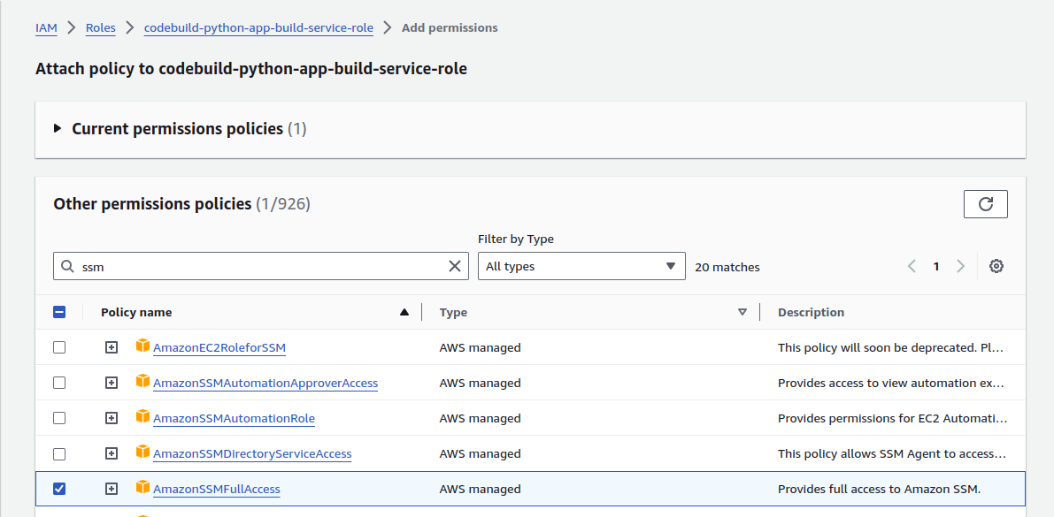
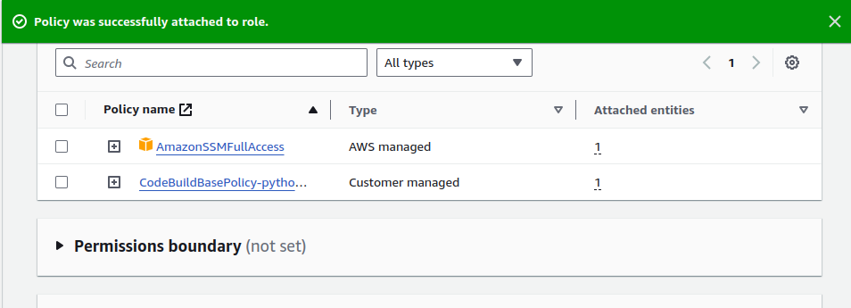

Now click on build to see any other error will come.

It is failed login into docker registry,it did not update the parameter to variable properly
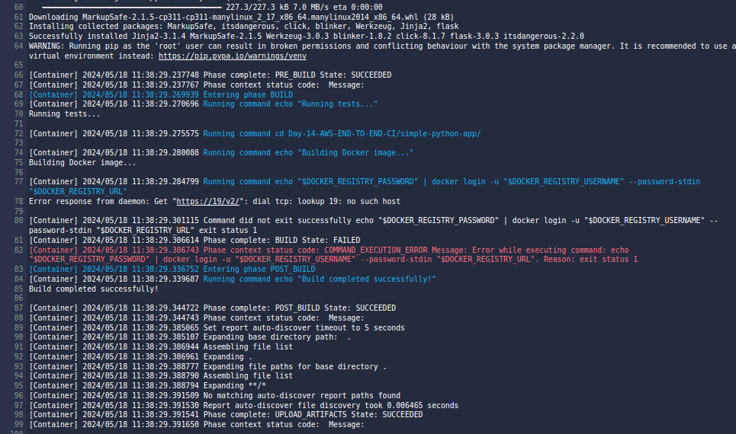
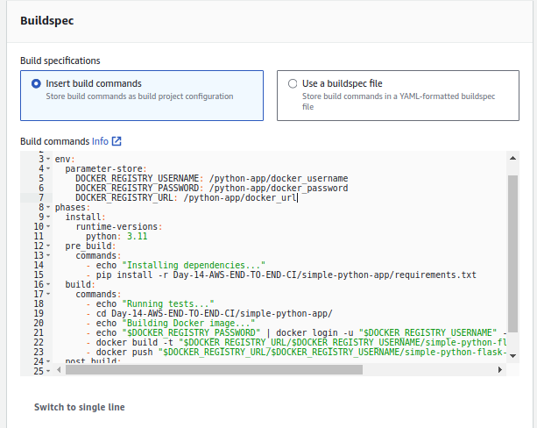

Successfully build and pushed the image into my docker registry

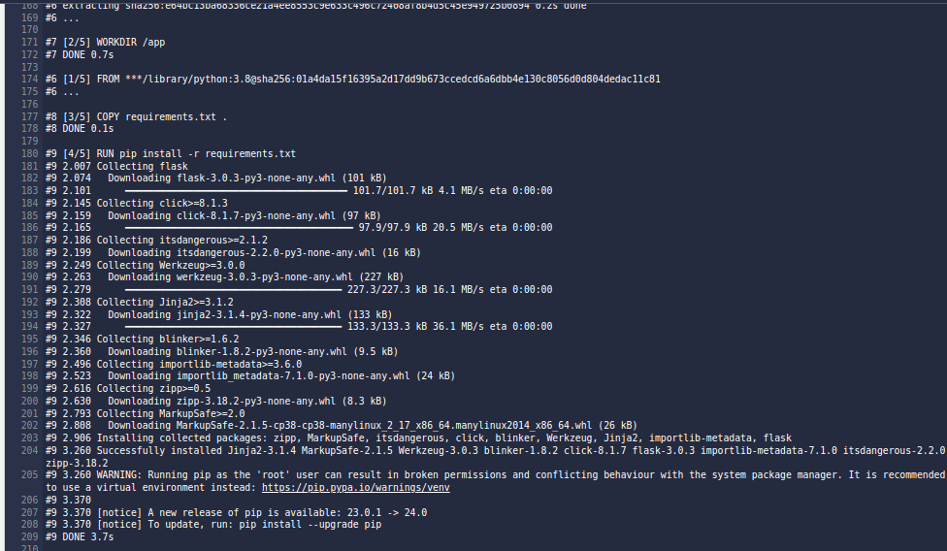
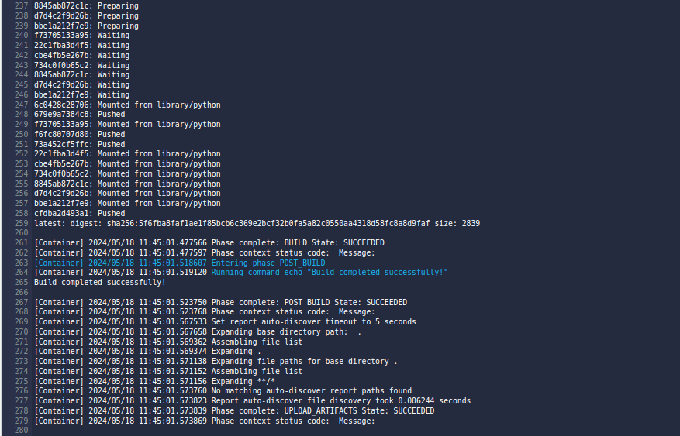
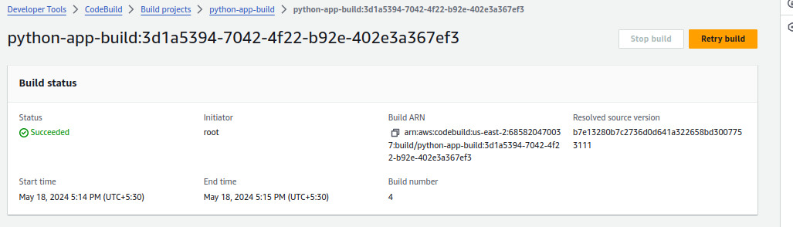

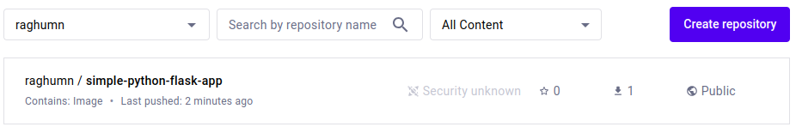

Now integrating the AWS pipeline to trigger AWS build when code changes commit to repo.

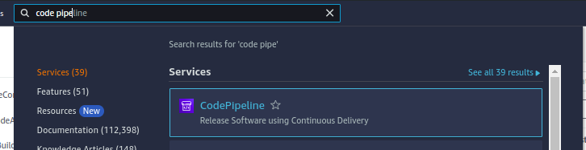

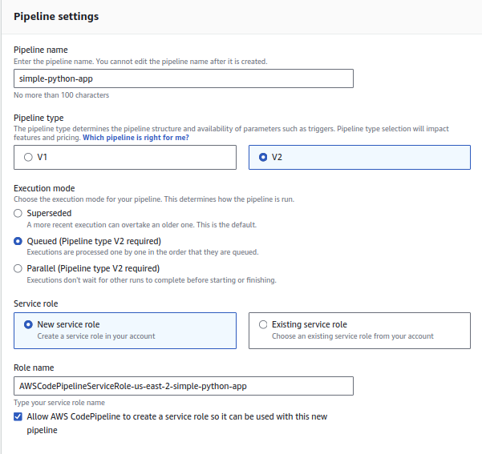

Give name for connection between pipeline and github,click on connect to authenticate

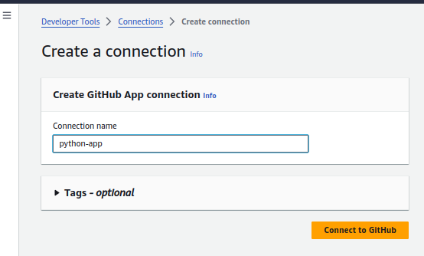
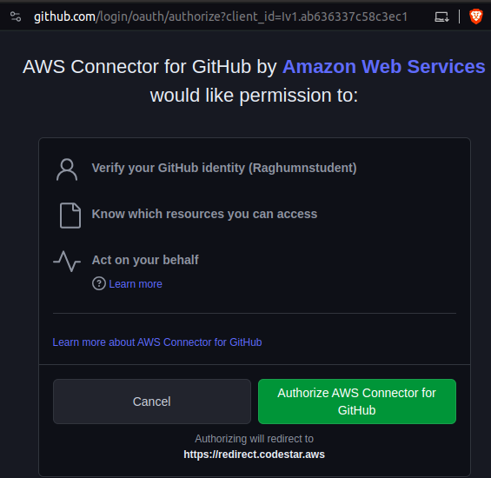

First click on install new app --> it will install github app with your github
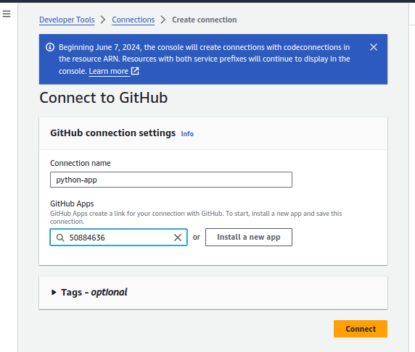

Select repo,branch

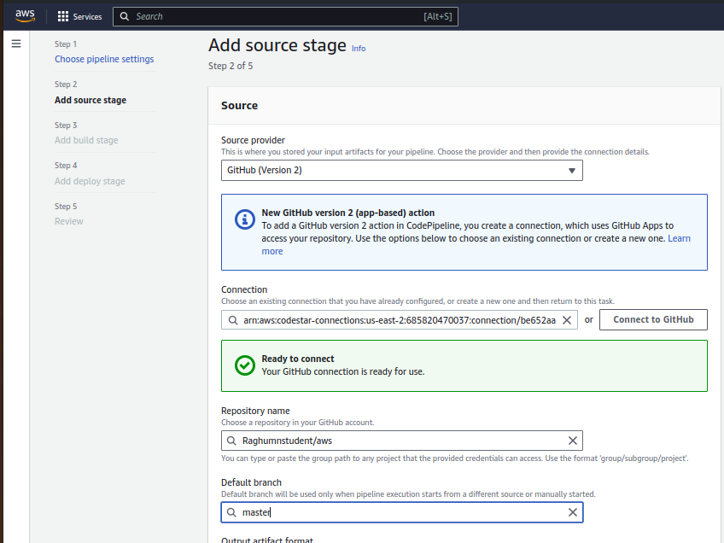

On which event this pipeline need to be triggered,selected push event
and provide the branch on which branch changes pipeline need to trigger
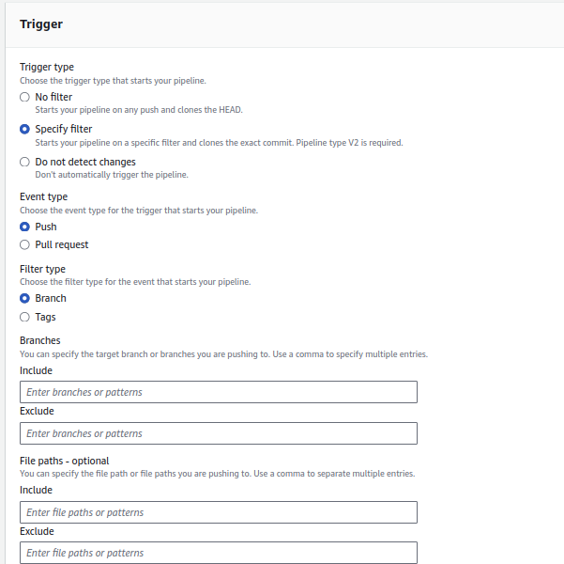

score down and click on next.

Select aws build to integrate,in drop down it is showing add jenkins also as option may be added jenkins as builder in aws now

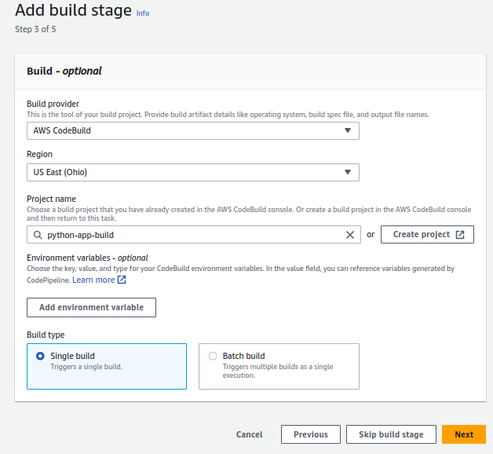
click skip deploy,we are focusing on CI only now.

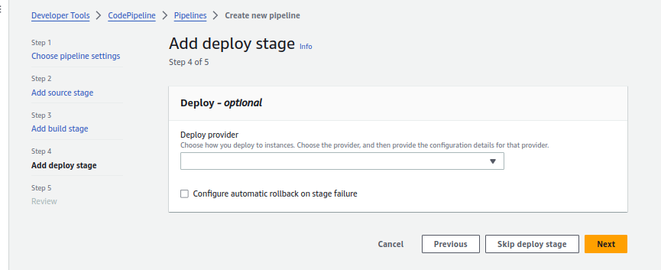
Scole down and click on create pipeline

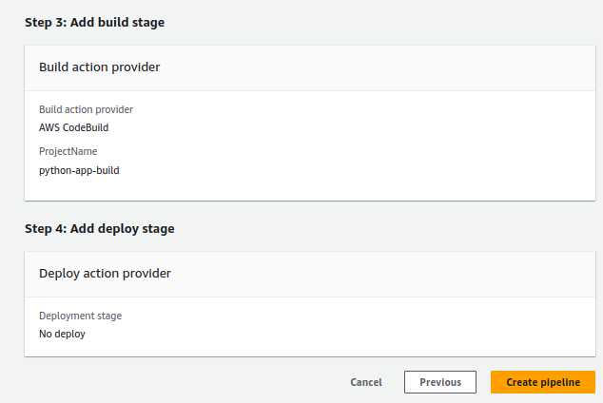

Intergared AWS pipeline into AWS build and configured to trigger pipeline when any changes push to repo of master branch.

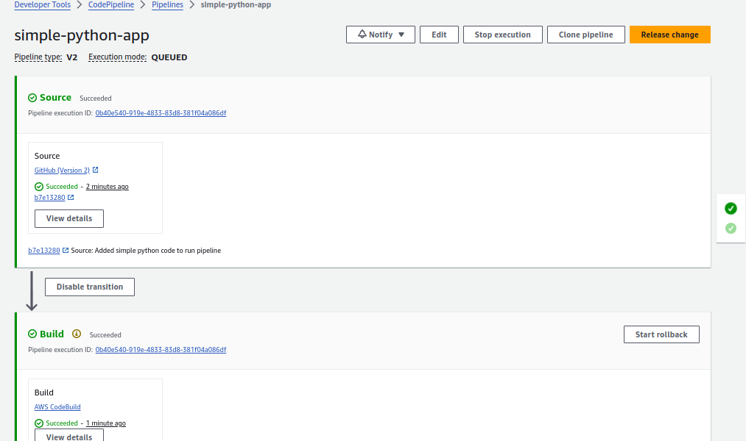

Let push code to repo and see

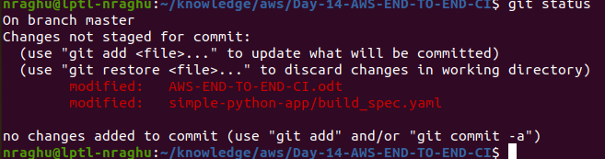

once I pushed the changes,pipeline got triggered

