AWS LAMBDA:

what problems AWS LAMBDA will solve?
*Compute --> As like EC2 instance,no need to manage and we can easily scale up
*Serverless architecture --> means once the application ran completed,aws will ter-down the lambda instance (remove lambda instance),that is the reason we call it as serverless.

Ex:
In food delivery app,custom order food,raised the request to make payment, that time payment application is spined by lambda,onec customser completed the pay within spicified time,aws will ter-down the payment lambda instance

What is aws lambda?

AWS lambda is serverless compute service provided from aws,that allow you to run code without provisioning or managing servers. With aws lambda you can execute code in responses to changes data in s3 bucket,updating to Dynamodb tables. You only pay for compute time you consume,so it is cost effective and scalable

in responses means --> we will configure to trigger lambda function if event happen, events are changes in data of s3 bucket,when updating to DynomaDB tables, API call etc.

What is difference between aws lambda and EC2 instance?

In LAMBDA:
*No need to provide the details to create lambda,based application it will automatically allocate cpu,memory etc,scale up if required
*Once the appliction ran,aws will automatically turn off
*you will not get any instance ip address,security policy and where it is created like on which region. No control on details.

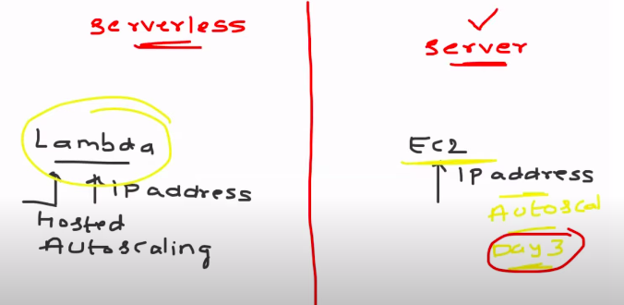

In EC2 Instance:
*we have to provide all details to create it
*we have to take-care about the stoping of instance.
*you will get all details about the ec2 instance.

As a devops engineer,you will not decide on which one serverless or server based approach go through.
Architecture team,implement team will decide this.

We can use Lambda function for cost optimization for all services.
Some one created EBS volume,not using from last 30 days,we can write lamabda funtion to report about ESB volume not used by anyone from last 30 to optimize the cost.

In aws,serverless functions are only event driven.

Written 10 scripts to run every day at 5am,
you will tell to Cloud watch by creating cron job to trigger the lambda function (lambda function automatically run script and terdown)for every day at 5am,lamba function is event driven function.

Best usage of serverless architecure from devops engineer:

*Cost optimization --> ex:explain above example
*Security --> ex: your org told to don’t create EBS volume with GP2,write the lambda function check any EBS with GP2 is created and schedule labda funtion at everyday, s3 bucket with public access etc score of using lambda funtion is endless
*Regular routine activity --> perform you regular routine activity.

Creating the lambda function:

In lambda function,we will watch the s3 bucket with public access.
Aws will provides more default script,also we can write function to add into lambda function.

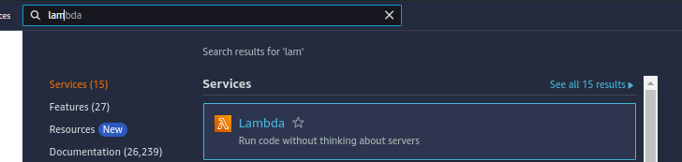
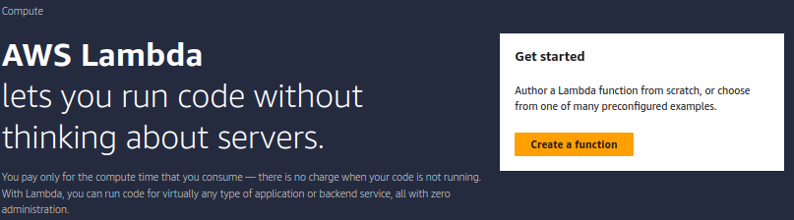
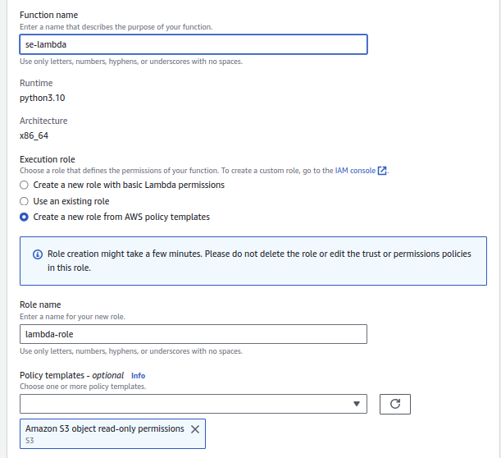
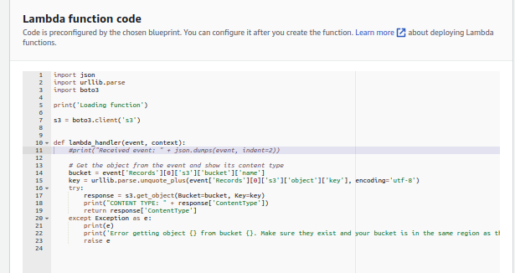

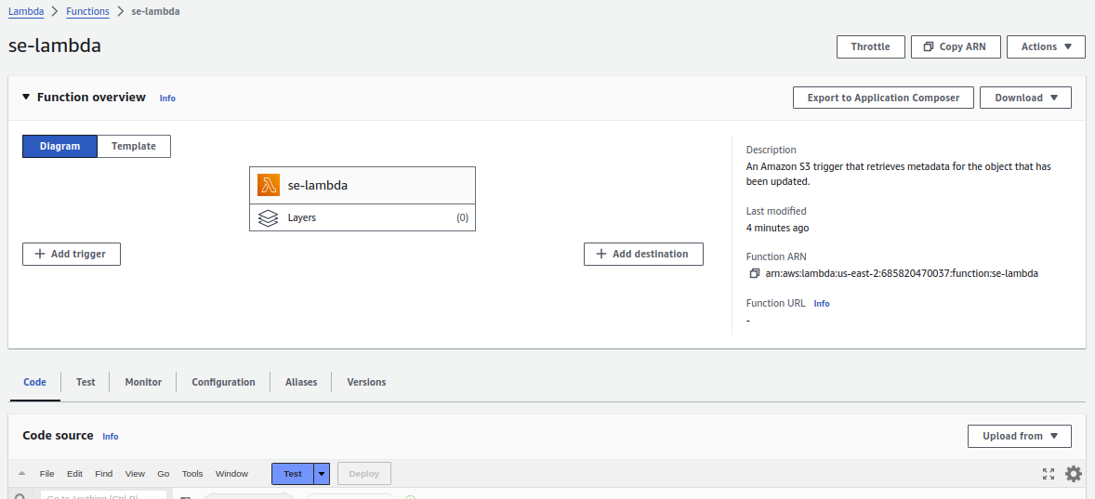
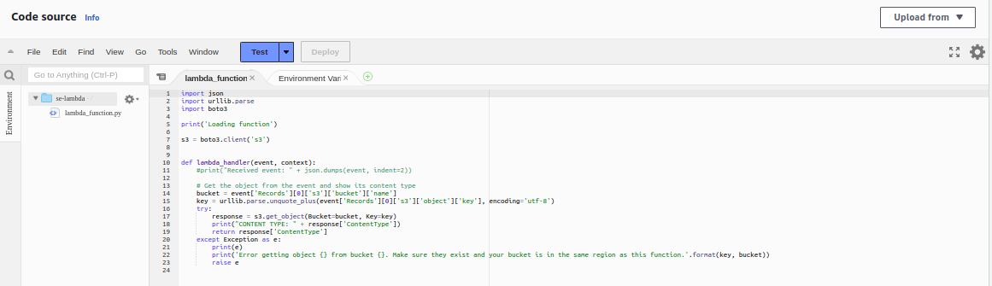
Lambda will also support the environment variables.
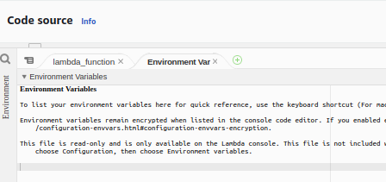

Lambda configuration.
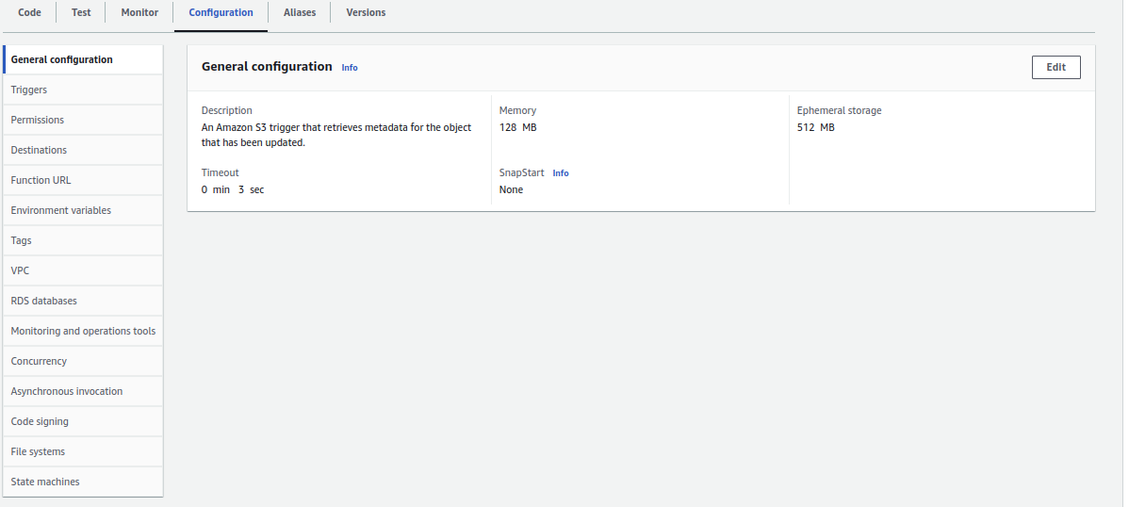
Once we create lambda function,we need to add trigger using cloud watch or s3, both are event trigger.

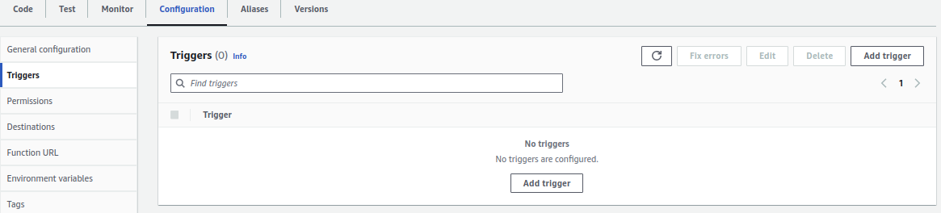

Permission: role must be have permission to talk to other services to complete task
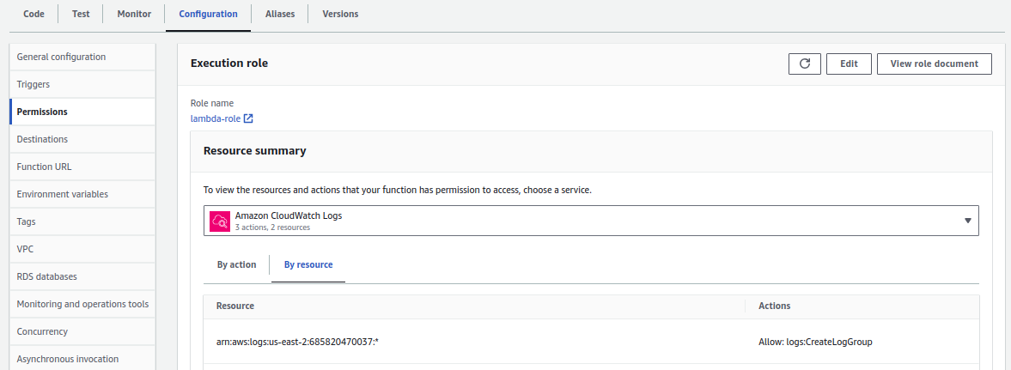

Destination: we need to be done once it is completed like sending alarm mail.
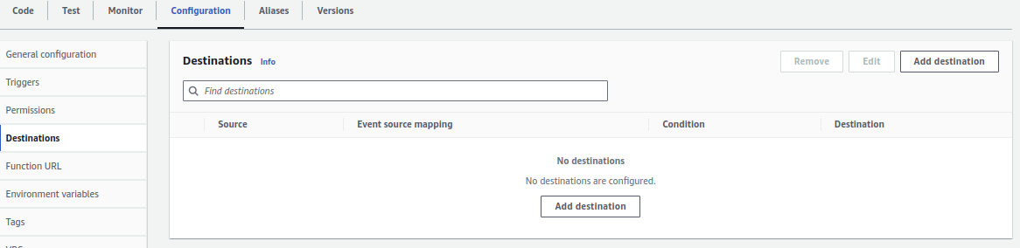

Function url : To access with IAM user
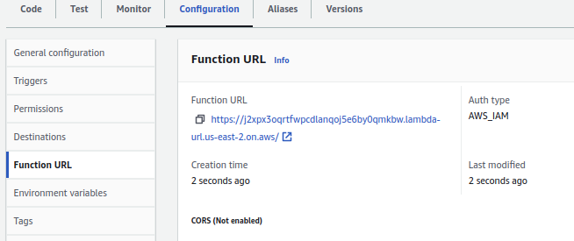

VPC: create this lambda function within specific VPC.
