AWS Cloud Front

AWS Cloud Front is content delivery network(CDN) service provided from aws. It helps to delivery your web page content such as html,css,image,videos to user accross world with low latency and high transfer speed. Cloudfront achieves this by caches copies of your content at edge locations globally,which is closer to users,ensuring faster access and better user experience.

Edge locations: these are data centers located around the word where cloudfront copies content of your webpage

How It Works:
- User Requests Content: When a user requests content from your website, the request is routed to the nearest CloudFront edge location.
- Cache Check: If the content is already cached at that edge location, CloudFront delivers it directly to the user.
- Origin Fetch: If the content is not cached, CloudFront retrieves it from the origin server (e.g., an S3 bucket, an EC2 instance, or an on-premises server), caches it at the edge location, and then delivers it to the user.
- Subsequent Requests: Future requests for the same content from nearby users will be served from the cache, reducing load on the origin server and speeding up delivery.

Benefits:
- Improved Performance: Faster content delivery improves website performance and user satisfaction.
- Scalability: CloudFront can handle high traffic loads, automatically scaling as needed.
- Security: CloudFront offers security features such as SSL/TLS encryption and integration with AWS Shield.
- Cost-Effective: You pay only for the data transfer(size) and requests(number of requests) used to deliver your content.

Instagram app.

User in US uploaded the image,his friend in india need to see,we have one datacenter in us and request goes to multiple routes and latency will be inscreased and user experience will become worst.
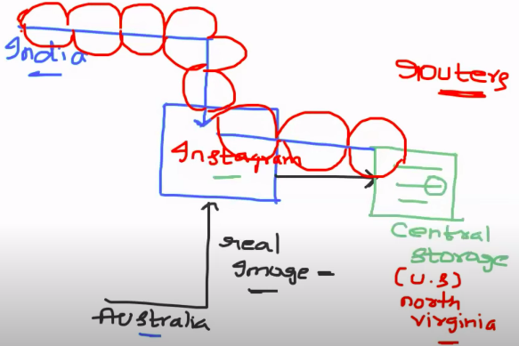

Content Delivey Network solve the problem:

Map the instagram dsn into CDN( based on CDN configuration),CloudFront will create local copies and store it in egde location(means closest servers)when first request come, for second request the content will be served from edge location,served immidiately.

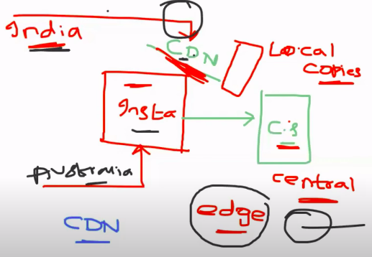

Create the s3 bucket to host the static file and create cloud frontend into your s3 bucket to provide access and reduce the latency problem.

Creattion of s3:
Bucket name must be match with your domain name.

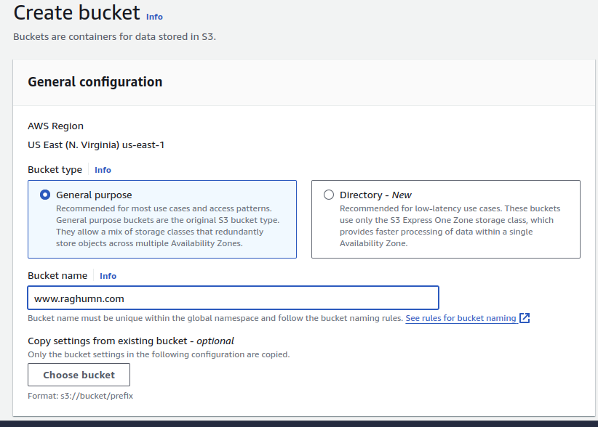
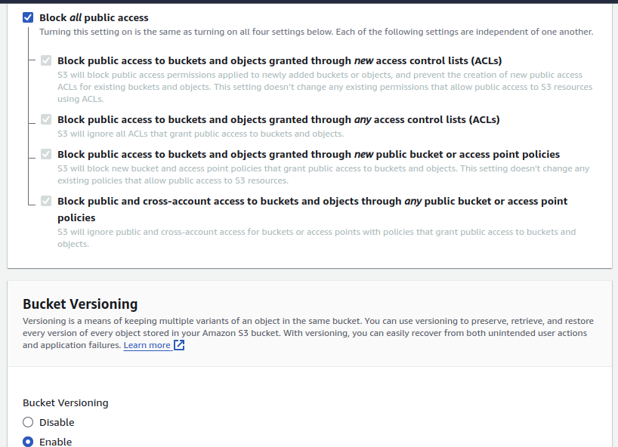
Block public access to s3 bucket and have track of object changes in s3

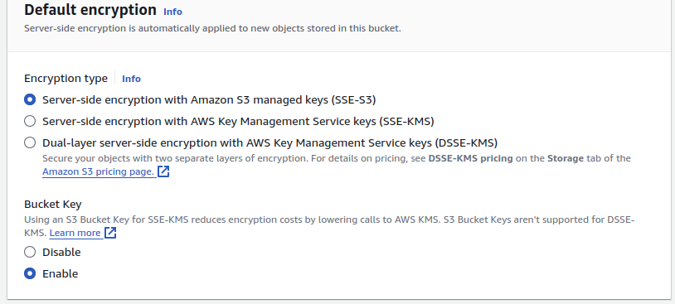
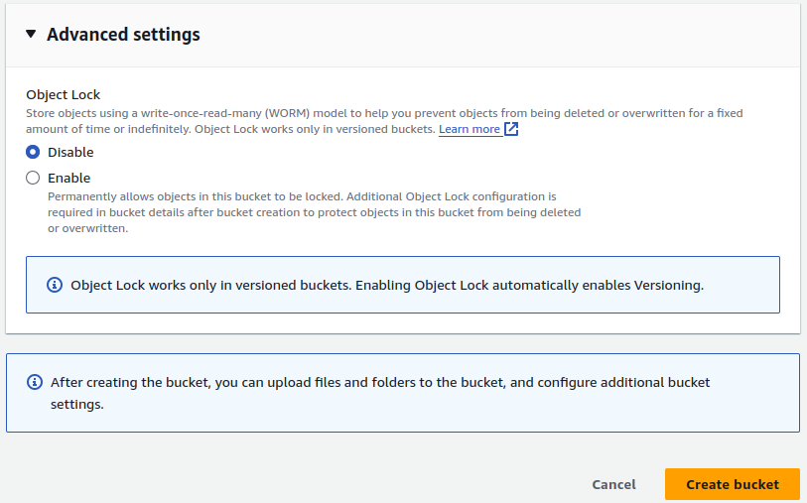

Enable static file hosting:

Click on s3 bucket and go to properties tag.

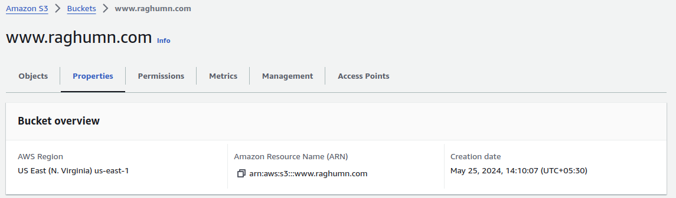
Click on edit and enable
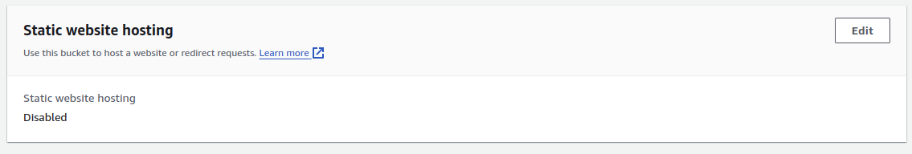

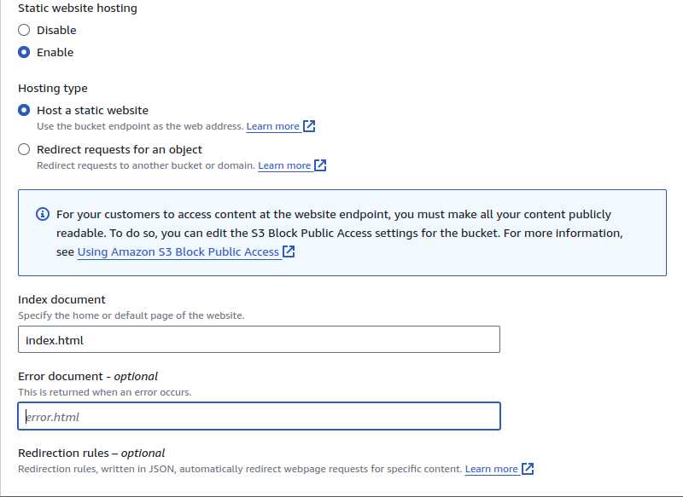
upload the index.html file
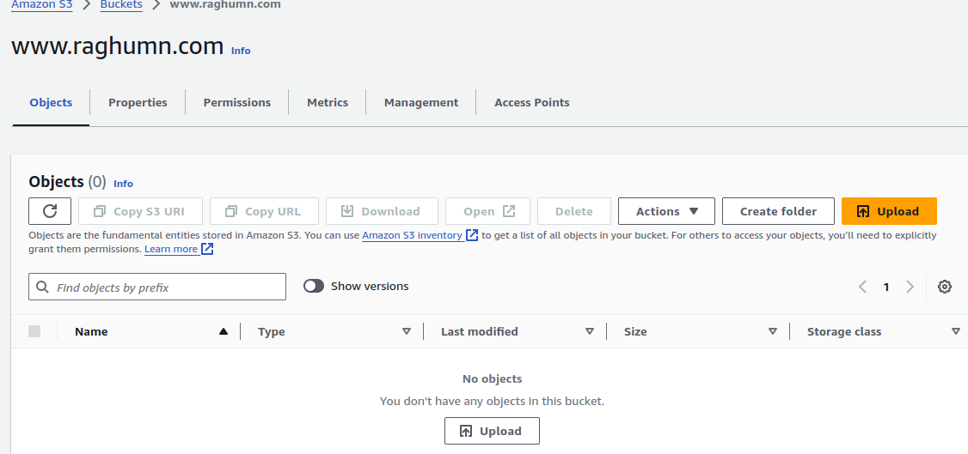
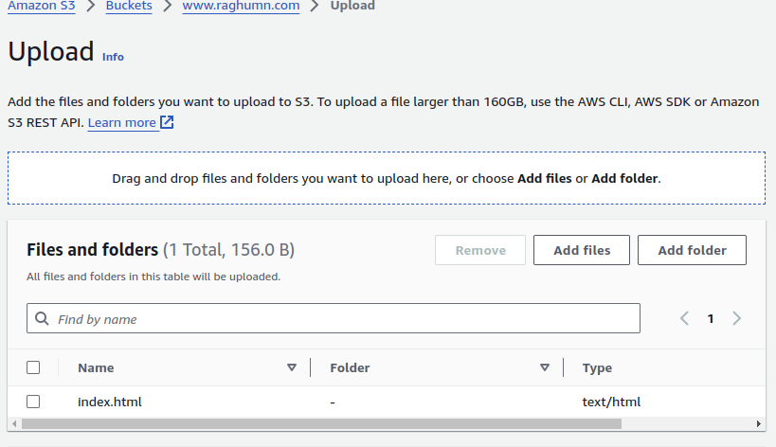
uploaded the index.html

Creation of Cloud front:

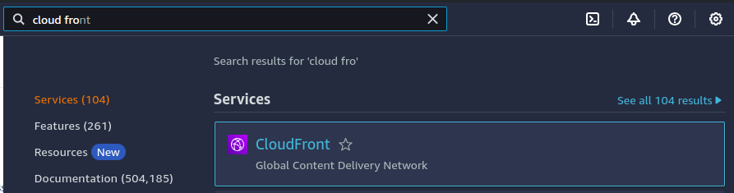
click on create cloudfront distribution
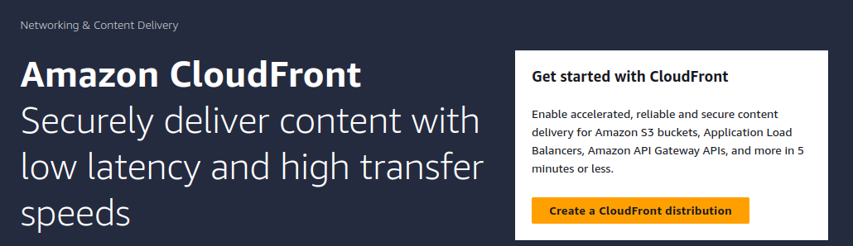
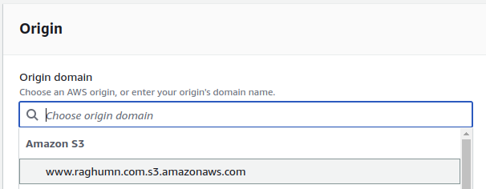
select your s3 bucket

click on create new OAI --> create virtual user for your this distibution to access your s3 bucket
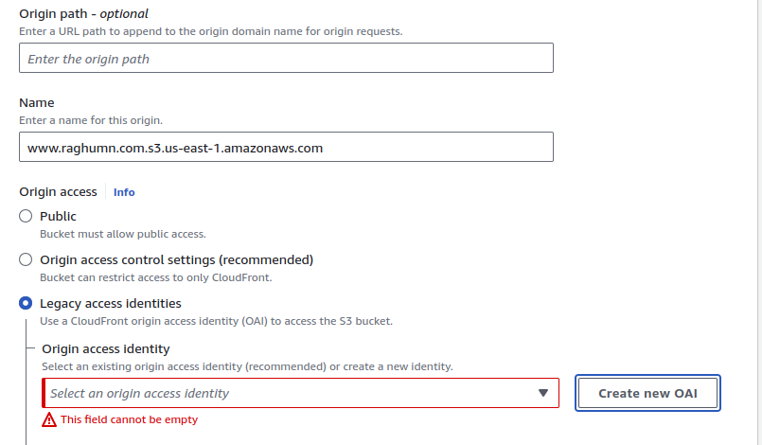
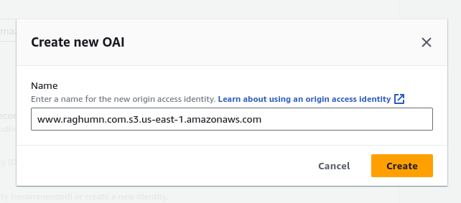
click on update policy, policy of s3 bucket will get updated like this OAI role able to access s3 bucket

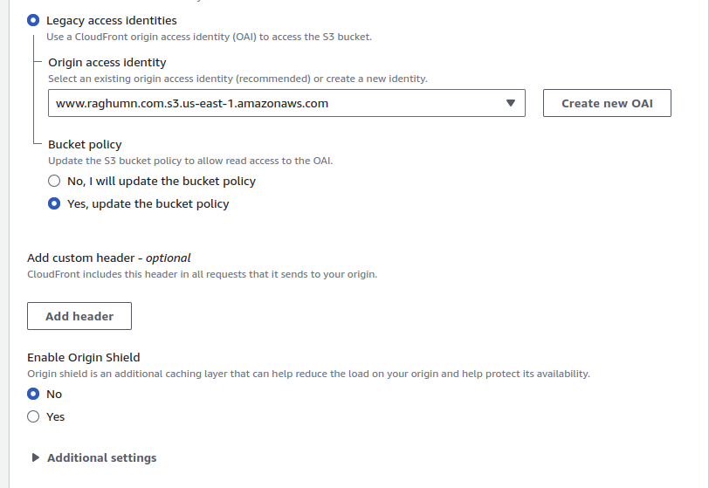
Keep all below options as default
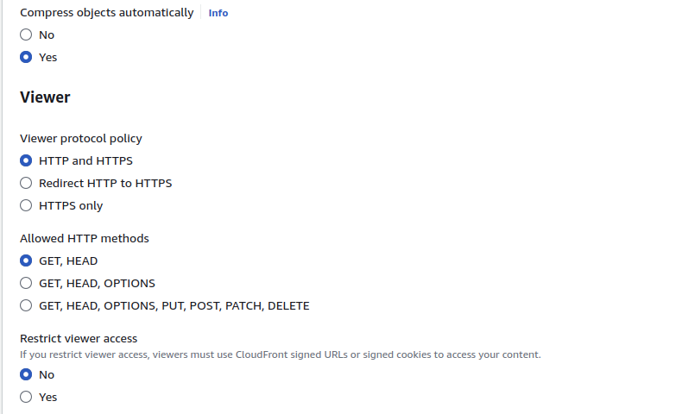
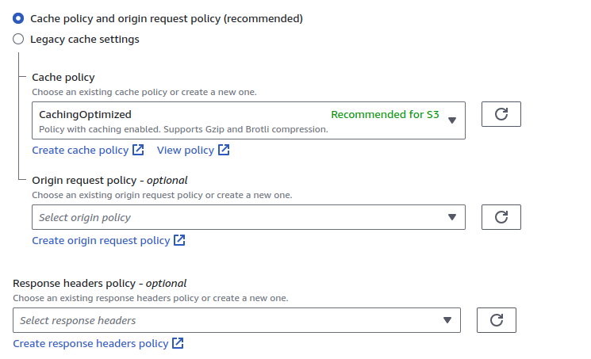

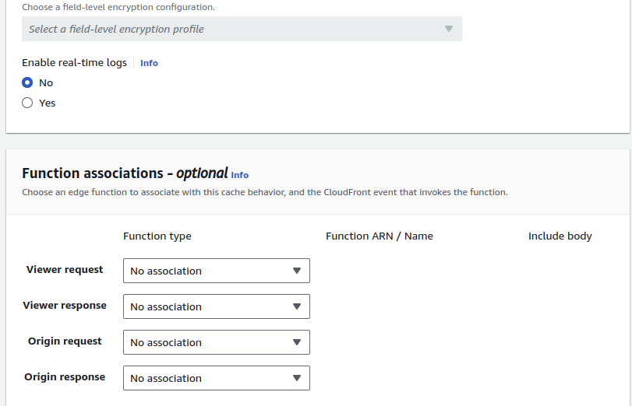
Update the defaut object,otherwise you will not be access to acccess content
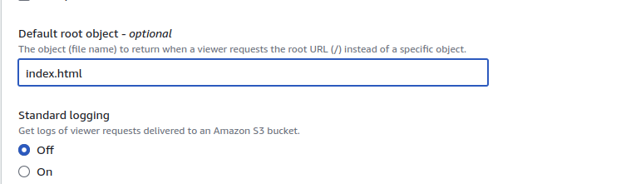

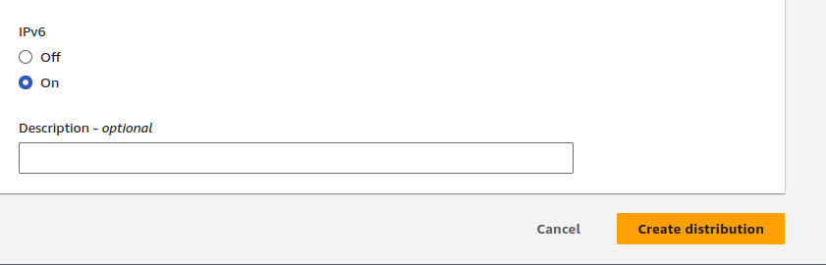

Policy got updated by automatically becasue of we clikced on yes update policy option
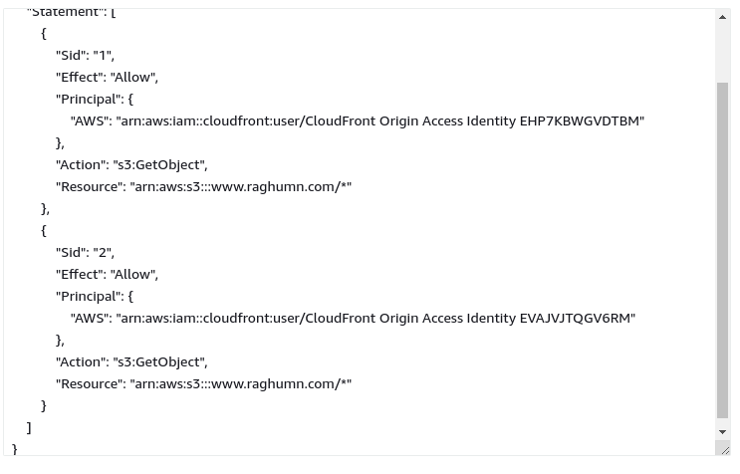

Copy the domian and paste it into browser

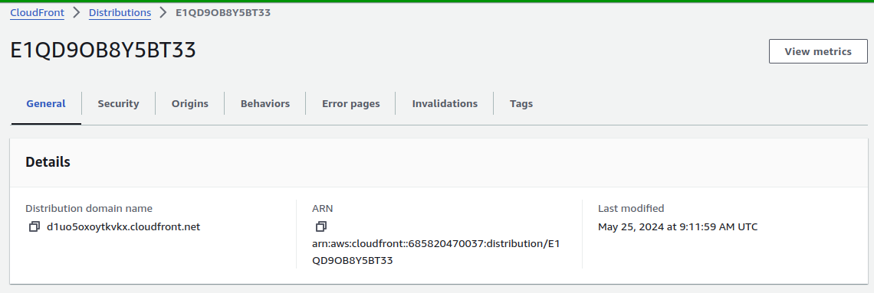
Able to accees website --> https://d1uo5oxoytkvkx.cloudfront.net/
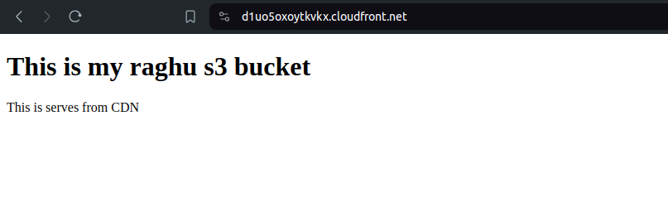

Delete the distribution,otherwise you end up billings
Delete s3 bucket

first click on disable then delete option will be enabled after 2min

