Cost Optimization:

As Devops engineer,if your organization is a small scall or mid range company,suggest to go with public cloud usage like aws azure GCP.

Once started using aws or any other public cloud,Devops engineer play importance role in cost optimization.

Ex: you given access to developer as IAM user with creating EC2 instance permission.
Created and taking the backup of volume,later he created ec2 instance but not deleted snapshots(means backup),aws will charge for snapchatts,as a devops engineer you have to track and reduce the cost.
We can have like many example as above.

If interviewer ask about we need snapshot that is the resoan we kept it,that time you will check snapshot based timestamp to delete which are older than 6 months.

Devops engineer need to monitor the stale resources(stale resources means create but not using) and send out mail about it

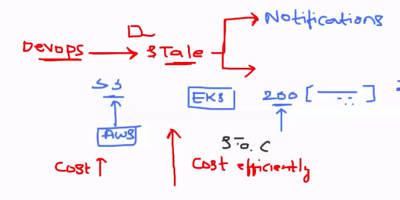
Problem statement for demo:

Developer created the ec2 instance and taking snapshot of instance for every day,later he delete instance but snapshot remians in aws. How we can identify unused EBS volume snapshot and delete them using pyton code. We will use boto3 python package,which will communicate with aws apis.

Steps:
*List all ESB volume snapshots
*filter out the stale snapshots
*delete the stale snapshots

Creating the Ec2 instance for this.

There is a storage configuration,you edit and add more size,by default aws attache 8gb volume. Once EC2 instance got deleted,volume attached to it will also got deleted automatically but if you taken the snapshot from volume,that snapshot will not be deleted.

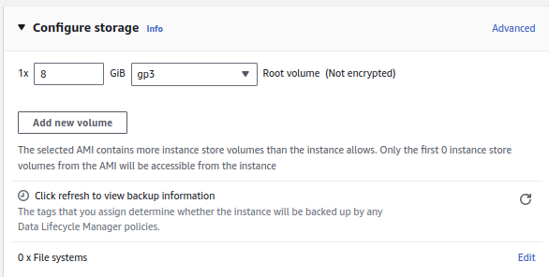
Go to stoage section in ec2,you will get the details of volume.
Then got EC2 dashboard,click on volume,aws will list all avaialble volumes.

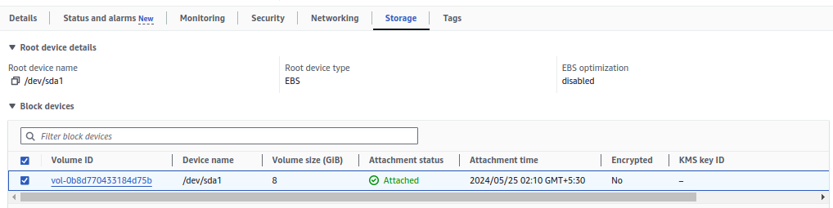

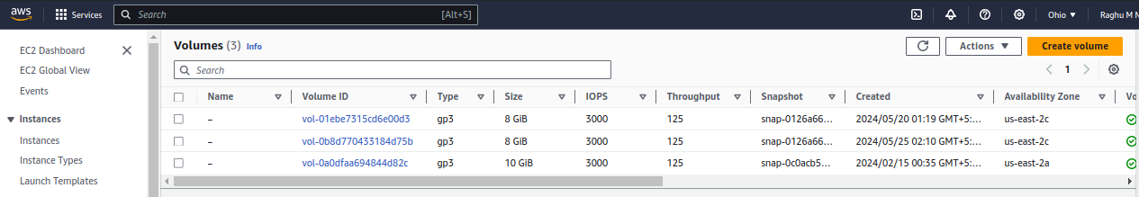
Taking the snapshot.
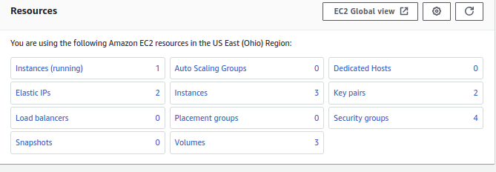

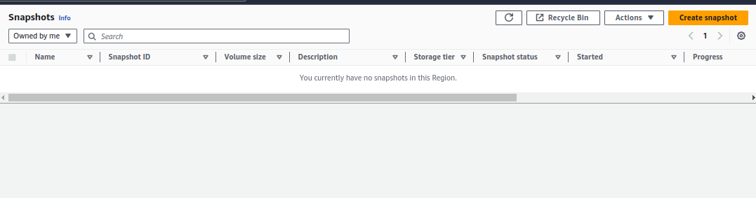
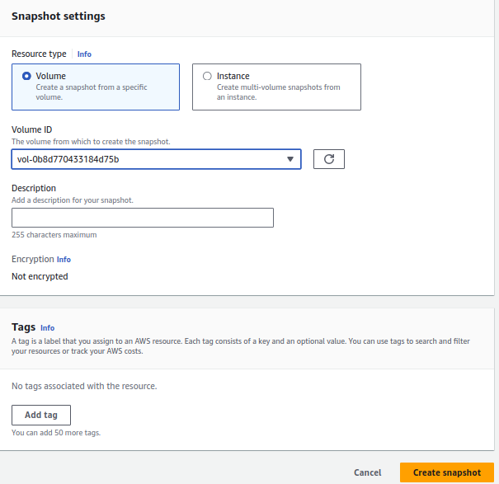

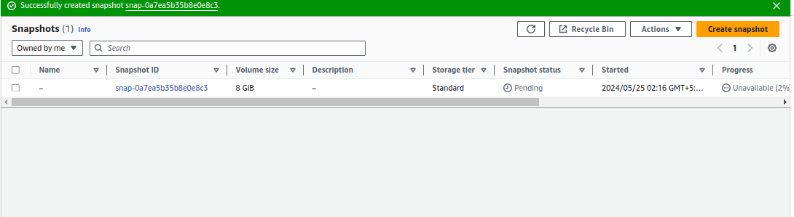

Create lambda function.

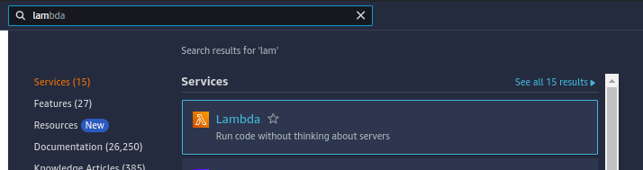
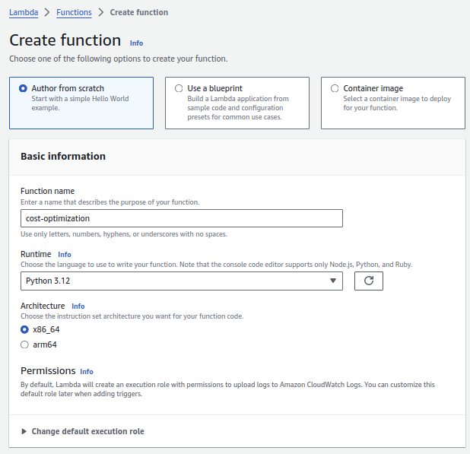

Added the code ,click on deploy and click on test to perform the task

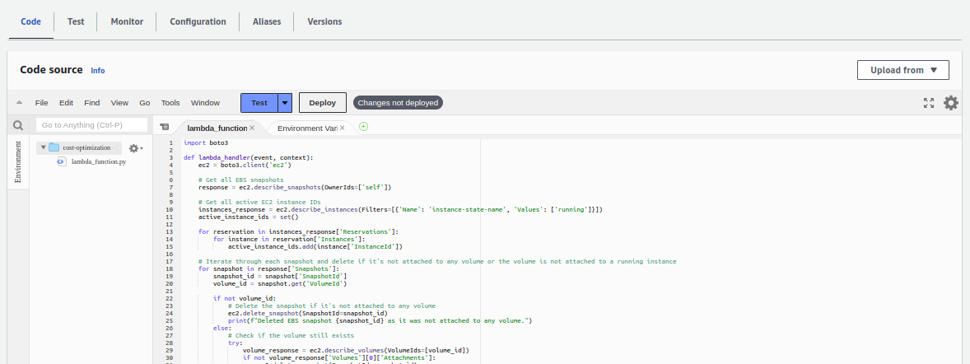
fisrt time will fails because service role assigned to lamabda funtion don’t have function to list snapshot,let see
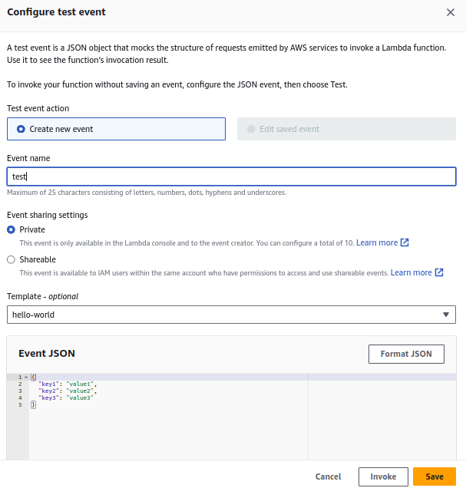
if we add trigger from cloud watch or s3, no need to trigger manually by clickin g test

As we expected,it will show in very small case

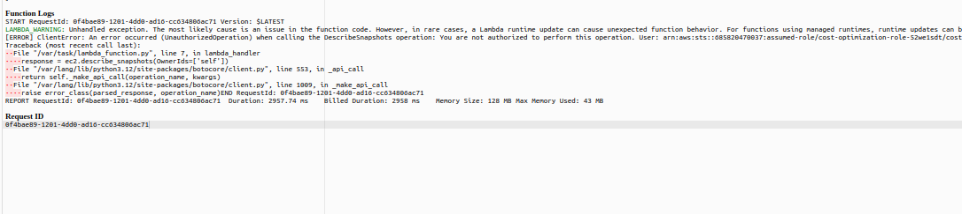

Default execution time for lambda is 3 second,you can increase

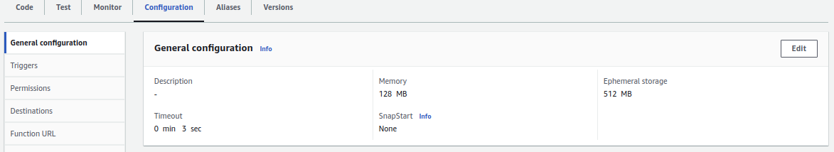
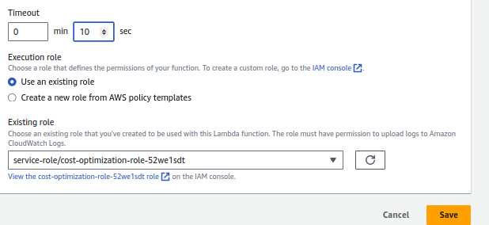
lambda execution time is also chargable,keep low only
Create the custom policy,then attach to service role
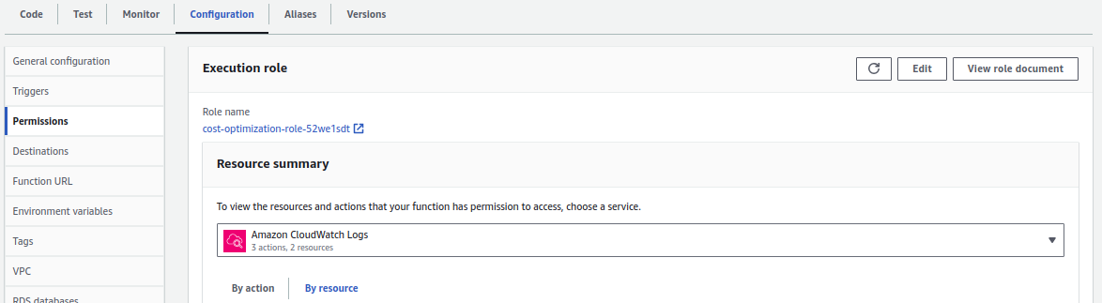
click on create policy
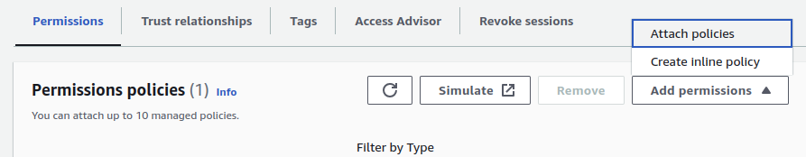
search for your usecase,need to decribe snapshot here
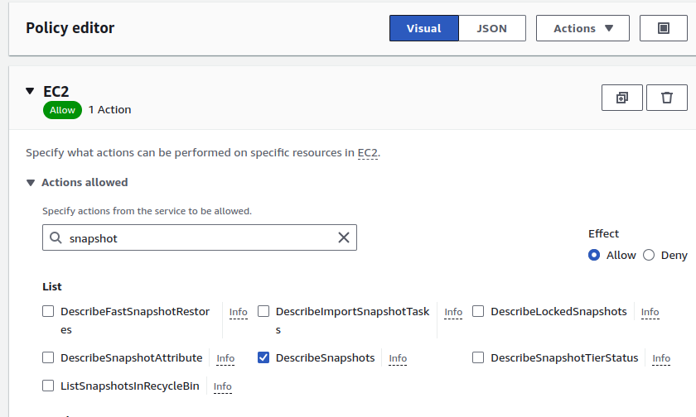
Once it is create,it will get attached to service role,

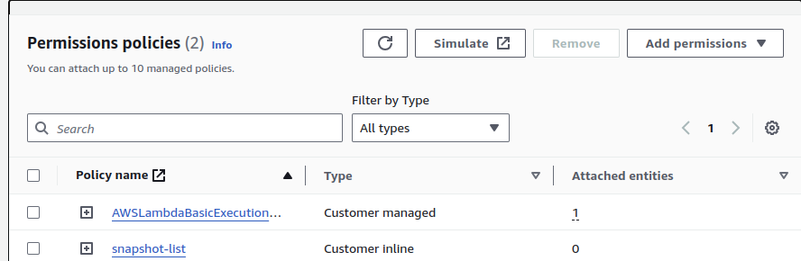
Run it now

Now it will give error on don’t have permission to describe instance,same thin create policy which have describe instance and volume and attach

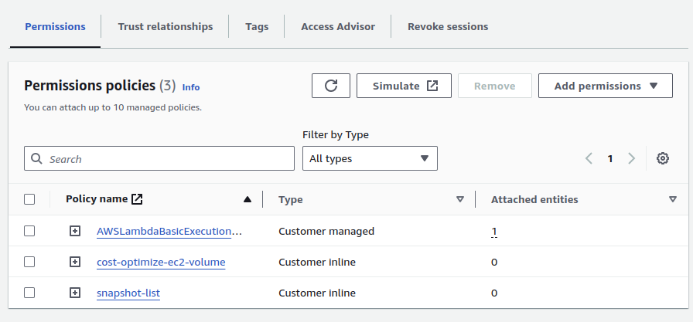
it executed but not deleted snapshot because snapshot belong to volume ,volume still attached to ec2 instance.

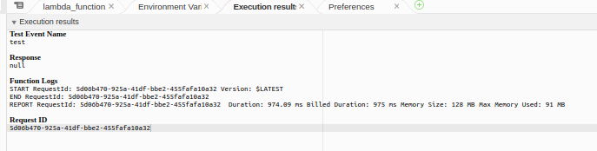
Delete ec2 instance,automatically volume also got deleted,i have 3 volume,let see it become 2 volumes

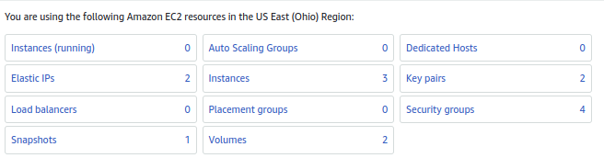
Now run lambad function and see
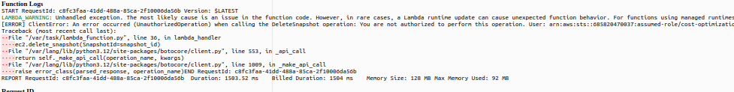

i don’t have permission to delete the snapshot,let add it.
Select resource as all,otherwise you need to mention it.
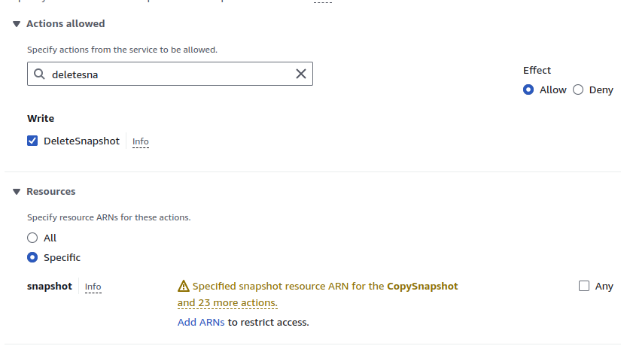

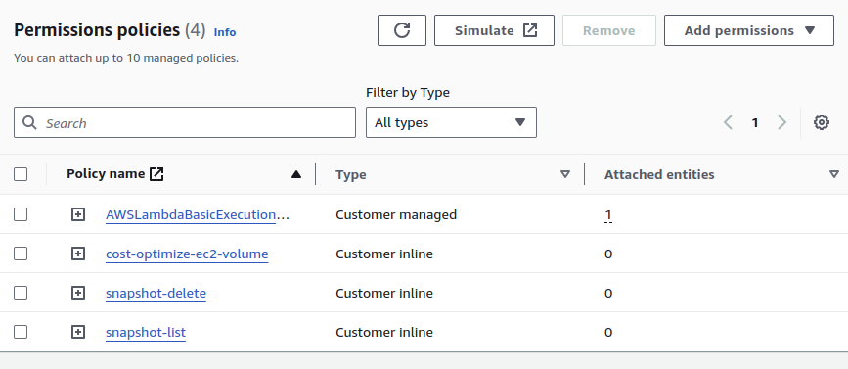

Let run it again.

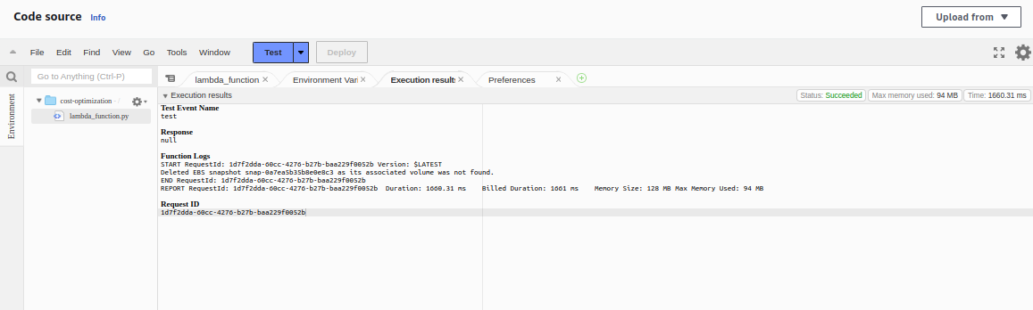
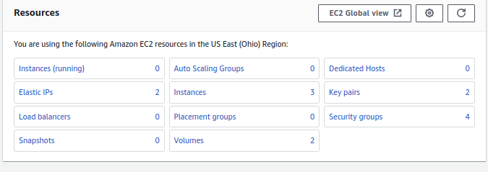
Successfully deleted the snapshots. Which are not taken from volume,that volume are not present now.

